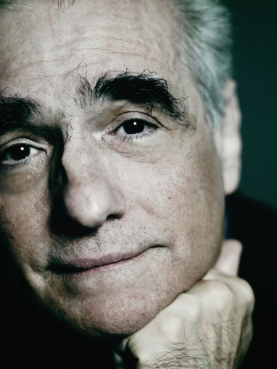
Hartmann, Marcel. Photohartmann.com. 2006. 20 April 2009 <http://www.photohartmann.com/marcelhartmann/celebrities/1/9/50/martin_scorsese.html >.

Martin Scorsese was born in Flushing, New York on November 17, 1942. Much of his childhood was spent alone, and after finishing high school in the Bronx, he tried his hand at seminary for one year before enrolling in New York University. This is where he discovered his true passion: filmmaking. He went on to graduate from the film school at NYU in 1964. Scorsese was inspired by the Italian and French New Wave and independents such as John Cassavetes. Among others Scorsese has also acknowledged the influence that The Bicycle Thief had on his perception of his own Sicilian heritage and the influence of Satyajit Ray on his career.

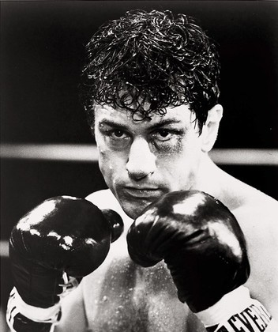
United Artists. The Museum of Modern Art. 1980. 20 April 2009 <http://www.moma.org/collection/browse_results.php?criteria=O%3AAD%3AE%3A26658&page_number=3&template_id=1&sort_order=1>.

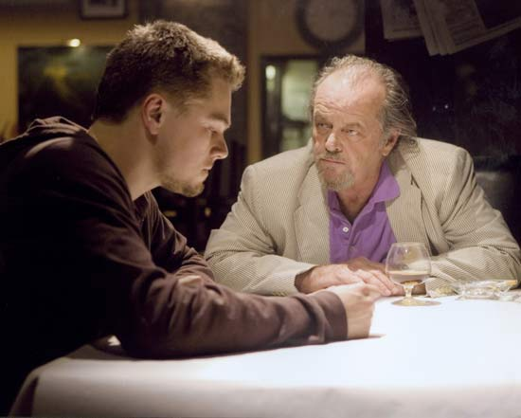
Miramax Films. Britannica. 2006. 20 April 2009 <http://media-2.web.britannica.com/eb-media/90/99190-004-61249490.jpg>.

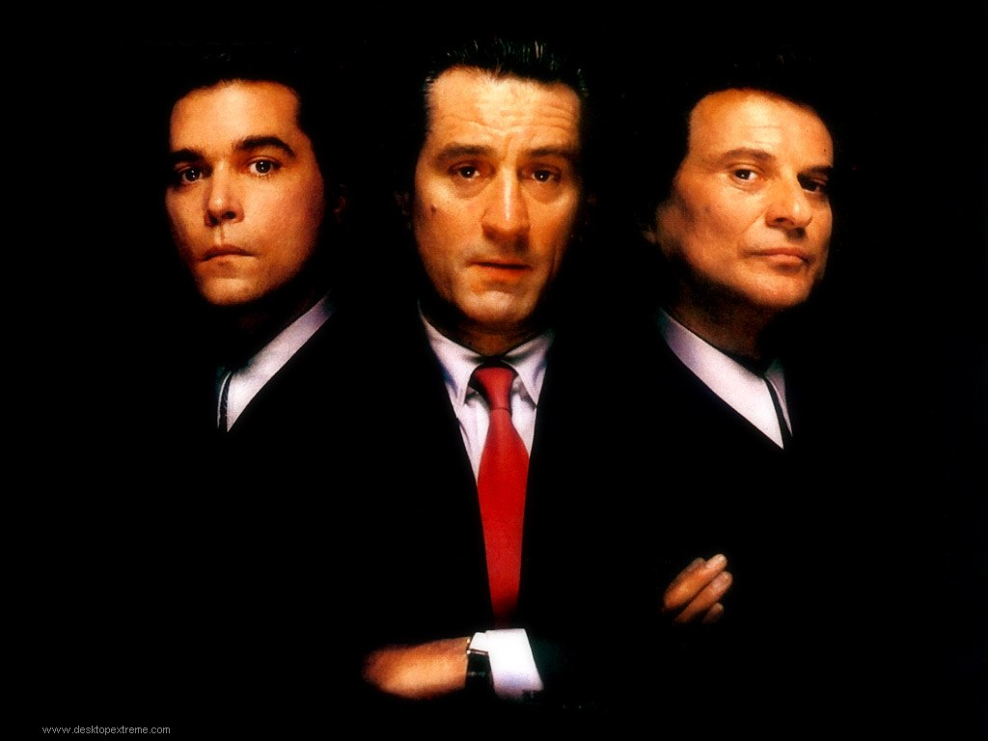
Mainstream Films. SGNewWave. 1990. 20 April 2009 <http://www.sgnewwave.com/main/wp-content/uploads/2008/10/goodfellas.jpg>.

Evidence of Art Cinema’s Influence on Scorsese:
Raging Bull (1980), filmed in black and white, displays signs of expressionism. Scorsese portrays a distorted reality such as the inconsistent sizes of the boxing rings and also uses slow motion sequences for dramatic effect. Exhibiting a common thread in Scorsese’s protagonists, Jake La Motta in his youth was a violent unsympathetic boxer who’s ascension to the pinnacle of the boxing world is coincided with a tantamount collapse of his personal life. Also other themes in Raging Bull (1980) and movies such as Goodfellas (1990) and The Departed (2006) are the use of freeze frames and tracking shots. The main characters of each film wrestle within and search for redemption but ultimately, driven by their internal conflict, must suffer the consequences of their actions. In several of his movies (Raging Bull (1980), Goodfellas (1990), and Casino (1995) the scenes are not presented in chronological order. Often starting the film with a segment of the plot from the middle or end of the story, the sequence of events is disarranged to add emotion.
Goodfellas Tracking Shot
http://www.youtube.com/watch?v=sWYe-Ef3u5M
Raging Bull Final Monologue
http://www.youtube.com/watch?v=ORFo8JGHK50

Resources:
IMDb.com, Inc. "Biography for Martin Scorsese." The Internet Movie Database. 1990-2009. 20 April 2009 <http://www.imdb.com/name/nm0000217/bio>.
Public Broadcasting Service. "Martin Scorsese." American Masters. 2009. Educational Broadcasting Corporation. 20 April 2009 <http://www.pbs.org/wnet/americanmasters/database/scorsese_m.html>.
Wikimedia Foundation, Inc. "Martin Scorsese." Wikipedia. 20 Apr. 2009. Wikimedia Foundation, Inc. 20 April 2009 <http://en.wikipedia.org/wiki/Martin_Scorsese>.

