**Wes Anderson’s Films Influenced by Art Cinema**

***The Royal Tenenbaums (2001)***

*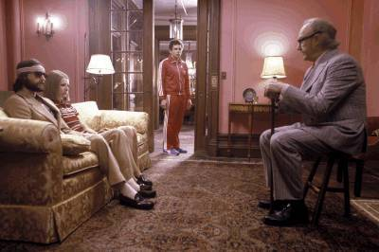The Royal Tenenbaum* (2001) is one of Wes Anderson’s brilliant films centered on several characters including “Royal” Tenenbaum, his wife Etheline, and three children—Chas, Margot, and Ritchie. The family of Tenenbaum has a tradition of having child prodigies. Chas is a financial wizard. Margot is a sensational playwright. Ritchie is a national tennis champion. Royal abandons his family, but later comes back after he gets kicked out of his hotel. He also discovers that his wife is marrying her accountant. His kids are all grown physically, but not emotionally. The kids struggle with their tough adulthood because of many crises that confront them. The family eventually reunites after their own disasters and Royal fakes terminal illness to prevent the marriage of his wife.

Anderson clearly demonstrates how art cinema has influenced *The Royal Tenenbaum*. The film tends to reject traditional norms, displaying many characters with many digressions. There are many narrative threads left hanging, and the sardonic comedy focuses on child prodigies influenced by JD Salinger’s famous novel *The Catcher in the Rye.* Anderson shows subjective realism by focusing on the main characters rather than the plot. Thus, art cinema aims at exhibiting character rather than plot. Although Royal is the key to overcoming the dilemma of his family, Anderson focuses on many protagonists who are the family members. All of them are struggling with their own hardships which Anderson effectively delivers by showing their own storyline. Through these unique storylines, Anderson prudently illustrates how each one of the family members strengthen their inner minds and resolve their conflicts.

There are other essential elements that Anderson displays from art cinema. Anderson also makes great use of popular music to reflect the emotions of characters in particular scenes. A wealthy, reserved family of dysfunctional geniuses, grown up and separated, the Tenenbaums are shown through stylistic techniques of art cinema. The scenes flow together smoothly, even when jumping back and forth between the younger and older days of the children, maximizing Anderson’s flexible means of expression. In art cinema, the drifting protagonist views the social world around him, and occupations such as writers and photographers are well fitted in this case. Anderson applies Margot, a playwright. Throughout the storyline, Anderson conveys art cinema’s core characteristic—emphasizing judgments on modern life and observations of the human condition.

Links to:

<http://www.videosift.com/video/The-Royal-Tenenbaums-Trailer>

Works Cited:

<http://www.hollywoodjesus.com/movie/royal_tenenbaums/04.jpg>

<http://z.about.com/d/movies/1/0/R/L/royaltenpub2.jpg>

<http://www.filmfreakcentral.net/screenreviews/royaltenenbaums.htm>

<http://www.thestopbutton.com/2009/03/30/royal-tenenbaums-2001/>

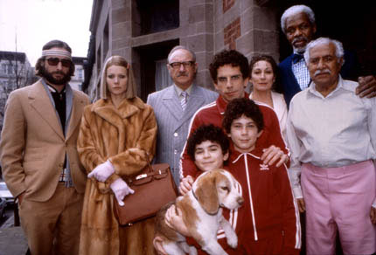

***Rushmore (1998)***

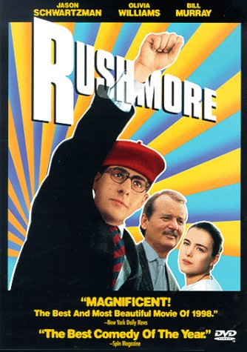 In *Rushmore* directed by Wes Anderson, a fifteen year old student named Max Fisher attends Rushmore Academy during his sophomore year. A barber’s son, Max is able to attend the rich private academy since he won a scholarship. He is not in a good academic standing, but is versatile, contributing and leading many extracurricular activities. He befriends a steel-baron millionaire, Herman Bloom, but they later become enemies for their mutual love for a grade school teacher—Rosemary Cross.

Anderson, like in *The Royal Tenenbaum*, concentrates on characters over plot. Through the characters, Anderson conveys an interesting morality study on our modern ideals of success—American dream. Anderson sets up Max as a drifting protagonist who observes the social world around him as he enjoys writing plays rather than studying. Through his hobby and his conflict in the film, the director makes sure that characters express their mental states. Anderson also uses a stylistic art film technique through several editing patterns. For instance, Anderson, through his distinctive editing pattern, demonstrates an important role a letter can play in the story. While Miss Cross is outside painting with her class, Blume walks up and hands her the letter from Max. We cut away to a close up of "Dear Miss Cross" on the letter and we hear Max's voice reading it. We then cut back to Miss Cross and Blume as Max continues reading. This art film technique, also known as insertion of verbal messages, helps the audience better understand the behavior and emotions of the characters.

In art cinema, personal identity is unstable and characters tend to be inconsistent throughout the plot. When Max first met Blume, he really liked him. However, after he finds out Blume’s relationship with Miss Cross, he falls into a dilemma and seeks for revenge. He tells 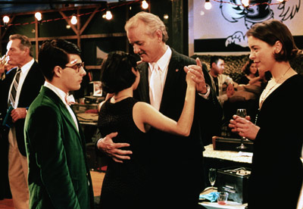Blume’s wife about his affair and eventually contributes to their divorce. Later on, Max gives up on Miss Cross and is again friends with Blume. When he discovers that Blume and his teacher no longer are dating, he helps them reunite. The protagonist acts inconsistently and questions his own purpose throughout the story. Anderson’s music selection is also exceptional in the film. He effectively uses various bands including The Faces, The Rolling Stones, Cat Stevens, and The Kinks.

Works Cited:

<http://www.criterionconfessions.com/2008/05/rushmore-65.html>

<http://www.wildsound-filmmaking-feedback-events.com/rushmore.html>

<http://www.dvdverdict.com/reviews/rushmorecc.php>

<http://www.insidesocal.com/tomhoffarth/rushmore.jpg>

<http://img2.timeinc.net/ew/dynamic/imgs/070808/gallery/rushmore_l.jpg>

Links to:

<http://www.youtube.com/watch?v=yly2UDQp6fc>