
Title Page
URS – The Clubhouse
Title of document: User Requirement Specifications
Date: TBD
Location: Fontys R10
Members: Georgi Ivanov, Boris Petrov, Matei Cooperu, Georgi Tinchev
Tutor: Sachin Bhardwaj

Table of Contents
- Title Page
- Agreements with Client
- Functional Requirements
- Non-functional requirements
- Use Cases
- Graphical User Interface (GUI)

Agreements with Client
The client has agreed that the first version of the desktop application should be completed within 6 weeks. The focus of the first version will be on the employee management system and the other functionalities are extra at this point of time.

Functional Requirements
System Capabilities
- CRUD Functionalities
- ID: FR-1
- Name: Perform CRUD operations on employee records.
- Constraints: Managers and HR Managers can create, read, update, and delete employee records.
- Authentication & Authorization:
- ID: FR2
- Name: Implement authentication and authorization mechanism.
- Constraints: Only authorized users (Managers and HR Managers) can access and manipulate employee data.
- Enforcing Business Rules
- ID: FR3
- Name: Implement business rules and regulations governing employee management.
- Constraints: Ensure compliance with regulations.
Employee Information
The system should store the following information about each employee:
- Name, surname, username & password
- Address
- Email address
- Date of birth
- BSN number
- Employee department
- Employment start date
- Employment end date (if applicable)
- Reason for termination (if applicable)
- Emergency contact information (spouse's name and phone number)
Department Roles
- Human Resources: HR Managers
- Customer Service Department: Sales Representatives, Support Employees, Cashiers
- Security: Security Guards
- Logistic Department: Depot Workers
Prioritization
The employee management part will be completed first, other parts will be completed later.
Non-Functional Requirements
- Performance
- ID: NFR-1
- Name: Ensure the system performs efficiently even with a large number of employees.
- Constraints: Response time should be within 2 seconds for most operations.
- Maintainability
- ID: NFR-2
- Name: Design the system for easy maintenance and future updates.
- Constraints: Code should follow industry-standard coding practices and be well-documented.
- Security
- ID: NFR-3
- Name: Implement security measures to protect employee data
- Constraints: Use encryption for sensitive data, implement secure authentication mechanisms.
- Scalability
- ID: NFR-4
- Name: Design the system to handle future growth in terms of users and data
- Constraints: The system should support at least 1000 employees initially and scale to accommodate more.
Use Cases
Add New Employee
- UC ID: UC-1
- Description: HR Manager adds a new employee to the system.
- Trigger: HR Manager initiates the process.
- Pre-condition: HR Manager is logged in.
- Post-condition: New employee added successfully.
Main Success Scenario (MSS):
- HR Manager initiates the process to add a new employee.
- System prompts HR Manager to enter personal information, department, and employment details.
- HR Manager enters the required information.
- System validates the information and adds the new employee to the database.
- System confirms successful addition.
Extensions:
- 3a: HR Manager cancels the process.
  - MSS Steps:
    - System cancels the operation.
    - End of use case.
- 3b: HR Manager encounters an error during data entry.
  - MSS Steps:
    - System displays an error message.
    - HR Manager corrects the error and continues from step 3.
Update Employee Information
- UC ID: UC-2
- Description: HR Manager updates the information of an existing employee.
- Trigger: HR Manager initiates the process.
- Pre-condition: HR Manager is logged in.
- Post-condition: Employee information updated successfully.
MSS:
- HR Manager selects the employee to update.
- System displays the current information of the selected employee.
- HR Manager modifies the required information.
- System validates the changes and updates the employee information.
- System confirms successful update.
Extensions:
- 3a: HR Manager cancels the update.
  - MSS Steps:
    - System cancels the operation.
    - End of use case.
- 3b: HR Manager encounters an error during data modification.
  - MSS Steps:
    - System displays an error message.
    - HR Manager corrects the error and continues from step 3.
Remove Employee
- UC ID: UC-3
- Description: HR Manager removes an employee from the system.
- Trigger: HR Manager initiates the process.
- Pre-condition: HR Manager is logged in.
- Post-condition: Employee removed successfully.
MSS:
- HR Manager selects the employee to remove.
- System prompts HR Manager for confirmation.
- HR Manager confirms the removal.
- System removes the employee from the database.
- System confirms successful removal.
Extensions:
- 3a: HR Manager cancels the removal.
  - MSS Steps:
    - System cancels the operation.
    - End of use case.
Search for Employee
- UC ID: UC-4
- Description: HR Manager searches for a specific employee within the system.
- Trigger: HR Manager initiates the search.
- Pre-condition: HR Manager is logged in.
- Post-condition: Search results displayed.
MSS:
- HR Manager initiates the search by entering criteria like name, department, or employee ID.
- System retrieves and displays the search results.
Extensions:
- 2a: No matching employees found.
  - MSS Steps:
    - System displays a message indicating no matching employees.
    - End of use case.
Filter Employees
- UC ID: UC-5
- Description: HR Manager filters the list of employees based on specific criteria.
- Trigger: HR Manager initiates the filter.
- Pre-condition: HR Manager is logged in.
- Post-condition: Filtered employee list displayed.
MSS:
- HR Manager selects the filter criteria, such as department, employment status, or position.
- System filters the employee list based on the selected criteria.
- System displays the filtered employee list.
Extensions:
- 2a: HR Manager cancels the filter.
  - MSS Steps:
    - System cancels the operation.
    - End of use case.
View Employee Worksheets
- UC ID: UC-6
- Description: Department Manager views the worksheets of specific employees.
- Trigger: Department Manager initiates the view.
- Pre-condition: Department Manager is logged in.
- Post-condition: Employee worksheets displayed.
MSS:
- Department Manager selects the employee whose worksheets to view.
- System retrieves and displays the worksheets of the selected employee.
Extensions:
- 2a: Department Manager cancels the view.
  - MSS Steps:
    - System cancels the operation.
    - End of use case.
Assign Worksheets to Employees
- UC ID: UC-7
- Description: Department Manager assigns worksheets or tasks to employees within their department.
- Trigger: Department Manager initiates the assignment.
- Pre-condition: Department Manager is logged in.
- Post-condition: Worksheets assigned successfully.
MSS:
- Department Manager selects the employee to assign worksheets.
- System prompts Department Manager to enter details of the assignment.
- Department Manager enters the required information.
- System validates the information and assigns worksheets to the selected employee.
- System confirms successful assignment.
Extensions:
- 2a: Department Manager cancels the assignment.
  - MSS Steps:
    - System cancels the operation.
    - End of use case.

Use Case Diagram:
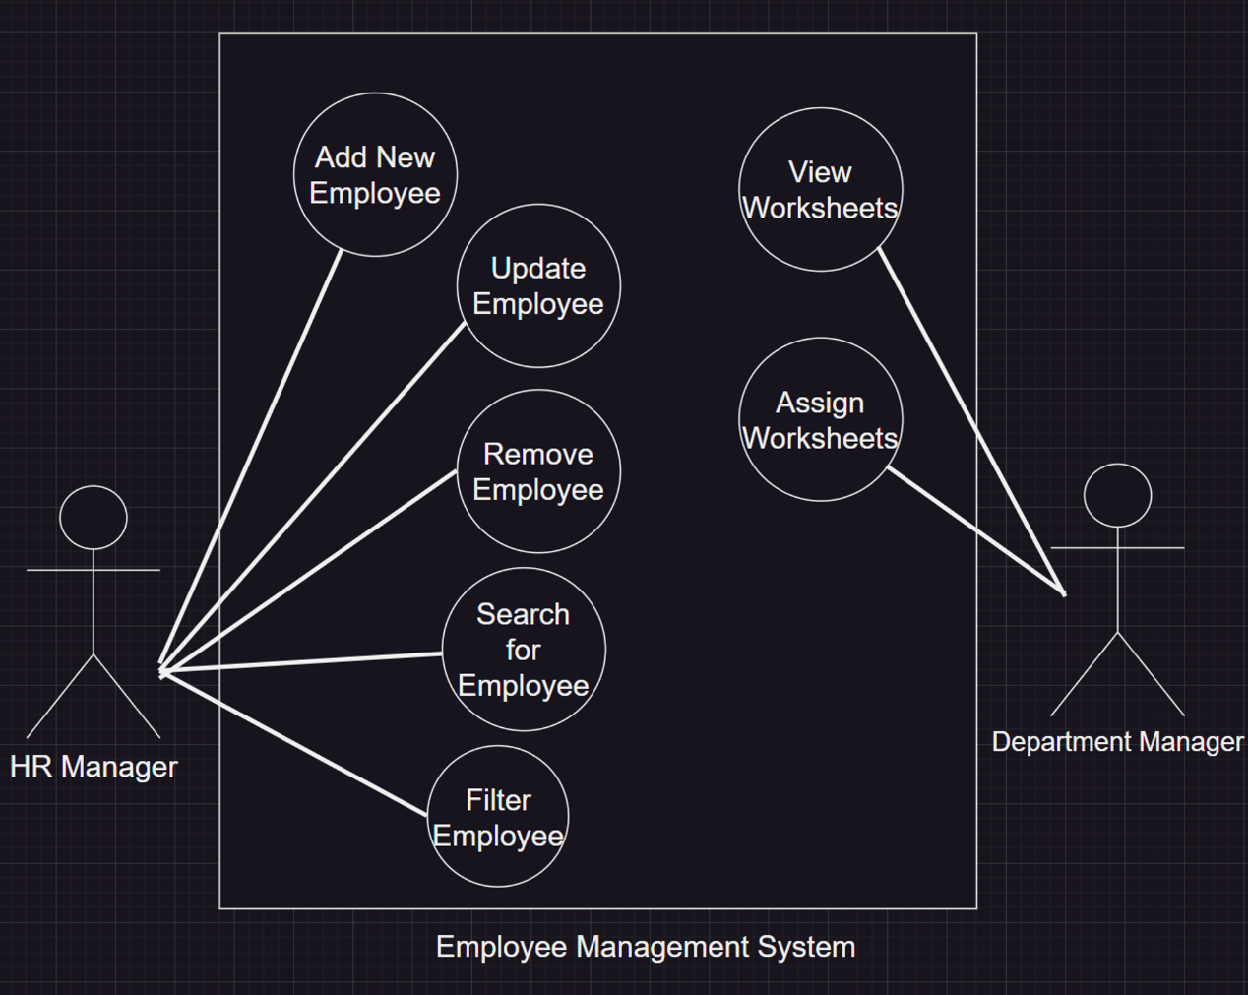
GUI Desktop:
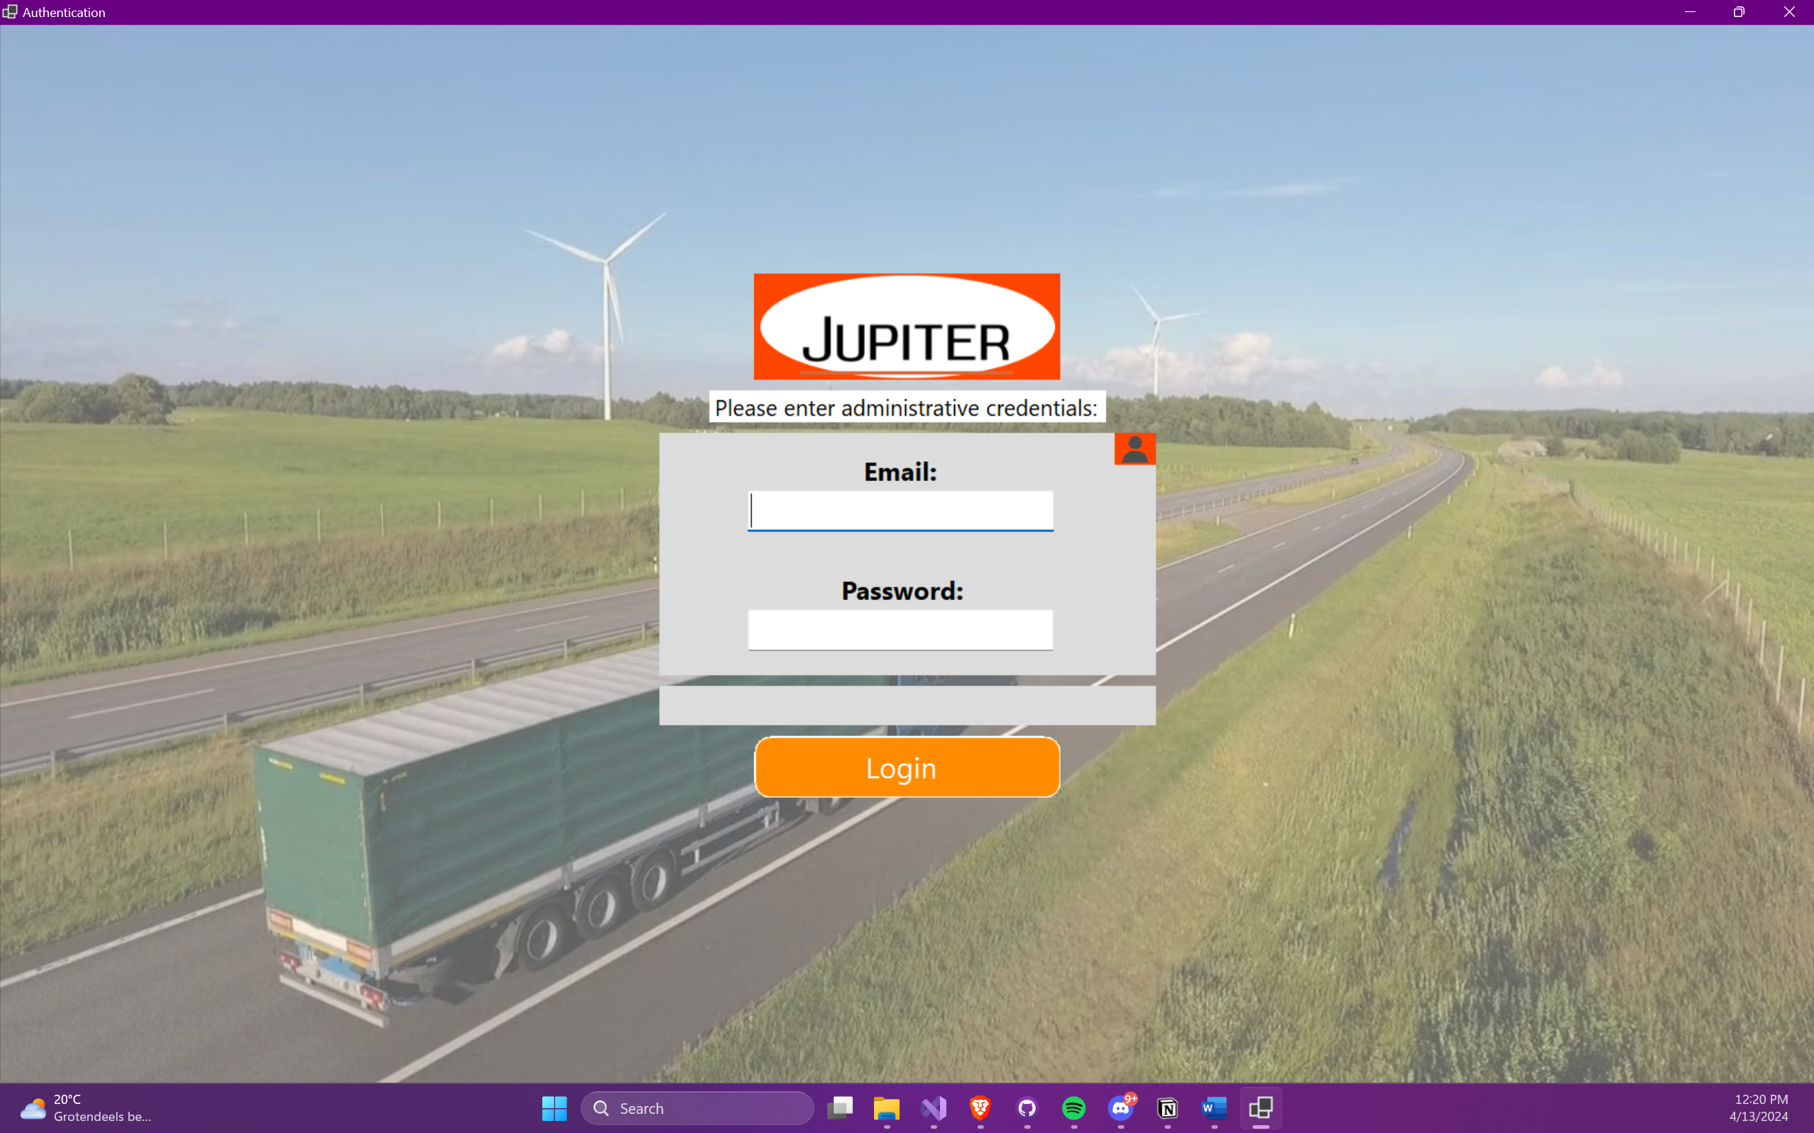
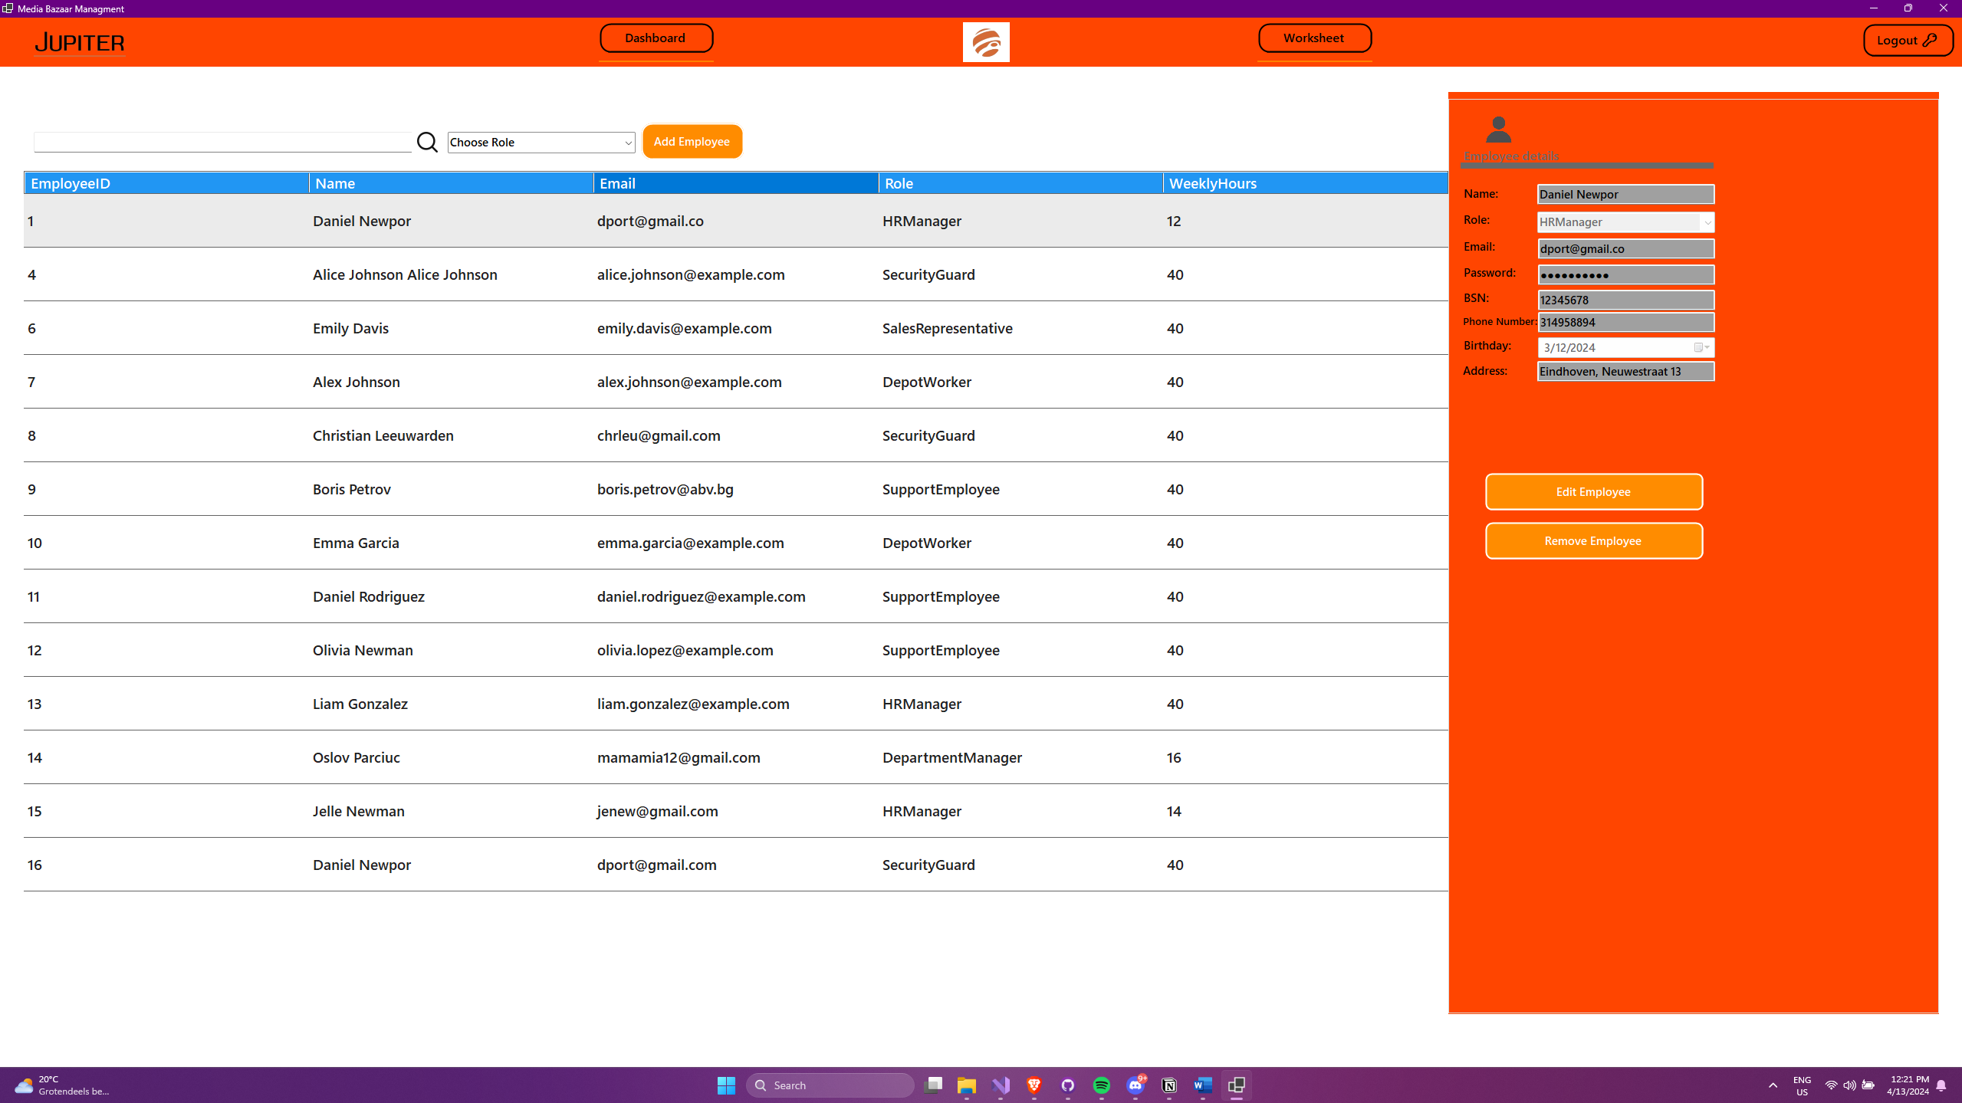
GUI Website:
Should include a website that allows employees to check their schedules.

