Assignment - 3

Machine Learning (CS 5710) CRN: 22002

Name: Midhun Kumar Chintapalli

700739502

Github link: <https://github.com/midhun-ch/ML_Assignment3>

**Question – a)**

Using NumPy create random vector of size 15 having only Integers in the range 1-20.

Solution :

* creating a numpy array with random integers from 1 to 12 and with size 15

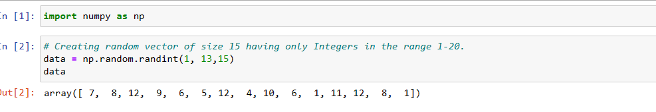

**Question – a1)**

**Reshape the array to 3 by 5**

**Sol:** reshaping the numpy array with the size 3*5

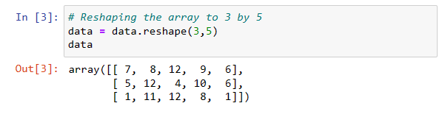

**Question – a2)**

**print shape of the array**

* printing the shape of the numpy array using shape function.

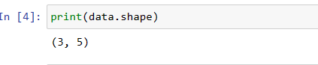

**Question – a3)**

**Replace the max in each row by 0**

* using argmax taking the indexes of the max values in each row by giving axis = 1 in line 1
* getting the row index of the numpy array in line 2
* getting an 2d array of max valued index and the row index in line 3
* ravel_multi_index Converts a tuple of index arrays into an array of flat indices in line 4
* replacing the max values in each row to 0 in line 5 using the assignment operator

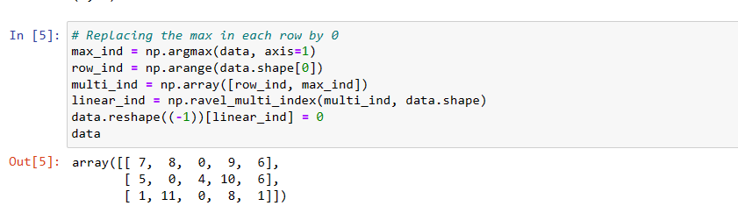

**Question – 2)**

**Create a 2-dimensional array of size 4 x 3 (composed of 4-byte integer elements), also print the shape, type and data type of the array.**

* creating an numpy array with integers from 1 to 12 with datatype as 4 byte int and with shape 4*3
* And printing the shape of the array along with its datatype

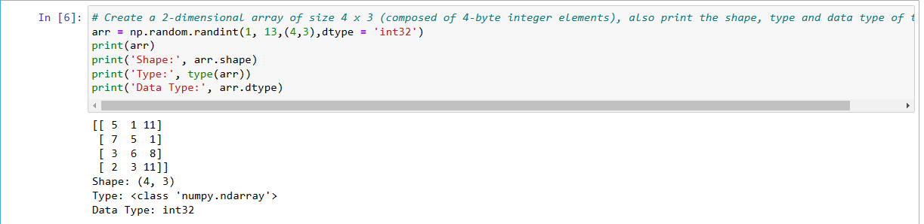

**Question – 2a)**

**Write a program to compute the eigenvalues and right eigenvectors of a given square array given below: [[ 3 -2] [ 1 0]]**

* creating the given numpy array
* getting the eigen values and eigen vectors of the the given numpy array using the linear algebra method.
* Printing the eigen values and eigen vectors of the given numpy array.

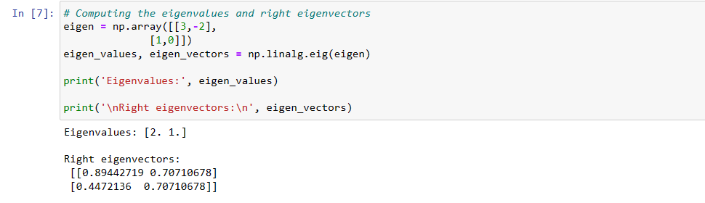

**Question – 2b)**

* **Compute the sum of the diagonal element of a given array. [[0 1 2] [3 4 5]]**
* creating the given numpy array
* getting the sum of the diagnol elements using the trace method.
* Printing the trace of the given numpy array.

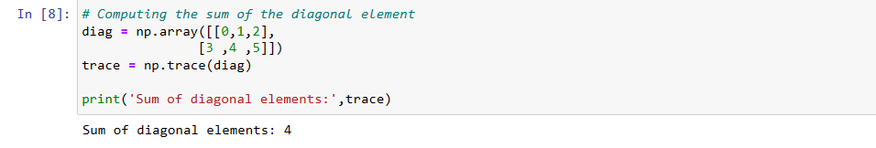

**Question – 2c)**

**Write a NumPy program to create a new shape to an array without changing its data.**

* creating the numpy array using np.arange method
* Printing the array after reshaping it to 3*2 and 2*3 arrays without changing its data with the help of reshape method.

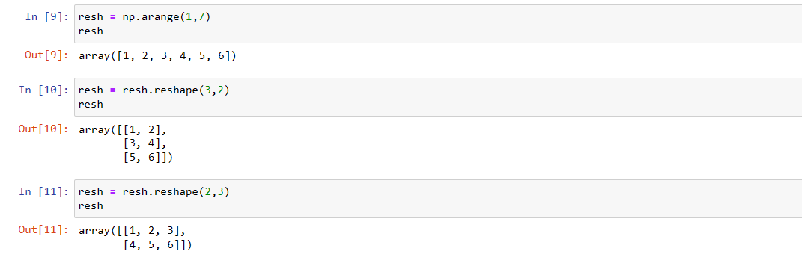

**Question – 2c)**

Write a Python programming to create a below chart of the popularity of programming Languages.

Sample data: Programming languages: Java, Python, PHP, JavaScript, C#, C++

Popularity: 22.2, 17.6, 8.8, 8, 7.7, 6.7

**Solution :**

* creating a list of labels
* creating a list of values
* creating a tuple to create partition in the pie chart
* Creating the pie chart using subplot methods and giving arguments to it for labelling, placing percentage, slicing it and giving the shadow.

