**Capstone Project - The Battle of Neighborhoods**

# Introduction

New Delhi, India’s capital territory, is a massive metropolitan area in the country’s north.  It is the world's [second-largest urban area](https://en.wikipedia.org/wiki/List_of_urban_areas_by_population) according to the United Nations. New Delhi is one of the most visited cities of India by foreign tourists.

Delhi has no specific food culture. Food culture in [Delhi](https://www.mapsofindia.com/delhi/) is a mixture of North [Indian food](https://www.mapsofindia.com/my-india/food), Mughlai Cuisines, Punjabi food and mouthwatering street food. It also includes a variety of cuisines from different parts of India. Delhi is a hot spot for Continental, Thai, Mexican and Chinese food as well.

A group of foreigners from Italy are planning to visit New Delhi for Business purpose. As this place is new for them, they need to find best restaurants for their Italian cuisine. Also, they need to find solutions to following problems-

Which areas have large number of Italian Restaurant Market?

Which is the best place to stay if I prefer Italian Cuisine?

Which Restaurant has the highest rated Italian Cuisine in New Delhi city?

In this project we will use the **Foursquare API** to explore neighborhoods in New Delhi City. We will use the **explore** function to get the most common venue categories in each neighborhood, and then use this feature to group the neighborhoods into clusters. Also, we will use the k-means clustering algorithm to complete this task. Finally, we will use the Folium library to visualize the neighborhoods in New Delhi City and their emerging clusters.

# Data

After reading the Introduction part we get to know that we need a dataset that contains New Delhi city and its neighborhood having Restaurants Data as well as their latitude and longitude coordinates of each neighborhood.

* Data source : Zomato Kaggle dataset : <https://www.kaggle.com/shrutimehta/zomato-restaurants-data>
* Description: Kaggle is the world`s largest data science community with powerful tools and resources to help you achieve your data science goals. This data set contains information about Restaurants with their Id No. and Name of different Countries and their cities with Locality. As we require only New Delhi city for our project, we extract only the data having country as India and city as New Delhi from **zomoto.csv** file. And we will use this data set to explore various locality of New Delhi city.

Nearby places in each locality of New Delhi city.

* Data source: Foursquare API: <https://developer.foursquare.com/>
* Description: By using this API we can explore the neighborhoods of New Delhi city and segment them. Also, we can search for nearby venues of a specific type, explore a particular venue and search for trending venues around a location.

# Methodology

* 1. Collect the New Delhi city data from Zomato Kaggle dataset.

From the Zomato Kaggle dataset we require only samples having New Delhi city. So, we first read the Zomato.csv file to a DataFrame.

Select Country Code as 1 (which is ‘India’) and City as ‘New Delhi’.

Our new updated DataFrame is ready.

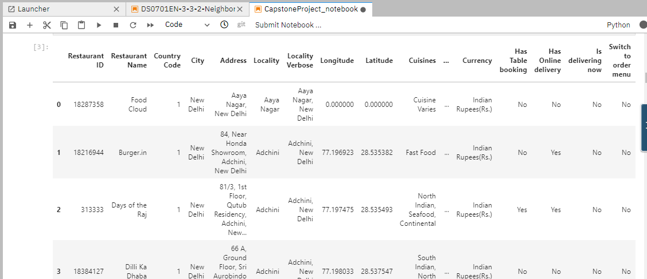

* 1. Data Cleaning

Discard Unwanted Columns and Rows from the Dataset.

As shown below are our final columns in our Dataset after data cleaning.

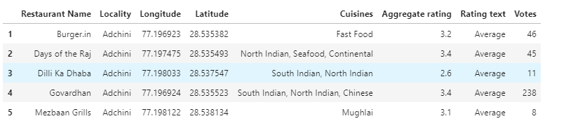

* 1. Created a Folium Map to show Restaurants Clusters in New Delhi city.

The below New Delhi city map is divided into 5 Clusters with various colors.

New_Delhi_Rest = folium.Map (location= [28.52, 77.25], zoom_start=12)

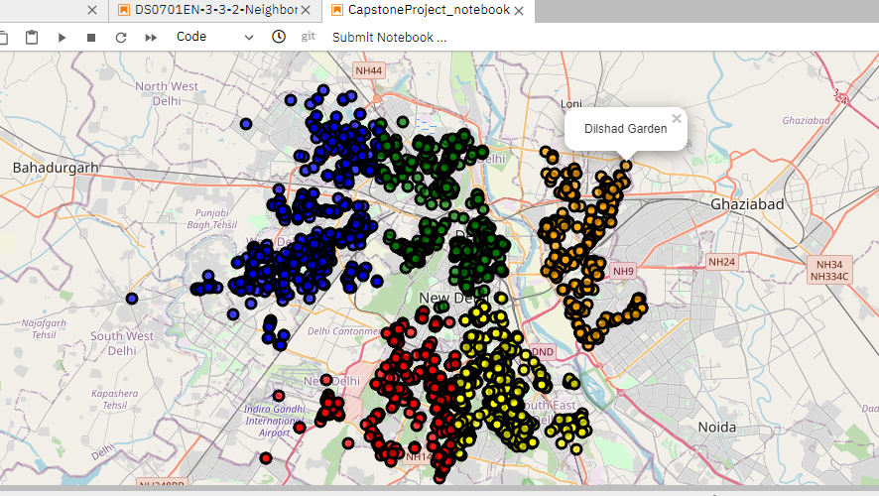

* 1. Using Data Visualization, we can do Data analysis to find out answers to our problems.

1. Top 5 Localities with Highest number of Restaurants in New Delhi city (used Bar chart for Visualization)

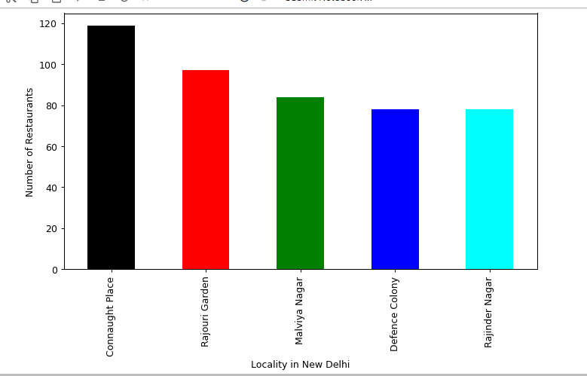

The above plot show that- **Connaught Place** has the Highest number of Restaurants in New Delhi.

1. Top 5 highest rated Restaurants Based on Locality of New Delhi (used Bar chart for Visualization)

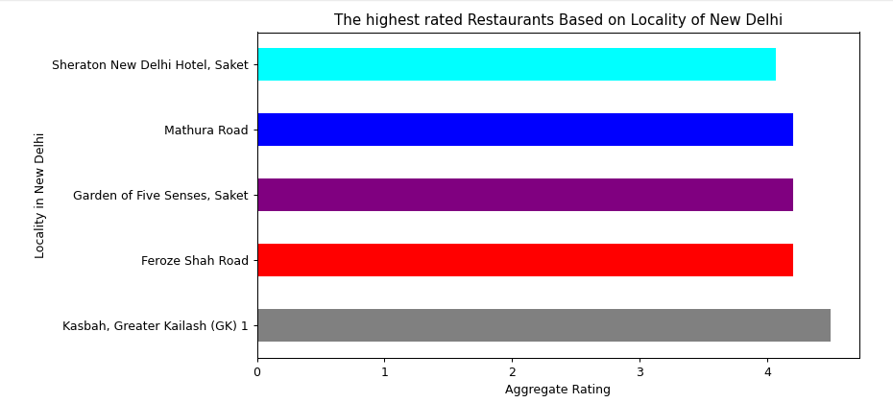

The above plot shows **Kasbah, Greater Kailash(GK)** is the Locality in New Delhi with highest rated Restaurants.  
So, This is the best Locality to try out new foods. It has rating around 4.5.

1. Now let`s take a look at the Localities you should probably not visit due to low rating reviews. So, we have also plotted 5 Least Rated Restaurants available in Locality of New Delhi using Bar chart Visualization.

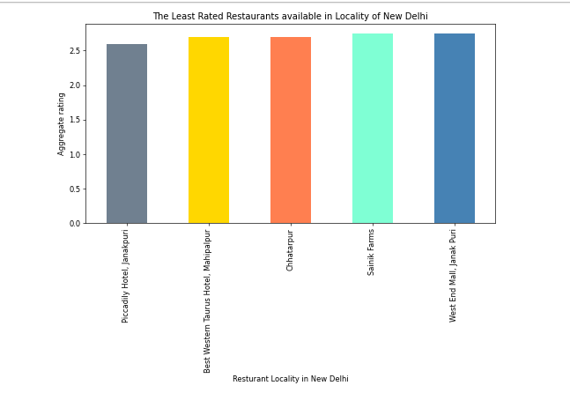

The above plot shows **Piccadily Hotel, Janakpuri** is the Locality in New Delhi with least rated Restaurants.

1. 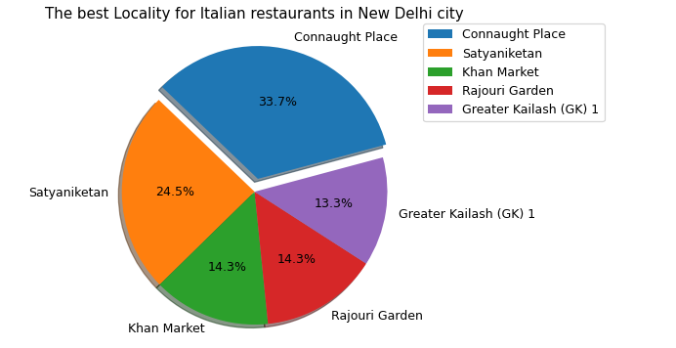Now as per our requirement we want to find good Italian Restaurants in New Delhi city. So, we tried to find out Top 5 best Locality for Italian restaurants in New Delhi city.

So, the above Pie Chart shows **Connaught Place** is the Locality in New Delhi where you can find large number of Italian Restaurants. This place has been exploded in the chart.  
This place has 33.7% of total Italian Restaurants.

1. 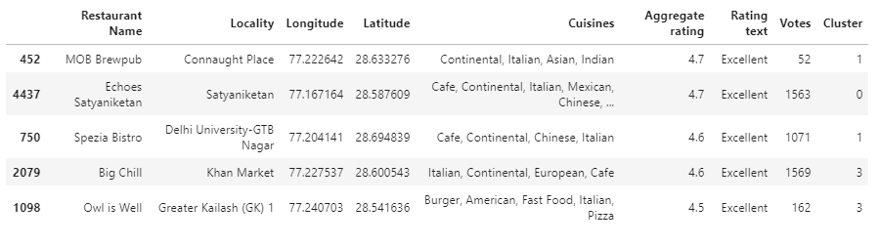As well have found out in above analysis about the top 5 best Locality for Italian restaurants in New Delhi city. Now, we are interested to find most popular or Most rated Italian Restaurants within these Localities.

We have also plotted these Italian Restaurants on Folium Map.

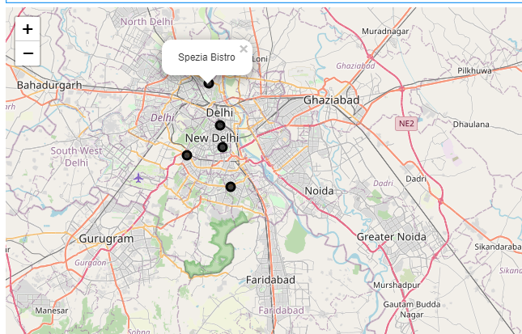

1. Finally, we perform Data Transformation i.e. based on Locality grouping of Data and create a final dataframe (df_final) for final processing the data.
2. Define Foursquare Credentials and Version and create a function to repeat the same process to all the Locality in New Delhi (function name as getNearbyVenues).
3. Find the venues in all New Delhi Locality and print each Locality along with the top 5 most common venues.
4. Run k-means to cluster the Locality into 5 clusters. Create final map and add markers to the map. Finally, examine the Clusters.
5. Results

As our Dataset Zomato.csv contains many unwanted samples so we performed data cleaning and then did data analysis.

* **Connaught Place** has the Highest number of Restaurants in New Delhi.
* **Kasbah, Greater Kailash(GK)** is the Locality in New Delhi with highest rated Restaurants.
* **Piccadily Hotel, Janakpuri** is the Locality in New Delhi with least rated Restaurants.
* **Connaught Place** is the Locality in New Delhi where you can find large number of Italian Restaurants. This place has 33.7% of total Italian Restaurants.
* **MOB Brewpub and Echoes Satyaniketan is the Italian Restaurants which is most rated or popular amongst the all Italian Restaurants in New Delhi city. These both restaurants have Aggregate rating of 4.7 and got Rating text as ‘Excellent’.**

1. Discussions

Since, **MOB Brewpub and Echoes Satyaniketan is the Italian Restaurants which is most rated or popular amongst the all Italian Restaurants in New Delhi city. MOB Brewpub comes under Cluster 1 and having locality as “Connaught Place**”. Similarly, **Echoes Satyaniketan comes under Cluster 0 and is under the locality “Satyaniketan”.**

**Also we know that Connaught Place** has the Highest number of Restaurants in New Delhi and it is the Locality in New Delhi where you can find large number of Italian Restaurants. So, instead for recommending **Echoes Satyaniketan we can prefer MOB Brewpub as the best restaurants for Italian as they can even try different restaurants nearby as this place mostly contains Italian cuisines.**

1. Conclusion

* **Connaught Place** has the Highest number of Restaurants in New Delhi.
* **Kasbah, Greater Kailash(GK)** is the Locality in New Delhi with highest rated Restaurants.
* **Connaught Place** is the Locality in New Delhi where you can find large number of Italian Restaurants. This place has 33.7% of total Italian Restaurants.
* **MOB Brewpub as the best restaurants for Italian as they can even try different restaurants nearby as this place mostly contains Italian cuisines.**
* **Cluster 1 is mostly recommended for Pizza Place and Fast food.**
* **Cluster 2 is mostly recommended for** Indian Restaurants.
* **Cluster 3 is mostly recommended for** Pizza Place.
* **Cluster 4 is mostly recommended for Hotels.**
* **Cluster 5 is mostly recommended for Cafes.**