**Bank-Marketing-Campaign**

**Objective**

The objective of this project is to optimize the cost-efficiency of Znailla Bank's call center campaign for promoting its term deposit product by leveraging analytics.

**Solution**

The aim is to reduce the number of "wasted calls" - calls made to non-converting customers while minimizing the loss of potential business. By using machine learning to accurately predicting which customers are likely to convert and target those customers to reduce number of calls without impacting the potential business.

**EDA and Model building Steps:**

1. Use bank marketing data from [Bank Additional Full](https://archive.ics.uci.edu/dataset/222/bank+marketing) for the analysis.
2. Performed EDA, imputed missing values, encoded categorical values.
3. Spitted the data in to 80-20% using stratified split get same distribution of target in train and test data.
4. Trained a classification model using Ada boost to predict which customers are likely to convert
5. Saved the trained model and encoded training data column names as pickle file for prediction.
6. Predicted using test data to validate the model
7. To improve the model accuracy, need more tuning on feature engineering, class balance handling using technique like over sampling, Under sampling or SMOTE, and more hyperparameter tuning etc.

**Fast API**

1. Created api using Fast API and implemented the inference pipeline using trained model.

Input

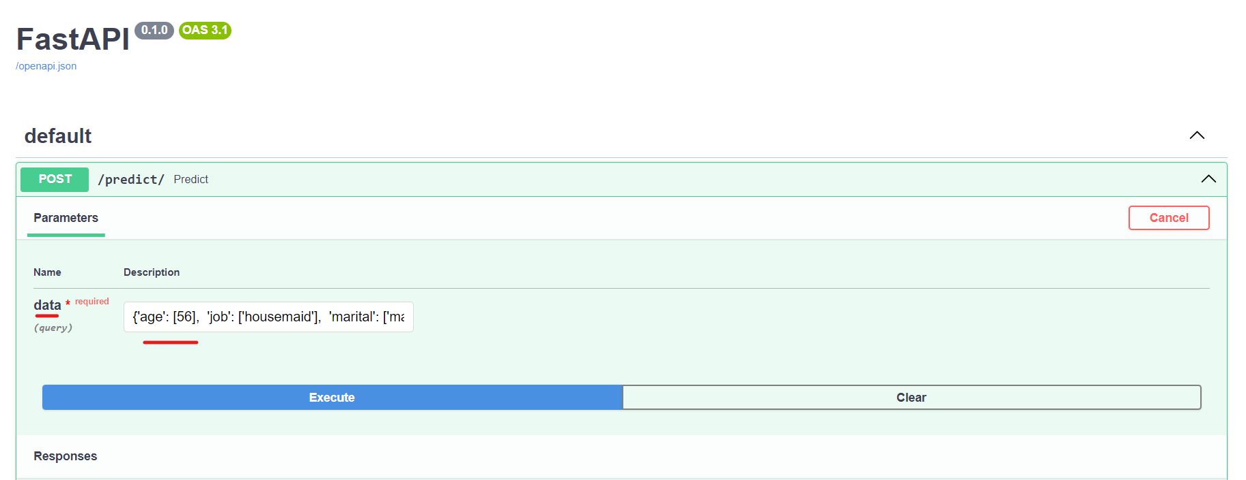

Output

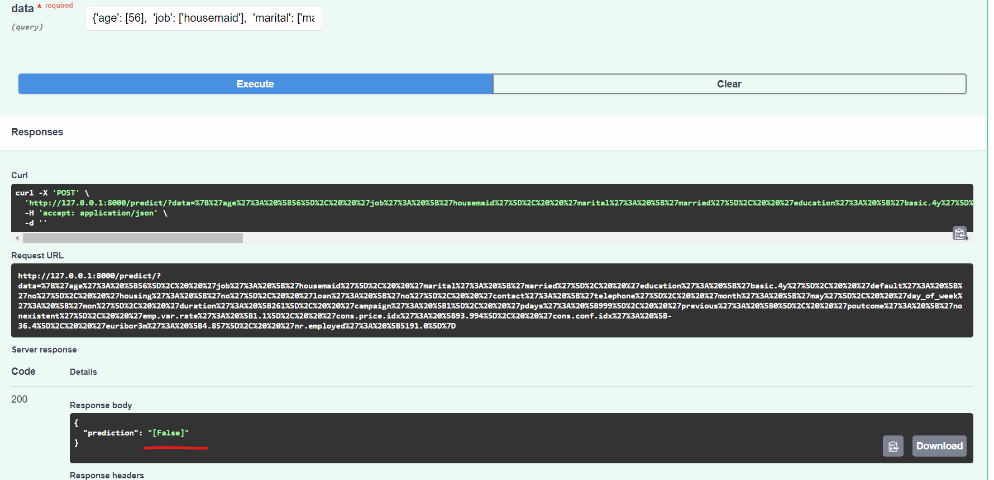

**Docker implementation**

1. Created the Dockerfile with instructions for building the Docker image
2. Added requirement.txt with packages
3. Build the Docker
4. Run Docker

**Productionization (eg:azure)**

1. Dockerize FastAPI based ML application by creating a Dockerfile.
2. Create azure container registry and Push docker image to ACR.
3. Deploy Docker image to Azure Container Instances. Use AKS for scaling.
4. Azure Monitor to monitor container instances, including metrics such as CPU usage, memory usage, and container health.
5. Setup CI/CD in Azure DevOps for streamlining and automates the deployment, monitoring, and management of machine learning models, ensuring efficiency, scalability, and reliability in production environments.

**Top 5 Drivers of conversion are:**

1. euribor3m

2. emp.var.rate

3. cons.conf.idx

4. Campaign

5. Age

**What your recommendation would be to cut the number of calls supposing that you get a**

**"test/prediction set" of new customers every week**

1. Use trained model and predict whether the new customer will buy or not.

2. Select the customers whose probability of conversion is more

**This way bank can reduce the number of calls without impacting the business.**