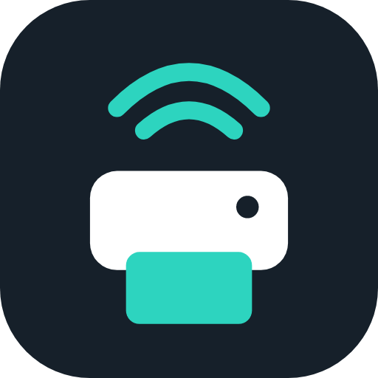
LIFETRENZ | dWise Healthcare IT Solutions
PrintBridge
User and Installation Guide
Label printing for web applications on Windows and Mac. Install it, choose a printer, and print labels from your Lifetrenz applications with one click.

Document | Details
Product version | PrintBridge 1.1.0
Guide version | 1.0 (23 October 2026)
Applies to | Windows 10 and 11 (64-bit), macOS 12 or later
Audience | Clinic and pharmacy staff, support teams and IT administrators
Where to start | Installing: Part 2 (Windows) or Part 3 (Mac). Day-to-day use: Parts 4 and 5. Problems: Part 7.

Document history
Version | Date | Change
1.0 | 23 October 2026 | Version 1.1.0: fixes from the November 2026 review (see CHANGELOG).

Contents
1. Overview
1.1 What PrintBridge does
1.2 What you need
1.3 Supported printers and label languages
1.4 Supported browsers
2. Installing on Windows
2.1 Before you start
2.2 Install
2.3 Trust the certificate
2.4 If Windows blocks the app
2.5 Install the printer in Windows
2.6 Check that it works
2.7 Updating
2.8 Uninstalling
3. Installing on a Mac
3.1 Install from the disk image
3.2 First open
3.3 Trust the certificate
3.4 Add the printer in System Settings
3.5 Menu bar and starting at login
3.6 Uninstalling
4. First-time setup
5. Using PrintBridge
5.1 The window at a glance
5.2 Printers
5.3 Default printer and "Send every print request here"
5.4 Websites
5.5 Preview before printing
5.6 Print jobs
5.7 Diagnostics
5.8 Settings
5.9 Light and dark appearance
6. Browser setup
6.1 Chrome and Edge: allow local network access
6.2 Firefox
6.3 Safari
6.4 For IT: allow websites by policy
7. Troubleshooting
8. Frequently asked questions
9. For IT administrators
9.1 Install, update and remove without prompts
9.2 Preloading settings with policy.json
9.3 Files and locations
9.4 Network and firewall
9.5 Security summary
9.6 Developer reference
10. Glossary
Quick reference

1. Overview

1.1 What PrintBridge does
Web pages cannot talk to a label printer directly. PrintBridge is a small program that runs quietly on the computer next to the printer. When a Lifetrenz application prints a label, it hands the label to PrintBridge, and PrintBridge sends it to the printer. No change to the web application is needed.
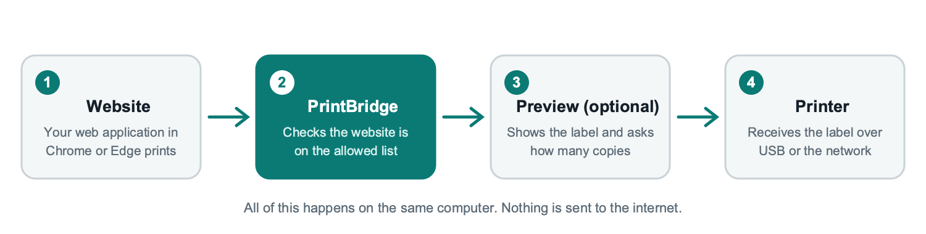
Figure 1. What happens when a website prints a label
PrintBridge only listens on the computer it is installed on. It cannot be reached from other computers or from the internet.

1.2 What you need
Item | Requirement
Computer | Windows 10 or 11, 64-bit. Or a Mac running macOS 12 or later (Apple silicon and Intel).
Rights | No administrator rights are needed on Windows. On a Mac you will be asked for your password once.
Printer | A label printer connected by USB or the network, with its driver installed (see 2.5 and 3.4).
Browser | Google Chrome or Microsoft Edge recommended. Firefox and Safari need one extra step (Part 6).
Other software | Quit Zebra Browser Print or QZ Tray if they are installed. They use the same ports (9100 and 9101).

1.3 Supported printers and label languages
Every label printer has a language it understands. The web application sends labels in one language, and the printer must be set to the same one in PrintBridge.
Language | Typical printers | Notes
ZPL II | Zebra (ZD, ZT, GK, GX, ZQ series) | Preview picture available.
TSPL / TSPL2 | TSC and compatible (TE, TTP, DA series) | Preview picture available.
EPL | Older Zebra and compatible models | Preview picture available.
BPLE (EPL-style) | TVS-E and SNBC (for example LP46 Dlite) | Treated like EPL. Preview shown when the commands match EPL.
CPCL | Zebra and Comtec mobile printers | Preview shows the commands.
DPL | Datamax and Honeywell | Preview shows the commands.
ESC/POS | Receipt printers (Epson, Star, Bixolon) | Preview shows the commands.

Note PrintBridge sends the label commands to the printer exactly as the website produced them. It does not convert between languages and does not print PDF or image files. Printers that need the manufacturer driver to draw the label (for example Brother QL and DYMO LabelWriter) are not supported in version 1.0.

1.4 Supported browsers
Browser | Status
Google Chrome, Microsoft Edge | Supported. The first time a website prints, the browser asks permission to reach devices on this computer. Allow it (see 6.1).
Mozilla Firefox | Supported with one extra step: import the PrintBridge certificate (see 6.2).
Safari (Mac) | Supported over the secure connection after the certificate is trusted (see 6.3).
Chromebook, Android, iPhone, iPad | Not supported. PrintBridge needs to run on the computer.

2. Installing on Windows

2.1 Before you start
- Quit Zebra Browser Print or QZ Tray if they are running, then close them from the system tray.
- Switch the printer on and connect the USB cable (or network cable).
- Install the printer's Windows driver from the manufacturer (see 2.5).
- Download PrintBridge-1.1.0-win-x64.zip and extract it. It contains PrintBridge.exe and a short README.

2.2 Install
- Double-click PrintBridge.exe. A box asks whether to install PrintBridge on this computer.
- Click Yes. PrintBridge copies itself to your user folder (%LOCALAPPDATA%\Programs\PrintBridge), adds a PrintBridge shortcut to the Start menu and an entry under Settings > Apps.
- The application opens. The PrintBridge icon appears in the system tray near the clock. Windows may hide it under the ^ arrow.
- Trust the certificate. The first time it opens, Windows asks whether to trust the "PrintBridge Local CA" certificate. Click Yes (see 2.3).
- Choose your printer on the Printers page (see Part 4).
Note Choosing No on the first box runs PrintBridge from the folder you downloaded it to, without installing. This is useful for a quick test, but the Start menu shortcut and "start when I sign in" will not point to a permanent location.

2.3 Trust the certificate
Websites talk to PrintBridge over a secure connection (https://localhost:9101). So that the browser does not show "Your connection is not private", PrintBridge creates a certificate that is unique to this computer and asks Windows to trust it.
- When Windows shows the security prompt for "PrintBridge Local CA", click Yes.
- Open the Diagnostics page and check that Secure connection shows Pass. If it does not, click Install certificate and answer Yes again.
The certificate is added for your Windows user only, and the private key is deleted as soon as the certificate is signed, so no one can use it to impersonate another website.

2.4 If Windows blocks the app
Important PrintBridge 1.0 is not yet digitally signed. Windows may show a warning until a signed version is published. Ask your IT team before using the workarounds below.

What you see | What to do
Windows protected your PC (SmartScreen) | Click More info, then Run anyway. Before extracting, you can also right-click the ZIP, choose Properties, tick Unblock and click OK.
Smart App Control blocked an app that may be unsafe | Windows 11 blocks unsigned apps completely and offers no Run anyway button. IT must either turn Smart App Control off for that computer (this cannot be turned back on without resetting Windows) or deploy the signed build when it is available.

2.5 Install the printer in Windows
PrintBridge sends labels through the printer that Windows already knows about, so the printer must appear in Settings > Bluetooth & devices > Printers & scanners first.
- Download the driver for your exact model from the manufacturer's website (Zebra, TSC or TVS-E) and run the installer. For USB printers, connect and switch the printer on when the installer asks.
- Print the Windows test page from the printer's properties to confirm the printer works.
- Open PrintBridge. The printer appears on the Printers page and shows USB in its tags.
- Set the printer's Language in PrintBridge to match your labels (for example TSPL for TSC).
Tip Network printers do not need a Windows driver. Use Add network printer (see 5.2) and enter the printer's IP address with port 9100.

2.6 Check that it works
- Open PrintBridge and go to Diagnostics. Every line should show Pass.
- Go to Printers, select your printer and click Print test label. A label with TEST LABEL and a barcode should come out.
- Open your Lifetrenz application and print a real label.

2.7 Updating
Run the newer PrintBridge.exe and click Yes when it offers to update. Your settings, allowed websites and certificate are kept.

2.8 Uninstalling
- Open Settings > Apps > Installed apps, find PrintBridge and choose Uninstall.
- PrintBridge asks whether to also delete your settings, print history and trusted certificate. Choose No if you plan to reinstall.

3. Installing on a Mac
There are two files: PrintBridge-1.1.0-mac-arm64.dmg for Apple silicon Macs (M1 to M4) and PrintBridge-1.1.0-mac-x64.dmg for Intel Macs. Check Apple menu > About This Mac if you are not sure which you have.

3.1 Install from the disk image
- Quit Zebra Browser Print or QZ Tray if they are running.
- Open the DMG and drag PrintBridge into the Applications folder.
- Open PrintBridge from Applications (or Launchpad).

3.2 First open
Important PrintBridge 1.0 for Mac is not yet notarized by Apple, so macOS blocks the first open. This is a one-time step.

- When macOS says it cannot verify PrintBridge, click Done.
- Open System Settings > Privacy & Security, scroll to Security and click Open Anyway next to PrintBridge.
- Enter your Mac password, then click Open.

3.3 Trust the certificate
On the first start macOS asks for your password (or Touch ID) once so that PrintBridge's local certificate can be trusted in your keychain. Approve it. Safari and Chrome then connect without warnings. Firefox keeps its own list (see 6.2).

3.4 Add the printer in System Settings
Add the label printer under System Settings > Printers & Scanners before using it in PrintBridge.
- Click Add Printer, Fax or Scan, select your printer and choose the manufacturer's driver from the Use list.
- If the maker has no Mac driver, choose Zebra ZPL Label Printer for ZPL printers. PrintBridge still sends the labels in their original language.
- Open PrintBridge. The printer appears on the Printers page.
Note Recent macOS versions do not allow raw printer queues, so a driver (any driver) must be selected. The label commands still reach the printer unchanged.

3.5 Menu bar and starting at login
PrintBridge shows a small icon in the menu bar. Click it to open the window or quit. By default it starts when you log in, quietly in the background. Turn this off in Settings.

3.6 Uninstalling
- Quit PrintBridge from the menu bar icon and drag it from Applications to the Trash.
- Optional: delete ~/Library/Application Support/PrintBridge and ~/Library/LaunchAgents/com.lifetrenz.printbridge.plist, and remove "PrintBridge Local CA" from Keychain Access.

4. First-time setup
Setting up takes about five minutes. Do this once on each computer.
- Open the Printers page. Your printers are listed. A green Reachable or Ready tag means the printer is available.
- Choose the Default printer in the row at the top. This is where your labels come out.
- Leave "Send every print request here" on. Every website then prints to this printer, whatever printer it asks for. This is the simplest and safest setting for a single-printer desk.
- Check the Language in the printer details (for example TSPL for TSC, ZPL II for Zebra) and click Print test label.
- Print from your application. The first time a new website prints, PrintBridge asks whether to allow it (see 5.4).
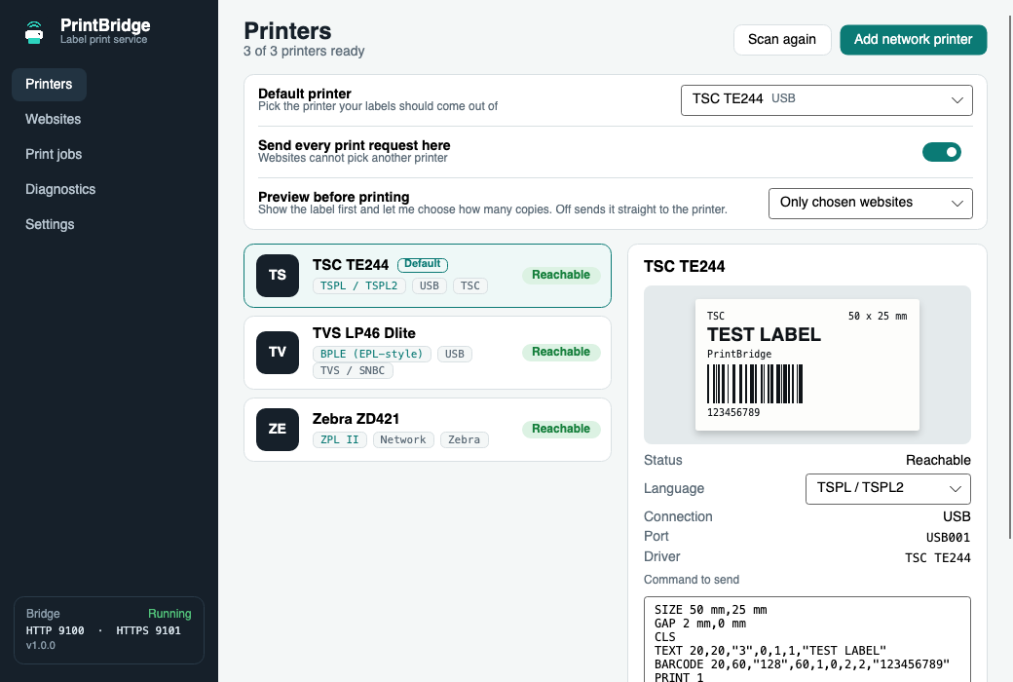
Figure 2. The Printers page: default printer settings at the top, printers below, details on the right
Tip Not sure which language your printer uses? Try Print test label with TSPL, ZPL II and EPL in turn. Garbled text or no output means the wrong language is selected. The TVS-E LP46 Dlite is documented as BPLE (EPL-style); confirm with the printer manual.

5. Using PrintBridge

5.1 The window at a glance
The list on the left switches between pages. PrintBridge keeps running in the background when you close the window; use the tray icon (or menu bar icon on a Mac) to open it again.
Page | What it is for
Printers | Choose the default printer, check each printer, set its language, print a test label, add a network printer.
Websites | Decide which websites may use your printers. See which websites have connected.
Print jobs | The history of recent labels: when, which website, which printer, and the result.
Diagnostics | A health check you can run before calling support.
Settings | Start with the computer, ports, data folder, reset and quit.

The tray (or menu bar) icon is a single-colour printer with signal arcs. It adapts to light and dark taskbars:
  Light taskbar / Mac menu bar |   Dark taskbar | Application icon

5.2 Printers
The Printers page (Figure 2) lists every printer PrintBridge can see. Select one to see its details, change its language and print a test label.
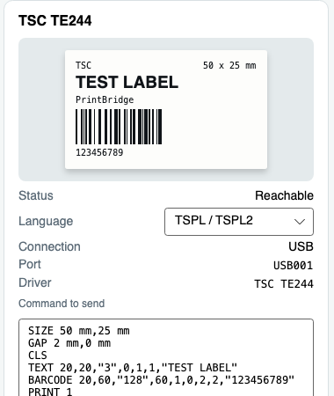
Figure 3. Printer details: language, connection, test label and command box
Item | What it means
Status tag | Reachable or Ready: the printer can be used. Offline, Paper out, Door open or Error: fix the printer, then print again.
USB / Network tags | How the printer is connected. USB comes from the Windows or Mac printer queue. Network printers are added by IP address.
Language | The label language the printer understands. It must match what the website sends.
Print test label | Prints a small TEST LABEL with a barcode in the selected language.
Send command | Sends exactly the text in the Command box to the printer. For support use.
Make default | Sets this printer as the default for all prints.
Remove | Removes a network printer you added. USB printers are removed in Windows or macOS.
Scan again | Looks for printers again. PrintBridge also checks every few seconds by itself.

Adding a network printer. Click Add network printer, enter a name, the printer's IP address and port 9100, choose the brand and language, then click Add printer. PrintBridge checks that it can reach the printer.
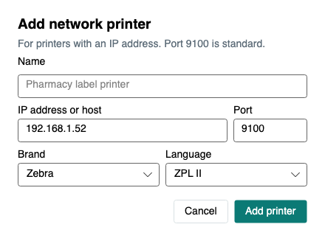
Figure 4. Add network printer

5.3 Default printer and "Send every print request here"
The two settings at the top of the Printers page decide where labels go.
Setting | Result
On (recommended) | Every print request from every website goes to the default printer. Websites only see that one printer. Best for a desk with one label printer.
Off | Websites can choose among all your printers. The default printer is used when a website does not choose one.

Important The website's label language must match the default printer. For example, a website that sends ZPL to a printer set up for TSPL prints nothing useful.
Important If the default printer you chose is switched off or unplugged, PrintBridge refuses print requests and says so on the Diagnostics page. It never sends labels to a different printer on its own. Switch the printer on, or choose another default.

If the printer is off, unplugged or out of paper, PrintBridge tells the website straight away instead of letting the label wait silently in the Windows queue.

5.4 Websites
Only websites on the Allowed list can see your printers or print. Any other website asks first.
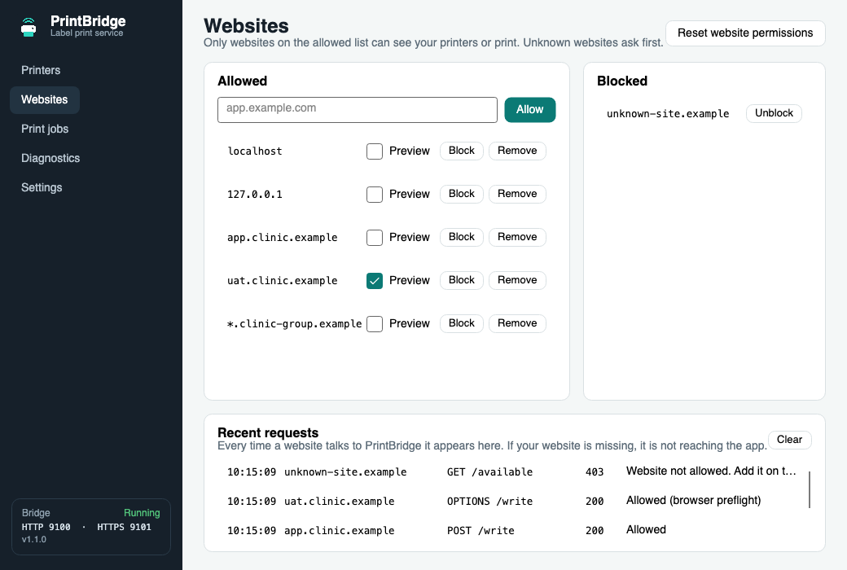
Figure 5. Websites page: allowed and blocked websites, and the live request log
The first time a new website prints, PrintBridge shows this window on top of everything:
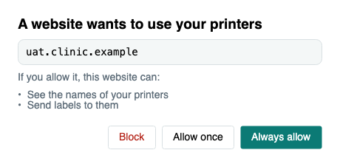
Figure 6. Permission prompt for a new website
Button | What it does
Always allow | Adds the website to the Allowed list. It will not ask again.
Allow once | Allows the website until PrintBridge restarts.
Block | Adds the website to the Blocked list.

If nobody answers within 90 seconds, that request is refused and the website can ask again.
Managing the list
- Add a website yourself: type its name (for example app.clinic.example) in the box and click Allow.
- Several websites at once: use a wildcard such as *.clinic.example to cover Dev, SIT, UAT, QA and production if they share a domain.
- Block, Remove, Unblock: use the buttons beside each website.
- Reset website permissions (top right) forgets every decision. Click it twice to confirm. localhost stays allowed and every website asks again.
- Recent requests (bottom) lists every request: time, website, request, code and result. A website that is missing here is not reaching PrintBridge (see Part 7).

5.5 Preview before printing
PrintBridge can show the label first and let the user choose how many copies to print. This works without changing the web application.
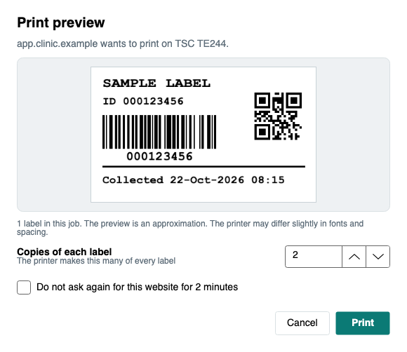
Figure 7. The print preview window, with the number of copies
Turn it on on the Printers page, in the row "Preview before printing":
Choice | Result
Off | Labels print straight away (default).
All websites | A preview window appears for every print.
Only chosen websites | A Preview tick appears next to each website on the Websites page. Tick it for the websites that should show a preview.

- The picture is an approximation drawn on your computer. Fonts and spacing on the real label can differ slightly.
- Pictures are drawn for ZPL, TSPL and EPL labels. For other languages the window shows the printer commands instead, and copies still work.
- Print sends the label. Cancel stops it, and the website is told it was cancelled. If nobody clicks within two minutes the print is cancelled.
- For ZPL, TSPL and EPL, the copies are written into the label itself (ZPL ^PQ, TSPL PRINT, EPL P), so the printer produces exactly that many (up to 9999). For other languages the whole job is sent once per copy (up to 100). If you leave the number as it is, the job is sent exactly as the website made it.
- "Do not ask again for this website for 2 minutes" is useful when a page sends many labels in a row.
- The preview window never opens for the test labels you print from PrintBridge itself.

5.6 Print jobs
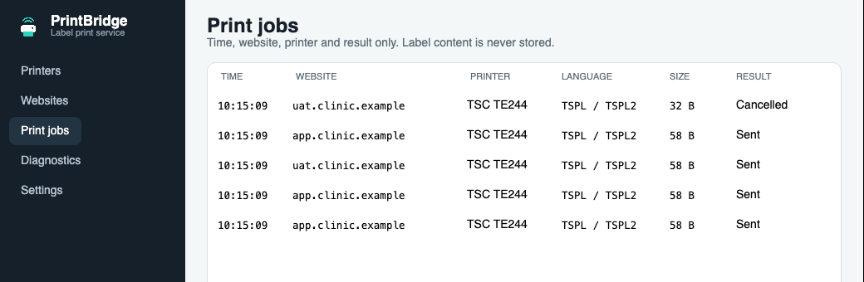
Figure 8. Print jobs page
Each line shows the time, the website, the printer, the language, the size and the result (Sent, Cancelled or the reason it failed). Label content is never stored, so patient information is not kept in the history.

5.7 Diagnostics
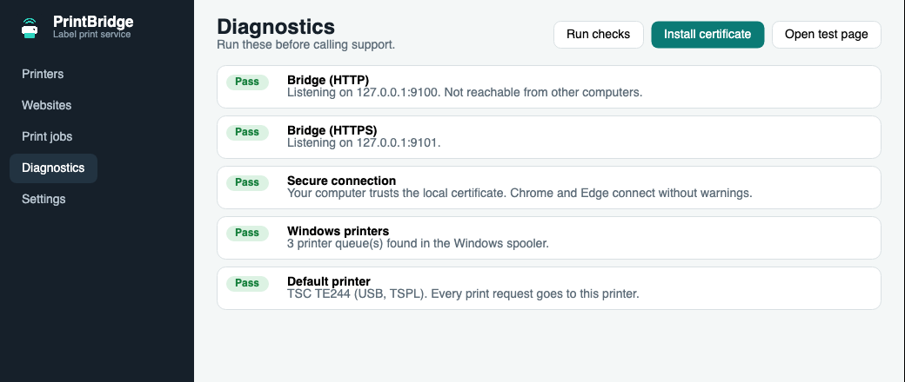
Figure 9. Diagnostics page on a healthy computer
Check | If it does not pass
Bridge (HTTP) / (HTTPS) | Another program uses port 9100 or 9101. Quit Zebra Browser Print or QZ Tray, then restart PrintBridge.
Secure connection | Click Install certificate and answer Yes (Windows) or enter your password (Mac).
Windows / Mac printers | No printers found. Install the printer driver and switch the printer on.
Default printer | Choose one on the Printers page.

The buttons at the top: Run checks repeats the tests, Install certificate trusts the certificate, and Open test page opens a small page in your browser from which you can test printing.

5.8 Settings
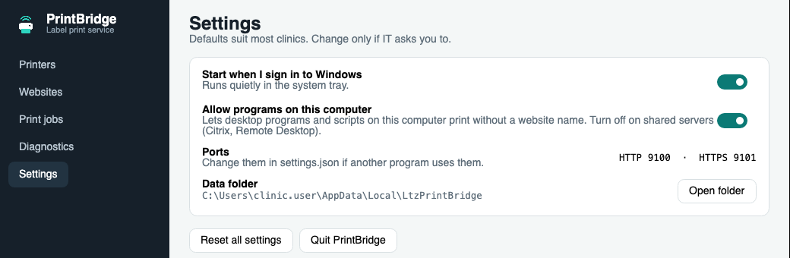
Figure 10. Settings page
Setting | Meaning
Start when I sign in | Starts PrintBridge quietly when you log in so it is always ready. On by default.
Allow programs on this computer | Lets desktop programs and scripts on this computer print without a website name. On by default. Turn it off on shared servers (Citrix, Remote Desktop) so that only allowed websites can print.
Ports | HTTP 9100 and HTTPS 9101. IT can change them in settings.json if another program needs them.
Data folder / Open folder | Where settings, logs, the print history and the certificate are kept.
Reset all settings | Clears allowed websites, preview choices, manual printers, language choices and the default printer. The certificate is kept. Click twice to confirm.
Quit PrintBridge | Stops PrintBridge completely. Closing the window only hides it.

5.9 Light and dark appearance
PrintBridge follows the computer's light or dark setting automatically.
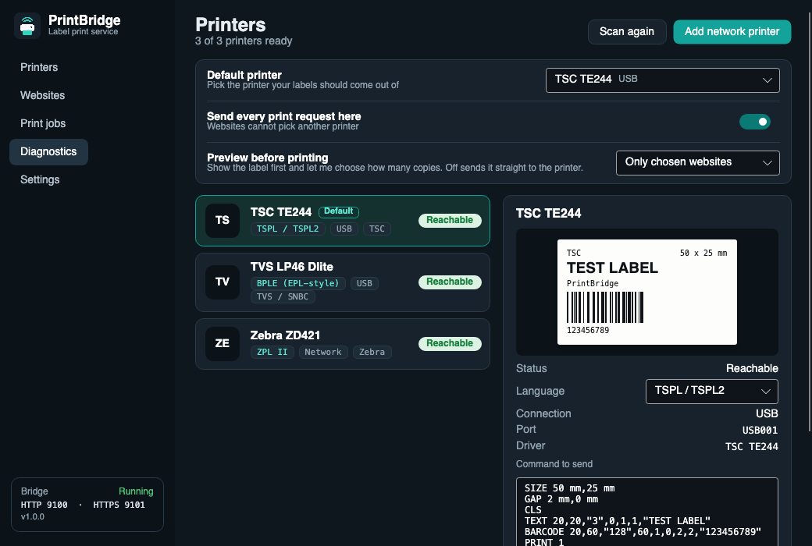
Figure 11. The Printers page in dark mode

6. Browser setup

6.1 Chrome and Edge: allow local network access
Recent versions of Chrome and Edge ask permission before a website may reach a program on your own computer. The permission is remembered per website, so you give it once for each Lifetrenz environment (Dev, SIT, UAT, QA, production).
- Open the Lifetrenz website and print a label. If the browser shows a prompt about finding and connecting to devices on your local network, click Allow.
- If printing silently does nothing, click the icon to the left of the address bar, choose Site settings, find Local network access and set it to Allow.
- Reload the page and print again.
Note If the browser console shows "Permission was denied for this request to access the loopback address space", this permission is blocked for that website. Use step 2 above.
Note If the PrintBridge permission window is closed without choosing, or nobody answers it within 90 seconds, the website is refused this time only and is asked again on the next print. Only the Block button blocks a website for good.

6.2 Firefox
Firefox keeps its own certificate list, so the PrintBridge certificate must be imported once:
- Open a Firefox window and go to Settings > Privacy & Security > Certificates > View Certificates > Authorities > Import.
- Choose the file ltz-printbridge-ca.cer from PrintBridge's data folder (Settings > Open folder, then the certs folder), tick Trust this CA to identify websites and click OK.
- Firefox 153 and later also asks permission before a website may reach this computer, the same way Chrome does. Allow it for each Lifetrenz website. Recent Firefox versions normally trust certificates installed in Windows or macOS, so the import above is only needed if Firefox still shows a certificate warning.

6.3 Safari
Safari does not allow websites to call plain http://localhost, so it uses PrintBridge's secure connection. After the certificate has been trusted (see 3.3), no further setup is needed. If Diagnostics shows Secure connection as Pass but Safari still cannot print, restart Safari.

6.4 For IT: allow websites by policy
On managed computers, administrators can allow Lifetrenz websites by browser policy, so users never see the permission prompt. For Chrome and Edge the policies are LoopbackNetworkAllowedForUrls (version 146 and later) and LocalNetworkAccessAllowedForUrls (older versions); for Firefox it is LocalNetworkAccess.SkipDomains. List the website addresses (for example https://app.clinic.example). Check the exact policy names in the current Chrome, Edge and Firefox policy lists before deploying, because the browser makers have renamed these settings several times. A web page shown inside another page (an iframe) also needs the outer page to permit it; this is a change for the website team, not for PrintBridge.

7. Troubleshooting
Problem | Likely cause | What to do
Nothing prints and no prompt appears | The browser is blocking the website from reaching PrintBridge. | Open Websites > Recent requests and print again. If the website does not appear, allow Local network access in the browser (6.1). If it appears with 403, add the website to the Allowed list.
Prompt "A website wants to use your printers" | First use of a new website. | Click Always allow if you trust it.
"Your connection is not private" in the browser | The certificate is not trusted yet. | Diagnostics > Install certificate. Firefox needs a manual import (6.2).
Request log shows 403 | The website is not on the Allowed list. | Add it on the Websites page, for example *.clinic.example.
Diagnostics: Bridge not running or port in use | Zebra Browser Print or QZ Tray is using ports 9100 or 9101. | Quit that program, then restart PrintBridge.
"The printer is offline. Check power, USB cable and paper." | The printer is off, unplugged, paused or out of paper. | Switch it on, check the cable and paper, then print again.
Labels print as garbage or text | The printer language does not match the website. | Select the right Language on the Printers page and print a test label.
Wrong printer prints | "Send every print request here" is off and the website chose a different printer. | Turn the setting on and choose the default printer.
Preview window does not appear | Preview is Off, or the website is not ticked in Only chosen websites. | Set Preview before printing and tick the website on the Websites page.
Preview shows commands, not a picture | The label language is not ZPL, TSPL or EPL. | This is expected. Copies still work.
The app does not start after sign-in | Start when I sign in is off, or the app was moved. | Turn the setting on in Settings. If you moved the app, open it from its new place once.
Windows blocks the installer | SmartScreen or Smart App Control. | See 2.4.
Mac says the app cannot be opened | The build is not yet notarized. | Privacy & Security > Open Anyway (3.2).

Information to send to support
Please include the following when asking for help:
- A screenshot of the Diagnostics page.
- A screenshot of Websites > Recent requests right after the failed print.
- The log file bridge.log from the data folder (Settings > Open folder).
- The printer model, how it is connected (USB or network), and the language selected.
- The website address and the browser name and version.

8. Frequently asked questions
Does PrintBridge send anything to the internet?
No. It only listens on the same computer (127.0.0.1) and cannot be reached from other computers.
Does it store patient information?
No. The print history keeps only the time, website, printer, language, size and result. The label content is never stored.
Do I need administrator rights?
Not on Windows. On a Mac you enter your password once to trust the certificate.
Can two printers be used?
Yes. Turn off "Send every print request here" and let websites choose, or switch the default printer when needed.
Can I use PrintBridge together with Zebra Browser Print?
Not at the same time, because both use ports 9100 and 9101. PrintBridge understands the same requests, so websites built for Zebra Browser Print work with it.
Does the website need to be changed?
No. Websites that already print through Zebra Browser Print or call PrintBridge directly work unchanged.
Why does the preview look slightly different from the real label?
The preview is drawn on your computer from the label commands and assumes a 203 dpi printer. Real printers differ a little in fonts and spacing.
Can I print PDF files or images?
Not in version 1.0. The website must send printer commands.
How do I stop PrintBridge?
Settings > Quit PrintBridge. Closing the window keeps it running.

9. For IT administrators

9.1 Install, update and remove without prompts
Task | Command
Silent install or update (Windows) | PrintBridge.exe --install --silent
Silent uninstall (keeps settings and certificate) | "%LOCALAPPDATA%\Programs\PrintBridge\PrintBridge.exe" --uninstall --silent
Run without installing | PrintBridge.exe --portable
Start hidden in the tray | PrintBridge.exe --minimized (used by "Start when I sign in")
Mac | Copy PrintBridge.app to /Applications. A LaunchAgent (com.lifetrenz.printbridge) is created in each user's ~/Library/LaunchAgents when "Start when I log in" is on.

Note Installation is per user and needs no administrator rights. Deploy it in each user's context, for example with Intune or a logon script.

9.2 Preloading settings with policy.json
A policy.json file preloads approved websites and the default printer so staff never see a prompt for the clinic's own websites. Place it in C:\ProgramData\LtzPrintBridge\policy.json (or next to PrintBridge.exe) before the first start. A sample, policy.sample.json, is included in the download.
{
"acceptedHosts": ["app.yourclinic.com", "*.yourclinic.com"],
"blockedHosts": [],
"defaultPrinter": "Pharmacy Label Printer",
"httpPort": 9100,
"httpsPort": 9101
}

Notes: wildcards such as *.yourclinic.com are supported; comments and trailing commas are allowed; invalid ports are ignored; the policy is applied at every start and merged with what the user has set.

9.3 Files and locations
Item | Location
Program (Windows) | %LOCALAPPDATA%\Programs\PrintBridge\PrintBridge.exe
Settings, logs, print history, certificate (Windows) | %LOCALAPPDATA%\LtzPrintBridge (settings.json, bridge.log, jobs.jsonl, certs\)
Settings, logs, certificate (Mac) | ~/Library/Application Support/PrintBridge
Policy file | C:\ProgramData\LtzPrintBridge\policy.json, or next to the program
Certificate | "PrintBridge Local CA (computer name)" in the current user's trusted root store (Windows) or login keychain (Mac)

9.4 Network and firewall
- PrintBridge listens only on 127.0.0.1 and ::1, ports 9100 (HTTP) and 9101 (HTTPS). No inbound firewall rule is needed and none should be created.
- For network printers, the computer needs outbound access to the printer's IP address on TCP port 9100.
- No internet access is required.
- Proxies and antivirus tools must not intercept traffic to localhost.

9.5 Security summary
Control | How it works
Loopback only | The service is bound to the local computer. Requests with any other host name are refused (protects against DNS rebinding).
Website allow-list | Only allowed websites can list printers or print. Unknown websites need a person to approve them. Requests from other origins are refused.
Browser safeguards | Cross-site requests without a website name are rejected, and browser permission headers are only sent to allowed websites.
Size limit | A single job is limited to 2 MB.
No content stored | The job history stores metadata only: time, website, printer, language, size and result.
Certificate | A certificate unique to each computer is created; the certificate authority's private key is deleted once the certificate is signed; only the public certificate is trusted, for the current user only.

9.6 Developer reference
Websites written for Zebra Browser Print (BrowserPrint.js) work unchanged. No setting is needed. New integrations can call the HTTP API directly. The website must be on the Allowed list.
Request | Purpose
GET /api/v1/status | Service status, version and number of visible printers.
GET /api/v1/printers | List of printers visible to the website.
POST /api/v1/print | Print. JSON body: printerId (or printer), data (label commands) or base64, copies (1 to 100), encoding (optional, for example windows-1252; UTF-8 when omitted).
GET /available, GET /default, POST /write, POST /read | Zebra Browser Print compatible endpoints.

POST http://127.0.0.1:9100/api/v1/print
Content-Type: application/json

{ "data": "^XA^FO20,20^A0N,36,36^FDHello^FS^XZ", "copies": 1 }

A cancelled preview returns HTTP 409 with error PRINT_CANCELLED; a printer problem returns HTTP 502 with error PRINT_FAILED and a message.

10. Glossary
Term | Meaning
Raw printing | Sending the printer its own commands directly, without a driver drawing the label.
ZPL, TSPL, EPL, BPLE, CPCL, DPL, ESC/POS, EZPL, PPLA, PPLB, Fingerprint, IPL, SBPL, TPCL | Label languages used by Zebra, TSC, TVS-E and other printers.
Default printer | The printer that receives labels when no other is chosen or when "Send every print request here" is on.
Allowed list | The websites that may use your printers.
Certificate | A small file that lets the browser trust the secure connection to PrintBridge on your computer.
Loopback / localhost / 127.0.0.1 | The computer's own address. Traffic to it never leaves the computer.
Local network access | A browser permission that lets a website reach programs and devices on your computer or network.
Tray / menu bar | The icons near the clock (Windows) or at the top of the screen (Mac) where PrintBridge lives.

Quick reference
Step | Do this
1 | Install the printer driver and switch the printer on.
2 | Run PrintBridge.exe (or open PrintBridge on a Mac) and choose Yes to install.
3 | Click Yes (Windows) or enter your password (Mac) to trust the certificate.
4 | Printers page: choose the Default printer, check the Language, Print test label.
5 | Open your application and print. Click Always allow when asked about the website.
6 | In Chrome or Edge, click Allow if asked about local network access.
7 | Trouble? Websites > Recent requests and Diagnostics tell you where it stops.

