A SIMPLE GUIDE TO THE SCRIPTS
Running the Following Robot
What each script does, and exactly which one to run to start following

⭐ The short answer — to start real-time following:
Make sure the robot is switched on and connected. Then, in a terminal on the VM, run this ONE command:
bash /mnt/host_project/scripts/06-follow-real.sh
That single script starts the robot's motors and camera, then the person-detector and the decision-maker on the VM. The robot then drives toward the nearest person.

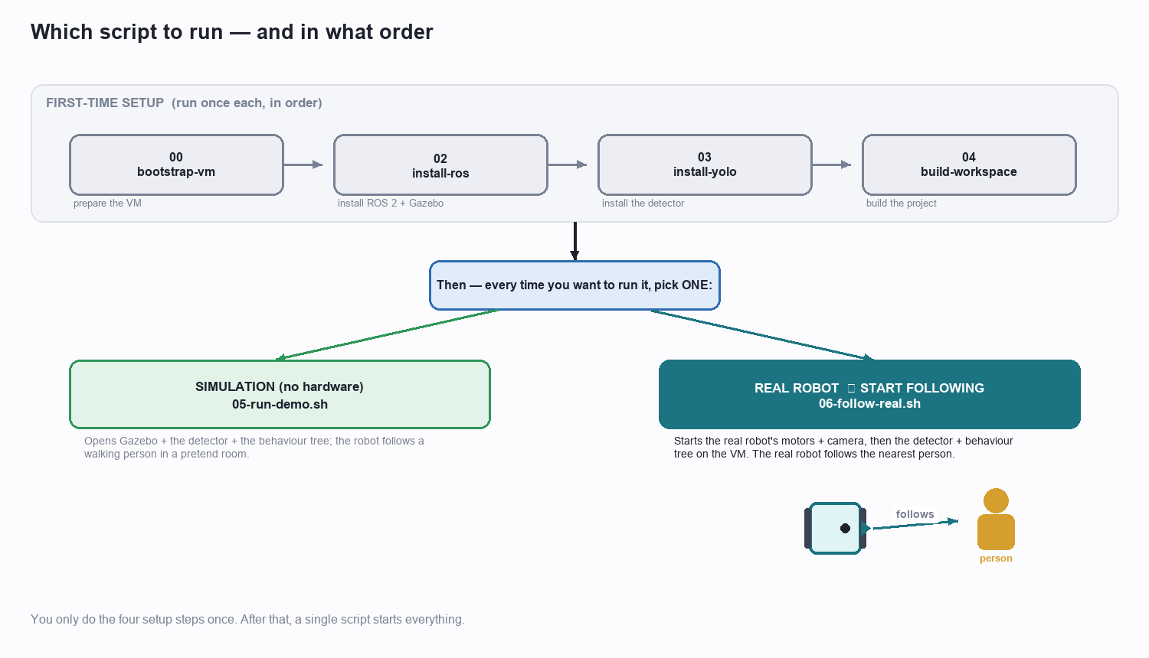
You do the four setup steps once; after that, one script starts everything.

1. All the scripts at a glance
There are six scripts. The first four are a one-time setup you do once when preparing the machine. The last two are the ones you actually run to start the robot — one for simulation, one for the real robot.
Script | When you run it | What it does
00-bootstrap-vm.sh | Once, first | Prepares the virtual machine (lets scripts run without password prompts).
02-install-ros.sh | Once | Installs ROS 2, the TurtleBot3 packages, and the Gazebo simulator.
03-install-yolo.sh | Once | Installs the YOLO person-detector and downloads its model file.
04-build-workspace.sh | Once (and after code edits) | Builds this project's code so ROS 2 can run it.
05-run-demo.sh | Every time (SIMULATION) | Runs the whole demo in the Gazebo pretend world.
06-follow-real.sh | Every time (REAL ROBOT) ⭐ | Starts the real robot following a person. THIS is the follow script.
💡 Rule of thumb: numbers 00–04 are 'install & build' (done once). Numbers 05 and 06 are 'go' — 05 for the simulation, 06 for the real robot.

2. First-time setup (run once)
These four prepare everything. You run them in order the first time only. Each prints coloured progress and is safe to re-run if something is interrupted.

00-bootstrap-vm.sh — prepare the VM
A tiny helper that lets the other scripts run smoothly without stopping to ask for a password, and makes the project folder easy to reach inside the VM.

02-install-ros.sh — install ROS 2 + Gazebo
Installs the robot 'operating system' (ROS 2 Humble), the TurtleBot3 packages, and the Gazebo simulator. The key lines it runs:
sudo apt install -y ros-humble-desktop ros-dev-tools ... # ROS 2 itself
sudo apt install -y ros-humble-turtlebot3 ros-humble-turtlebot3-gazebo ... # robot + simulator
sudo apt install -y tmux # runs several panes at once
→ In plain words: it downloads and installs all the robot software so the computer 'speaks robot'.

03-install-yolo.sh — install the detector
Installs the YOLO detector (the software that recognises people) and downloads its small 'brain' file, plus the py_trees library used for the decision-making.
python3 -m pip install --user torch torchvision # the neural-network engine (CPU version)
python3 -m pip install --user ultralytics # YOLOv8 person detector
# ... then downloads the model file to ~/models/yolov8n.pt
→ In plain words: it installs the 'spotter' that finds people in the camera picture.

04-build-workspace.sh — build the project
Compiles this project's own code (the detector node, the behaviour tree, the messages) so ROS 2 can run it. You run this once, and again any time the code is changed.
cd ~/ros2_ws && colcon build --symlink-install
→ In plain words: it turns the project's source code into something the robot can actually run.

3. Running the SIMULATION — 05-run-demo.sh
This is for testing without any hardware. It opens three panels side-by-side (using a tool called tmux) and starts the three parts of the system together.
SESSION="tb3-follower"
# the settings every panel needs (find ROS, the project, the robot model, Gazebo)
SETUP='export DISPLAY=:0 && source /opt/ros/humble/setup.bash && \
source ~/ros2_ws/install/setup.bash && export TURTLEBOT3_MODEL=waffle_pi && ...'
# Panel 0: the Gazebo pretend world + the robot
tmux send-keys "$SETUP && ros2 launch tb3_follower_bringup sim.launch.py"
# Panel 1: the YOLO person-detector (waits 8 s for the world to load first)
tmux send-keys "$SETUP && sleep 8 && ros2 launch tb3_follower_bringup perception.launch.py"
# Panel 2: the behaviour-tree decision-maker (waits 10 s)
tmux send-keys "$SETUP && sleep 10 && ros2 launch tb3_follower_bringup behavior.launch.py"
→ In plain words: it opens the pretend world, the person-detector, and the decision-maker in three panels, one after another, so the robot follows a walking person in simulation.
Run it, watch it, stop it:
bash /mnt/host_project/scripts/05-run-demo.sh # start
tmux kill-session -t tb3-follower # stop

4. Running the REAL robot — 06-follow-real.sh ⭐
This is the main script — the one you run to make the real robot follow a person. It is clever because it starts things in the right place automatically: the robot's own parts on the robot's computer (the Raspberry Pi), and the 'thinking' parts on the VM.
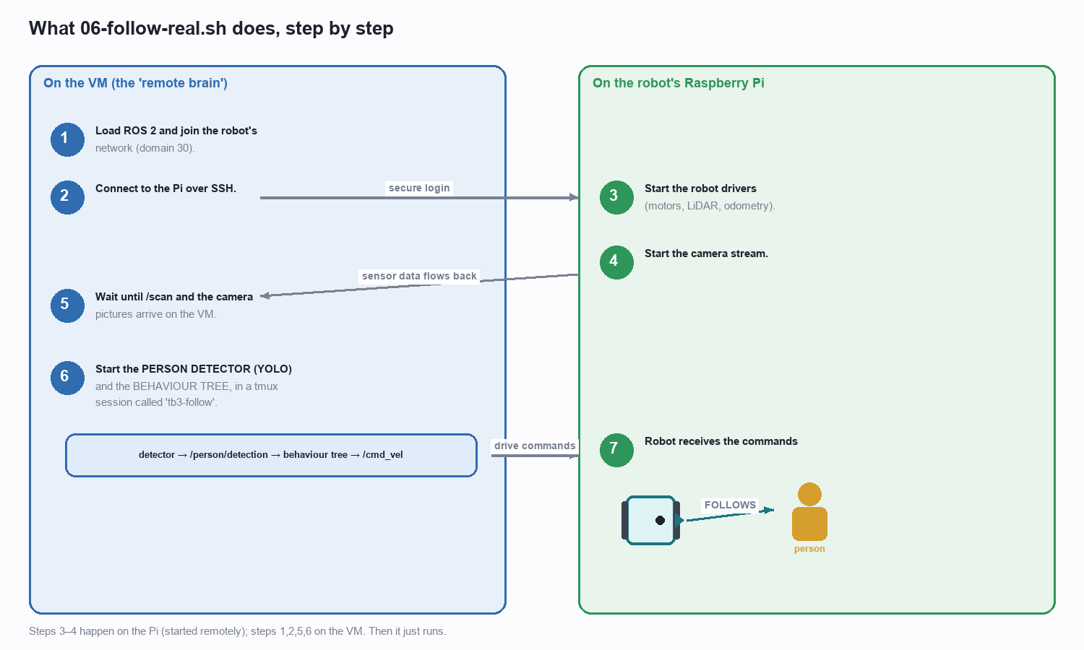
The seven things 06-follow-real.sh does — some on the Pi, some on the VM.

Reading the script, block by block
Block 1 — settings. Where the robot is, how to log in, and which network number to use.
PI_HOST="192.168.137.105" # the robot's address
PI_USER="ubuntu"; PI_PASS="turtlebot"
DOMAIN="30" # the shared ROS network number (VM and robot must match)
TB3_MODEL="waffle_pi"
→ In plain words: this is just the address book — who to call and on which channel.
Block 2 — get ready on the VM. Load ROS 2, load the project, and join the robot's network.
source /opt/ros/humble/setup.bash
source ~/ros2_ws/install/setup.bash
export ROS_DOMAIN_ID=30 ROS_LOCALHOST_ONLY=0
# then check we can actually reach the robot, or stop with a clear error:
$SSH 'echo ok' || die "Cannot reach the Pi — check the network."
→ In plain words: it gets the VM ready and makes sure the robot is reachable before going further.
Block 3 — start the robot's drivers ON THE PI (only if not already running). This turns on the motors, the LiDAR and odometry.
$SSH 'bash -s' <<REMOTE
... export ROS_DOMAIN_ID=30 TURTLEBOT3_MODEL=waffle_pi LDS_MODEL=LDS-02
if pgrep -f robot.launch >/dev/null; then echo "already running"
else ros2 launch turtlebot3_bringup robot.launch.py & fi
REMOTE
→ In plain words: it logs into the robot and switches on its motors and laser.
Block 4 — start the camera ON THE PI (again, only if needed), at a small size so it streams smoothly over Wi-Fi.
$SSH 'bash -s' <<REMOTE
ros2 launch realsense2_camera rs_launch.py \
enable_depth:=false rgb_camera.color_profile:=424x240x15 &
REMOTE
→ In plain words: it switches on the robot's camera.
Block 5 — wait for the sensors. The script pauses until the laser scan and the camera pictures are actually arriving at the VM, so the follower doesn't start blind.
for i in $(seq 1 40); do
ros2 topic list | grep -q "/scan" && ros2 topic list | grep -q "$COLOR_TOPIC" && break
sleep 2
done
→ In plain words: it waits until it can see the robot's laser and camera data before continuing.
Block 6 — start the 'brain' on the VM. It opens a tmux session called tb3-follow and launches the person-detector and the behaviour tree.
tmux new-session -d -s tb3-follow
# panel: the YOLO person-detector, reading the robot's camera
tmux send-keys "... ros2 run tb3_follower_perception person_detector_node ..."
# panel: the behaviour tree, which sends drive commands (/cmd_vel) to the robot
tmux send-keys "... ros2 launch tb3_follower_bringup behavior.launch.py"
→ In plain words: it starts the person-detector and the decision-maker; from here the robot follows the nearest person.
💡 It's safe to re-run: if parts are already running (the robot drivers, the camera), the script notices and skips them — so running it twice does no harm.

5. The exact run order for real-time following
Putting it all together, here is the complete sequence to make the real robot follow you:
- One time only: run 00-bootstrap-vm.sh, then 02-install-ros.sh, then 03-install-yolo.sh, then 04-build-workspace.sh (in that order). You never repeat these unless you rebuild the machine.
- Switch the robot on and wait a minute or two for it to start up and join the Wi-Fi hotspot.
- Check the connection — from the VM you should be able to reach the robot (the follow script checks this for you and stops with a clear message if not).
- Start following — in a VM terminal run the one command:
bash /mnt/host_project/scripts/06-follow-real.sh
- Stand a couple of metres in front of the robot — it detects you and drives toward you, keeping about a 1-metre gap, turning to face you, and steering around obstacles.
So, which script starts real-time following?
06-follow-real.sh
Everything else is either one-time setup (00–04) or the simulation (05). For the real robot, this is the only script you run.

6. Watching and stopping

Watch what's happening
tmux attach -t tb3-follow # see the detector + behaviour panels (leave with Ctrl+B then D)
ros2 topic echo /cmd_vel # the drive commands going to the robot
ros2 topic echo /follower/state # the robot's current action (approaching / holding / avoiding ...)

Stop it
# stop the follower on the VM:
tmux kill-session -t tb3-follow
# stop the robot's drivers + camera (from the VM):
sshpass -p turtlebot ssh ubuntu@192.168.137.105 \
"pkill -f robot.launch; pkill -f realsense2_camera_node"
💡 Safety: the real robot moves. Give it clear floor space, and keep the stop command (or the robot's power switch) within reach.

7. Quick reference card
I want to... | Run this
Set up the machine (once) | 00 → 02 → 03 → 04 (in order)
Run the SIMULATION | bash scripts/05-run-demo.sh
Start the REAL robot following ⭐ | bash scripts/06-follow-real.sh
Watch the panels | tmux attach -t tb3-follow
Stop the real follower | tmux kill-session -t tb3-follow

— End of scripts guide —

