A VISUAL, PLAIN-ENGLISH GUIDE
How the Following Robot Works
Explained step by step, with pictures — no programming needed

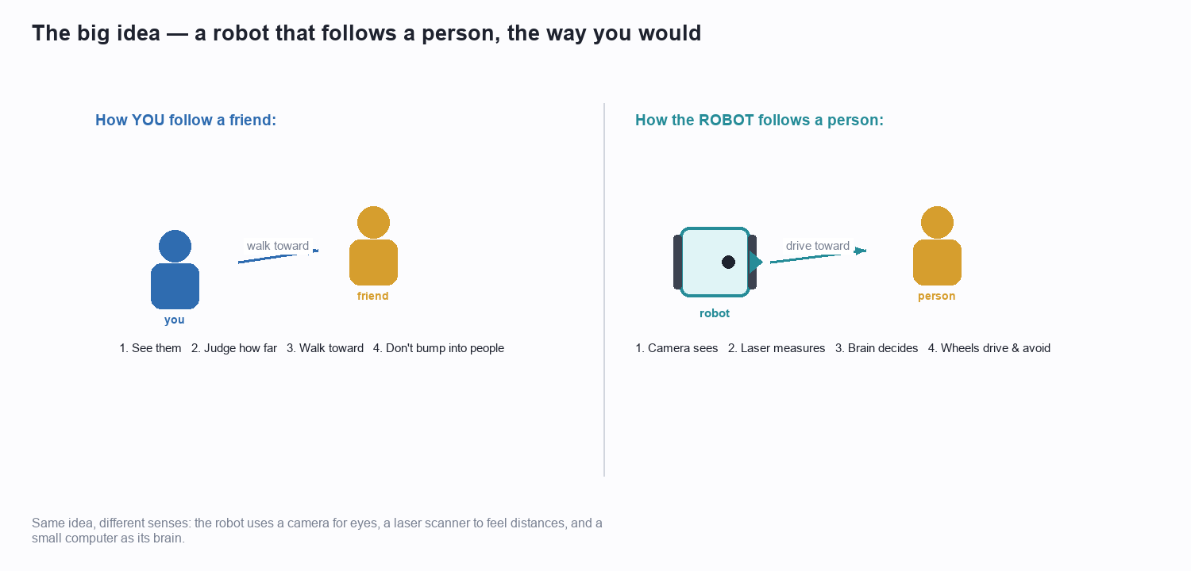

This guide explains, in everyday language and with lots of diagrams, exactly how a small robot can recognise a person, work out how far away they are, decide what to do, and drive after them while avoiding obstacles. Read it top to bottom — each idea builds on the last.

What's inside
Part 1 — The big idea (an everyday analogy)
Part 2 — Meet the robot (its body parts)
Part 3 — The robot's two senses
Part 4 — Step 1: finding the person
Part 5 — Step 2: judging the distance
Part 6 — Step 3: making a decision
Part 7 — The five follow behaviours
Part 8 — Staying safe: avoiding obstacles
Part 9 — The repeating loop that ties it together
Part 10 — Watching the robot think (the dashboard)
Part 11 — Two worlds: practice and real life
Part 12 — One moment, start to finish
Part 13 — In a nutshell

Part 1 — The big idea
Imagine you are walking through a busy shopping centre with a friend. Without thinking about it, you do four things at once: you keep your eyes on your friend, you sense how far ahead they are, you walk toward them at a comfortable pace, and you step around other shoppers so you don't bump into anyone.
A following robot does exactly the same four things — it just uses different tools. Where you use your eyes, it uses a camera. Where you use your sense of space, it uses a spinning laser. And where you use your brain, it uses a small on-board computer.

The robot copies what a person naturally does when following someone.
The rest of this guide simply unpacks those four things, one at a time: how the robot SEES the person, how it MEASURES the distance, how it DECIDES what to do, and how it MOVES safely. Everything else is a detail on top of this simple loop.
💡 Keep this in mind: the robot is not 'intelligent' in a mysterious way. It follows a clear, fixed set of common-sense rules — the same rules you would use — over and over, very fast.

Part 2 — Meet the robot
Before we follow the logic, let's get to know the machine. Our robot is a TurtleBot3 — a small, wheeled robot about the size of a dinner plate. It has four important parts, shown below.
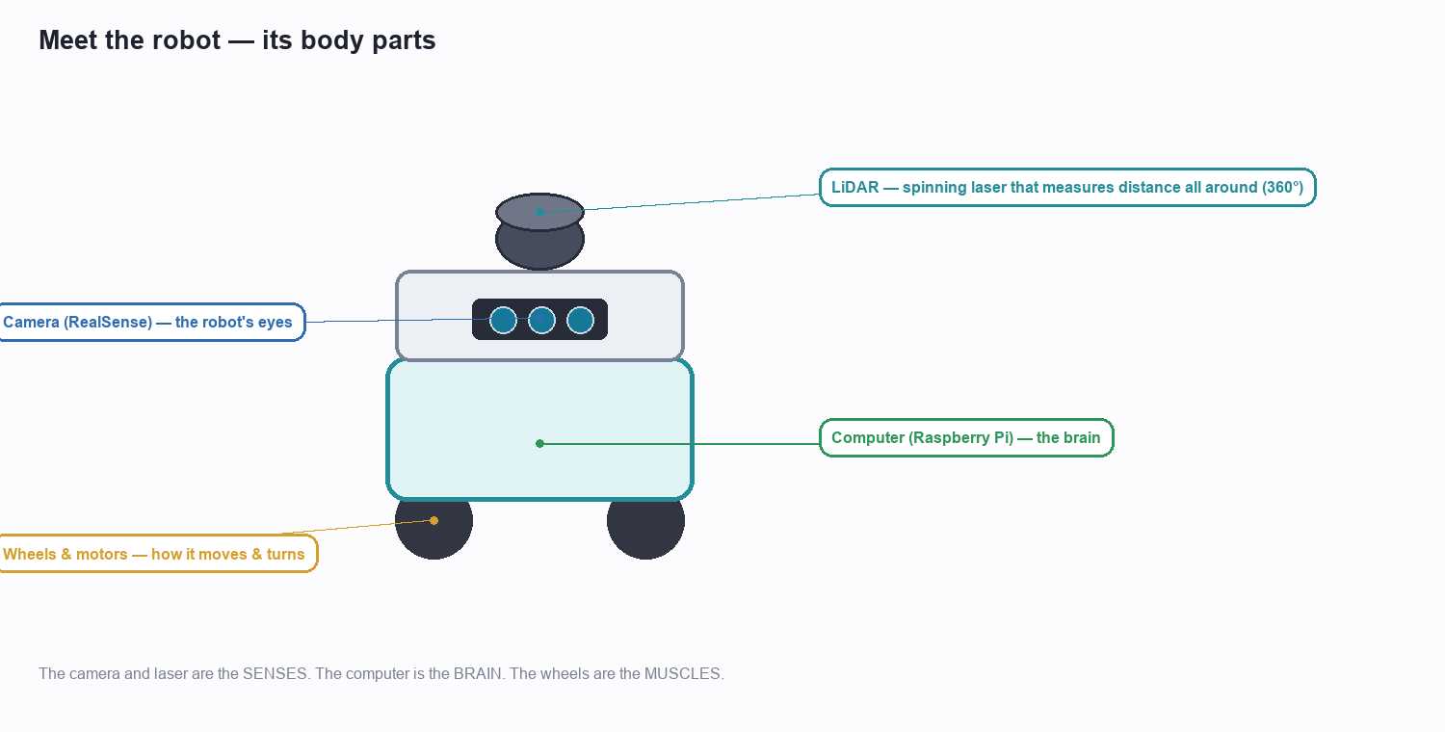
The robot's main parts — its senses, its brain, and its muscles.
- The camera (its eyes): a small colour camera on the front. It takes pictures of whatever is ahead, just like a phone camera. This is how the robot RECOGNISES a person.
- The laser scanner / LiDAR (its sense of space): a little device on top that spins around and fires invisible laser pulses in every direction. By timing how long each pulse takes to bounce back, it measures the distance to everything around the robot — a full 360° picture of 'how far'.
- The computer (its brain): a Raspberry Pi, a computer no bigger than a credit card. It takes in the camera and laser information and runs the decision rules.
- The wheels and motors (its muscles): two driven wheels let the robot roll forward and turn on the spot, so it can both chase and pivot to face someone.
That's the whole machine: two senses feeding one brain that drives two wheels. Simple hardware — the cleverness is in how the information is used, which is what the rest of this guide is about.

Part 3 — The robot's two senses
The robot has two very different senses, and it needs both because each is good at something the other is not.
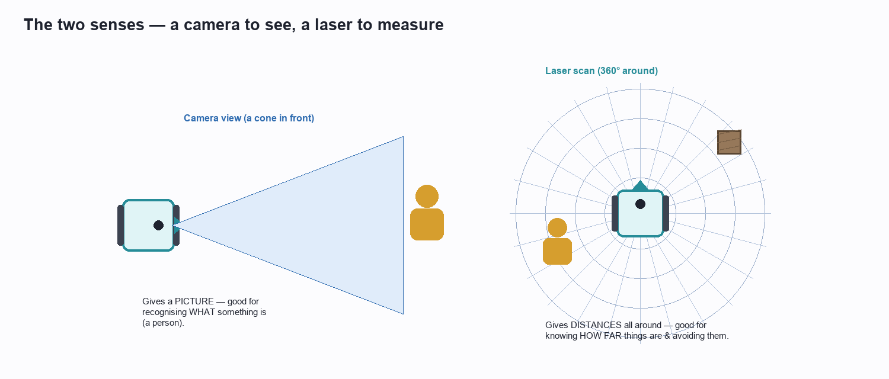
The camera says WHAT something is; the laser says HOW FAR it is.

The camera — good at recognising things
The camera looks forward in a cone, like your own eyes. It produces a normal colour picture. From a picture you can tell WHAT you are looking at — 'that's a person', 'that's a chair'. But a flat picture on its own doesn't reliably tell you HOW FAR away something is.

The laser — good at measuring distance
The spinning laser can't tell a person from a chair — to it, everything is just 'a surface at some distance'. But it is superb at exactly the thing the camera is weak at: it measures distances precisely, all the way around the robot, many times a second.
💡 The key idea: use the camera to find and recognise the person, and use the laser to measure how far away they are and to spot obstacles. Together they cover each other's blind spots.

Part 4 — Step 1: finding the person
The first job is to look at the camera picture and answer a simple question: is there a person in view, and if so, where in the picture are they?
To do this the robot uses a 'spotter' — a piece of software (called YOLO) that has been trained on millions of example photos until it became very good at recognising everyday objects. When we show it a picture, it draws a box around each person it finds and gives a confidence score, like '87% sure this is a person'. We tell it to ignore everything except people.
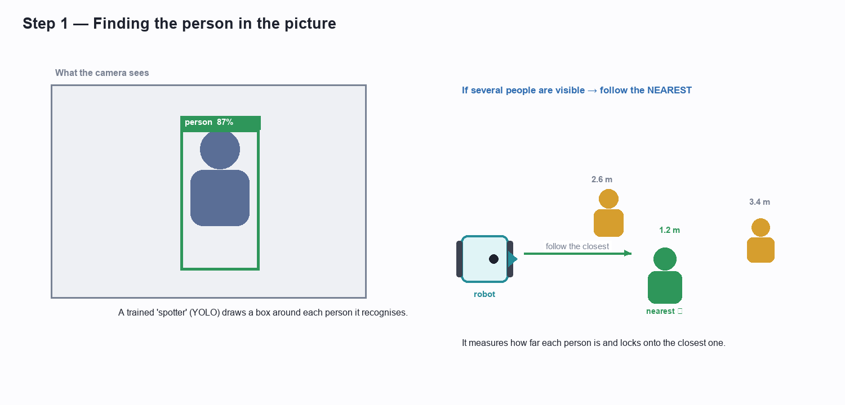
The spotter draws a box around each person; if there are several, the robot picks the nearest.

What if there is more than one person?
In a real room there may be several people. The robot doesn't try to follow everyone — that would be confusing. Instead it works out how far away each detected person is and simply locks onto the CLOSEST one. If that person walks away and someone else becomes nearer, the robot naturally switches to the new nearest person. This 'follow the nearest' rule keeps its behaviour predictable.
💡 Why the box matters later: the position of the box also tells the robot whether the person is dead ahead or off to one side — which it will use to decide whether to turn. And the box's height gives a first clue to distance, as we'll see next.

Part 5 — Step 2: judging the distance
Knowing there's a person isn't enough; the robot needs to know how far away they are, because that decides whether it should drive forward, hold still, or stop. It works this out using two clues and then combines them.
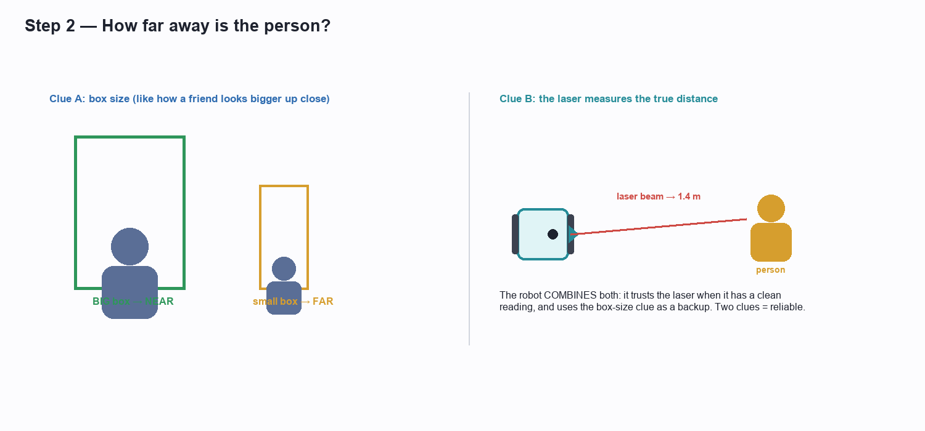
Two clues to distance — the size of the box, and a direct laser measurement.

Clue A — the size of the box
Think about how a friend looks as they walk toward you: they appear larger and larger. It's the same in the camera picture — a nearby person fills a tall box, while a distant person makes only a small box. So the robot can estimate distance just from how tall the detection box is: a big box means near, a small box means far. It's a good, quick estimate, and it's always available whenever a person is seen.

Clue B — the laser measurement
The box tells the robot which DIRECTION the person is in. The robot then looks at the laser reading in exactly that direction to get the true, precise distance. This is very accurate — but only when the laser gets a clean bounce off the person.

Combining the two
The robot prefers the laser measurement because it is precise; but if the laser reading looks unreliable for that instant (for example the person is partly hidden), it falls back on the box-size estimate, which is always there. Using two independent clues and choosing the trustworthy one makes the distance robust — the robot rarely gets fooled.

Part 6 — Step 3: making a decision
Now the robot knows whether it can see a person, how far away they are, and whether anything is in the way. It runs these facts through a simple decision chart — the same chart, about ten times every second. The chart is read strictly from top to bottom, and the FIRST rule that applies wins. That top-to-bottom order is really a list of priorities.
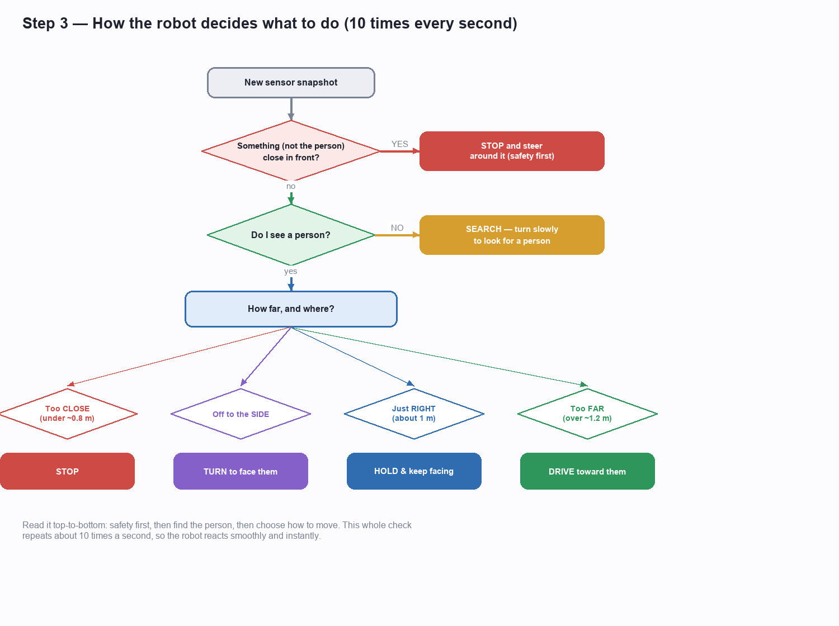
The decision chart. Safety is checked first, then finding the person, then how to move.

Reading the chart in words
- First — safety: 'Is something that is NOT the person close in front of me?' If yes, the robot stops and steers around it. Nothing is more important than not crashing, so this is checked first.
- Second — is there a person? If the robot can't see anyone, it slowly spins on the spot to look around until a person comes into view.
- Third — how far, and where? If it can see a person and the way is clear, it picks ONE of four actions based on the distance and whether the person is centred or off to the side.
Those four actions are the heart of the following behaviour, and we look at each of them next.
💡 Why a chart and not a tangle of 'ifs'? laying the rules out as a priority chart makes the robot's behaviour easy to predict and easy to trust. At any instant you can point to exactly which rule is active and know why the robot is doing what it's doing.

Part 7 — The five follow behaviours
When the path is clear and a person is in view, the robot always does exactly one of five things. Each is a common-sense reaction to where the person is.
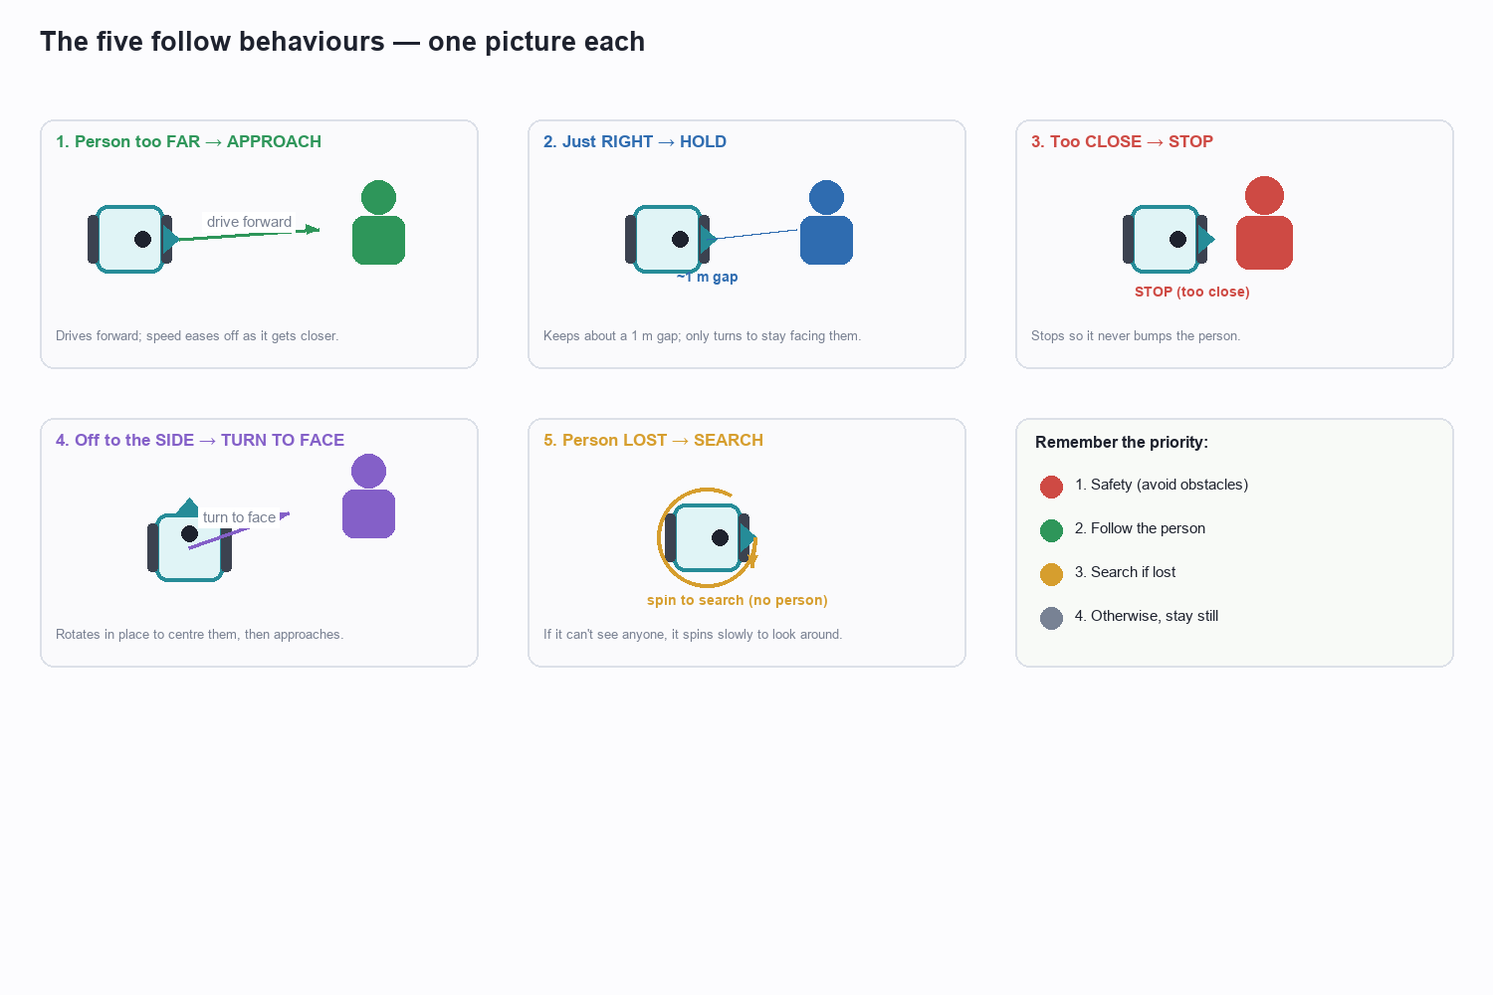
The five things the robot can do while following, each a simple reaction to the person's position.
- Too far → APPROACH: the person is further than about 1.2 m, so the robot drives forward to catch up. It slows down as it gets closer, so it arrives gently rather than lurching.
- Just right → HOLD: the person is at a comfortable gap (around 1 m), so the robot stops moving forward and simply turns as needed to keep facing them. It 'keeps station'.
- Too close → STOP: the person is closer than about 0.8 m, so the robot stops completely. This is a safety cushion so it never bumps into the person.
- Off to the side → TURN TO FACE: if the person has stepped well to the left or right, the robot first rotates on the spot to point straight at them, then approaches. This avoids driving off at an awkward angle and looks much more natural.
- Person lost → SEARCH: if the person disappears from view for more than a moment, the robot spins slowly to hunt for them, and resumes following the instant it sees them again.
💡 The comfortable gap: the robot is tuned to keep roughly a one-metre gap — close enough to clearly be 'following you', far enough to feel safe and give you room to move.

Part 8 — Staying safe: avoiding obstacles
Chasing a person is useless if the robot drives into a wall or a chair on the way. So, before it ever decides to move forward, the robot checks the laser scan in the cone directly ahead. If something is close in that cone, it stops going forward and turns toward whichever side has more open space, curving around the obstacle — then carries on following once the way is clear.
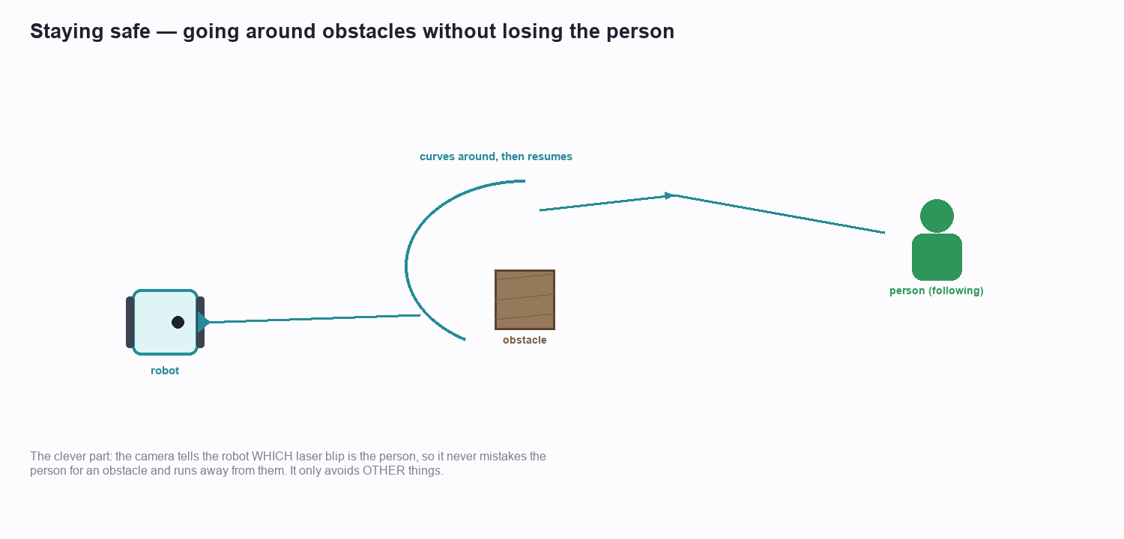
The robot curves around an obstacle, then rejoins the person — without ever fleeing the person.

The clever bit — not running away from the person
Here's a subtle problem: the person the robot is following is ALSO 'something in front of it'. If the robot naively treated everything ahead as an obstacle, it would try to avoid the very person it's supposed to chase, and flee from them!
The robot avoids this trap by using the camera. The camera already knows the direction the person is in, so the robot deliberately IGNORES the laser readings coming from the person's direction when it looks for obstacles. In other words, it says: 'that close thing is the person — that's fine; is there anything ELSE close?' Only genuine obstacles trigger avoidance.
💡 Safety comes first: obstacle avoidance sits at the very top of the decision chart, above following. If there's ever a conflict between chasing the person and not crashing, not crashing always wins.

Part 9 — The repeating loop that ties it together
None of these steps happens just once. The robot repeats the whole cycle — see, measure, decide, move — about ten times every second. Each trip around the loop is tiny, but because it happens so often, the following looks smooth and the robot reacts almost instantly when you change direction.
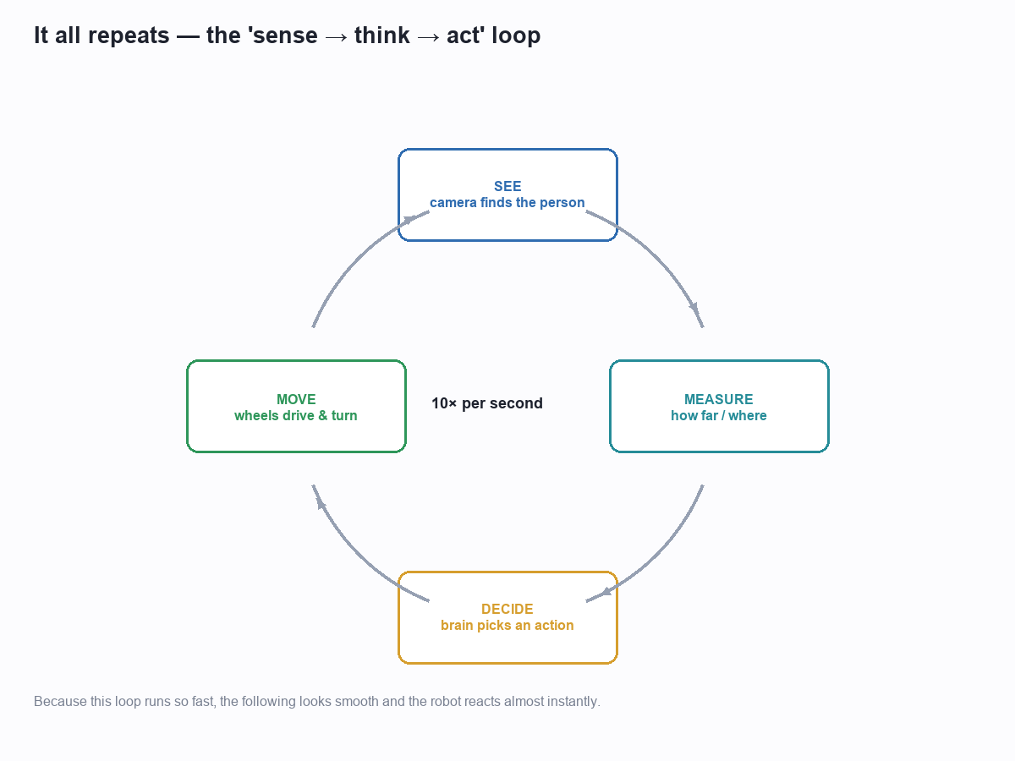
The four steps repeat about ten times a second, which is why following looks smooth.
This constant repetition is also why the robot copes with a moving, unpredictable person. It never assumes anything will stay the same; it simply looks again a tenth of a second later and adjusts. If you speed up, it speeds up; if you dart to the side, it turns; if you stop, it stops.

Part 10 — Watching the robot think (the dashboard)
To make all of this visible — for demonstrations and for checking that everything is working — there is a dashboard: a window on a laptop screen that shows what the robot is seeing and thinking, live.
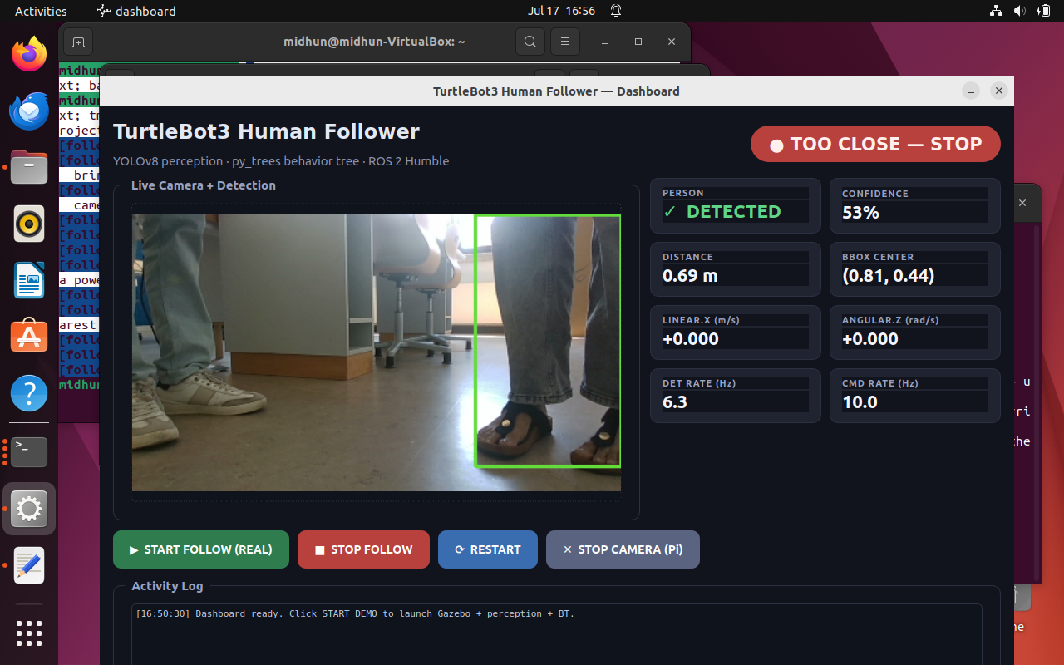
The dashboard: the live camera with the detection box, plus the robot's current state and readings.
The dashboard shows three useful things at a glance:
- The live camera view with the green box drawn around the person the robot has locked onto — so you can see exactly what it sees.
- A big coloured status badge telling you the robot's current mood: SEARCHING, APPROACHING, HOLDING, TOO CLOSE — STOP, ORIENTING (turning to face), or AVOIDING an obstacle.
- Simple readings such as the measured distance, the detector's confidence, and how fast the wheels are being told to move.
Crucially, the badge doesn't guess — the robot reports its own current action each moment, so the dashboard always shows the true state. It turns the robot's invisible 'thinking' into something you can watch, which makes it easy to explain and easy to trust.

Part 11 — Two worlds: practice and real life
The same robot 'brain' is used in two settings, and this is one of the most useful ideas in the whole project.
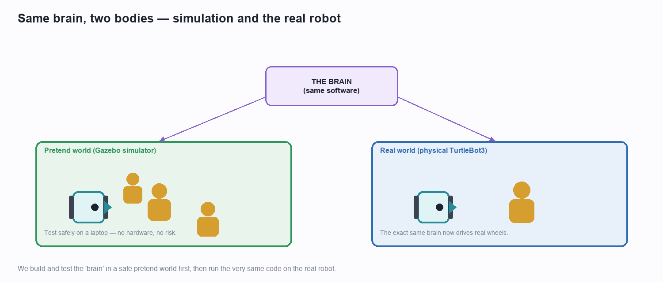
The identical decision software runs first in a safe pretend world, then on the real robot.
- A pretend world (a simulator): a realistic 3-D computer world — a room with walls and several walking people — where the robot exists only as software. Here we can test the rules endlessly with no cost and no risk: nothing can be damaged and no batteries run flat.
- The real world: the same decision software, unchanged, now drives a physical robot with real wheels, a real camera and a real laser.
Because the brain is identical in both, anything we get working in the safe pretend world behaves the same way on the real robot. We iron out the logic first where mistakes are harmless, then simply switch the same brain onto real hardware.

Part 12 — One moment, start to finish
To pull it all together, here is a single moment in the robot's life, told as a short story. This entire sequence takes a fraction of a second, and then it repeats.
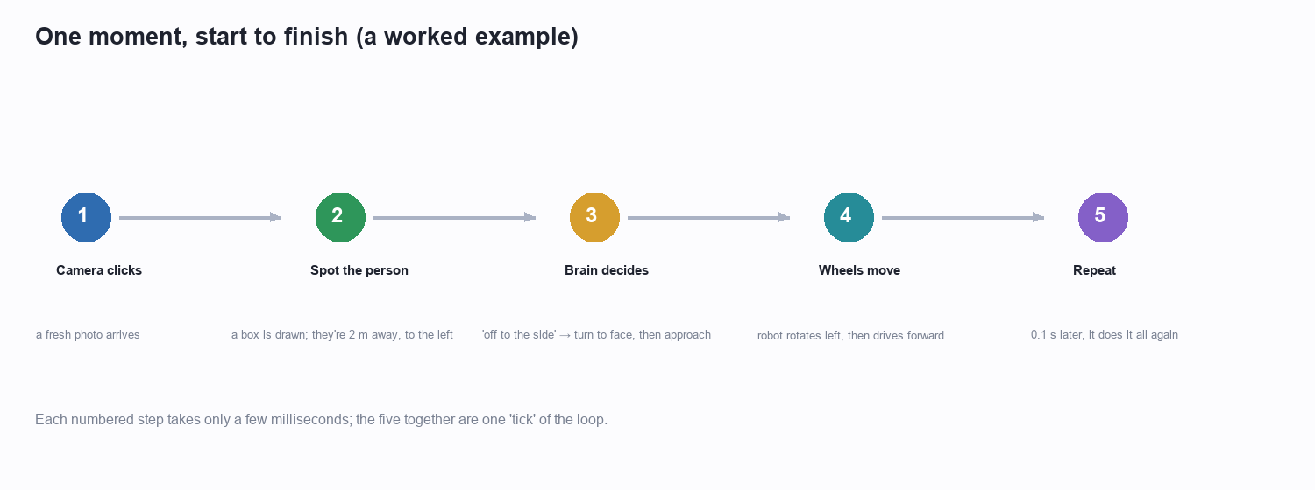
A single tick of the loop, from the camera snapshot to the wheels moving.
- 1. The camera clicks and hands the computer a fresh photo of the scene ahead.
- 2. The spotter finds the person and draws a box: the person is about two metres away and a little to the left.
- 3. The brain runs the chart — nothing is in the way, a person is visible, and they're off to the side — so it chooses 'turn to face them, then approach'.
- 4. The wheels obey — the robot rotates slightly left to centre the person, then rolls forward.
- 5. A tenth of a second later it all happens again, keeping the following smooth and responsive.
💡 That's the whole robot: this five-step story, repeated ten times a second, with safety checked first — is everything the following robot does.

Part 13 — In a nutshell
If you remember only a few things from this guide, remember these:
- Two senses: a camera to recognise the person, a laser to measure distances and spot obstacles.
- One brain: a small computer running clear, common-sense rules — no mystery.
- A priority chart: safety first, then find the person, then choose how to move (approach, hold, stop, or turn to face).
- Follow the nearest: when several people are visible, it locks onto the closest.
- Never flee the person: it uses the camera to tell the person apart from real obstacles.
- A fast loop: the whole see–measure–decide–move cycle repeats about ten times a second, so following looks smooth and natural.
Everything the robot does is one of these simple ideas, applied over and over, very quickly. That is how a small robot with a camera, a laser and a tiny computer can reliably follow a person around a room.

— End of guide —

