**PROJECT TITLE**

***Submitted by***

**NAME OF STUDENT1**

**NAME OF STUDENT2**

**NAME OF STUDENT3**

**NAME OF STUDENT4**

**PROJECT REPORT**

***Submitted in partial fulfilment of the requirements***

***for the award of Bachelor of Computer Application degree of University of Kerala***



**DEPARTMENT OF COMPUTER SCIENCE**

**COLLEGE OF APPLIED SCIENCE MAVELIKARA**

***(Affiliated to University of Kerala)***

**Managed by**

**INSTITUTE OF HUMAN RESOURCES DEVELOPMENT**

***(Established by Govt. of Kerala)***

**2022**

**COLLEGE OF APPLIED SCIENCE MAVELIKARA**

***(Affiliated to University of Kerala)***



**Managed by**

**INSTITUTE OF HUMAN RESOURCES DEVELOPMENT**

***(Established by Govt. of Kerala)***

**Certificate**

Certified that the project report titled **“PROJECT TITLE”** is a bonafide record of the work done by **STUDENT1 (Register no: 332198030**), STUDENT2 (Register no: 332198030**), STUDENT 3 (Register no: 33219 8030**)** and **STUDENT4 (Register no: 332198030**)** of the sixth semester BCA programme under our supervision, towards partial fulfilment of the requirements for the awards of the Degree of BCA of the University of Kerala.

|  |  |  |
| --- | --- | --- |
|  |  |  |
| **Mrs NIDHI S**  ***(Project Guide)***  **Asst. Professor**  **Dept. of CS** | **Mr REGIMON V R**  ***(Head of Department)***  **Dept. of CS** | **Mrs LAILA JASMIN**  ***(Principal)*** |
| **External Examiner** |  |  |

**DECLARATION**

We hereby declare that this project report entitled “**PROJECT NAME**” is the bonafide work of ours carried out under the supervision of our project guide **Mrs Nidhi S, Assistant Professor in Computer Science, College of Applied Science, Mavelikara** and declared further that to the best of our knowledge, the work reported herein does not form part of any other project report or dissertation based on which a degree or award was conferred on an earlier occasion to any other candidate. The content of this report is not being presented by any other student to this or any other University for the award of a degree.

**Signature:**

**STUDENT1 (Register no: 33219 8030**)**

**STUDENT2 (Register no: 33219 8030**)**

**STUDENT3 (Register no: 33219 8030**)**

**STUDENT4 (Register no: 33219 8030**)**

**Countersigned**

**Head, Department of Computer Science**

**College of Applied Science, Mavelikara**

**ACKNOWLEDGEMENT**

First and foremost, we would like to acknowledge the **Almighty God** for the successful completion of our project.

We are very thankful to our guide, **Mrs Nidhi S**, for providing her invaluable guidance, comments and suggestions throughout this project work. We would specially thank our Head of Department, **Mr Regimon V R**, for constantly motivating us.

We would like to thank our Principal **Mrs Laila Jasmin** and all the faculties of the Department of Computer Application, who brought us to the present performance and shaped us like this during the last three years.

We wish to record sincere thanks to all our family members whose blessings made this task possible.

**STUDENT1**

**STUDENT2**

**STUDENT3**

**STUDENT4**

**TABLE OF CONTENTS**

ABSTRACT i

LIST OF FIGURES ii

LIST OF TABLES iii

1. INTRODUCTION 1

1.1. PROBLEM STATEMENT 1

1.2. SCOPE OF PROJECT 1

1.3. PRODUCT FEATURES 2

2. SYSTEM SPECIFICATION 7

2.1. HARDWARE SPECIFICATION 7

2.2. SOFTWARE SPECIFICATIONS 7

2.3. ABOUT DEVELOPING TOOLS 7

3. PROBLEM DESCRIPTION 11

3.1. PROBLEM STATEMENT 11

3.2. PROBLEM SOLUTION 11

3.3. MODULES AND ITS DESCRIPTION 11

3.4. SYSTEM ARCHITECTURE 12

4. SYSTEM ANALYSIS 13

4.1. EXISTING SYSTEM 13

4.2. FEASIBILITY STUDY 14

4.3. PROPOSED SYSTEM 16

5. SYSTEM DESIGN 18

5.1. OVERALL DESIGN 18

5.2. USE CASE DIAGRAM 18

5.3. SYSTEM FLOWCHART 20

5.4. DATA FLOW DIAGRAMS 21

5.5. ER DIAGRAM 24

5.6. TABLE DESIGN 26

6. SYSTEM TESTING 29

6.1. TESTING METHODS 29

6.2. TEST CASES 31

7. SYSTEM IMPLEMENTATION 34

7.1. IMPLEMENTATION PROCEDURE 34

7.2. TRAINING 35

7.3. EVALUATION 35

7.4. DOCUMENTATION 35

8. SOFTWARE MAINTENANCE 36

8.1. CORRECTIVE MAINTENANCE 36

8.2. ADAPTIVE MAINTENANCE 36

8.3. PERFECTIVE MAINTENANCE 36

8.4. PREVENTIVE MAINTENANCE 36

9. CONCLUSION 37

10. FUTURE ENHANCEMENT 38

11. APPENDIX 39

11.1. SCREENSHOTS 39

11.2. SAMPLE SOURCECODE 42

11.3. GANTT CHART 51

12. REFERENCES 52

# ABSTRACT

This project is mainly intended for automating this procedure that can help the people who belong to the T&P cell by saving their time, based on this basic operation. Their activity is under two steps the first one is, to maintain the list of students and their credit records and the second job is to maintain the company details and based on the company requirements, need to select the students and make the list of students branch wise, which is a more complex task, and here informing is through notice boards. Whereas this is also a bit old fashioned task, which can be automated in our proposed system by sending mails to the respective candidates. This proposed system is far more advantageous than the existing one in many cases such as retrieving the student details is easily maintained in a manner that with just one click we can easily attain the details of the company such as the responsible person contacts and company contact details such as address and phone numbers can be maintained. T&P cells mainly include the details of students. The percentage of the students must be appropriate and true. The notices can be generated so that we notify all the departments of the corresponding information about campus recruitment drives. The student detail can also be viewed.

# LIST OF FIGURES

Figure 3.1: System architecture 12

Figure 5.1:Use case diagram for admin 19

Figure 5.2:Use case diagram for company 19

Figure 5.3: Use case diagram for student 20

Figure 5.4: System flowchart 20

Figure 5.5: Context diagram 21

Figure 5.6: Level 1 DFD for student 21

Figure 5.7: Level 1 DFD for Admin 22

Figure 5.8: Level 2 DFD for student 23

Figure 5.9: Level 2 DFD for company 23

Figure 5.10: Entity-Relationship Diagram 25

Figure 11.1: Home page 39

Figure 11.2: Admin login page 39

Figure 11.3: Company login page 40

Figure 11.4: Student regiatration page 40

Figure 11.5: Admin filtering page 41

Figure 11.6: Message service 41

Figure 11.7: Data management 42

Figure 11.8: Gantt chart 51

# LIST OF TABLES

Table 5.1: Admin 26

# INTRODUCTION

This project is mainly intended for automating this procedure that can help the people who belong to the T&P cell by saving their time, based on this basic operation. ATheir activity is under two steps the first one is, to maintain the list of students and their credit records and the second job is to maintain the company details and based on the company requirements, need to select the students and make the list of students branch wise, which is more complex task, and here informing is through notice boards. Whereas this is also a bit old fashioned task, which can be automated in our proposed system by sending mails to the respective candidates. This proposed system is far more advantageous than the existing one in many cases such as retrieving the student details is easily maintained in a manner that with just one click we can easily attain the details of the company such as the responsible person contacts and company contact details such as address and phone numbers can be maintained. T&P cells mainly include the details of students. The percentage of the students must be appropriate and true. The notices can be generated so that we notify all the departments of the corresponding information about campus recruitment drives. The student detail can also be viewed.

## PROBLEM STATEMENT

This project is aimed at developing an online application for the Training and Placement Dept. of the college. The system is an online application that can be accessed throughout the organization and outside as well with proper login provided. This system can be used as an application for the TPO of the college to manage the student information with regard to placement. Students logging should be able to upload their information in the form of a CV.Visitors/Company representatives logging in may also access/search any information put up by students.

## SCOPE OF PROJECT

The project covers a wide scope. The information of all the students can be stored. CVs are categorized according to various streams. Various companies can access the information. Students can maintain their information and can update it. Notifications are sent to students about the companies. Students can access previous information about placement.

* StudentRegistration facility
* Company page
* Company recruitment schedule page
* Administrator ControlPanel
* Updates by theAdministrator
* View Updates by the Students

## PRODUCT FEATURES

* Complete automation is possible in this sector, which is against the main disadvantage namely time-consuming.
* Can maintain student details who have been studying in the college.
* Any kind of list based on students' profiles can be retrieved within less time.
* Results are uploaded directly from the net so that no errors exist in calculating percentages.
* Effective and good means of communication can be facilitated as we have included a mailing module in the proposed system.
* User can also register students and can view and delete their profile.

# SYSTEM SPECIFICATION

## HARDWARE SPECIFICATION

The selection of hardware configuration is a very important task related to software development. Insufficient random access memory may affect adversely on speed and efficiency of the entire system. The process should be powerful to handle the entire operation. The hard disk should have sufficient capacity to store the file and application**.**

Processor: 1.7GHz i3 Processor or above

HardDisk: 550 GB or above

RAM: 2.00 GB or above

Input Device: Standard Mouse and Keyboard

Output Device: High-Resolution Monitor

## SOFTWARE SPECIFICATIONS

OperatingSystem: Windows 7 or above

FrontEnd: PHP 5.6

Back End: MYSQL

TechnologiesUsed: JAVASCRIPT, AJAX, JQUERY, CSS, HTML

## ABOUT DEVELOPING TOOLS

### CSS

Cascading Style Sheets (CSS) is a style sheet language used for describing the presentation of a document written in a markup language. Although most often used to set the visual style of web pages and user interfaces written in HTML and XHTML, the language can be applied to any XML document, including plain XML, SVG and XUL, and applies to rendering in speech, or on other media. Along with HTML and JavaScript, CSS is a cornerstone technology used by most websites to create visually engaging webpages, user interfaces for web applications, and user interfaces for many mobile applications.

CSS is designed primarily to enable the separation of document content from document presentation, including aspects such as the layout, colours, and fonts are separation can improve content accessibility, provide more flexibility and control in the specification of presentation characteristics, enable multiple HTML pages to share formatting by specifying the relevant CSS in a separate .css file, and reduce complexity and repetition in the structural content.

CSS helps Web developers create a uniform look across several pages of a Web site. HTML, commonly used styles need to be defined only once in a CSS document. Once the style is defined in cascading style sheet, it can be used by any page that references the CSS file. Plus, CSS makes it easy to change styles across several pages at once. For example, a Web developer may want to increase the default text size from 10pt to 12pt for fifty pages of a Web site. If the pages all reference the same style sheet, the text size only needs to be changed on the style sheet and all the pages will show the larger text. While CSS is great for creating text styles, it is helpful for formatting other aspects of Web page layout as well. For example, CSS can be used to define the cell padding of table cells, the style, thickness, and colour of a border, and the padding around images or other objects. CSS gives Web developers more exact control over how Web pages will look than HTML does. This is why most Web pages today incorporate cascading stylesheets.

### JAVASCRIPT

JavaScript, often abbreviated as "JS", is a high-level, dynamic, untyped, and interpreted runtime language. It is a client-side technology and is mainly used for client-side validation. It has been standardized in the ECMAScript language specification. Alongside HTML and CSS, JavaScript is one of the three core technologies of World Wide Web content production; the majority of websites employ it, and all modern Web browsers support it without the need for plugins. JavaScript is prototype-based with first-class functions, making it a multi-paradigm language, supporting object-oriented, imperative, and functional programming styles. It has an API for working with text, arrays, dates and regular expressions, but does not include any I/O, such as networking, storage, or graphics facilities, relying for these upon the host environment in which it is embedded. Although there are strong outward similarities between JavaScript and Java, including language name, syntax, and respective standard libraries, the two are distinct languages and differ greatly in their design. JavaScript was influenced by programming languages such as Self and Scheme. JavaScript is also used in environments that are not Web-based, such as PDF documents, site-specific browsers, and desktop widgets.

### Java

Java is an object-oriented coding language created by Sun Microsystems in 1995. Java has English-based commands used to create applications for a single computer or whole server and tiny applets for websites. Java is a popular favourite for programming mobile apps and video games, especially on Android operating systems.

### PHP

PHP, or hypertext processor, is a coding language for web development founded in 1994 by Rasmus Lerdorf. PHP is widely used for server scripting with HTML to piece together dynamic website content. WordPress, an open-source online platform that accounts for 20 per cent of websites and blogs, is notably written with PHP.

### APACHE

Its job is to establish a connection between a server and the browsers of website visitors (Firefox, Google Chrome, Safari, etc.) while delivering files back and forth between them (client-server structure). Apache is a cross-platform software; therefore, it works on both Unix and Windows servers.

### MYSQL

MYSQL, or structured query language, is a domain-specific coding type that streams information into a database. First introduced by IBM researchers in 1974, SQL has simple syntax to run back-end web databases. SQL is used by most businesses to load, retrieve, and analyze text or numbers in their servers.

During implementation, the team created an actual product. Product implementation can be an exciting phase for the customer because their idea for the project becomes something tangible. Project developers begin building and coding the software. For example, if a customer wants a new gaming application, the project developers must program the application to perform the customer's gaming requirements. As the team develops the code, the team must follow specific coding requirements. Customer requirements may call for specific computer programming languages or upgrades, and developers need to run the applications to ensure they function properly.

Most companies that design and develop software using some form of the software development life cycle (SDLC) to plan for, create, and release their products. The implementation and coding phase of the software development life cycle is the third phase of the SDLC process. The first phase of the SDLC is the requirements gathering and analysis phase, which is when the project team and business managers gather the wants and needs of the customer. After the project, the team obtains the customer's requirements for the project, the second phase of the SDLC starts, which is when the team designs the software. The project team then uses the design to begin the implementation and coding phase.

During the implementation process, developers must write enough comments inside the code so that if anybody starts working on the code, later on, he/she can understand what has already been written. Writing good comments is very important, as all other documents, no matter how good they are, will be lost eventually. Ten years after the initial work, you may find only that information that is present inside the code in the form of comments Review meetings during the development phase also prove helpful. Potential problems are caught earlier in the development. These meetings are also helpful to keep track of whether the product is on time or if more effort is needed complete it in the required period. Sometimes you may also need to make some changes in the design of some components because of new requirements from the marketing and salespeople. Review meetings are a great tool to convey these new requirements. Again, architecture documents and MRDs are kept in sync with any changes/problems encountered during development.

# PROBLEM DESCRIPTION

## PROBLEM STATEMENT

In the present existing system a form is given to students in which he/she has to fill with some details such as his name, roll number, contact details, percentages(from first year to till date), Intermediate particulars(name of institution , place, year of pass, percentage) , SSC particulars(name of institution , place, year of pass, percentage). Afterwards the marks of each student are collected from green book (a book containing marks and other details maintained by each department in college). From the data collected through filled-forms and green book, excel sheets are prepared. These excel sheets are used to prepare a list of students who full-fill the requirements of a company visiting the campus and these students are eligible to attend the campus placement. Now this process is an extremely time consuming and slow process.

## PROBLEM SOLUTION

We are overcoming the difficulty of student details, which were manual in the current system, here we generate detailed information about the students, which will save our time to inform each and every batch and section, and student profile is maintained. This project is aimed at developing an online application for the Training and Placement Department. of the college. The system is an online application that can be accessed throughout the organization and outside as well with proper login provided. This system can be used as an application for the TPO of the college to manage the student information with regards to placement. Students logging should be able to upload their information in the form of a CV. Visitors/Company representatives logging in may also access/search any information put up by Students.

## MODULES AND ITS DESCRIPTION

The major User classes in the System would be:

### Student

* New Student needs to sign up or register giving complete details
* They can submit resumes and update profile information.
* They can register for a particular placement.
* They can access the training materials provided

### Administrator

* The Admin has the supreme power of the application
* Admin provides approval to the Student and the corporate registration
* Admin is responsible for maintaining and updating the whole system.
* Admin has the responsibility to notify the Company for any application from a student.
* Admin has to notify the students regarding any changes in the procedure or selection.
* Admin is the person who approves the registration of the company and the student.
* Shortlisting is done by the admin based on the condition of the company.

### Company

* The Company has to notify the Admin or the Placement officer.
* The Company initially has to sign up.
* The Company may view the shortlisted list of students.

## SYSTEM ARCHITECTURE

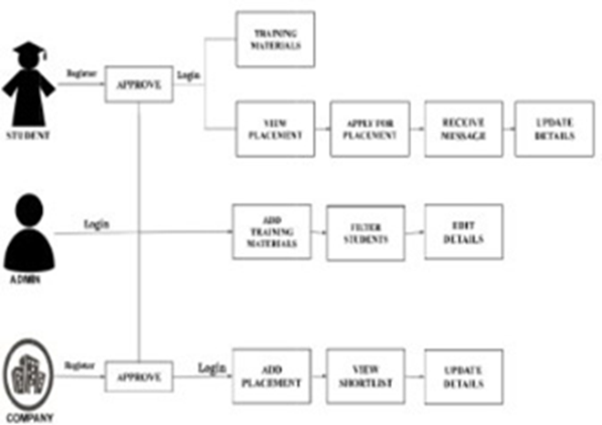

Figure .: System architecture

# SYSTEM ANALYSIS

System Analysis is the process of gathering and interpreting facts, diagnosing the problems and using the information to recommend improvements. System analysis is a proproblem-solvingtivity that requires intensive co between the system user and system developers. System analysis or study is an important phase of any system development process. The system is viewed on a whole and inputs to the system are identified. The output from the organization is travel through various phases of the processing of inputs.

The system is viewed as a whole and inputs to the system are in defined the output from the system are traced through the various data are collected on available files. Description points and transaction held by the present system. Based on analysis, a cost or benefit analysis are considered, cost of the system is calculated on the basis of analysis made on the solution is given as a proposal. The proposal is then d with the existing system analytically and the best on is selected.

A detailed study of these processes must be made by the various techniques like interviews, questionnaires, etc. The data collected by these sources must be scrutinized to arrive to a conclusion. The conclusion is an understanding of how the system functions. This system is called the existing system. Now, the existing system is subject to close study and the problem areas are identified. The designer now functions on a problem solver and tires to sort out the difficulties that weighed with the existing faces. The solutions a given on a proposal. The proposal is then weighed with the existing system analytically and the best one is selected. The proposal is presented to the user for any endorsement by the user. The proposal is reviewed on user request and suitable changes that made. This is a loop that ends as soon as the user in satisfied with the proposal.

## EXISTING SYSTEM

In the present existing system a form is given to students in which he/she has to fill with some details such as his name, roll number, contact details, percentages(from first year to till date), Intermediate particulars(name of institution , place, year of pass, percentage) , SSC particulars(name of institution , place, year of pass, percentage). Afterwards the marks of each student are collected from green book (a book containing marks and other details maintained by each department in college). From the data collected through filled-forms and green book, excel sheets are prepared. These excel sheets are used to prepare a list of students who full-fill the requirements of a company visiting the campus and these students are eligible to attend the campus placement. Now this process is an extremely time consuming and slow process.

### Disadvantages

* Time-consuming
* Slow process

## FEASIBILITY STUDY

A feasibility analysis usually involves a thorough assessment of the operational (need), financial and technical aspects of a proposal. Feasibility study is carried out to determine whether the proposed system is possible to develop with available resources and what should be the cost consideration. Facts considered in the feasibility analysis were...Technical feasibility includes whether the technology is available in the market for development and its availability. Considering our project it is technical feasible. Training and Placement System, with its emphasis on a more strategic decision making process is fast gaining ground as a popular outsourced function. Economic feasibility study present tangible and intangible benefits from the project by comparing the development and operational cost. The technique of cost benefit analysis is often used as a basis for assessing economic feasibility. This system needs some initial investment than the existing system, but it can be justifiable that it will improve quality of service. Our project is economically feasible. It does not require much cost to be involved in the overall process. The overall objective is in easing out the recruitment processes. Operational feasibility analysis involves how it will work when it is installed and the assessment of managerial environment in which it is implemented. People are inherently resistant to change and computers have been known to facilitate change. The new proposed system is very much useful to the users and therefore it will accept broad audience from around the world.

* Technical feasibility
* Operational feasibility
* Economic feasibility
* Legal feasibility

### Technical Feasibility

This evaluation determines whether the technology needed for the proposed system is available and how it can be integrated within the organization. Technical evaluation must also assess whether the existing systems can be upgraded to use the new technology and whether the existing systems can be upgraded to use the new technology and whether the organization has the expertise to use it. Technical feasibility centers on the existing computer system (hardware, software, etc.) and to what extend it can support the proposed addition. It considered the accuracy, reliability, case of access and data security of the system. This involves financial considerations to accommodate technical enhancements. If the budget is a serious constraint, then the project will be judged as not possible.

### Operational Feasibility

It addresses the question of whatever the use can run the system. In the existing system, the user needs to send more times with it to retrieve data. But the proposed system can reuse the work load of users and item produced greater flexibility. Operationally, the proposed system is easy to use. The proposed system reduces the amount of lost and cost.

### Economic Feasibility

Economic feasibility analysis is currently known as a cost benefit analysis. This evaluation looks at the financial aspects of the project. It determines whether the investment needed to implement the system will be removed. It concerns returns from the investments in a project. It determines whether it is worthwhile to invest the money in the proposed project or whether something else should be done it. To carry out economic feasibility study, it is necessary to place actual money values against any purchases or activities needed to implement the project. Our system is economically feasible to develop.

### Legal Feasibility

Legal feasibility is the determination of any infringement, violation, or liability that could result from the development of the system. Legal feasibility environment passes abroad range of concerns that include contract and liability. The proposed project is also a legally feasible one.

## PROPOSED SYSTEM

In the proposed system, the user need not do all the hectic work. He will be provided with an interface with which he can easily get his work done. The main aim of the proposed system is to develop a system with improved facilities. The proposed system can overcome all the limitation of the existing system, such as student's information is maintained in the database, it gives more security to the data, ensures data accuracy, reduces paperwork and save time, only eligible students get chance, it makes information flow efficient and paves way for easy report generation, reduce the space. The proposed system is cost-effective. The following are the facilities that are provided by the system to the user.

* Student enrolment: The students can enrol themselves for the placement drive.
* Company enrolment: Various organizations can enrol themselves and give information about their placements to be conducted. However, the administrator later verifies this.
* Training information: The training for the cadets appearing for a placement drive would be conducted in the institution and the administrator in the website would constantly update its status.
* Notice generation: Here user has to provide information to the system about company name, date and venue at which campus drive might take place. With this information, the system will generate a notice, which can be seen on students' account to intimate students about placement drive.
* Student list generation: Here the user has to provide information to the system about the requirements of the Company (such as, cut off percentage, number of backlogs allowed etc.) and then the required filtering is done automatically.
* View student profile: Here the user is able to view a student's profile of his interest by giving the student's roll number as input.
* Result analysis: Here the user is able to get the results, which are released and store them for later usage.
* Posts: Here the user is provided to post updates or any necessary details to students or others (for example-company officials) depending on his need.
* Online test: The website also provides links that would help the students to participate in mock tests and hence prepare for the real one.
* Company details: The website also provides information on the companies conducting the placement drive. So that the students can contact them for any information required.

# SYSTEM DESIGN

## OVERALL DESIGN

The system provides a user-friendly interface for the placement management cell of the institution. It focuses on major modules like entry of student details, entry of company details and filtering of students as per the requirement of various companies. We are overcoming the difficulty of student details, which were manual in the current system, here we generate detailed information about the students, which will save our time to inform each batch and section, and student profile is maintained. For the purpose of training and placement of the student in colleges, TPO's have to collect the information and CV is of students, manages them manually, and arranges them according to various streams. If any modification is required, that is to be also done manually.

Therefore, to reduce the job required to manage CV’s and the information of various recruiters, a new system is proposed which is processed through computers. This project is aimed at developing an online application for the Training and Placement Dept. of the college. The system is an online application that can be accessed throughout the organization and outside as well with proper login provided. This system can be used as an application for the TPO of the college to manage the student information about placement. Students logging should be able to upload their information in the form of a CV. Visitors/Company representatives logging in may also access/search any information put up by students.

## USE CASE DIAGRAM

### Use Case Diagram for Admin

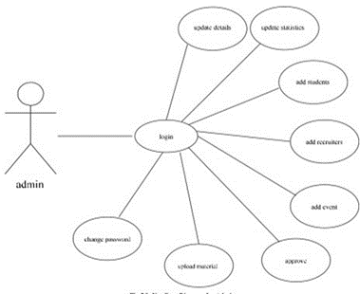

Figure .:Use case diagram for admin

Once the admin login process is completed, he can perform actions like provide confirmation, add placement notifications, upload shortlist, and provide links or materials for practice.

### Use Case Diagram for Company

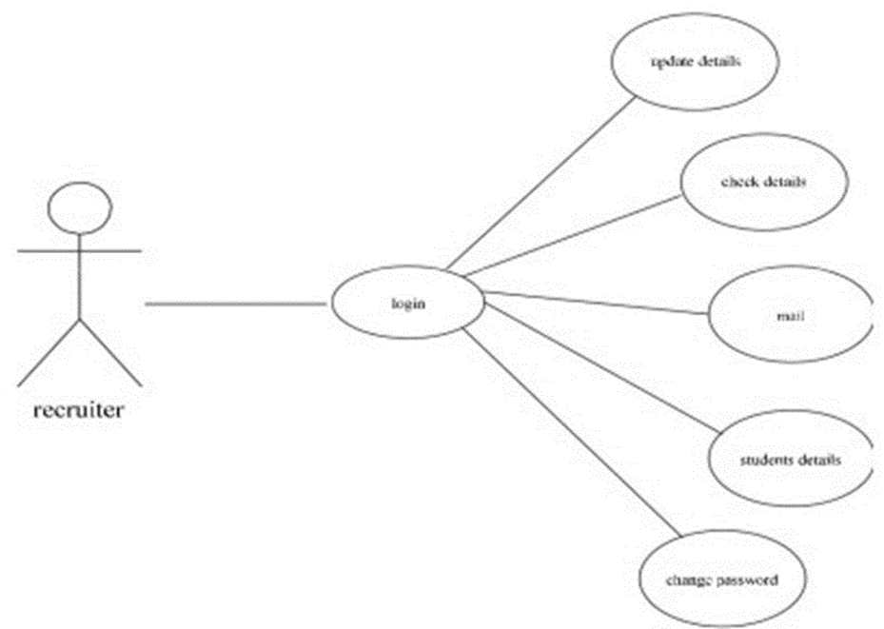

Figure .:Use case diagram for company

This diagram shows the case diagram for the companies. In order to perform various tasks, the company has to initially log in after he/she has been authenticated by the admin. Once logged in he can perform various tasks like introducing a placement, view shortlist and view student details.

### Use Case Diagram for Student

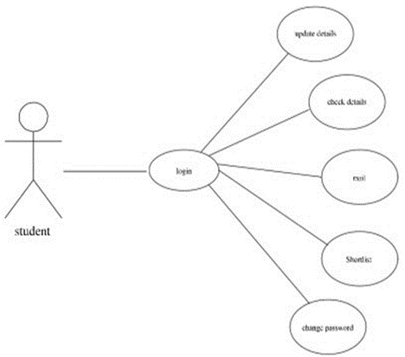

Figure .: Use case diagram for student

This diagram shows the case diagram for students.Inorder to perform various tasks. The student has to initially login after he/she has been authenticated by the admin.Once logged in he can perform various tasks like apply for a placement, receive emails, view shortlist etc.

## SYSTEM FLOWCHART

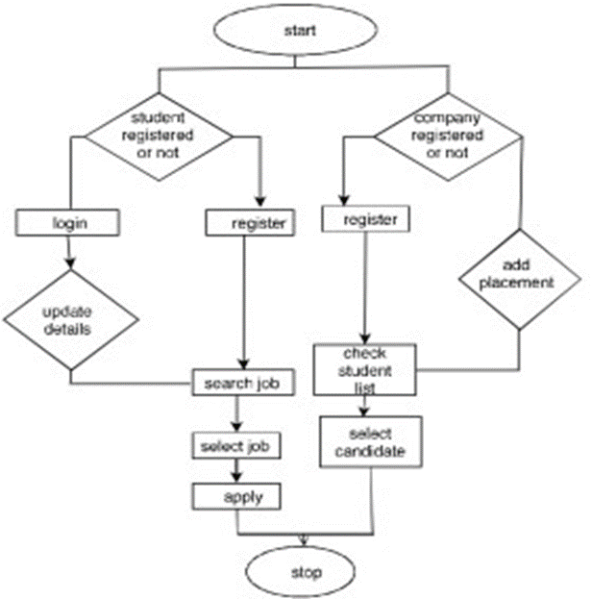

Figure .: System flowchart

This diagram explains the flow of control of the software. The major parts involved in the control flow are actions like acceptance and rejection of student and company, login process, editing of information and notification publications.

## DATA FLOW DIAGRAMS

### Level 0 OR Context Level DFD

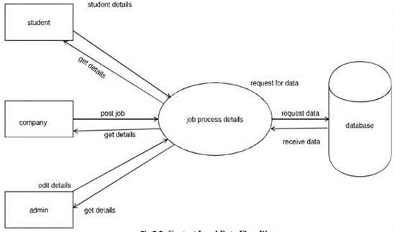

Figure .: Context diagram

This diagram shows the data flow of the entire software in an overall manner. Here the admin, company and students who are registering and applying for the placements give the main inputs. After the processing is done, the data is stored in the database.

### Level 1 DFD for Students

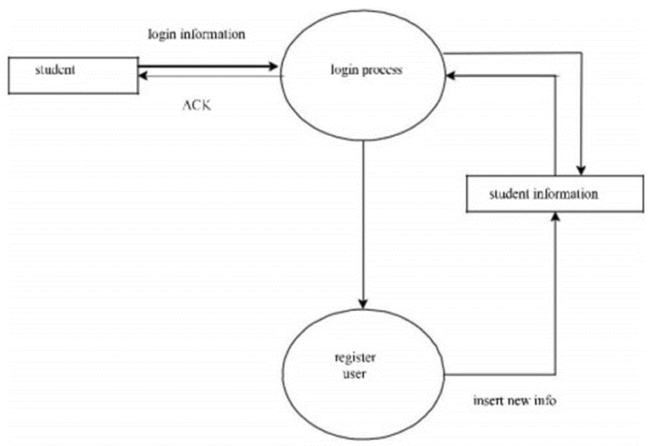

Figure .: Level 1 DFD for student

Here the filtering is done and the students can apply for the jobs that they are eligible. If qualified then they receive an alert through online means. However only the filtered category of students who are eligible can only apply for the placements.

### Level 1 DFD for Admin

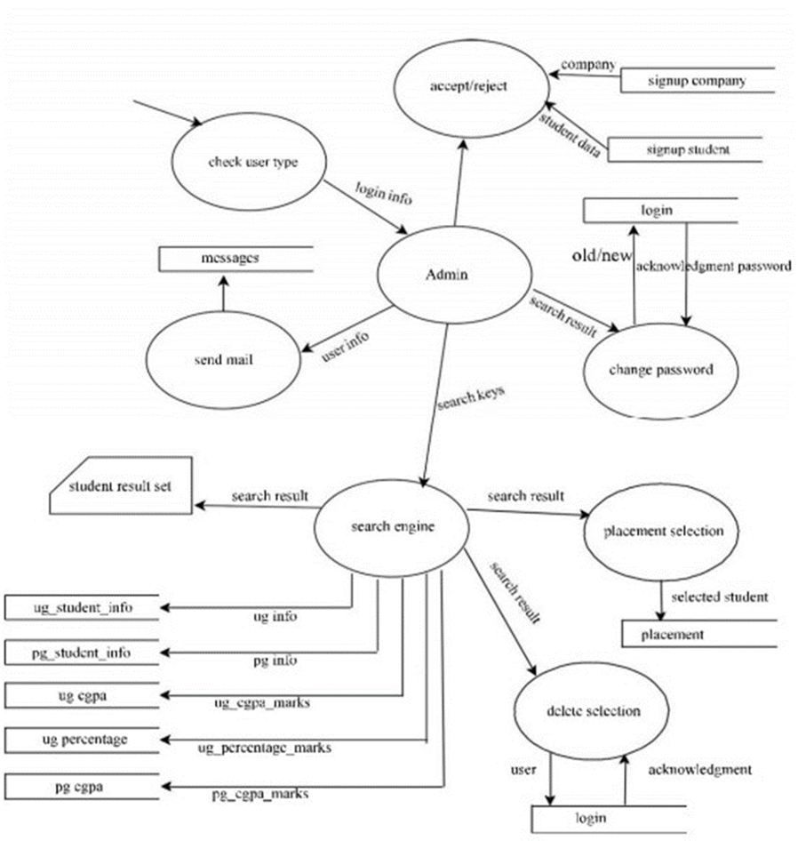

Figure .: Level 1 DFD for Admin

This shows the second level data flow of the admin. Admin is the only person who can give access to companies and the students after their details are verified. Admin has to login in order to perform various operations.

### Level 2 DFD for Student

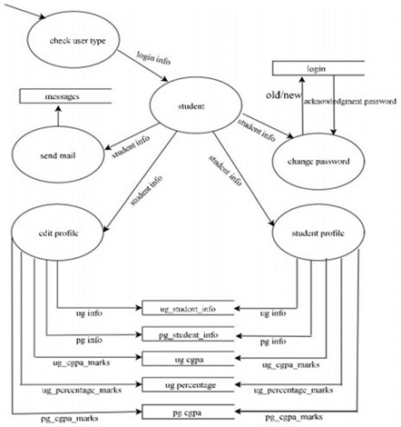

Figure .: Level 2 DFD for student

This diagram describes the second level data flow for students. The diagram shows the functions that student can performs. However, the student require an authentication from the admin in order to perform various task.

### Level 2 DFD for Company

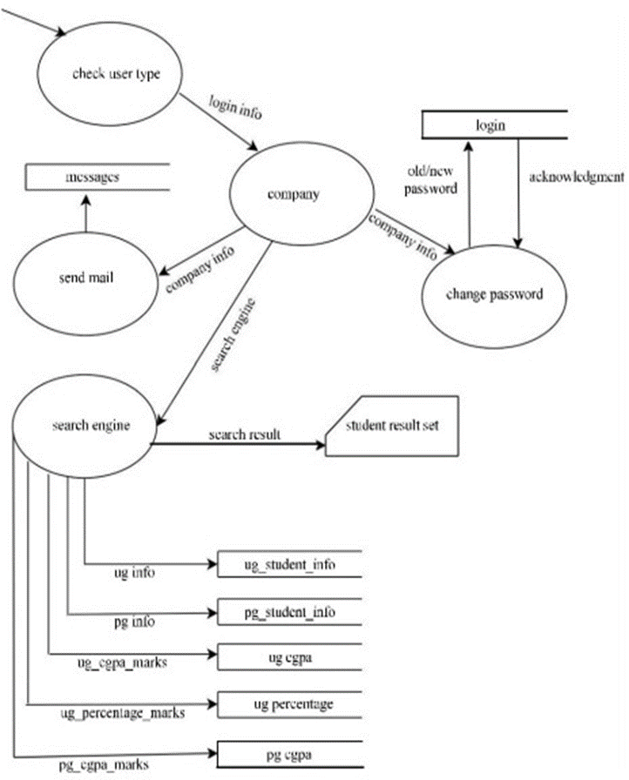

Figure .: Level 2 DFD for company

This diagram shows the second level data flow of the companies. This describes the functions that the companies can perform. However, companies also require an authentication from the admin in order to perform various tasks.

## ER DIAGRAM

The ER diagram explains the relationship between the entities and their attributes. The following ER diagram has several entities like:

* Admin
* Company
* Student
* Student Marks
* Placement
* Notification
* ShortList

Every attribute have their own attributes that further describes it’s properties and behavior The student can login to their page by entering their username and password. However, before that, they have to register and this is verified by the admin. Admin verify whether the details provided are true or not. The same is applicable for companies. The company once registered is verified by the admin only then they can login and access the features of the website. Later on, the student can apply for the available placements that is eligible for. The company have the option to add placements. Then there is filtering process based on marks and backlogs. The students can access the training materials provided by theadmin.

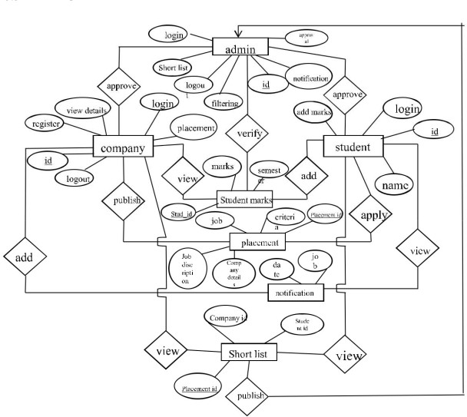

Figure .: Entity-Relationship Diagram

## TABLE DESIGN

### Admin

|  |  |  |  |
| --- | --- | --- | --- |
| Field Name | Datatypes | Description | Remarks |
| id | Int(11) | Id number | Primary key |
| username | Varchar(34) | For admin username |  |
| password | Varchar(34) | For admin password |  |

Table .: Admin

### Do not paste the screenshots. Create tables for all database tables like the above.

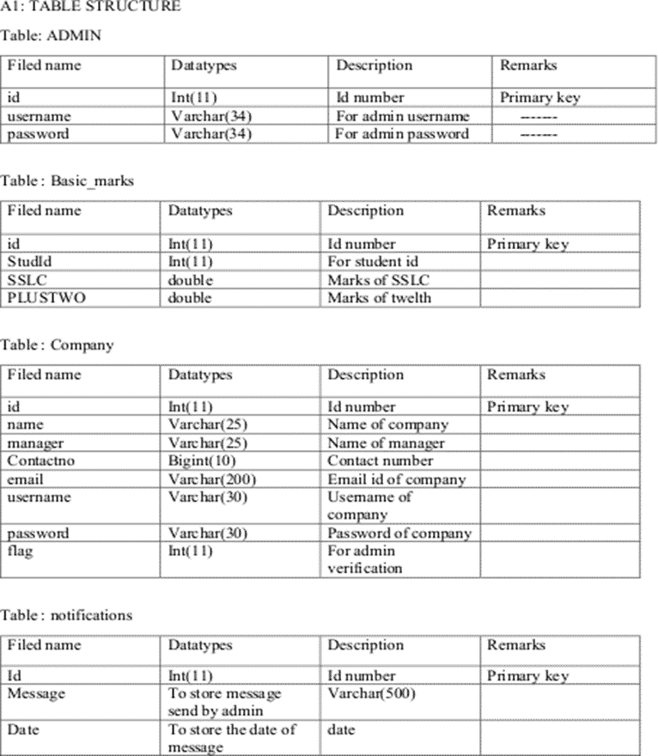

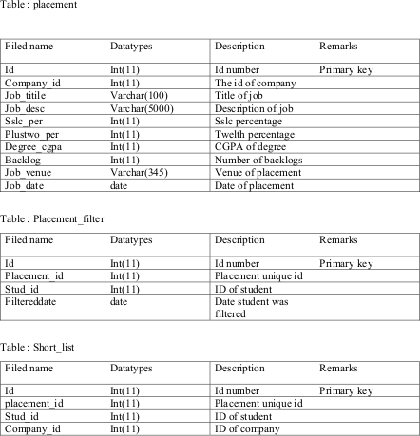

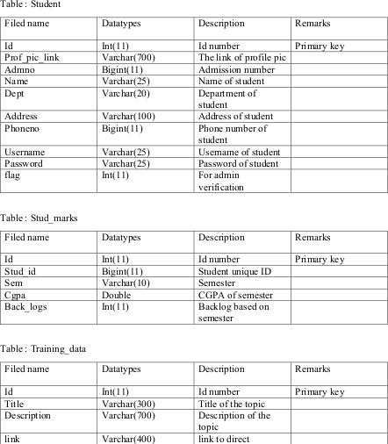

# SYSTEM TESTING

Software Testing is the process used to help identify the correctness, completeness, security, and quality of developed computer software. Testing is a process of technical investigation, performed on behalf of stakeholders, that is intended to reveal quality-related information about the product with respect to the context in which it is intended to operate. This includes, but is not limited to, the process of executing a program or application with the intent of finding errors. Quality is not an absolute; it is value to some person. With that in mind, testing can never completely establish the correctness of arbitrary computer software; testing furnishes a criticism or comparison that compares the state and behavior of the product against a specification. An important point is that software testing should be distinguished from the separate discipline of Software Quality Assurance (SQA), which encompasses all business process areas, not just testing.

There are many approaches to software testing, but effective testing of complex products is essentially a process of investigation, not merely a matter of creating and following routine procedure. One definition of testing is "the process of questioning a product in order to evaluate it", where the "questions" are operations the tester attempts to execute with the product, and the product answers with its behavior in reaction to the probing of the tester[citation needed]. Although most of the intellectual processes of testing are nearly identical to that of review or inspection, the word testing is connoted to mean the dynamic analysis of the product—putting the product through its paces. Some of the common quality attributes include capability, reliability, efficiency, portability, maintainability, compatibility and usability. A good test is sometimes described as one, which reveals an error; however, thinking that is more recent suggests that a good test is one, which reveals information of interest to someone who matters within the project community.

## TESTING METHODS

### Unit Testing

Unit testing is undertaken when a module has been coded and successfully reviewed. This can be done by two methods:

Black box testing: Test cases are designed from an examination of the input/output values only and no knowledge of designing or coding is required.

Equivalence class partitioning: The domain of input values to a program is partitioned into a set of equivalence classes. This partitioning is done in such a way that the behaviour of the program is similar to every boundary value analysis.

In our project particularly, first, we create the login form and then by running the form we conclude and tested that whether it runs properly or not. So such a way we perform the Unit Testing and in this way, we have done the testing to all the forms.

### Integration Testing

During integration testing, different modules of the system are integrated using integration plan. This integration plan specifies the steps and the order in which modules are combined to realize the full system. Its purposes are:

* To test whether the module performs its intended task
* Once all the modules have been integrated and tested, system testing can start.

In this project, the Login module, Candidate and Company registration module Update candidate and Company module, and displaying the companies list were integrated and tested whether the system is running properly or not. Thus with the following way we performed integration testing.

### System Testing

System tests are designed to validate a fully developed system with a view to assuring that it means its requirements. The major types of system testing are as follows :

##### Alpha Testing:

The initial testing of a computer program or system under actual usage conditions, it can be done in-house by the vendor, or outside by a customer or third party user. Acceptance testing performed by the customer in a controlled environment at the developer’s site. The software used by the customer in a setting approximating the target environment with the developer observing and recording errors and user problems.

##### Beta Testing:

Beta testing is done after alpha testing. The main purpose of Beta testing are as follows:

* Testing done by the potential or existing users, customers and end users at the external site without developers involvement is known as beta testing.
* It is operation testing i.e. it tests if the software satisfies the business or operational needs of the customer and end users.
* Beta testing is done for external acceptance testing of the software.

##### Output Testing

After performing the validation testing, the next step is output testing of the proposed system since no system could be useful if it does not produce the required output in specific format. Asking the users about the format required by them tests the outputs generated or displayed by the system under consideration. The output format of the screen is found to be correct as the format was designed in the system design phase according to the user needs. For the hard copy also, output comes out as the specified requirements by the user.Hence output testing does not result in any correction in the system. Various reports are generated in graphical output format and being pictorial representation it is found more convenient to understand by the users of the system.

### Validation Testing

In validation testing, the requirements established as a part of software requirements analysis are validate against the software that has been constructed Validation testing provides final assurance that the software meets all functional, behavioral and performance requirements. After each validation test case has been done, one of the two possible conditions exists:

The function or performance characteristics conform to specifications and are accepted. A deviation from specification is uncovered and a deficiency list is created.

## TEST CASES

### Do not paste the screenshots. Create a table for listing the test cases.

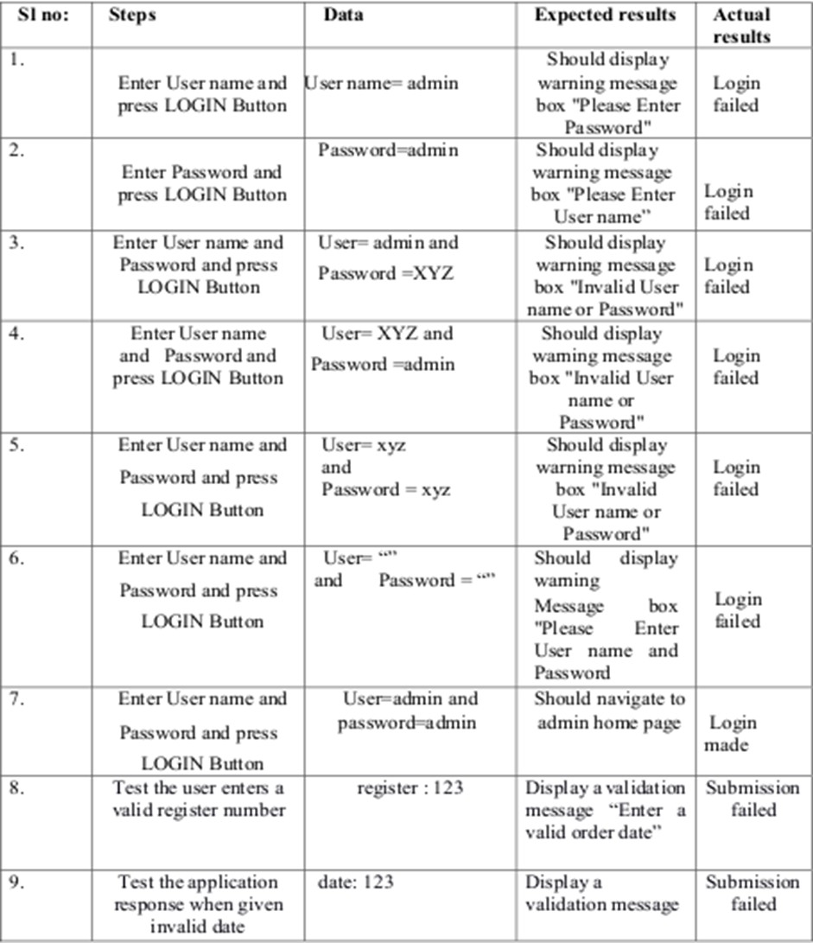

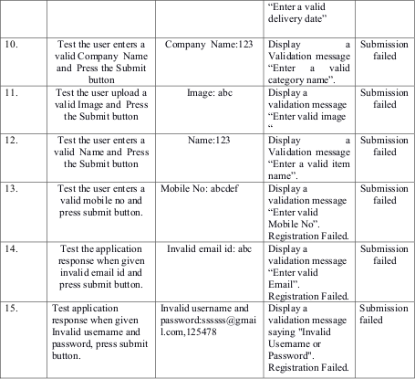

# SYSTEM IMPLEMENTATION

Implementation is the most difficult stage to achieving a successful new system. Implementing is the stage in the project where the theoretical design giving confidence on the new system for the users that it will work effectively. In order to implement a system, planning is very essential, proper planning has been done to take care of the following issues

* Implication of the system environment
* Stand-by facilities
* channels of communication
* Methods of change over resource
* Resources available
* Staff selection and allocation for every task
* Consultations with unions

## IMPLEMENTATION PROCEDURE

Implementation is the stage of the project where the theoretical design is turned into a working system. At this stage, the main work load, the greatest upheaval and the major impact on the existing system shifts to the department. If the implementation is not carefully planned and controlled, it can cause confusion. Implementation includes all those activities that take place to convert from the old system to the new one. Proper implementation is essential to provide a reliable system to meet the organizational requirements. Successful implementation may guarantee improvement in the organization using the new system, but improper installation will prevent it. The process of putting the developed system into the actual use is called system implementation. This includes all those activities that take place to convert from the old system to the new system. The system can be implemented only after through testing is done and if it is found to be working according to the specification of the system. The most crucial stage is achieving a new successful system and giving confidence on the new system for the user that it will work efficiently. It involves careful planning, investigation of the current system and is constraints on implementation, design of methods to achieve the changeover. The more the complex system being implemented is, the more involved will be the system analysis and the design effort required for its implementation.

## TRAINING

For this system, it was explained to the users how to use the system, what details are to be given while creating a new profile, how to use it so that we get the maximum output out of it. The proposed system may be entirely new, replacing an existing one or it may be modifications to the existing system. In either case, proper implementation is necessary to provide a reliable system to meet organizational requirements.

## EVALUATION

Evaluation of the system is performed to identify its strength and weaknesses.

* Operational evaluation: Assessment of the manner in which the system functions including ease of use, response time, overall reliability and level of utilization.
* User management assessment: Evaluation of attitude of senior and user managers within the organization, as well as end users.
* Development performance: Evaluation of the development process as overall development time and effort, conformance to budgets and standards, and other project management criteria. Includes assessment of development methods and tools.

## DOCUMENTATION

After the testing and implementation was completed, the whole system was documented and presented in a readable manner. This was to ensure that when any corrections, manipulations or updating are performed in future; the users would face no problem in performing those changes. Documentations of the source code; the tables that were used to construct the base for the system, the framework which bound the programs.

# SOFTWARE MAINTENANCE

Software maintenance denoted any changes made to a software product after it has been delivered to the customer. Maintenance is inevitable for almost any kind of product. Most products need maintenance due to wear and tear by use. Although software does not wear out like a piece of hardware it “ages” and eventually fails to perform. So maintenance becomes necessity. Types of software maintenance:

## CORRECTIVE MAINTENANCE

Corrective maintenance of a software product is necessary either to rectify the bugs observed while the system is in use.

## ADAPTIVE MAINTENANCE

A software product might need maintenance when the customers need the product to run on new platforms, on new operating systems, or when they need the product to interface with new hardware or software.

## PERFECTIVE MAINTENANCE

A software product needs maintenance to support the new features that users want it to support, to change different functionalities of the system according to customer demands, or to enhance the performance of the system.

## PREVENTIVE MAINTENANCE

Modification of a software product after delivery to detect and correct latent faults in the software product before they become effective faults.

# CONCLUSION

This project is mainly intended for automating a procedure that can help the people who belong to the T&P cell by saving their time, based on this basic operation. Actually their activity is under two steps the first one is, to maintain the list of students and their credit records and the second job is to maintain the company details and based on the company requirements, need to select the students and make the list of students branch wise, which is more complex task, and here informing is through notice boards. Whereas this is also a bit old fashioned task, which can be automated in our proposed system by sending mails to the respective candidates. The proposed system is fully computerized, which removes all the drawbacks of existing system. Proposed system is an online application that can be accessed throughout the organization and outside as well with proper login provided. This system can be used as an application for the TPO of the college to manage the student information about placement. Students logging should be able to upload their information in the form of a CV. Visitors/Company representatives logging in may also access/search any information put up by Students. All the users have some common services like changing password, updating details, searching for details, checking the details, mailing to administrator, and reading the material uploaded by admin if the user is a student. Administrator has to do the services like adding events, achievements and he can reply to the mails sent by users. He can upload materials, search for student details, and he has the right to approve the students. So at last, we conclude that this Project will be useful to several students to search for better jobs and Search for Companies according to their convenience to the profession that they are looking onto.

# FUTURE ENHANCEMENT

* We can give more advance software for training and placement system including more facilities.
* We will host the platform on online server to make it accessible worldwide.
* Modify the project with better approach with more graphics.
* Backup procedure can be incorporated to make sure of the data integrity.
* Placement officers can contact both students and companies through messages. Students and companies can also send messages to placement officers.

# APPENDIX

## SCREENSHOTS



Figure .: Home page

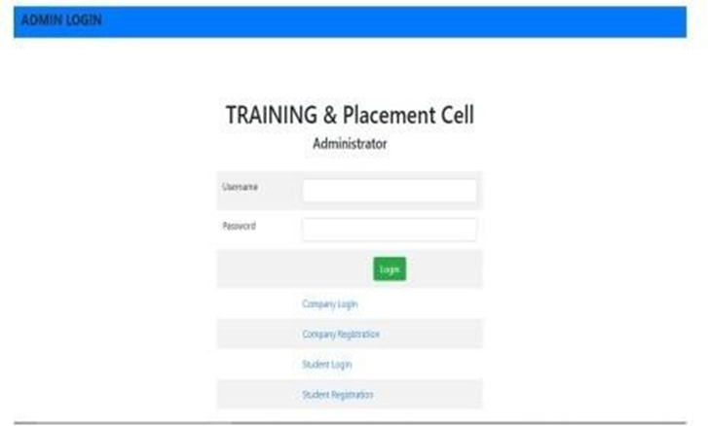

Figure .: Admin login page

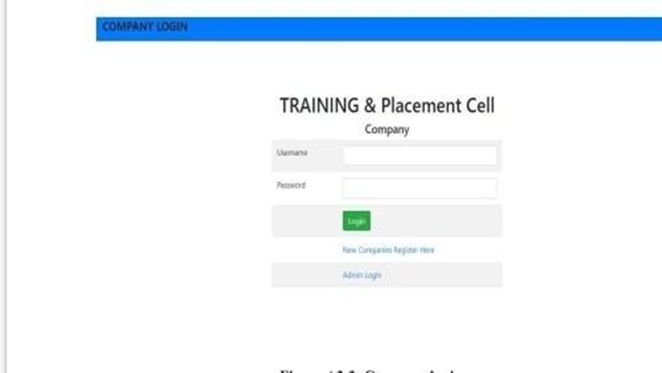

Figure .: Company login page

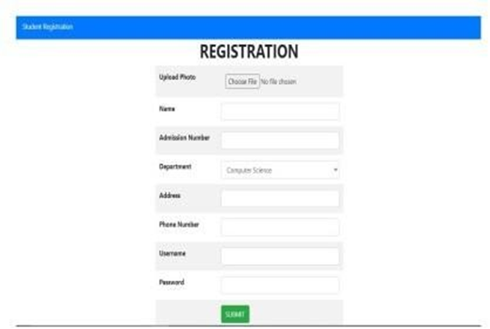

Figure .: Student regiatration page

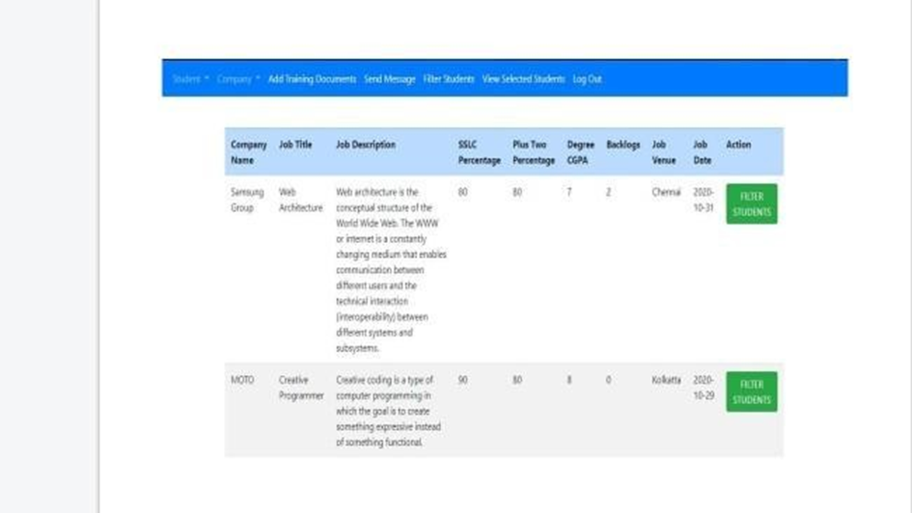

Figure .: Admin filtering page

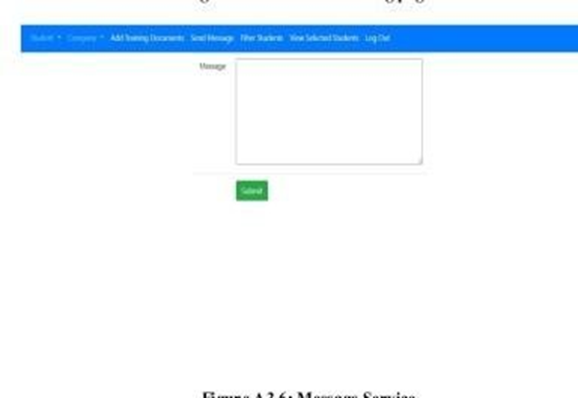

Figure .: Message service

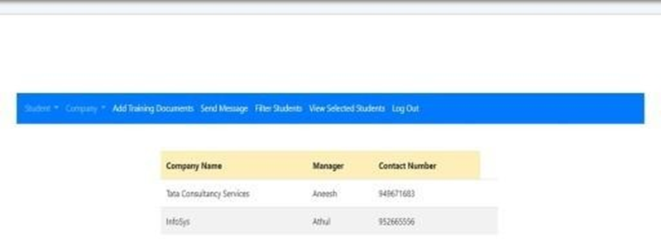

Figure .: Data management

## SAMPLE SOURCECODE

### HOMEPAGE

<!DOCTYPE html>

<html lang="en">

<head>

<meta charset="utf-8">

<meta http-equiv="X-UA-Compatible" content="IE=edge">

<meta name="viewport" content="width=device-width, initial-scale=1">

<meta name="description" content="">

<meta name="author" content="">

<!--favicon-->

<link rel="shortcut icon" href="favicon.ico" type="image/icon">

<link rel="icon" href="favicon.ico" type="image/icon">

<title>SREE AYYAPPA COLLEGE, ERAMALLIKKARA</title>

<!-- Bootstrap Core CSS -->

<link rel="stylesheet" href="css/bootstrap.min.css" type="text/css">

<!-- Footer -->

<link type="text/css" rel="stylesheet" href="css/style.css">

<!-- Custom Fonts -->

<link hre[f='http://fonts.googleapis.com/css?family=Open+Sans:300italic,400italic,600italic,](http://fonts.googleapis.com/css?family=Open%2BSans%3A300italic%2C400italic%2C600italic) 700italic,800italic,400,300,600,700,800'

rel='stylesheet' type='text/css'>

<link hre[f='http://fonts.googleapis.com/css?family=Merriweather:400,300,300italic,400itali](http://fonts.googleapis.com/css?family=Merriweather%3A400%2C300%2C300italic%2C400itali) c,700,700italic,900,900italic'

rel='stylesheet' type='text/css'>

<link rel="stylesheet" href="font-awesome/css/font-awesome.min.css" type="text/css">

<link rel="stylesheet" href="css/animate.min.css" type="text/css">

<!-- Custom CSS -->

<link rel="stylesheet" href="css/creative.css" type="text/css">

<!-- HTML5 Shim and Respond.js IE8 support of HTML5 elements and media queries -->

<!-- WARNING: Respond.js doesn't work if you view the page via file:// -->

<!--[if lt IE 9]>

<script src="https://oss.maxcdn.com/libs/html5shiv/3.7.0/html5shiv.js"></script>

<script src="https://oss.maxcdn.com/libs/respond.js/1.4.2/respond.min.js"></script>

<![endif]-->

</head>

<body id="page-top">

<nav id="mainNav" class="navbarnavbar-default navbar-fixed- top" style="background:black">

<div class="container-fluid">

<!-- Brand and toggle get grouped for better mobile display -->

<div class="navbar-header">

<button type="button" class="navbar-toggle collapsed" data-toggle="collapse" data- target="#bs-example-navbar-collapse-1">

<spanclass="icon-bar"></span>

<spanclass="icon-bar"></span>

<spanclass="icon-bar"></span>

</button>

<a class="navbar-brand page-

scroll" href="https://[www.sreeayyappacollege.ac.in/](http://www.sreeayyappacollege.ac.in/)">SREE AYYAPPA COLLEGE, ERAMALLIKKARA</a>

</div>

<!-- Collect the nav links, forms, and other content for toggling -->

<div class="collapse navbar-collapse" id="bs-example-navbar-collapse-1">

<ul class="navnavbar-navnavbar-right">

<li>

<a class="page-scroll" href="admin.php">Admin Login</a>

</li>

<li>

<a class="page-scroll" href="studlogin.php">Student Login</a>

</li>

<li>

<a class="page-scroll" href="companylogin.php">Company Login</a>

</li>

</ul>

</div>

<!-- /.navbar-collapse -->

</div>

<!-- /.container-fluid -->

</nav>

<header>

<div class="header-content">

<div class="header-content-inner">

<h1>Training & PLACEMENT MANAGEMENT SYSTEM</h1>

<hr>

<p>We are here to Build your Skills and Career with our Driven Passion and Reality

.</br>Click Below to Get Our Current Drive Details</p>

<a href="./drive/products.php" class="btnbtn-primary btn-xl page- scroll">Current Drives</a>

</div>

</div>

</header>

</body>

</html>

### FILTERATION

<?php include './admin_navbar.php';?>

<br>

<br>

<div class="container">

<div class="row">

<div class="col col-12 col-sm-12">

</div>

<div class="col col-12 col-sm-12">

<form action="" method="post">

<table class="table table-striped">

<trclass="table-primary">

<th>CompanyName</th>

<th>Job Title</th>

<th>Job Description</th>

<th>SSLC Percentage</th>

<th>Plus Two Percentage</th>

<th>Degree CGPA</th>

<th>Backlogs</th>

<th>Job Venue</th>

<th>Job Date</th>

<th>Action</th>

</tr>

<?php

$server_name="localhost";

$db_username="root";

$db_password="";

$db_name="training";

$connection=new mysqli($server_name,$db_username,$db_password,$db_name);

$sql="SELECT p.`id`, c.name, `job_title`, `job_desc`, `sslc_per`, `plus two_per`,

`degree_cgpa`, `backlog`, `jobvenue`, `jobdate` FROM `placement` p JOIN company c ON c.id=p.`company_id` WHERE `jobdate`>=now() ";

$res=$connection->query($sql); if($res->num_rows>0){ while($row=$res->fetch_assoc()){

$id=$row["id"];

$Cname=$row["name"];

$job_title=$row["job_title"];

$job_desc=$row["job_desc"];

$sslc_per=$row["sslc_per"];

$plustwo_per=$row["plustwo_per"];

$degree_cgpa=$row["degree_cgpa"];

$backlog=$row["backlog"];

$jobvenue=$row["jobvenue"];

$jobdate=$row["jobdate"]; echo "<tr>

<td> $Cname</td>

<td> $job_title</td>

<td> $job_desc</td>

<td> $sslc_per</td>

<td> $plustwo_per</td>

<td>$degree_cgpa</td>

<td>

<td>

<td>

$backlog </td>

$jobvenue</td>

$jobdate</td>

<td><Button type='submit' name='approvebtn'value='$id' class='btnbtn-success' > FILTER STUDENTS </Button></td>

</tr>";

}

}

else{

echo "<script> alert('No new Student details available') </script>";

}

?>

</table>

</form>

</div>

<div class="col col-12 col-sm-12"></div>

</div>

</div>

</body>

</html>

<?php

if(isset($_POST['approvebtn'])){

$i=0;

$placementId=$_POST['approvebtn'];

$server_name="localhost";

$db_username="root";

$db_password="";

$db_name="training";

$connection=new mysqli($server_name,$db_username,$db_password,$db_name);

$Sql11="DELETE FROM `placement_filter` WHERE `PlacementId`=$placementId";

$res11=$connection->query($Sql11);

$sql="SELECT `sslc_per`, `plus two_per`, `degree_cgpa`, `backlog` FROM `placement` WHERE `id`=$placementId";

$res=$connection->query($sql); if($res->num_rows>0){ while($row=$res->fetch_assoc()){

$sslc_perCriteria=$row['sslc_per'];

$plus_two_perCriteria=$row['plus two_per'];

$degree_cgpaCriteria=$row['degree_cgpa'];

$backlogCriteria=$row['backlog'];

$Studsql="SELECT DISTINCT(`stud_id`) FROM `stud_marks`";

$res1=$connection->query($Studsql); if($res1->num_rows>0){ while($row=$res1->fetch_assoc()){

$stud_id=$row['stud_id'];

$Sql3="SELECT avg(`cgpa`)cgpa,sum(`back_logs`)back_logs FROM `stud_marks` WHERE

`stud_id`=$stud_id";

$res3=$connection->query($Sql3); if($res3->num_rows>0){

while($row=$res3->fetch_assoc()){

$studcgpa=$row['cgpa'];

$studbacklog=$row['back_logs'];

if($studcgpa>=$degree_cgpaCriteria&& $studbacklog<=$backlogCriteria)

{

$Sql4="SELECT `Id`, `StudId`, `SSLC`, `PlusTwo` FROM `basic_Marks` WHERE

`StudId`=$stud_id";

$res4=$connection->query($Sql4); if($res4->num_rows>0){ while($row=$res4->fetch_assoc()){

$SSLC=$row['SSLC'];

$PlusTwo=$row['PlusTwo'];

if($SSLC>=$sslc_perCriteria&& $PlusTwo>=$plus_two_perCriteria)

{

$i++;

$Sql5="INSERT INTO `placement_filter`(`PlacementId`, `StudId`, `FilteredDate`) VALUES( $placementId,$stud_id,now())";

$res5=$connection->query($Sql5);

}

}

}

}

}

}

}

}

}

// echo "<script> alert('Updated Succesfully') </script>";

// echo "<script>window.location.href='student_approval.php' </script>";

}

else{

echo "Error in Updation";

}

echo "<script>alert(' $i students are filtered for this placement drive') </script>";

}

?>

## GANTT CHART

The Gantt chart was developed by Henry Gantt. Those are used in software project management and enhanced version of standard Gantt chart. These are mainly allocating resources to activities. It is a special type of bar chart. Each bar represents an activity. Bars are drawn alone a time line. Length of each bar is proportional to duration of time planned for corresponding activity.

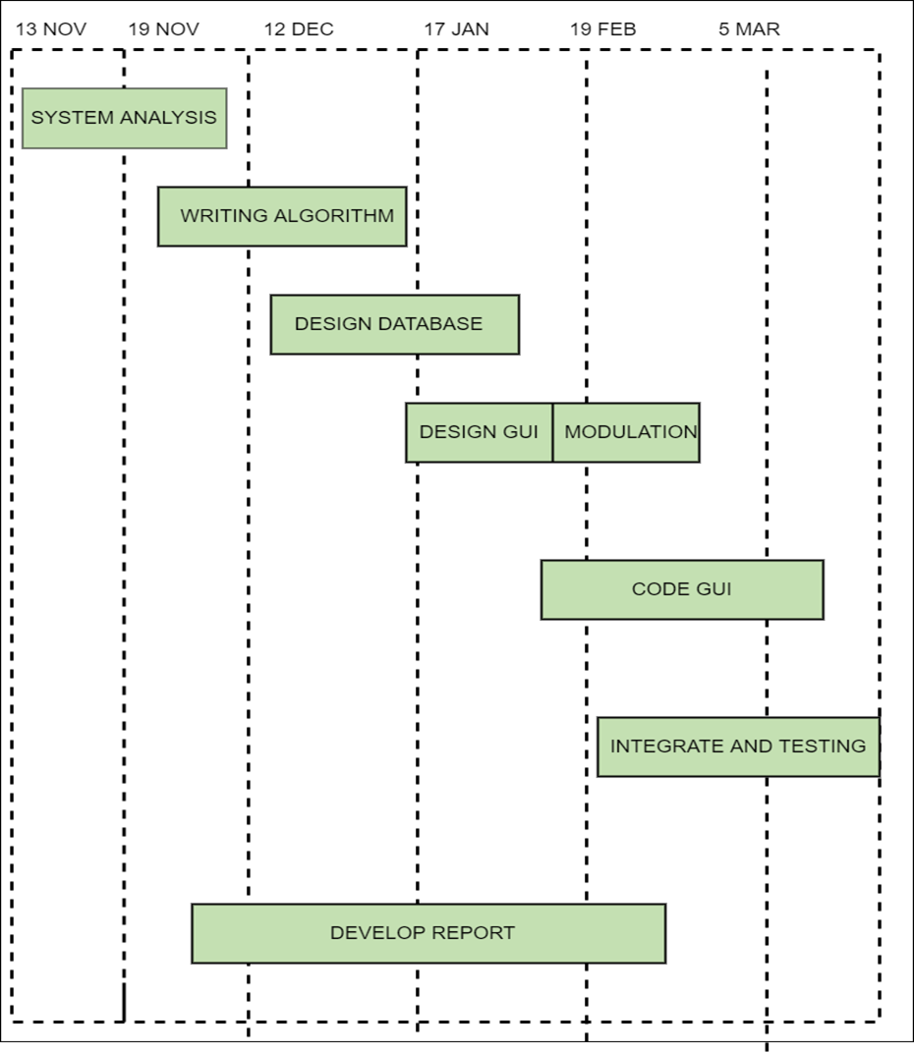

Figure .: Gantt chart

# REFERENCES

**Textbook:**

1. PHP and MySQL Bible - Tim Converse, Joy Spark
2. Software Engineering - Rajib Mall
3. Beginning Android - Mark L.Murphy
4. Most core and additional references available in the library.

**Websites**

1. [http://phpgurukul.com](http://phpgurukul.com/)
2. [http://developer.android.com](http://developer.android.com/)
3. <http://javatpoint.com/android>
4. http://studytonight.com/android
5. [http://tutorialspoint.com](http://tutorialspoint.com/)
6. [http://www.w3schools.com](http://www.w3schools.com/)
7. [http://www.academia.edu](http://www.academia.edu/)
8. [http://wikipedia.com](http://wikipedia.com/)