**CHAPTER 1**

**INRODUCTION**

Speech and textual information play a crucial role in communicating between humans. An article in “The New York Times” published that now-a-days the adults are spending more than 8 hours a day on screens of computers or mobiles. So the major communication between humans is conducted through web applications such as WhatsApp, Facebook, and Twitter etc. as a form of speech and textual conversation. In the present system, I have focused on designing a study application for students for communication to tutor through application namely Chabot in the educational domain. The proposed Chabot assists in answering questions provided by the students. To develop the system, I have employed an ensemble prediction method as linear regression in the presence of extracted features from our prepared dataset. In our current society most of us choose internet as the best teacher. They can find any information from internet easily even though some of them still demand a tutor or person to solve this doubts and query. It has also been the rise of online training centers and organization. Such like organization and sites are widely available today but in this system these have few limitations for serving the user’s doubts with a assistance for such organization few persons have to wait for all the time. It is not feasible because those users came different time and also request manual efforts. As a remedy we will proved a virtual trainer who isn`t an actual trainer it a program that can reply the queries with the help of given set of data. For collecting those data this program under goes training under the real trainers so they don’t want to seat all the time in front of those computer. It will help to reduce the manual effort. Virtual tutor is program that is working under machine learning technique.

**CHAPTER 2**

**SYSTEM SPECIFICTAION**

**2.1 HARDWARE SPECIFICATION**

Processor : Intel i3 or aboveProcessor

Speed : 2.3GHZorabove

Ram : 4GBorHigher

HardDisk : 1TBorhigher

Keyboard : Standard

Mouse : OpticalMouse

Printer : LaserPrinter

**2.2SOFTWARE SPECIFICATION**

OS Platform : Windows7

WebBrowser : Mozilla/Chrome

Front-End Tool : PYTHON

Back-EndTool : MYSQLServer

**2.2DEVELOPING TOOLS**

## PYTHON

Python is an interpreter, object-oriented, high-level programming language with dynamic semantics. Its high-level built in data structures, combined with dynamic typing and dynamic binding; make it very attractive for Rapid Application Development, as well as for use as a scripting or glue language to connect existing components together. Python's simple, easy to learn syntax emphasizes readability and therefore reduces the cost of program maintenance. Python is dynamically typed and garbage-collected. It supports multiple programming Paradiagrams, including structured (particularly, procedural), object-oriented, and functional programming. Python is often described as a "batteries included" language due to its comprehensive standard library. Python is meant to be an easily readable language. Its formatting is visually uncluttered, and it often uses English keywords where other languages use punctuation. Unlike many other languages, it does not use curly brackets to delimit blocks, and semicolons after statements are optional. It has fewer syntactic exceptions and special cases than C or Pascal. SQL Server SQL Server Management Studio (SSMS) is an integrated environment for managing any SQL infrastructure. Use SSMS to access, configure, manage, administer, and develop all components of SQL Server, Azure SQL Database, and Azure Synapse Analytics. SSMS provides a single comprehensive utility that combines a broad group of graphical tools with a number of rich script editors to provide access to SQL Server for developers and database administrators of all skill levels. SQL Server Management Studio (SSMS) is a software application first launched with Microsoft SQL Server 2005 that is used for configuring, managing, and administering all components within Microsoft SQL Server. It's the successor to the Enterprise Manager in SQL 2000 or before. The tool includes both script editors and graphical tools which work with objects and features of the server. A central feature of SSMS is the Object Explorer, which allows the user to browse, select, and act upon any of the objects within the server. It also shipped a separate Express edition that could be freely downloaded; however recent versions of SSMS are fully capable of connecting to and manage any SQL Server Express instance. Microsoft also incorporated backwards compatibility for older versions of SQL Server thus allowing a newer version of SSMS to connect to older versions of SQL Server instances. It also comes with Microsoft SQL Server Express 2012, or users can download it separately. Starting from version 11, the application was based on the Visual Studio 2010 shell, using WPF for the user interface. Versions 18 and after are based on the Visual Studio 2017 Isolated Shell.

## HTML

It is a language used for the specification of structural markup. HTML give theweb authors the means to publish online documents with headings, texts, tables, lists,photos etc. HTML is used in our program to create forms in the server side for entering, updating and viewing the server applications in a user friendly environment.

**CHAPTER 3**

**PROBLEM DESCRIPTION**

**3.1 PROBLEM STATEMENT**

The current challenges faced by traditional colleges and universities follow this manual system. But several problems including higher tuition, budget cuts, and course shortages cause many students to search for alternatives. Convenience: Unlike our street market, online shopping site never close, they are available 24 hours a day, 7 days a week, and they are only a mouse click away.

The main objectives of the virtual Tutor are as follows: The students can resolve the doubts about a particular subject by contacting with the tutors

• Instant replies

• Easy interaction

• All time available

**3.2 PROBLEM SOLUTION**

The objective of the project is that it would be beneficial to the students in preparing study materials and conducting exams. They can resolve the doubts about a particular subject by contacting with the tutors.

The main purpose of the project “Virtual tutor” is to make available tutors for the students to resolve the doubts about a particular subject by using the system without wait for all the time. The Virtual Tutor system provides instant replies and easy interaction.

**3.3 MODULE DESCRIPTION**

The system consists of following modules:

1. Administrator Module
2. Tutor Module
3. Student Module
4. **Admin**: Admin is the main user of the system .Admin manages all the approval of the tutor and the students and also has the login system with the user name and password and manages the complaints
5. **Tutor**: Tutor is the module of the virtual tutor .The tutor uploads the videos, notes regarding their particular subject and they train the bot. And they also have the privacy management
6. **Student**: Student is the end user of the system. They can see all their notes and videos regarding their subjects’ .Student can complaint regarding their subjects and they can chat with the bot to clear the doubts and queries .And it also has the privacy system that is login that access through password and username

**3.4 SYSTEM ARCHITECTURE**

**CHAPTER 4**

**SYSTEM ANALYSIS**

System Analysis is the process of gathering and interpreting facts, diagnosing the problems and using the information to recommended improvements on the system. System analysis is a problem solving activity that requires intensive communication between system user and system developer. In system analysis the system is studied to the fundamental detail and analyzed. The system analyst plays the role of an interrogator and dills deep into the working of the present system. The system is viewed as a whole and the inputs to the system are identified. The outputs from the organization are traced through various phases of the processing of inputs. A detailed study of these processes must be made by the various techniques like interviews, questionnaires etc. The data collected by these sources must be scrutinized to arrive to a conclusion. The conclusion is an understanding of how the system functions. The system is called existing system. The existing system is subjected to close study and the problem areas are identified. The designer knows functions as a problem solver and tries to sort out the difficulties. The solutions are given as proposals, which is the proposed system. The proposal is then compared to the existing system. The proposal is presented to the user for an endorsement. The proposal is viewed on user request and suitable changes are made. This loop then ends as soon as the user is satisfied with the proposal.

**4.1 EXISTING SYSTEM**

Now days the Companies need to spent more money and human resource to promote marketing of their products or items. Referrals have to invest their money first and sometimes the referred persons may not wish to buy the product. Companies get their income from newcomers; hence there are no actual sales. The strategy can produce tentative results. There are no rights set for the different users accessing each document. There is no option in the existing system to provide security for the data being transferred from one user to another.

**4.2 DISADVANTAGES OF EXISTING SYSTEM**

* Schedule stiffness: There’s no flexibility to create a personal calendar in order to combine studies and personal or work life.
* Higher costs not only of money but also of time: as previously mentioned, commuting demands an economic expense. And if the classroom is far, time is also a factor to take into account. You have to decide whether the trip is worth it or not.
* Loss of individualization in a large group of students: it is hard for a teacher to have a customized study plan fit to the needs of each individual in the group.
* Less and more expensive didactic material available: traditional education is more limited when it comes to educational formats. Sometimes pictures, videos or forums are not accessible 24/7. This feature might limit the learning and hinder a good study plan.

**4.3 PROPOSED SYSTEM**

This proposed system “Virtual Tutor” is an efficient way to solve the student’ doubt and query. During snowstorms and thunderstorms, colleges may cancel classes to avoid putting commuting students at risk of dangerous driving conditions. Rather than miss important class sessions, students in online courses can always "attend" by participating in discussion boards or chat sessions, turning in their work on time, and watching lectures or reading materials. Many students also find substantial savings on fuel costs with no commute for classes.

**4.4 ADVANTAGES OF PROPOSED SYSTEM**

* More comfortable learning environment
* Easy to operate
* Lower cost
* Convenience and flexibility
* More interaction and greater ability to concentrate

**4.5 FEASIBILITY STUDY**

Feasibility is an important phase in the software development process it enables the developers to have an assessment of the product being developed it refers to the feasibility study of the product in terms of outcomes of the product, operational required for implementing it.

* + - The system can be implemented within the given cost and schedule constrains
    - The system contribute to the overall objectives

## Steps in Feasibility Analysis

Feasibility Analysis involves eight steps:

* Form a project team and appoint a project leader.
* Prepare a system flow chart.
* Enumerate potential candidate systems.
* Describe and identify characteristics of candidate systems.
* Describe and evaluate performance and cost effectiveness of each candidate systems.
* Weight system performance and cost data.
* Select the best candidate system.
* Prepare and report final project directive and management.

## The proposed system is tested in all aspects of feasibility.

* Technical Feasibility study
* Operational Feasibility study
* Economic Feasibility study
* Legal Feasibility study

## TECHNICAL FEASIBILITY

This is related to the technicality of the project. This evaluation determines whether the technology needed for the proposed system is available or not. It deals with hardware as well as software requirements. That is, type of hardware, software and the methods required for running the systems are analyzed. This involves financial consideration to accommodate technical enhancement. If the budget is a serious constraint, then the project is judged not feasible.

## ECONOMIC FEASIBILITY

Economical analysis is most frequently used method for evaluating the effectiveness of a candidate system. If benefits outweigh costs, then the decision is made to design and implement the system. Otherwise further justifications or alternatives in the proposed system will have to be made if it is to have a chance of being approved. Economic analysis is the most frequently used method for evaluating the effectiveness of the proposed system. Considering the benefits and savings that are expected from the proposed system, the administrators decided to design and implement a new system.

## OPERATIONAL FEASIBILITY

Proposed systems are beneficial only if they can be turned into information systems. That is it will meet the organizations operating requirements and also checks that whether the system will work when it is developed and installed.

## LEGAL FESIBILITY

Legal feasibility is the study to know if the proposed project conform the legal and ethical requirements.

It is important that the project is following the requirements needed to start a project including business licenses, certificates, copyrights, business insurance, tax number, health and safety measures, and many more.

.

**CHAPTER 5**

**SYSTEM DESIGN**

System design provides an understanding of the procedural details, necessary for implementing the system recommended in the feasibility study. Basically it is all about the creation of a new system. This is critical phase since it decides the quality of the system. It has a major impact on the testing and implementation phases. System Design develops the architectural details required to build system or product. The system design process encompasses the following activities:

* Partition the analysis model into subsystems.
* Identify concurrency that is dictated by the problem.
* Develop design for the user interface.
* Choose a basic strategy or implementing data management.
* Identify global resources and the control mechanisms required to access them.
* Design an appropriate control mechanism for the system, including task management. Consider how boundary

System design provides an understanding of the procedural details, necessary for implementing the system recommended in feasibility study. Basically it is all about the creation of a new system. This is critical phase since it decides the quality of the system and has a major impact on the testing and implementation phases. System design is the most creative and challenging phases of the system life cycle. The term design describes the final system and the process by which it is to be developed. During the system design phase the designers must design how to produce an efficient and effective system.

There are two levels of system design:

* Logical design
* Physical design

**Logical Design:**

The logical flow of a system and define the boundaries of a system. It includes the following steps:

* Reviews the current physical system – its data flows, file content, volumes, frequencies etc.
* Prepares output specifications – that is, determines the format, content and frequency of reports.
* Prepares input specifications – format, content and most of the input functions.
* Prepares edit, security and control specifications.
* Specifies the implementation plan.
* Prepares a logical design walk through of the information flow, output, input, Controls and implementation plan.
* Reviews benefits, costs, target dates and system constraints.

**Physical Design:**

Physical system produces the working systems by define the design specifications that tell the programmers exactly what the candidate system must do. It includes the following steps.

Design the physical system.

* Specify input and output media.
* Design the database and specify backup procedures.
* Design physical information flow through the system and a physical design
* Plan system implementation.
* Prepare a conversion schedule and target date.
* Determine training procedures, courses and timetable.
* Devise a test and implementation plan and specify any new hardware/software.
* Update benefits , costs , conversion date and system constraints

The delivered product of logical design includes current requirements of the following system components:

* Input design
* Output design
* Database design

**INPUT DESIGN**

The input design is the link between the information system and the user. It comprises the developing specification and procedures for data preparation and those steps are necessary to put transaction data in to a usable form for processing can be achieved by inspecting the computer to read data from a written or printed document or it can occur by having people keying the data directly into the system. The design of input focuses on controlling the amount of input required, controlling the errors, avoiding delay, avoiding extra steps and keeping the process simple. The input is designed in such a way so that it provides security and ease of use with retaining the privacy. Input Design considered the following things:

* What data should be given as input?
* How the data should be arranged or coded?
* The dialog to guide the operating personnel in providing input.

Input design is the process of converting a user- oriented description of them input into a computer based system. This design is important to avoid errors in the data input process show the correct direction to the management for getting correct information from the computerized system. It is achieved by creating user friendly screens for the data entry to handle large volume of data. The goal of designing input is to make data entry easier and to be free from errors. The data entry screen is designed in such a way that all the data manipulates can be performed. It also provides records viewing facilities.

When the data is entered it will check for its validity. Data can be entered with the help of screens. Appropriate management are provided as when needed so that uses will not be in maize of instant. Thus the objective of input design is to create an input layout that is easy to follow.

* Add: For adding all the specified details.
* Search: For searching the specified details.
* Edit: For editing the specified details.
* Delete: For deleting the specified details

**Input Objectives**

Controlling Amount of Input: Wherever user input is required, giving possible input values as default in that area reduces the amount of user keystrokes. Thus the user can pass on to next data without much typing. This makes the data entry much fast and error free. When the user has the format of input to be given, it will be very easy for the user to give input in the same format.

**Avoiding Delay**: A processing delay resulting from data entry operations is called a bottleneck. Such bottlenecks are made obsolete in this project by breaking up the amount of data to be entered in each form into different smaller and simpler forms.

**Avoiding Errors in Data:** The rate at which errors occur depends on the quantity of the data. As told in the above objective these errors are reduced by making the number of data to be entered in each form is reduced.

**Avoiding Extra Steps:** To fulfill any operation the user have no need to do complex steps, instead any operation can be done with simple easy to use steps.

**OUTPUT DESIGN**

Output design is one of the most important features of the information system. When the output is not of good quality, the users will be averse to use the newly designed system and may not use the system. There are many types of outputs, all of which can be either highly useful or can be critical to the users, depending on the manner and degree to which they are used.

Outputs from computer system are required primarily to communicate the results of processing to users. They are also used to provide a permanent hard copy of the results for later consultation.

**Output Objectives**

The output from an information system should accomplish one or more of the following objectives:

* Convey information about past activities, current status, or projections of the future.
* Signal important events, opportunities, problems or warnings
* Trigger an action
* Confirm an action

**5.1 USE CASE DIAGRAM**

**Use Case Diagram for Admin**

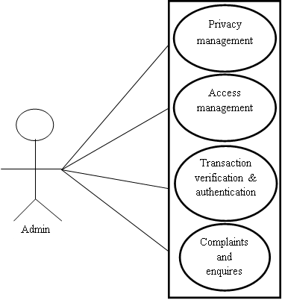

***Use Case Diagram for Admin***

**Use Case Diagram for Student**

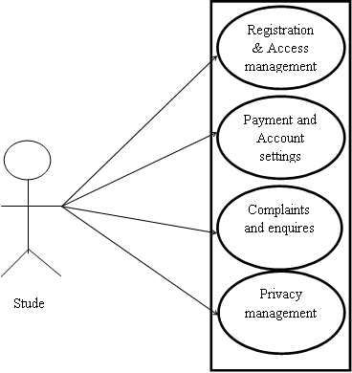

***Use Case Diagram for student***

**Use Case Diagram for Tutor**

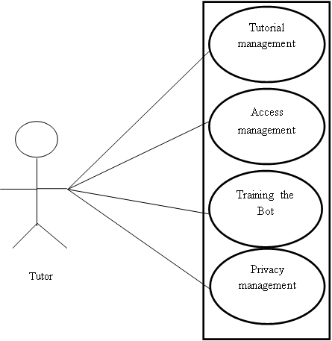

***Use Case Diagram for Tutor***

**5.2 FORM DESIGN**

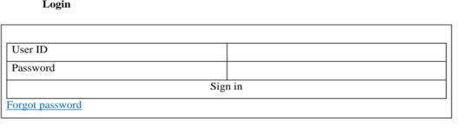

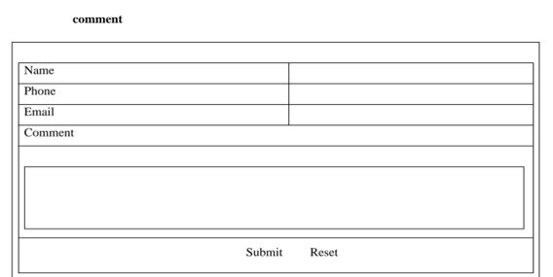

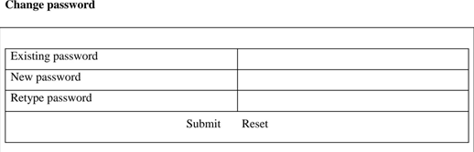

**5.3 TABLE DESIGN**

### TABLE 1:- topic

|  |  |  |  |
| --- | --- | --- | --- |
| **Field name** | **Data type** | **Constraints** | **Description** |
| topic_id | int (10) | Primary key | Topic id |
| topic_name | Varchar(20) | Not Null | Topic name |
| topic_details | Varchar(20) | Not Null | Topic details |
| topic_cover | Varchar(20) | Not Null | Topic cover |
| topic_package | Varchar(20) | Not Null | Topic package |
| tutor_id | int (10) | ForeignKey | Tutor id |

**TABLE 2:- login**

|  |  |  |  |
| --- | --- | --- | --- |
| **Field name** | **Data type** | **Constraints** | **Description** |
| log_id | int (10) | Primary key | Log_id |
| username | Varchar(20) | Not Null | Username |
| password | Varchar(20) | Not Null | Password |
| role | Varchar(20) | Not Null | Role |

### TABLE 3:- user

|  |  |  |  |
| --- | --- | --- | --- |
| **Field name** | **Data type** | **Constraints** | **Description** |
| user_id | int (10) | Primary key | User id |
| user_fname | Varchar(20) | Not Null | User first name |
| user_lname | Varchar(20) | Not Null | User last name |
| user_paddress | Varchar(50) | Not Null | User permanent address |
| user_caddress | Varchar(50) | Not Null | User communicative address |
| user_email | varchar (25) | Foreign Key | User email id |
| user_phone | int(10) | Not Null | Phone no |
| user_status | Varchar(20) | Not Null | Status |
| user_logid | Int(10) | Foreign Key | User login id |

**TABLE 4:- Complaint**

|  |  |  |  |
| --- | --- | --- | --- |
| **Field name** | **Data type** | **Constraints** | **Description** |
| comp_id | int (10) | Primary key | Compliant id |
| comp_subject | Varchar(20) | Not Null | Complaint subject |
| comp_msg | Varchar(20) | Not Null | Complaint message |
| comp_date | date | Not Null | Complaint date |
| comp_replay | Varchar(30) | Not Null | Reply |
| comp_user | Varchar(20) | Foreign Key | User |

### TABLE 5:- Hitlist

|  |  |  |  |
| --- | --- | --- | --- |
| **Field name** | **Data type** | **Constraints** | **Description** |
| hit_id | int (10) | Primary key | Hit id |
| hit_name | Varchar(20) | Not Null | Hit name |
| hit_descr | Varchar(20) | Not Null | Hit description |
| tutorial | Varchar(20) | Foreign Key | Tutorial |

**TABLE 6:- tutorial**

|  |  |  |  |
| --- | --- | --- | --- |
| **Field name** | **Data type** | **Constraints** | **Description** |
| tutorial_id | int (10) | Primary key | Tutorial id |
| tutorial_title | Varchar(20) | Not Null | Tutorial title |
| tutorial_description | Varchar(20) | Not Null | Tutorial description |
| tutorial_cover | Varchar(50) | Not Null | Tutorial cover |
| tutorial_video | File | Not Null | Tutorial video |
| topic_id | int (10) | Not Null | Topic id |

### TABLE 7:- purchase

|  |  |  |  |
| --- | --- | --- | --- |
| **Field name** | **Data type** | **Constraints** | **Description** |
| purchase_id | int (10) | Primary key | Purchase id |
| user_id | int (10) | Foreign Key | User id |
| topic_id | int (10) | Foreign Key | Topic id |
| purchase_amt | varchar(10) | Not Null | Purchase amount |
| purchase_date | date | Not Null | Purchase date |
| purchase_status | Varchar(30) | Not Null | Purchase status |

**5.4 DATA FLOW DIAGRAM**

A data flow diagram (DFD) is a graphical representation of the "flow" of data through an information system, modeling its process aspects. A DFD is often used as a preliminary step to create an overview of the system, which can later be elaborated. DFDs can also be used for the visualization of data processing (structured design). A DFD shows what kind of information will be input to and output from the system, where the data will come from and go to, and where the data will be stored. It does not show information about the timing of processes, or information about whether processes will operate in sequence or in parallel (which is shown on a flowchart).

# DFD Components

DFD consists of processes, flows, warehouses, and terminators. There are several ways to view these DFD components.

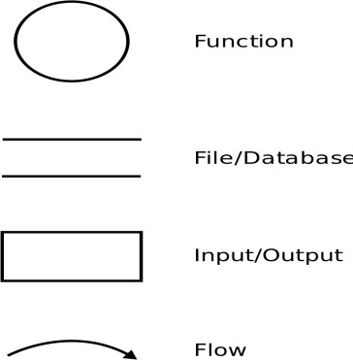

**Level 0 Context Level**

## Contextleveldiagram

**Level1**

## Admin

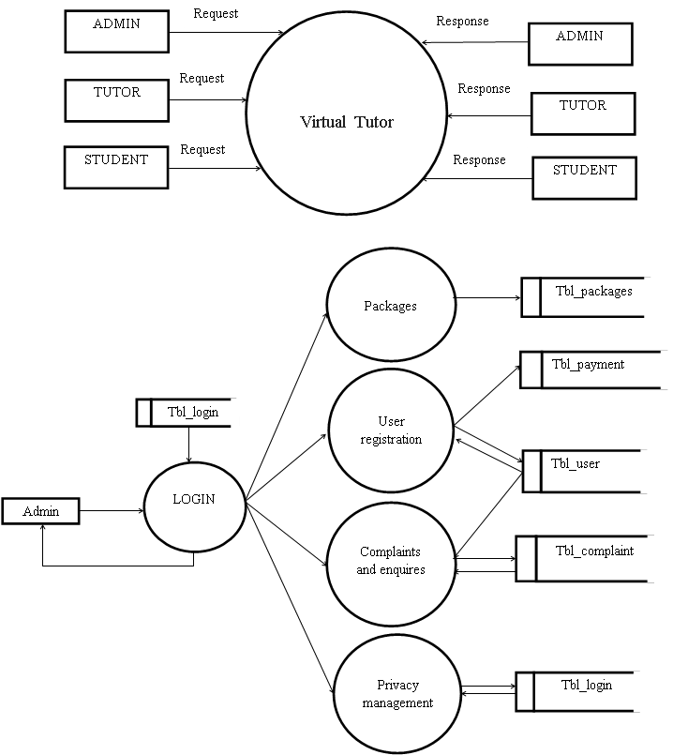

**DataflowdiagramforAdmin**

## Tutor

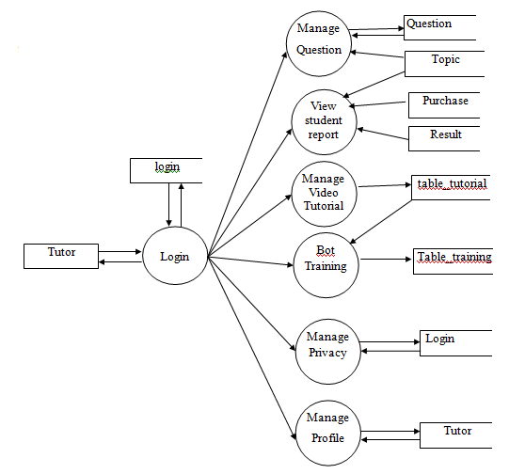

**Data flow diagram for Tutor**

**Student**

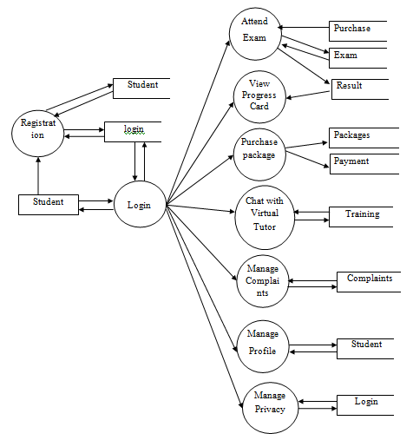

**DataflowdiagramforOwner**

**5.5 STRUCTURE CHART**

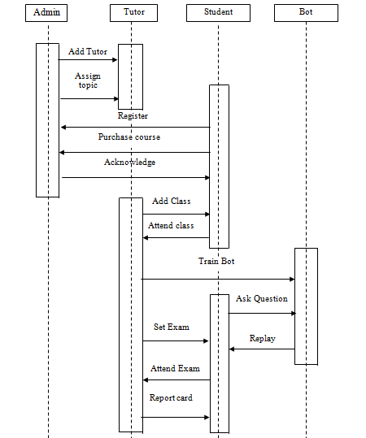

**5.6 MENU TREE**

**Virtual Tutor**

Privacy management

Attend Exam

View progress card

Purchase package

Chat with virtual tutor

**Admin**

Manage package

Verify user

Manage Complaints

payment

Manageenquiry

**Tutor**

Manage question

View student report

Manage video tutorial

Bot training

Privacy management

**Student**

Privacy management

**5.7 ER DIAGRAM**

## *An entity-relationship(ER) diagram is specialized graphic that illustrates the interrelationship between entities in a database. Boxes are commonly used to represent entity. Diamonds are normally used to represent relationships and ovals are used to represent attributes. An entity is piece of data is shared between entities.*

## *Entity*

## *Entities are represented by means of rectangles. Rectangles are named with the entity set they represent.*

## *Attributes*

## *Attributes are the properties of entities. Attributes are represented by means of ellipses. Every ellipse represents one attribute and is directly connected to its entity (rectangle). If the attributes are composite, they are further divided in a tree like structure. Every node is then connected to its attribute. That is, composite attributes are represented by ellipses that are connected with an ellipse.*

## *Relationship*

## *Relationships are represented by diamond-shaped box. Name of the relationship is written inside the diamond-box. All the entities participating in a relationship are connected to it by a line. A relationship where two entities are participating is called a binary relationship. Cardinality is the number of instance of an entity from a relation that can be associated with the relation.*

* + **One-to-one** − when only one instance of an entity is associated with the relationship, it is marked as '1:1'.
  + **One-to-many** − When more than one instance of an entity is associated with a relationship, it is marked as '1:N'.
  + **Many-to-one** − when more than one instance of entity is associated with the relationship, it is marked as 'N:1'.
  + **Many-to-many** −more than one instance of an entity on the left and more than one instance of an entity on the right can be add.

**The symbols used ER Diagram is**

Entity

Attributes

Relationships

Lines

**ER Diagram**

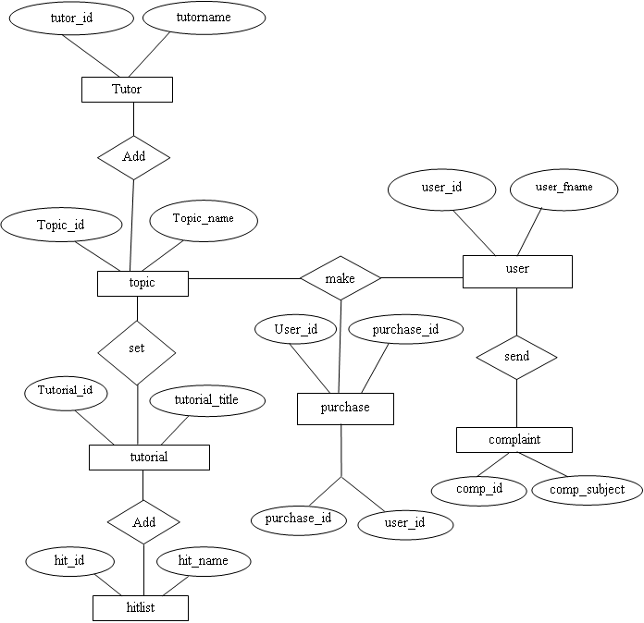

**CHAPTER 6**

**SYSTEM TESTING**

Software testing is defined as the process by which one detects in the software. Any software development team has to perform several software processes. Software testing is one of these processes and it is considered as the final opportunity for us to detect and convert any defect that may be in the software. Testing is a process of testing a program with the explicit intention of finding the errors that are making the program fail. In short, system testing and quality assures a review of the software products and related documentation for completion, correctness, reliability and maintainability.

Once code has been generated, program testing begins. The testing process focuses on logical internals of the software, ensuring that all statement have been tested and on the functional externals that is conducting test to uncover errors and ensure that defined input will produce actual result that agree with required results.

The objective of a system testing is to ensure that all individual programs are working as expected. The initial phase of system testing is the responsibility of the analyst who determines what conditions are to be tested, generates test data, produces a schedule of expected results, runs the tests and compares the computer produced results with the expected results. The analyst may also be involved in its procedures testing. When the analyst is satisfied with the system’s proper working, he hands it over to the users for testing. The importance of system testing by the user must be stressed. Ultimately it is the user who must verify and give the approval.

**6.1 LEVELS OF TESTING**Systems are not designed as entire systems nor are they tested as single systems. So, performing of both Unit and System testing is essential.

**Unit Testing**

In this testing we test each module individually and integrate the overall system. Unit testing focuses verification efforts on smaller unit of software design in the module. This is also known as module testing. The module of the system is tested separately. The testing is carried out during programming stage itself. In these testing steps each module is found to work satisfactory as regarding to the expected output from the module. In this project, after coding each module have been individually tested to determine whether they are coded correctly so that they satisfy the requirements in the specifications and execute effectively as individual units was tested and run individually.

**Integration Testing**

Integration testing is a systematic testing for conducting tests to uncover errors associated within the interface. The objective is to take unit tested modules and build a program structure. Here, correction is difficult because the vast expenses of the entire program complicate the isolation of causes.

Data can be lost across an interface; one module can have an adverse effect on the other sub functions when combined by May not produce the desired major functions. Integrated testing is the systematic testing for constructing the uncover errors within the interface. This testing was done with sample data. The need for integrated test is to find the overall system performance.

In our system, system testing is conducted on complete, integrated system to evaluate the system compliance with its specified requirements. It is conducted within the scope of all variables and the values. The database has also checked for errors and can see that no errors are happening for different values of input. Any user without prior knowledge can operate the system.

**Validation Testing**

Validation testing can be defined in many ways but a simple definition is the validation succeeds when the software functions in a manner that can be reasonably accepted by the customer.

After validation test have been conducted one of the two possible conditions exists.

* + The function or performance characteristics confirmed to specification and are accepted.
  + A deviation from specification is uncovered and a deficiency list is created.

**System testing**In this phase, the entire software system was tested. After integration testing, the entire software system was tested against various clients. The software has been tested for its functionally as well as limitation. The various interfaces developed were thoroughly debugged and were found to be working correctly.

**Output testing**After performing the validating testing, the next step is output testing of the proposed system since no system could be useful if it doesn’t produce the required data in the specific format. The output displayed or generated by the system under consideration is tested. The output format on the screen is found to be correct as the format was designed in the system according to the user needs.

6.2 **Test Cases**

Test cases are the key to the process because they identify and communicate the conditions that will be implemented in test and are necessary to verify successful and acceptable implementation of the product requirement. They are all about making sure that the product fulfils the requirements of thesystem.

|  |  |  |  |  |  |
| --- | --- | --- | --- | --- | --- |
| **Sl.No** | **Test Case** | **Test Procedure** | **Precondition** | **Expected Result** | **Passed/ Failed**  **(Yes/No)** |
| 1 | Login Page | To check whether thecontrol from the loginscreen goes to themain menu. | Enter a valid user name and password on thelogin screen | The control should go to the home page | yes |
| 2 | Datauser Registration | To check whether the control goes to the user registration screenwhen the staff select the registration fromhomepage | Select registration from the home page | The control should go to registration page | Yes |
| 3 | Data owner Registration | Tocheck whetherthe control goes to the user registration screenwhen the staff select the registration fromhomepage | Select registration from the home page | Select registration from the home page | Yes |
| 4 | Profile Management | There is an option in the datauser home page. | The user can update the profile details from their home page | The control should go to the profile management page | Yes |
| 5 | Access Management | There is an option in the data owner home page for view access management | The data owner can view access details | The control should go to the access management | Yes |

**Testing Methods**Two Category of Software Testing

* Black Box Testing
* White Box Testing

System test falls under the black box testing category of software testing.

**White Box Testing**

**White box testing**is the testing of the internal workings or code of a software application. In contrast, black box or System Testing is the opposite. System test involves the external workings**of the software from the user's perspective. White box testing of software is predicted on a close examination of procedural details. The status of the project may be tested points to determine whether the expected or asserted status is corresponding to the actual status. Using this, the following test cases can be derived.**

* **Exercise all logical condition on their true and false side**
* **Exercise all loops within their boundaries and their operation bounds\**
* **Exercise internal data structure to ensure their validity**

**Black Box Testing**

The black box testing focus on the functional requirements of the software this test attempts to find errors in the following categories.

* **In corrector missing functions**
* **Interface errors**
* **Errors in data structure**
* **Initialization or termination errors.**

**CHAPTER 7**

**SYSTEM IMPLEMENTATION**

About the new form having all required option. The implementation is the final and important phase. It involves user training, system testing in order to ensure successful running of the proposed system. Once the system design phase is over, the next stage is to implement and monitors the operation of the system to ensure that it continues the work effectively and efficiently.

The three main phases in implementation take place in series. These are the initial installation, the test of the system as a whole and evaluation maintenance and control of the system. The implementation plan and action to implement should be bound closely together. The implementation plan is a function of line management at least as far as key decision or alternative plans are concerned.

The implementation plan was to convert the existing clerical files to the computer. The implementation plan listed all sub tasks so that individuals in the organization may be assigned specific responsibilities.

The installation of the new system that is bound to replace the current one may require a major revision of computer facilities as well as completely new after space. Space planning took into account the space occupied by the people, space by equipment and the movement of people and equipment in the working investment. After conduction the initial testing the system is loaded on the client office’s computer. Some of the user employees in this case are selected. These users are trained first and they run the system. A detailed documentation is prepared to this set of employees. There may be slight modifications to meet the organization.

After all modifications specified by the users in the documentation are made, the computer system is run along with manual system. Even though this kind of parallel run make extra burden to the employees and management, the system is run in parallel for the sake of checking reliability and efficiency. After this document, which compares the result of the manual system with those of the computerized is prepared. If there is any modifications are made as needed.

A procedure is developed for delivering instructions and forms to supervisors for coordination and integrating the proposal with other parts of the organization, and for working out of problems with people involved. This procedure also helped for evaluation of hardware and software. A program was developed to emphasis the nature and goals of the new system on the management and the support personnel and train operation personnel in their new tasks.

In the case of management many of whom participated in the development of the system short seminars were given. Particular attention was paid to the training of end users. The training sessions were aimed at giving the user staff the specific skills required in their new jobs. They were given practical training to have a thorough understanding of what the new system is like and how it behaves.

**CHAPTER 8**

**SYSTEM MAINTANANCE**

Maintenance is the most costly process in the development of software. It is necessary to eliminate the errors in the system during its working life and to tune the system to tune the system to any variation in its working environment. The key software maintenance issues are both managerial and technical. The key management issues are: alignment with customer priorities, staffing which organization does maintenance, estimating costs. Key technical issues are: limited understanding, impact analysis, testing, and maintainability measurement.

Best and worst practices in software maintenance because maintenance of aging legacy software is very labor intensive it is quite important to explore the best and most cost effective methods available for dealing with the millions of applications that currently exists.

There are three different types of software maintenance:

**Corrective Maintenance**

This is concerned with fixing reported errors in the software. Coding errors are relatively cheap to correct; design errors are more expensive as they may involve the rewriting of several program components.

**Adaptive Maintenance**

Changing the software to some new environment such as a different platform or to execute in a different operating system, the software functionality does not radically change.

**Perfective Maintenance**

This involves implementing new functional or non-functional system requirements. These are generated by software customers as their organization or business changes

**CHAPTER 9**

**CONCLUSION**

This page is meant for the technology conclusions of the project report. In the former pages, all details about the development of software have been explained. Virtual Tutor is developed as a web application using Python as front end and MY SQL as back end. Every effort has been made to make the system as user friendly as possible. All the activities provide a feeling like an easy walk over to the user who is interacting with the system. Trial run of the system has been made and gave good results.

The new system has overcome most of the limitations of the existing system and works according to the design specification given. The developed systems dispense the problem and meet the needs of by providing reliable and comprehensive information. All the requirements projected by the user have been met by the system.

All the modules are tested separately and put together to from the main system.

The key features of the system are:

* + - User friendly
    - Ease in handling and implementation
    - Adaptable to future enhancements

**CHAPTER 10**

**FUTURE ENHANCEMENT**

Enhancement means adding, modifying or developing the code to support thechanges in the specification. Itis the process of adding new capabilities such asreport, new interface without other systems and new features such as better screen orreport layout. Every module in the system is being developed carefully such that thefuture enhancements do not affect the basic performance of the system. In future wecan add any links or services to the System very easily. Moreover, due to limited timeallotted for the project, there are features, which Icouldn’timplement. Thus thesystem offers the scope of future enhancement. As this software is reliable to use, anymodification in accordance with the necessity of the user can be done for the futureuse. Any additional feature can be implemented very easily. So what we call thissoftware alsoa userfriendly.

**CHAPTER 10**

**APPENDIX**

**11.1 SCREEN SHOTS**

**Home**

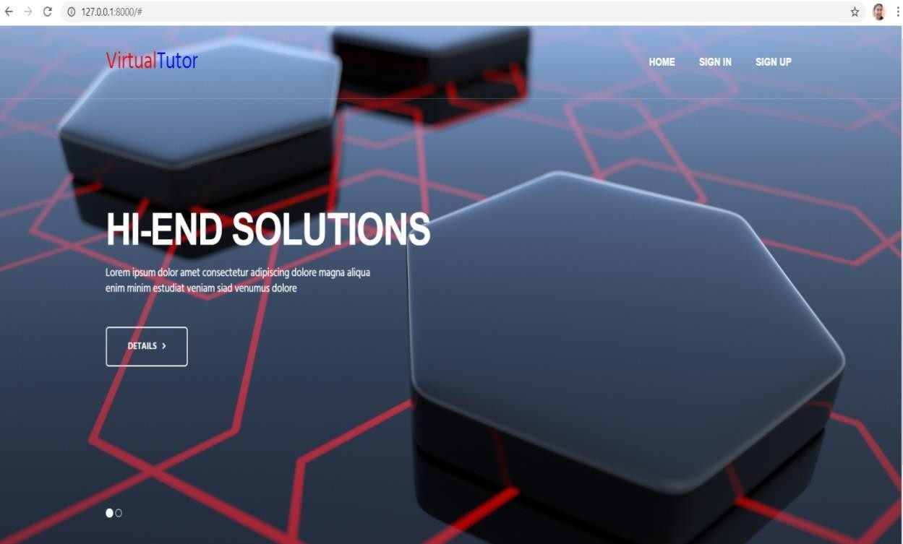

**11.SAMPLE SOURCE CODE**

Chatbot.py (library) import numpy as np

import nltk

import string

from django.shortcuts import render

from django.shortcuts import redirect ,HttpResponse

import datetime

from datetime import date

from django.core.files.storage import FileSystemStorage

from .models import login as log,Staff as stf,User as usr,Report as rep,Fine as fin, Payment as pay,Complaint as comp

# Create your views here.

def index(request):

    if(request.session.get('role', ' ')=="admin"):

            response = redirect('/AdminHome')

            return response

    elif (request.session.get('role', ' ')== "staff"):

            response = redirect('/Studenthome)

            return response

    elif (request.session.get('role', ' ')== "user"):

            response = redirect('/Tutorhome)

            return response

    else:

            return render(request,"index.html",{"msg":""})

def AdminHome(request):

    return render(request,"adminhome.html",{"msg":""})

def UserHome(request):

    return render(request,"userhome.html",{"msg":""})

def StaffHome(request):

    return render(request,"staffhome.html",{"msg":""})

def Logout(request):

    try:

        del request.session['id']

        del request.session['role']

        del request.session['username']

        response = redirect("/index")

        return response

    except:

        response = redirect("/index")

        return response

def Our_Staff(request):

        msg = ""

        data1=stf.objects.all()

        return render(request,"View_staff.html",{"msg":msg,"data":data1})

def Our_Users(request):

        msg = ""

        data1=usr.objects.all()

        return render(request,"View_user.html",{"msg":msg,"data":data1})

def delete_staff(request):

    stf.objects.filter(Staff_id=request.GET["id"]).delete()

    response = redirect('/Our_Staff')

**11.3 GANTT CHART**

The risk and uncertainty raises multirole with respect to the size of the project, even when the project is developed according to set methodologies. There are tools available, which aid for effective project management. A few are described

Gantt charts were devised by Henry Gantt (1917). It represents project schedule with respect to time periods. It is a horizontal bar chart with bars representing activities and time scheduled for the project activities. Tasks that can be completed in parallel.

|  |  |  |  |  |  |  |  |  |
| --- | --- | --- | --- | --- | --- | --- | --- | --- |
| **ACTIVITY** | **July** | | **August** | | **September** | | **October** | |
| **1-15** | **15-31** | **1-15** | **15-31** | **1-15** | **15-30** | **1-15** | **15-31** |
| System analysis and design |  |  |  |  |  |  |  |  |
| Design of program |  |  |  |  |  |  |  |  |
| Develop menus and control messages |  |  |  |  |  |  |  |  |
| Coding and construcred file structure |  |  |  |  |  |  |  |  |
| Develop input modules |  |  |  |  |  |  |  |  |
| Develop reporting modules and test cases |  |  |  |  |  |  |  |  |
| Software testing |  |  |  |  |  |  |  |  |

**CHAPTER 12**

**REFERENCES**

* Mell, P. and Grance, T. (2011). A NIST definition of cloud computing [wwwdocument] <http://csrc.nist.gov/publications/nistpubs/800-145/SP800-145.pdf>
* Armbrust, M., Fox, A., Griffith, R., Joseph, A.D., Katz, R., Konwinski, A.,Lee, G., Patterson, D., Rabkin, A., Stoica, I. and Zaharia, M. (2010). A ViewofCloudComputing,Communications oftheACM 53(4):50–58.
* Asatiani,A.,Apte,U.M.,Penttinen,E.,Ronkko,M.andSaarinen,T.(2014).OutsourcingofDisaggregatedServicesinCloud-BasedEnterpriseInformationSystems,in Proceedingsof the 47th Hawaii International Conference on SystemSciences(BigIsland,Hawaii,USA).
* Foster,I.,Zhao,Y.,Raicu,I.andLu,S.(2008).CloudComputingandGridComputing360-DegreeCompared,inProceedingsoftheGridComputingEnvironmentsWorkshop(Austin,Texas,USA).
* Marston, S., Li, Z., Bandyopadhyay, S., Zhang, J. and Ghalsasi, A. (2011). CloudComputing–Thebusinessperspective,DecisionSupportSystems51(1):176–189.
* Yang, H. and Tate, M. (2012). A Descriptive Literature Review and Classification ofCloudComputingResearch,CommunicationsoftheAIS31(1):35–60..
* Yanosky, R. (2008). From Users to Choosers: The cloud and the changing shape ofenterprise authority, in R. Katz (ed.) The Tower and the Cloud, Berkeley: Educause,pp.126–136.