Network MIDI 2.0 on macOS
Connecting a NetworkMIDI2USBBridge Device
Draft — covers both Host and Client bridge configurations

Overview
This guide walks through connecting a macOS computer to a NetworkMIDI2USBBridge device over Network MIDI 2.0 (UMP), using the built-in Audio MIDI Setup application. Two configurations are covered, depending on which side of the connection acts as the session Host:
- Use Case 1: The bridge device is configured as Host; the Mac connects as a Client.
- Use Case 2: The Mac is the Host (its default behavior); the bridge device connects to it as a Client.
Both configurations result in the same end state: a standard Core MIDI port that any MIDI application on the Mac can use to send and receive MIDI 2.0 data over the network.

Prerequisites
- A Mac running a version of macOS with Network MIDI 2.0 support in Audio MIDI Setup.
- A NetworkMIDI2USBBridge device running the bridge firmware, connected to the same network/link-local segment as the Mac.
- Access to the bridge's serial setup terminal (for initial configuration).

Use Case 1: Bridge Configured as Host
In this configuration, the bridge device hosts the Network MIDI 2.0 session and the Mac connects to it as a client.

Step 1 — Configure the bridge as Host
In the bridge's serial setup menu, select Host mode and accept or set the network name and network configuration:
--- NetworkMIDI2 Bridge setup ---
Role -- [C]lient or [H]ost [C]: H
Network MIDI name [NetworkMIDIUMPBridge]:
Network -- [D]HCP/link-local or [S]tatic IP [D]:
Saved. (Client host selection follows once the network link is up.)
[38848959] NM2 session state -> Idle
[Host] Listening at 10.0.0.45:5004
Bridge running. Press ESC at any time to re-enter setup.
The bridge is now listening for incoming connections on port 5004.

Step 2 — Open Audio MIDI Setup on the Mac
- Launch Audio MIDI Setup (Applications → Utilities).
- From the Window menu, choose Show MIDI Studio to open the MIDI Studio window.
- In the MIDI Studio toolbar, click the Globe icon (“Configure Network Driver”) to open the Network MIDI configuration.
Figure 1. MIDI Studio toolbar — the Globe icon opens the Network driver configuration.

Step 3 — Locate and connect to the bridge device
The MIDI Network Setup dialog opens, showing the Mac's own session under My Sessions, and any discoverable Network MIDI 2 devices under Sessions and Directories. Because the bridge is already running in Host mode, it appears in this list automatically.
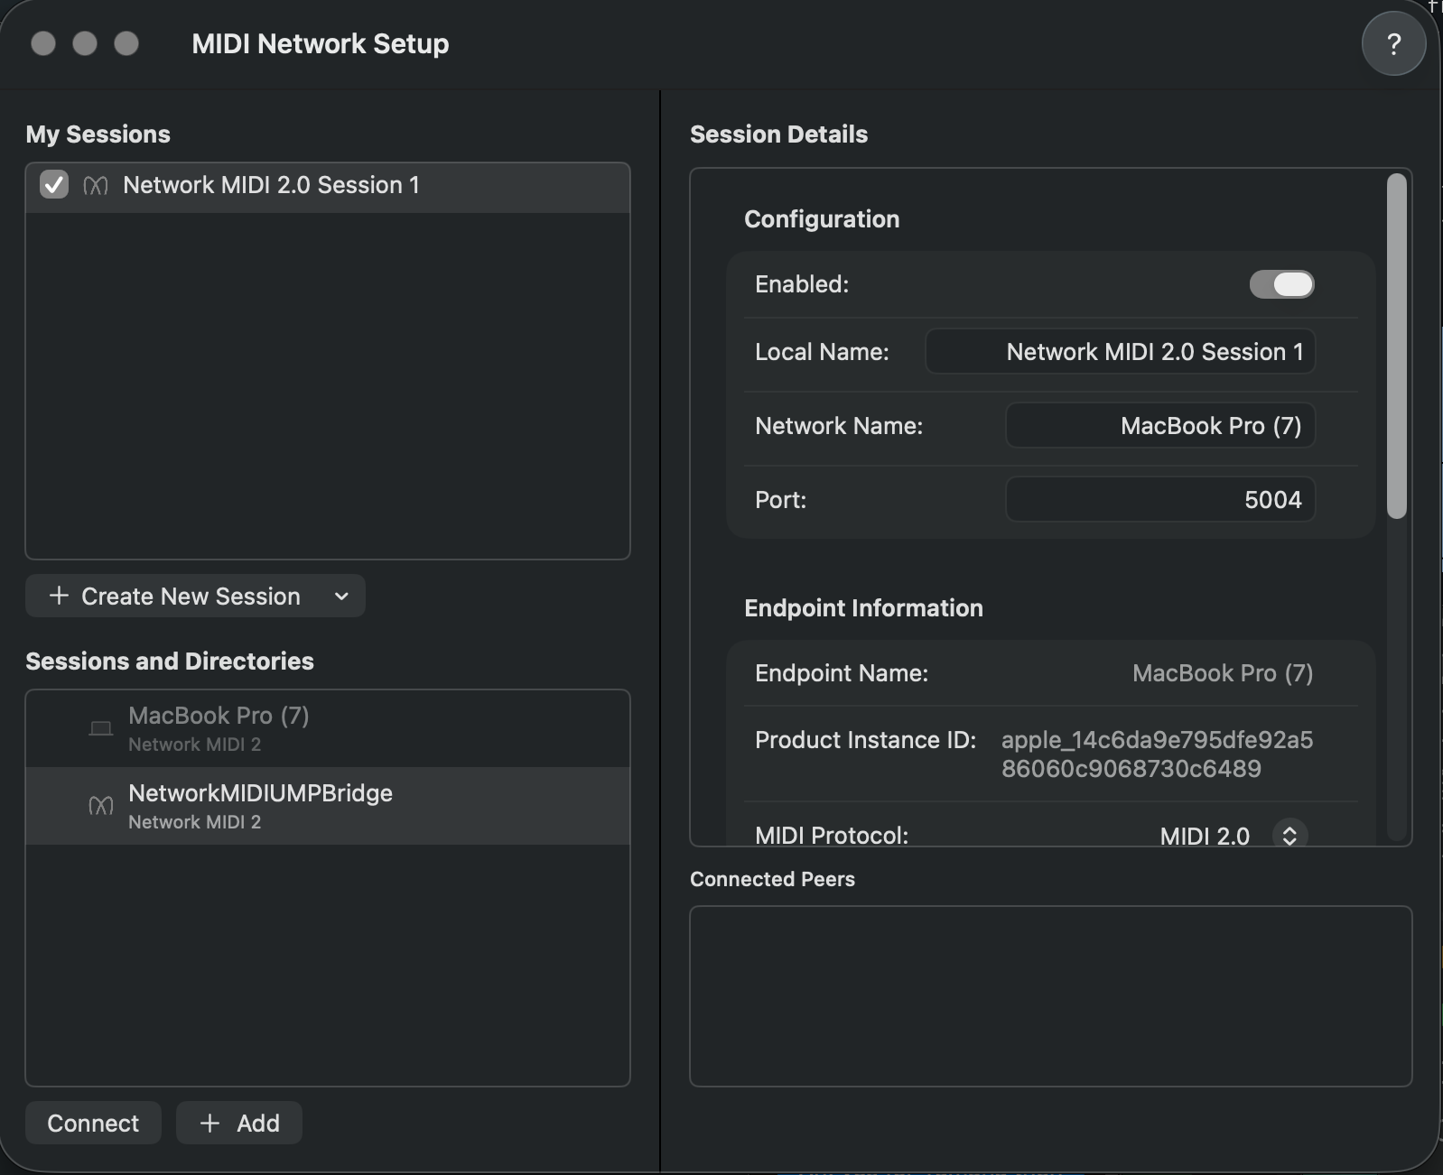
Figure 2. MIDI Network Setup dialog. NetworkMIDIUMPBridge is discovered under Sessions and Directories.
- Select NetworkMIDIUMPBridge in the Sessions and Directories list.
- Click Connect.

Step 4 — Confirm the connection
Once connected, the device appears under Connected Peers with a green status indicator and a live round-trip latency reading.
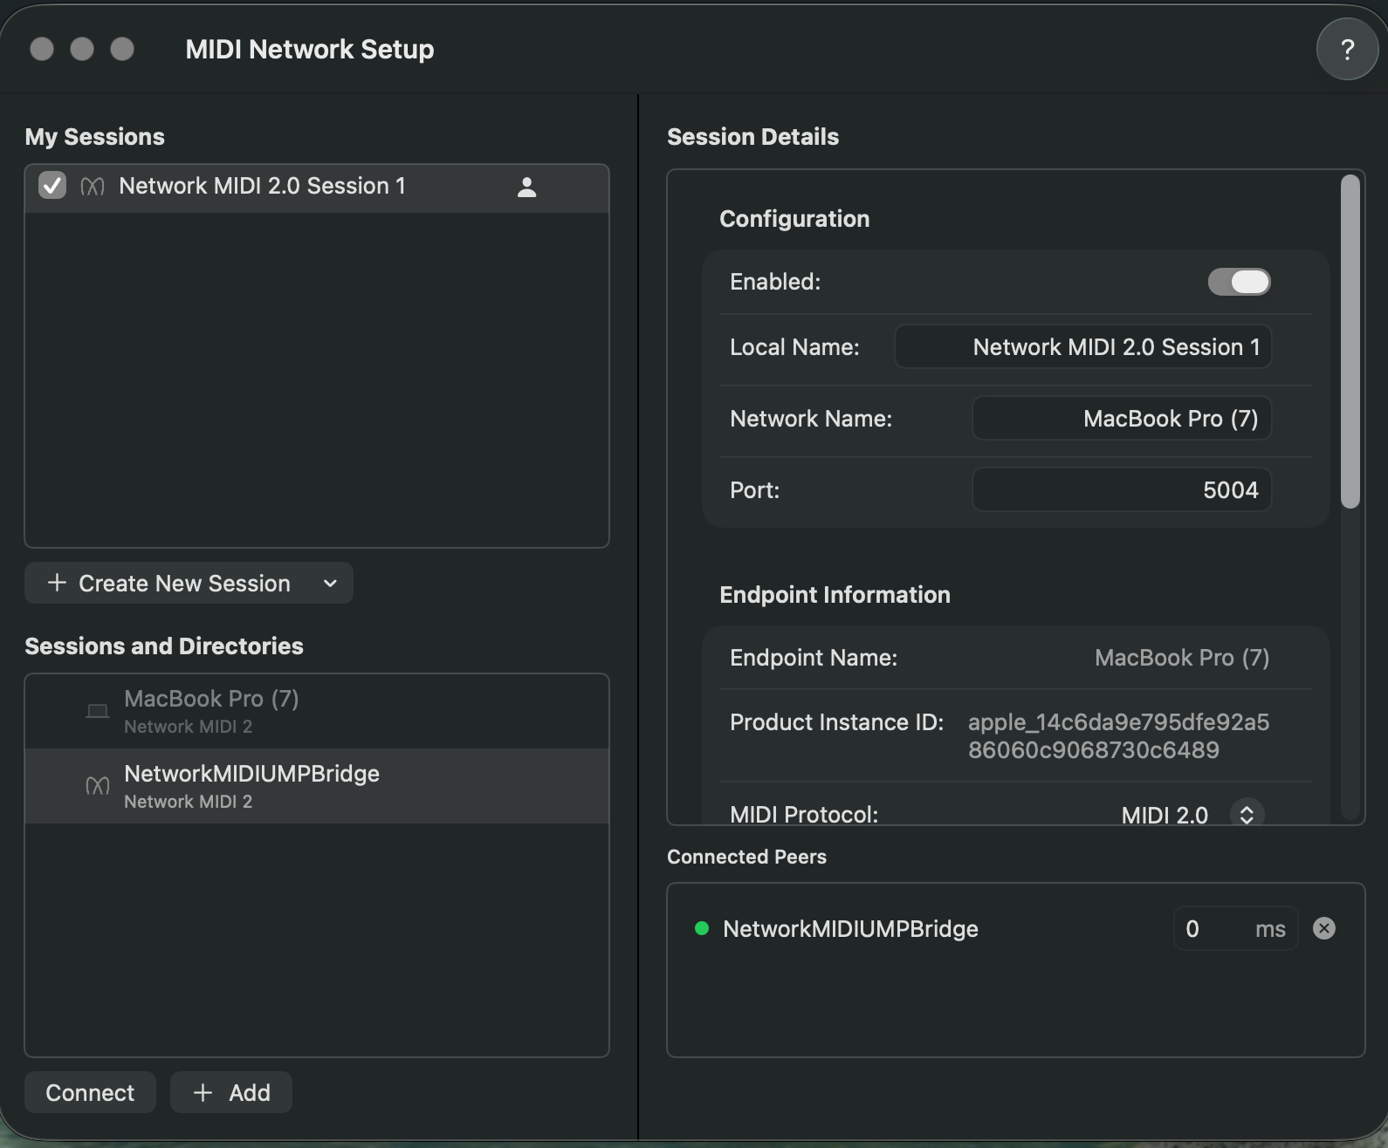
Figure 3. Connected Peers shows NetworkMIDIUMPBridge with an active (green) connection.
On the bridge's serial terminal, the session log confirms the established state:
[565219285] NM2 session state -> Established

Step 5 — Use the port in a MIDI application
With the session established, the connection appears as a standard MIDI port in any Core MIDI–compatible application. For example, in an application's output port selector:
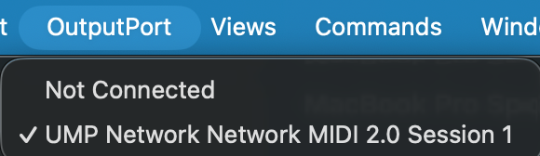
Figure 4. The bridge is now selectable as a standard MIDI port — here, “UMP Network Network MIDI 2.0 Session 1.”

Step 6 — Disconnect
To end the session, click the X button next to the device's entry under Connected Peers in the MIDI Network Setup dialog.

Use Case 2: Mac Configured as Host
In this configuration, the Mac hosts the Network MIDI 2.0 session (its default behavior when the Network driver is enabled), and the bridge device connects as a client.

Step 1 — Confirm the Mac's session
By default, once the Network configuration is enabled in Audio MIDI Setup, the Mac automatically creates its own Network MIDI 2.0 session, listed under My Sessions and labeled with the Mac's name. No additional setup is required on the Mac — it is already acting as Host.
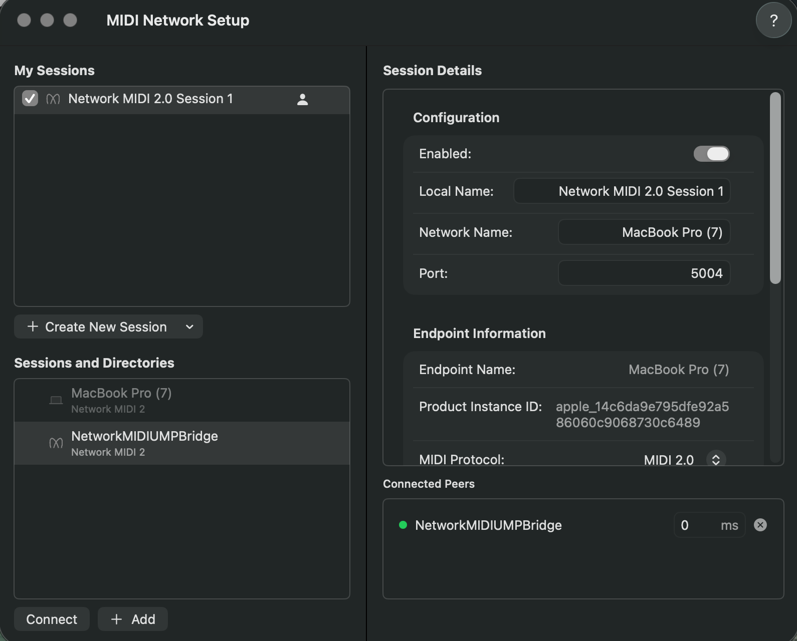
Figure 5. The Mac's default session (“Network MIDI 2.0 Session 1”, Network Name “MacBook Pro (7)”) listening on port 5004.

Step 2 — Configure the bridge as Client
In the bridge's serial setup menu, select Client mode and confirm the network configuration:
--- NetworkMIDI2 Bridge setup ---
Role -- [C]lient or [H]ost [H]: C
Network MIDI name [NetworkMIDIUMPBridge]:
Network -- [D]HCP/link-local or [S]tatic IP [D]:
Saved. (Client host selection follows once the network link is up.)
Searching for NetworkMIDI2 hosts (_midi2._udp) for 4 seconds...
(Enter at any time to stop early and pick from what's found so far,
or 'm' + Enter to enter a host IP manually.)
[1] MacBook Pro (7) 10.0.0.229:5004
Select host [1-1]: 1
Select the Mac from the discovered host list (in this example, option 1).

Step 3 — Connection established
The bridge's serial terminal shows the session progressing to the Established state:
Will connect to 10.0.0.229:5004
[939693599] NM2 session state -> PendingInvitation
Bridge running. Press ESC at any time to re-enter setup.
[940694706] NM2 session state -> Established
On the Mac, the MIDI Network Setup dialog shows NetworkMIDIUMPBridge under Connected Peers with a green status indicator, exactly as in Use Case 1.

Step 4 — Use in a MIDI application
As before, the connection appears as a standard Core MIDI port (e.g., “UMP Network Network MIDI 2.0 Session 1”) in any MIDI application on the Mac.

Step 5 — Disconnect
Click the X next to the device's entry under Connected Peers in the MIDI Network Setup dialog to end the session.

Persistent Reconnection Behavior
Note: In both configurations (Mac as Host or Mac as Client), if the session is not explicitly disconnected via the X button, the Mac will continually attempt to re-establish the connection. This behavior can be desirable for systems that need to automatically reconnect after a reboot or power cycle.

