Network MIDI 2.0 on Windows
Connecting a NetworkMIDI2USBBridge Device
Draft — covers both Host and Client bridge configurations

Overview
This guide walks through connecting a Windows PC to a NetworkMIDI2USBBridge device over Network MIDI 2.0 (UMP), using Windows MIDI Services. Two configurations are covered, depending on which side of the connection acts as the session Host:
- Use Case 1: The bridge device is configured as Host; the Windows PC connects as a Client.
- Use Case 2: The Windows PC is the Host; the bridge device connects to it as a Client.
Both configurations result in the same end state: a standard MIDI port that any MIDI application on the PC can use to send and receive MIDI 2.0 data over the network.

Prerequisites
- A Windows PC connected to the same network/link-local segment as the bridge device.
- A NetworkMIDI2USBBridge device running the bridge firmware.
- Access to the bridge's serial setup terminal (for initial configuration).
Network MIDI 2.0 support is not built into Windows by default. Windows MIDI Services must be installed and enabled first, by following the instructions at microsoft/MIDI: Windows MIDI Services on GitHub.
Once installed, the Windows MIDI Network Setup application becomes available for configuring Network MIDI 2.0 sessions and connections.

Use Case 1: Bridge Configured as Host
In this configuration, the bridge device hosts the Network MIDI 2.0 session and the Windows PC connects to it as a client.

Step 1 — Configure the bridge as Host
In the bridge's serial setup menu, select Host mode and accept or set the network name and network configuration:
--- NetworkMIDI2 Bridge setup ---
Role -- [C]lient or [H]ost [C]: H
Network MIDI name [NetworkMIDIUMPBridge]:
Network -- [D]HCP/link-local or [S]tatic IP [D]:
Saved. (Client host selection follows once the network link is up.)
[38848959] NM2 session state -> Idle
[Host] Listening at 10.0.0.45:5004
Bridge running. Press ESC at any time to re-enter setup.
The bridge is now listening for incoming connections on port 5004.

Step 2 — Open Windows MIDI Network Setup and find the device
- Launch Windows MIDI Network Setup.
- Select Network devices from the left-hand navigation.
- Under Network MIDI 2.0 devices, locate the bridge (e.g., NetworkMIDIUMPB...), which shows as Available since it is already running in Host mode.
- Click Connect next to the device.
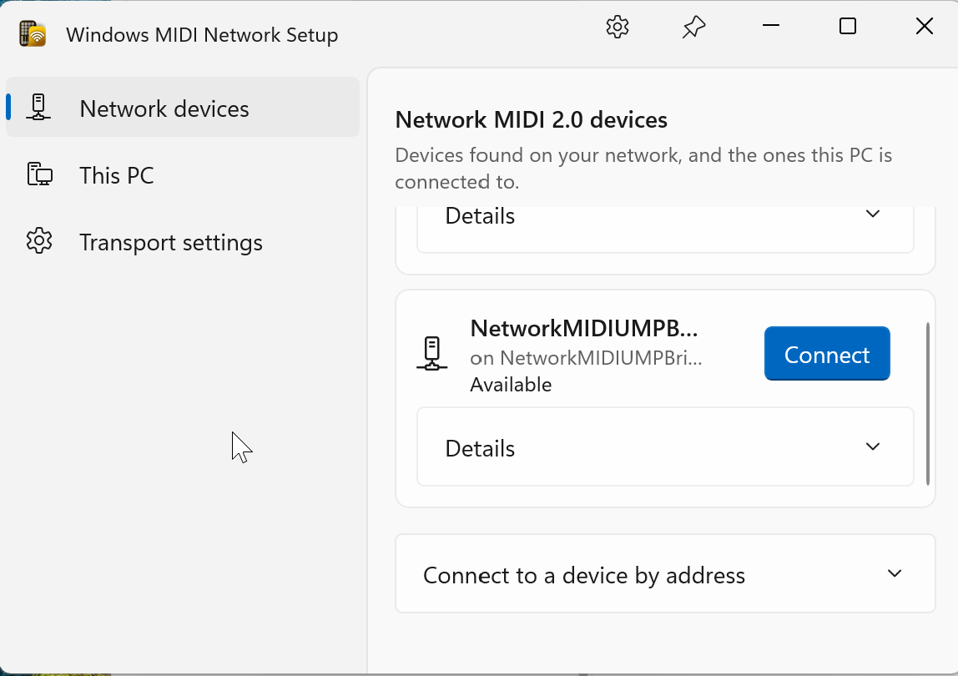
Figure 1. Network devices panel — the bridge appears as an available Network MIDI 2.0 device.

Step 3 — Confirm the connection and assign a display name
A “Connect to this device” dialog appears, confirming that Windows will connect to NetworkMIDIUMPBridge.
- Optionally enter a Name to show in Windows (e.g., “Bridge”) to customize how the device appears on this PC. Leave it empty to use the name the device itself reports.
- Click Connect to finalize, or Cancel to back out.
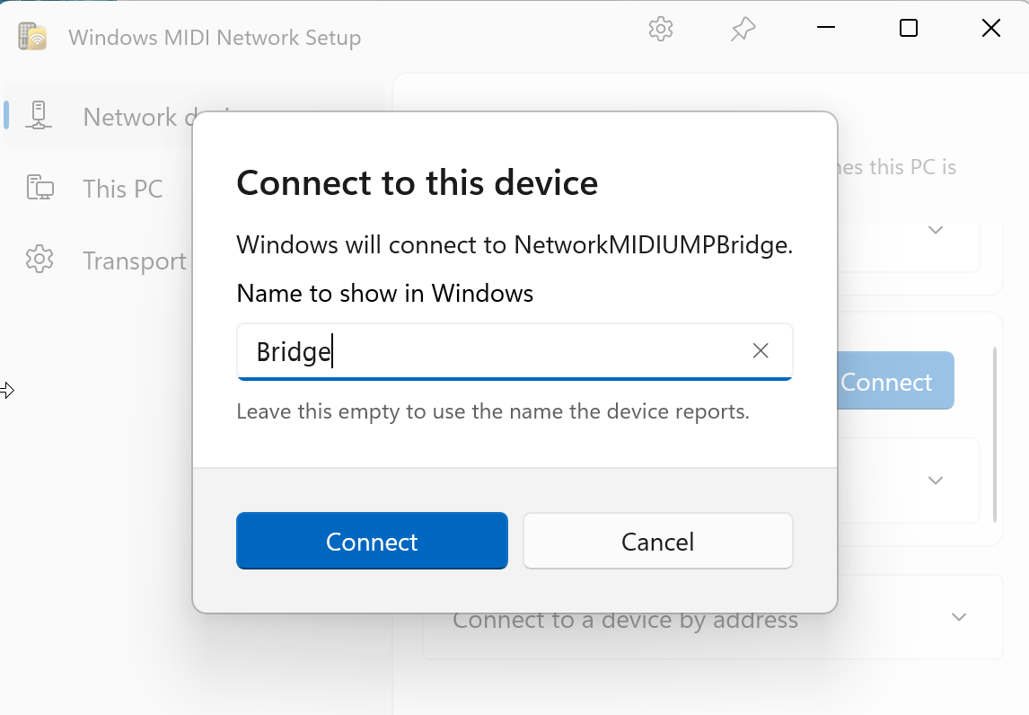
Figure 2. Connect to this device dialog, with an optional custom display name.

Step 4 — Confirm the connection
Once connected, the device card updates with a green checkmark, the connection address (10.0.0.45, port 5004), and status Connected. A live round-trip latency graph and reading (e.g., Round trip 4.52 ms) provide real-time diagnostic feedback on connection quality.
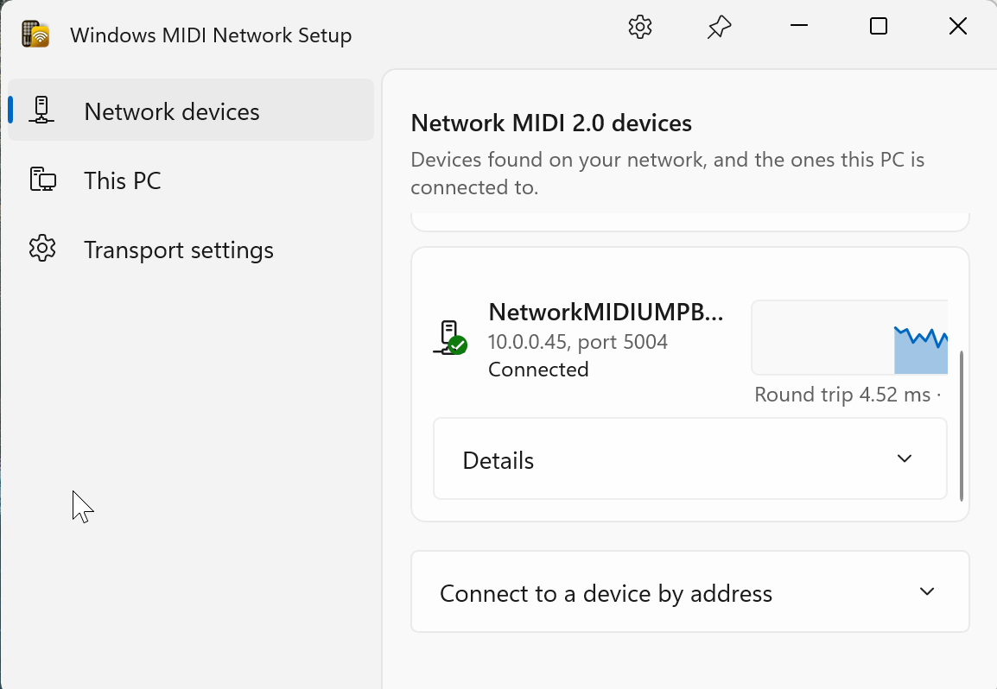
Figure 3. Connected device card showing address, status, and round-trip latency.

Step 5 — Verify traffic with the Windows MIDI Monitor
From the Windows MIDI Network Setup dialog, you can open the Windows MIDI Monitor tool for deeper diagnostics.
- Select the connected device (e.g., Bridge) as the MIDI Device, and optionally filter by Group or Channel.
- The monitor logs live MIDI messages in real time — message type (e.g., MIDI 1.0 Note On / Note Off), note number/name, and velocity.
- Useful for confirming that MIDI traffic is actually flowing correctly over the network connection.
- Stop listening pauses/resumes capture; Save to File exports the captured log.
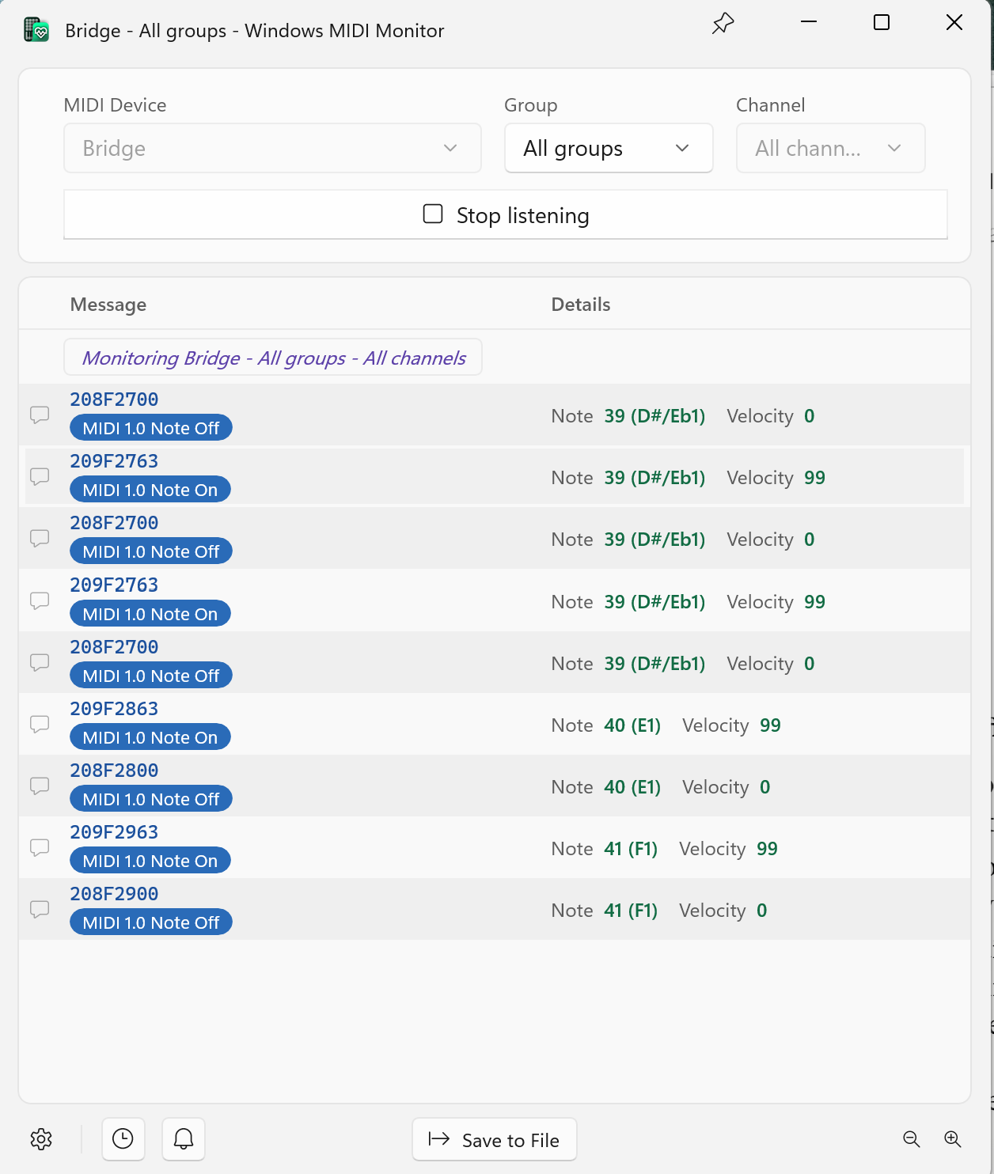
Figure 4. Windows MIDI Monitor showing live Note On/Off traffic from the bridge.

Use Case 2: Windows PC Configured as Host
In this configuration, the Windows PC hosts the Network MIDI 2.0 session, and the bridge device connects as a client.

Step 1 — Create a host on the Windows PC
- In Windows MIDI Network Setup, select This PC from the left-hand navigation.
- This panel shows Network MIDI 2.0 hosts on this PC. If none exists yet, you'll see: “This PC does not have a Network MIDI 2.0 host yet. Create one so other devices can connect to it.”
- Click Create host.
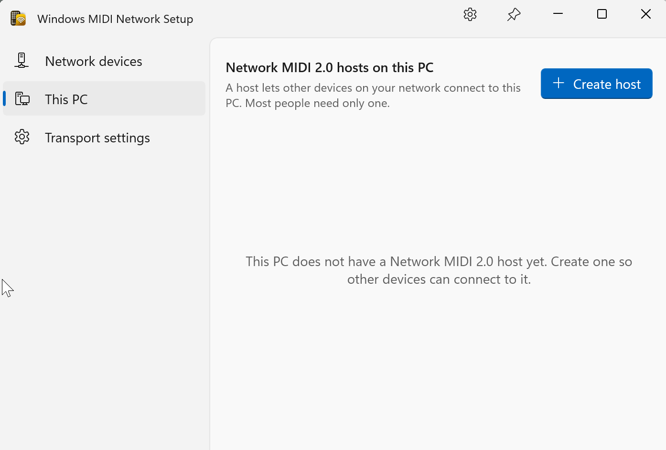
Figure 5. This PC panel, before any Network MIDI 2.0 host has been created.

Step 2 — Configure and create the host
In the Create a Network MIDI 2.0 host dialog, configure the following:
- Name other devices will see — the display name advertised to other devices on the network (defaults to the PC name, editable).
- Network service name — the underlying network service identifier (e.g., “AMENOTEBLACK_windows_midisrv”). Must be unique on this PC and the network; periods are automatically removed.
- When a device asks to connect — Ask me first (prompts for approval on each request, default) or Let any device connect (accepts automatically).
- Advertise this host on the network — checked by default, so the host is discoverable.
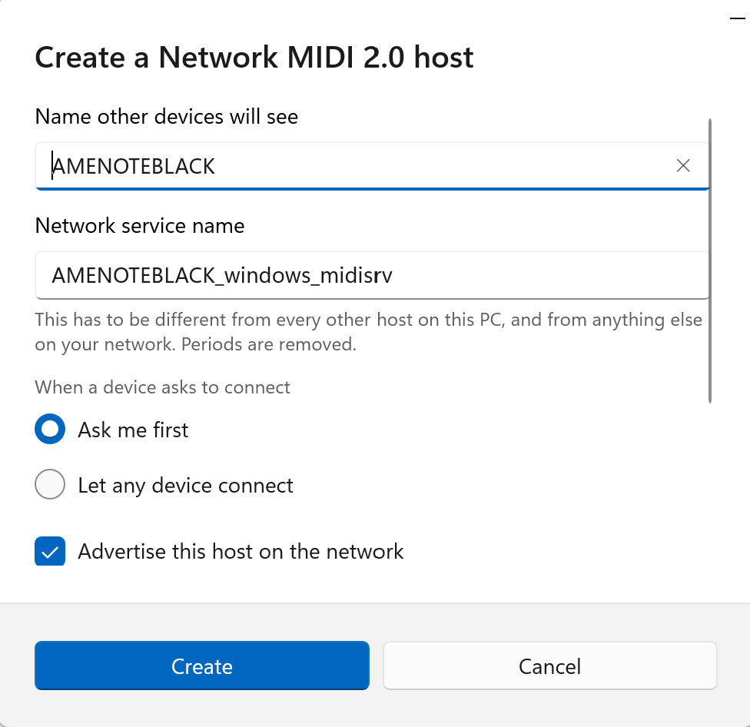
Figure 6. Create a Network MIDI 2.0 host dialog.
Once configured, click Create.

Step 3 — Configure the bridge as Client and connect to the Windows host
On the bridge's serial setup, select Client mode. It discovers the Windows host by its advertised Network service name:
--- NetworkMIDI2 Bridge setup ---
Role -- [C]lient or [H]ost [C]: c
Network MIDI name [NetworkMIDIUMPBridge]:
Network -- [D]HCP/link-local or [S]tatic IP [D]:
Saved. (Client host selection follows once the network link is up.)
Searching for NetworkMIDI2 hosts (_midi2._udp) for 4 seconds...
(Enter at any time to stop early and pick from what's found so far,
or 'm' + Enter to enter a host IP manually.)
[1] AMENOTEBLACK_windows_midisrv 10.0.0.229:42987
Select host [1-1]: 1
Will connect to 10.0.0.229:42987
[127049333] NM2 session state -> PendingInvitation
Bridge running. Press ESC at any time to re-enter setup.
The bridge finds the Windows host advertised as AMENOTEBLACK_windows_midisrv and connects to it. Note that the host listens on a dynamically assigned port (here, 42987) rather than the fixed port 5004 used in Use Case 1. The session enters the PendingInvitation state while the connection request is pending.
Known issue: Establishing a session when the Windows PC is configured as Host has been unreliable in testing — the session can stall at PendingInvitation and never reach Established. Possible causes under investigation include a missed or hidden connection-approval prompt on the Windows side (when “Ask me first” is selected), Windows Firewall blocking the dynamically assigned host port, or the network profile being set to Public rather than Private (which can restrict mDNS discovery and inbound connections). This section will be updated once the root cause and a reliable workaround are confirmed.

