PERSONAL DATA
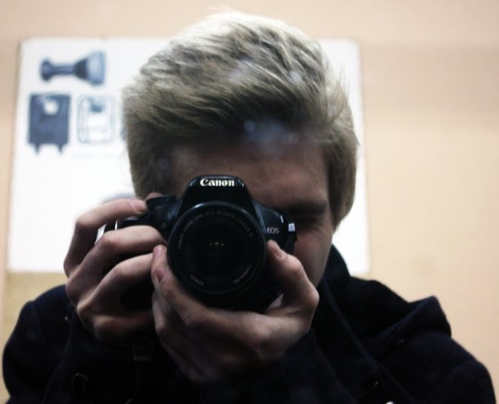 | Name: | Mikhail Didevich
 | Date of Birth: | 18/09/1997
 | Mobile | +375 (25) 971–48–02
 | E-mail: | atmeelos@gmail.com
 | Skype: | sub_zero547
 | LinkedIn: | http://www.linkedin.com/in/mididevich

OBJECTIVE
Desired Position: | Front-end Developer
Desired Salary: | Starting from 500$

SUMMARY OF QUALIFICATION
Experience in CMS (Joomla, WordPress) make-up and configuration since 2013.
Also, familiar with MySQL-requests (SELECT, UPDATE, INSERT, etc.).

TECHNICAL SKILLS
- С
- HTML, CSS.
- MySQL
- Basic knowledge of PHP and JS syntax

LANGUAGES
- Russian, Belarussian – Native Speaker
- English – Technical

EDUCATION
- 2004–2013 / Belarusian Secondary School / Nesvizh, Belarus
- 2013 – present days / Belarusian State Higher Radio Technical College / Department of Radio Engineering (Engineers) / Minsk, Belarus

OTHER INFORMATION
Engaged in design, development, programming and assembly of PIC architecture microcontrollers since 2015, possess basic knowledge of AVR architecture microcontrollers. Have an experience in programming on Arduino platform. Use my leisure time for self-education and improvement of my skills.

PROFESSIOANL EXPERIENCE

Web site “TeploDraiv.by”
Company: | Home project
Project Industry: | Web site
Project Links: | www.teplodraiv.by
Location: | Nesvizh, Belarus
Duration: | 09/2014–11/2014
Project Description: | Website directory for private enterprise offering goods and services.
Position: | Web developer
Overall Team Size: | 1 developer
Responsibilities: | - Development and maintenance of the web site.  - User support
Tools & Technologies: | - HTML  - CSS  - PHP  - CMS (Joomla)

Design of microcontroller systems
Company: | Educational Institution “MSHRTC”
Project Industry: | Microcontroller system
Company site: | www.mrk-bsuir.by
Location: | Minsk, Belarus
Duration: | 09/2015 – present days
Project Description: | Design, programming and assembly of microcontrolling devices
Position: | C developer
Overall Team Size: | 5 developers
Responsibilities: | - Development and maintenance of devices.  - User support
Tools & Technologies: | - C  - Altium Designer  - PIC, AVR, Arduino

