**Automated Employment Decision Tools and Ableism:**

**A Critical Analysis with Recommendations**

MELIS I. DIKEN and PATRICK HALL, The George Washington University

This study examines the potential for screen-out harm to job seekers with disabilities due to inadequate accommodations and accessibility features in automated employment decision tools (AEDTs) based on artificial intelligence or machine learning (AI/ML). Data was collected and analyzed from 30 organizations offering such AEDTs, focusing on publicly available information regarding accommodations and accessibility features, organizational size, specific products offered, bias testing practices, and accessibility staff. Most organizations in the study do not offer accommodations in their AI/ML-enabled AEDT products and are not actively addressing the needs of candidates with disabilities. Worse, some AEDT providers misrepresent their tools with claims of “bias-free” decision-making and offer employment assessments based on questionable video analysis approaches. These findings align with broader concerns about the potential for screen-out discrimination and other harms as a result of flaws in the design and implementation of AEDTs.

CCS Concepts: • Social and professional topics → People with disabilities; • Human-centered computing;

Additional Key Words and Phrases: Automated Employment Decision Tools, Bias, Screen-out

ACM Reference Format:

Melis I. Diken and Patrick Hall. 2023. Automated Employment Decision Tools and Ableism: A Critical Examination. In . ACM, New York, NY, USA, 10 pages. [**https://doi.org/XXXXXXX.XXXXXXX**](https://doi.org/XXXXXXX.XXXXXXX)

1. INTRODUCTION

In 2021, individuals in the United States (US) aged 16 to 64 with disabilities had an unemployment rate of 10.8%, more than double that of individuals without disabilities.[1] In 2020, the percentage of persons with a disability earning $75,000 or more a year was 40.01% less than those without disabilities.[2] Diminished workforce representation has been a persistent concern for disability activists, and some fear this trend may be exacerbated with the rapid advancement of automated employment decision tools (AEDTs) based on artificial intelligence or machine learning (AI/ML).[2, 3] Yet, Nearly all Fortune 500 organizations have AI/ML tools and AEDTs in their talent acquisition technology plans.[4]

Examples of AEDTs include resume screening based on natural language processing (NLP), gamification of hiring interviews and processes, AI/ML-based video interview analysis, and interview chatbots. AEDTs affect candidates with disabilities in different ways, in the worst case, affecting an automated form ableism. Some gamified employment tests may not be designed to accommodate neurodivergent candidates or candidates with physical disabilities. AI video interview software can negatively impact both neurodivergent candidates and those with physical disabilities. In addition to basic validity concerns,[5] AI/ML video analysis algorithm may, e.g., not recognize a candidate with a speech impairment or reduce the score of neurodivergent candidates based on atypical facial expressions. Shockingly, some AI video analysis algorithms are known to diagnose candidates as disabled.[2]

AEDTs are often marketed as objective, and as a means to reduce or eliminate bias. Indeed at least one of the products surveyed is misrepresented as “bias-free” [6]. Even for the small number of examined vendors that acknowledge statistical bias testing, physical design, graphical user interfaces (GUI), or other features can present difficulties for users with disabilities and lead to subsequent screen-out discrimination, where certain populations are unfairly disqualified from employment opportunities. While screen-out discrimination is a significant concern for impacted communities, often leading to adverse social and financial outcomes, screen out is also a potentially serious legal liability for employers operating AEDTs. The Americans with Disabilities Act (ADA) states that "Screen out because of a disability is unlawful if the individual who is screened out is able to perform the essential functions of the job, with a reasonable accommodation if one is legally required."[2] Various legal processes enable those impacted by screen out discrimination and regulators to seek redress or damages from employers.

In an effort to highlight the prevalence of screen-out discrimination risks due to AEDTs and to contribute to the broader dialog around AI/ML, AEDTs, and bias against those with disabilities, this study presents straightforward summary information related to 30 AEDT offerings, covering accommodations and accessibility features, organizational size, specific products offered, bias testing practices, and accessibility staff. Section 2 outlines data collection. Analysis in Section 3 indicates that some vendors appear to be actively addressing screen-out discrimination risks, while most are not. Section 4 closes this paper with recommendations for AEDT developers based on presented results, authoritative guidance, and in part, the author’s experience as a job seeker with a disability. Appendix A presents visual summaries of collected data, Appendix B contains a few supplemental results, and for improved reproducibility, the GitHub repository https://github.com/midiker/aedt-analysis contains anonymized data, scripts for analysis, and other related artifacts.

1. DATA COLLECTION

First, we created a 30 organizations list of the top AI organizations offering HCM/TA products including both well-known Fortune 500 organizations and small start-ups. Then we assessed what type of HCM/TA product(s) the organization offer such as video screening, resume/profile screening, and/or Chatbots. Furthermore, we investigated if the organization’s website marketed its product as "Bias-Free" or used similar language. We checked if there was public evidence of accessibility staff on the organization’s website or LinkedIn, and whether they had accommodations directly for the AI/ML software displays on their website like a timeframe on those given accommodations. Finally, we investigated the organization’s addressment of different types of disabilities. Descriptions shown in Table 1.

Table 1: Data Dictionary

| **Features** | **Values** | **Description** |
| --- | --- | --- |
| "Bias-Free"/No bias | 1 = yes, 0 = no, 2=maybe | If yes, organization’s website displays the term "Bias-Free" or similar language, such as “eliminates bias,” in relation to organization’s AI/ML technology or AI/ML technology in general. |
| Video Screening | 1 = yes, 0 = no, 2=maybe | If yes, organization’s website displays that organization integrates AI/ML screening algorithms in their TA/HR video software. |
| Resume/Profile Screening | 1 = yes, 0 = no, 2=maybe | If yes, organization’s website displays that organization integrates AI/ML screening algorithms on candidates resumes or profiles in their TA/HR software. |
| Chatbots | 1 = yes, 0 = no, 2=maybe | If yes, organization’s website displays that organization integrates Chatbots in their TA/HR software. |
| Addresses Physical Disabilities | 1 = yes, 0 = no, 2=maybe | If yes, organization’s website addresses ways to assist and/or the benefits of hiring candidates with physical disabilities. |
| Addresses Neurodiversity | 1 = yes, 0 = no, 2=maybe | If yes, organization’s website addresses ways to assist and/or the benefits of hiring neurodivergent candidates. |
| Public Accessibility Staff | 1 = yes, 0 = no, 2=maybe | If yes, there is public evidence of accessibility staff on the organization’s website or LinkedIn. |
| Offers Accommodations | 1 = yes, 0 = no, 2=maybe | If yes, organization has accommodations specifically for the AI/ML software |
| Immediate/Timeframe for Accommodations | 1 = yes, 0 = no, 2=maybe | If yes, organization gives immediate accommodations or a timeframe for when accommodations would be to candidates for AI/ML software. |
| Reports Bias Testing | 1 = yes, 0 = no, 2=maybe | If yes, organization states on its website that the organization has a third party audit or its own audits for bias in their AI/ML models. Note: this might not include bias testing for disability. |
| Number of Total Staff | Small < 100, Medium < 1000, Large > 1001 | Estimate total employee count |

1. ANALYSIS

After data collection, we performed data exploration with categorical descriptive statistics, such as counts, frequencies, and decision trees. These gave us the ability to find trends and draw conclusions about our dataset to evaluate our hypothesis.

* Column used as target in the final model: 'Offers Accommodations_Yes'
* Type of models: Decision Tree Model
* Software used to implement the model: Python on colab, 'sklearn', 'numpy', 'pandas', 'time', 'matplotlib.pyplot', and 'matplotlib.lines'.
* Version of the modeling software:'python 3.7.15','numpy 1.18.5', and 'pandas 1.0.5
* [Code implementation](https://github.com/midiker/aedt-analysis/blob/main/aedt_analysis.ipynb)

Comparison of smaller organizations to the whole sample

Table 2: Comparison of smaller organizations to the whole sample

|  | **Bias-Free'/No bias** | **Video Screening** | **Chatbots** | **Resume/Profile Screening** | **Addresses Physical Disabilities** | **Addresses Neurodiversity** | **Public Accessibility Staff** | **Offers Accommodations** | **Reports Bias Testing** | **Bias-Free'/No bias** |
| --- | --- | --- | --- | --- | --- | --- | --- | --- | --- | --- |
| Yes | -8.34 | 5.00 | -1.66 | -5.0 | -15.0 | -18.33 | -16.67 | -16.67 | -28.34 | -8.34 |
| No | 11.67 | -3.33 | 5 | 5 | 15 | 18.33 | 16.67 | 23.33 | 31.67 | 11.67 |
| Maybe | -3.33 | -1.67 | nan | nan | nan | nan | nan | nan | -3.33 | -3.33 |

In the pivot table 2 above, we can see in our dataset for small organizations which have less than 100 employees vary on performance. For example, smaller organizations tended to market their products as “Bias-Free” less than larger organizations, at a rate of 11.67% less. However, smaller organizations performed worse on the majority of categories, including “offering accommodations,” “having accessibility staff,” and “reporting bias testing.” This makes sense on its face, smaller organizations with access to less resources would not prioritize these accommodations; however, this does not excuse such behavior.

Organizations that don’t offer accommodations poor performance across other categories/features

Table 3: Organizations that don’t offer accommodations performance; To read this table start from the left most column and if a cell is blank then follow the first filled cell above

| **Bias-Free'/No bias** | **Video Screening** | **Offers Accommodations** | **Count** |
| --- | --- | --- | --- |
| Maybe | Maybe | Yes | 1 |
|  | No | No | 5 |
| No | Maybe | No | 2 |
|  | No | Maybe | 2 |
|  |  | No | 9 |
|  |  | Yes | 3 |
|  | Yes | No | 2 |
|  |  | Yes | 1 |
| Yes | No | No | 2 |
|  | Yes | No | 3 |

Table 3 shows a surprising trend of the highest count performing better across other categories/features specifically not marketing their product as ‘Bias-Free'/No bias and conducting AI Video Screening.

Organizations mentioning neurodiversity on their website versus physical disabilities

Table 4: Neurodiversity vs. Physical Disabilities; To read this table start from the left most column and if a cell is blank then follow the first filled cell above

| **Addresses Physical Disabilities** | **Addresses Neurodiversity** | **Offers Accommodations** | **Count** |
| --- | --- | --- | --- |
| No | No | No | 15 |
|  | Yes | Maybe | 2 |
|  |  | No | 2 |
|  |  | Yes | 4 |
| Yes | No | No | 2 |
|  | Yes | No | 4 |
|  |  | Yes | 1 |

As shown in table 4, we can observe that half of our organizations in the sample do not address physical disabilities or neurodiversity and do not offer accommodations of any kind. However, we can also see that for the organizations that do offer accommodations, most only address neurodiversity. There is only one organization out of the sample that addresses both physical disabilities and neurodiversity. Another interesting observation is that the four organizations that do not offer accommodations address both physical disabilities and neurodiversity.

Accommodations group by the organizations who reports bias testing

Table 5: Accommodations group by the organizations who reports bias testing

|  | **Offers Accommodations** |
| --- | --- |
| Yes | 27.27% |
| No | 54.55% |
| Maybe | 18.18% |

In table 5, we see an interesting trend in organizations reporting bias testing and offering accommodations. Out of the organizations that do bias testing the majority of those (54.55%) do not offer accommodations.

Accommodations group by the organizations who offer AI/ML video screening products

Table 6: Accommodations group by the organizations who offer AI/ML video screening products

|  | **Offers Accommodations** |
| --- | --- |
| Yes | 16.67% |
| No | 83.33% |
| Maybe | 0% |

In table 6, organizations which offer AI/ML video screening, 83.33% do not offer accommodations. This is particularly concerning because video screening is an AI technology that can severely impact candidates with disabilities. Relying so heavily on this one method can lead to screen outs.

1. RECOMMENDATIONS AND CONCLUSION

Cite/augment check against NIST AI RMF playbook and peatworks

After our analysis, there is clear evidence that AI organizations who produce HCM/TA products have the capability to improve their accessibility features and shrink the gap of screen-outs for candidates with disabilities. It’s important that organizations offer accessibility features and accommodations. However, issues go beyond accommodations. Only offering accommodations does not necessarily mean the risk of screen-out is significantly less. Specifically we recommend:

* Consideration of the timeframe of applicants receiving approval for accommodations. (Candidates need accommodations quickly.)
* Enabling information sharing could assist with accommodations. (By information sharing we mean the sharing of voluntarily given personal data between public entities or other organizations for a specific goal through the exchange, collection, use, or disclosure. Such information sharing may provide candidates with disabilities better opportunities to receive accommodations and do so in a timely manner, without having to request accommodations separately for each role.)
* Audits of AI/ML systems used in hiring for disparate treatment, disparate impact, screen out and other types of discrimination, particularly for resume/profile screening and other systems that rely more on AI/ML processes, since accommodations are not as applicable in these circumstances.
* Avoiding false and misleading language such as "bias-free" when describing AI/ML systems used in hiring.
* Organizations should collect demographically representative training data, sample and reweigh training data if necessary, and consider fairness metrics when selecting hyperparameters and cutoff threshold for employment decision making.
* Organizations should also have opt-out options for selection methods based on AI/ML. (E.g., providing a live interview in place of algorithmic evaluation.)
* Inclusion of those who have disabilities in product design, implementation, or testing. (This is especially important for organizations that do not have the resources for specific accessibility staff).
* Increased diversity in design teams. (This is important in producing more producing a more inclusive and accurate products. Teams with employees who have disabilities have 72% more productivity and produce 30% higher profit margins.[9])
* Organizations should apply external, independent standards to the design of AI/ML systems to mitigate bias, e.g., [NIST's Standard for Identifying and Managing Bias in Artificial Intelligence](https://nvlpubs.nist.gov/nistpubs/SpecialPublications/NIST.SP.1270.pdf).[10]

REFERENCES

[1] “Table A. Employment Status of the Civilian Noninstitutional Population by Disability Status and Age, 2020 and 2021 Annual Averages - 2021 A01 Results.” U.S. Bureau of Labor Statistics. U.S. Bureau of Labor Statistics, February 24, 2022., Retrieved December 4, 2022 from <https://www.bls.gov/news.release/disabl.a.htm>.

[2] Whittaker, Meredith, Meryl Alper, Cynthia L. Bennett, Sara Hendren, Liz Kaziunas, Mara Mills, Meredith Ringel Morris et al. "Disability, Bias, and AI." AI Now Institute, November, 2019. <https://ainowinstitute.org/disabilitybiasai-2019.pdf>.

[3] U.S. Equal Employment Opportunity Commission. "The Americans with Disabilities Act and the Use of Software, Algorithms, and Artificial Intelligence to Assess Job Applicants and Employees." EEOC.gov, May 12, 2022. <https://www.eeoc.gov/laws/guidance/americans-disabilities-act-and-use-software-algorithms-and-artificial-intelligence>.

[4] “Managing the Future of Work.” Harvard Business School, December 4, 2022. <https://www.hbs.edu/managing-the-future-of-work/Pages/default.aspx>.

[5] Schwartz, Reva, Apostol Vassilev, Kristen Greene, Lori Perine, Andrew Burt, and Patrick Hall. "Towards a Standard for Identifying and Managing Bias in Artificial Intelligence." NIST Special Publication 1270, no. 2022 (2022): 1-77.

[6] Author(s). " Talent Intelligence Platform" eightfold, Month Day, 2023. https://eightfold.ai/why-eightfold/talent-intelligence-platform/.**

[7]

Author(s). "Title of White Paper." Name of Company or Organization, Month Day, Year of publication. URL.

Smith, John, and Jane Doe. "The Future of AI in Employment." XYZ Corporation, March 15, 2021. https://www.xyzcorp.com/white-paper-future-of-ai-in-employment

<bib id="bib1"><number>[1]</number>“Table A. Employment Status of the Civilian Noninstitutional Population by Disability Status and Age, 2020 and 2021 Annual Averages - 2021 A01 Results.” U.S. Bureau of Labor Statistics. U.S. Bureau of Labor Statistics, February 24, 2022., Retrieved December 4, 2022 from  <https://www.bls.gov/news.release/disabl.a.htm></bib>

<bib id="bib2"><number>[2]</number>Dastin, Jeffrey. "Amazon scraps secret AI recruiting tool that showed bias against women." In Ethics of Data and Analytics, Auerbach Publications, 2018., 296-299 pages</bib>

<bib id="bib3"><number>[3]</number>Salganik, Matthew J., Ian Lundberg, Alexander T. Kindel, Caitlin E. Ahearn, Khaled Al-Ghoneim, Abdullah Almaatouq, Drew M. Altschul, et al. “Measuring the Predictability of Life Outcomes with a Scientific Mass Collaboration.” (March 2020), Vol. 117 | No. 15, DOI: <https://doi.org/10.1073/pnas.1915006117></bib>

<bib id="bib4"><number>[4]</number>Schwartz, Reva, Apostol Vassilev, Kristen Greene, Lori Perine, Andrew Burt, and Patrick Hall. "Towards a Standard for Identifying and Managing Bias in Artificial Intelligence." (March 2022), 86 pages, DOI: https://doi.org/10.6028/NIST.SP.1270</bib>

<bib id="bib6"><number>[6]</number>Issuing Authority This technical assistance document was issued upon approval of the Chair of the U.S. Equal Employment Opportunity Commission., and This technical assistance document was issued upon approval of the Chair of the U.S. Equal Employment Opportunity Commission. “The Americans with Disabilities Act and the Use of Software, Algorithms, and Artificial Intelligence to Assess Job Applicants and Employees.” US EEOC. Retrieved November 28, 2022 from  <https://www.eeoc.gov/laws/guidance/americans-disabilities-act-and-use-software-algorithms-and-artificial-intelligence>.</bib>

<bib id="bib8"><number>[8]</number>Bureau, U.S. Census. Explore census data. Retrieved December 4, 2022 from  <https://data.census.gov/table?q=Disability&tid=ACSST5Y2020.S1811>.</bib>

<bib id="bib9"><number>[9]</number>“Getting to Equal: The Disability Inclusion Advantage | Accenture.” Retrieved December 5, 2022 from <https://www.accenture.com/_acnmedia/PDF-89/Accenture-Disability-Inclusion-Research-Report.pdf></bib>

<bib id="bib10"><number>[10]</number>Schwartz, Reva, Apostol Vassilev, Kristen Greene, Lori Perine, Andrew Burt, and Patrick Hall. "Towards a Standard for Identifying and Managing Bias in Artificial Intelligence." (March 2022), 86 pages, DOI: https://doi.org/10.6028/NIST.SP.1270</bib>

APPENDIX A

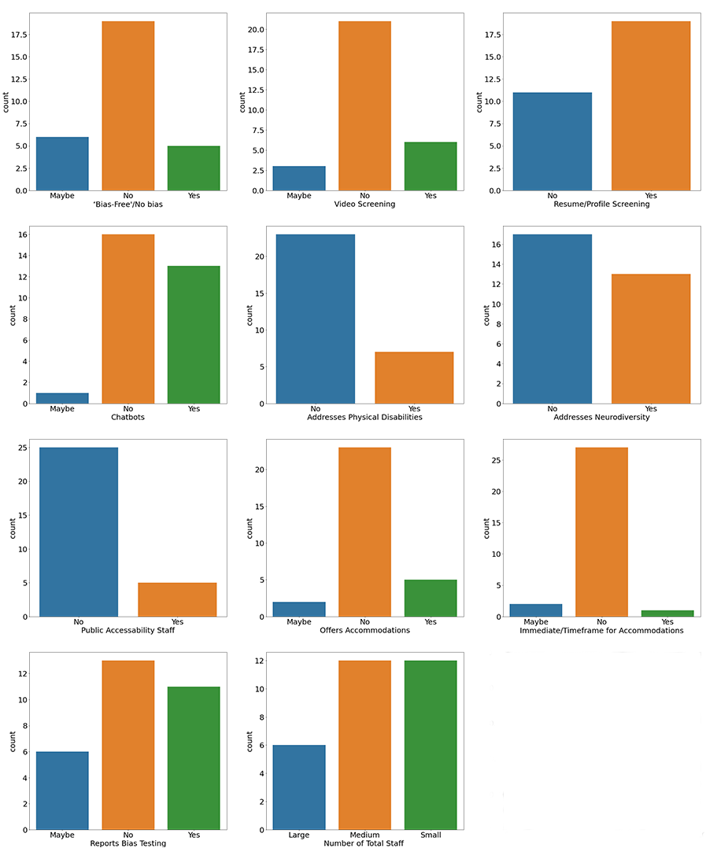

Figure A.1: Frequency of all features shown in bar charts.

The first set of bar charts below shows a holistic view of all 11 features shown in Figure A.1. There are a couple of interesting findings we see here, 23 of the 30 organizations do not offer accommodations and 25 do not have accessibility staff.

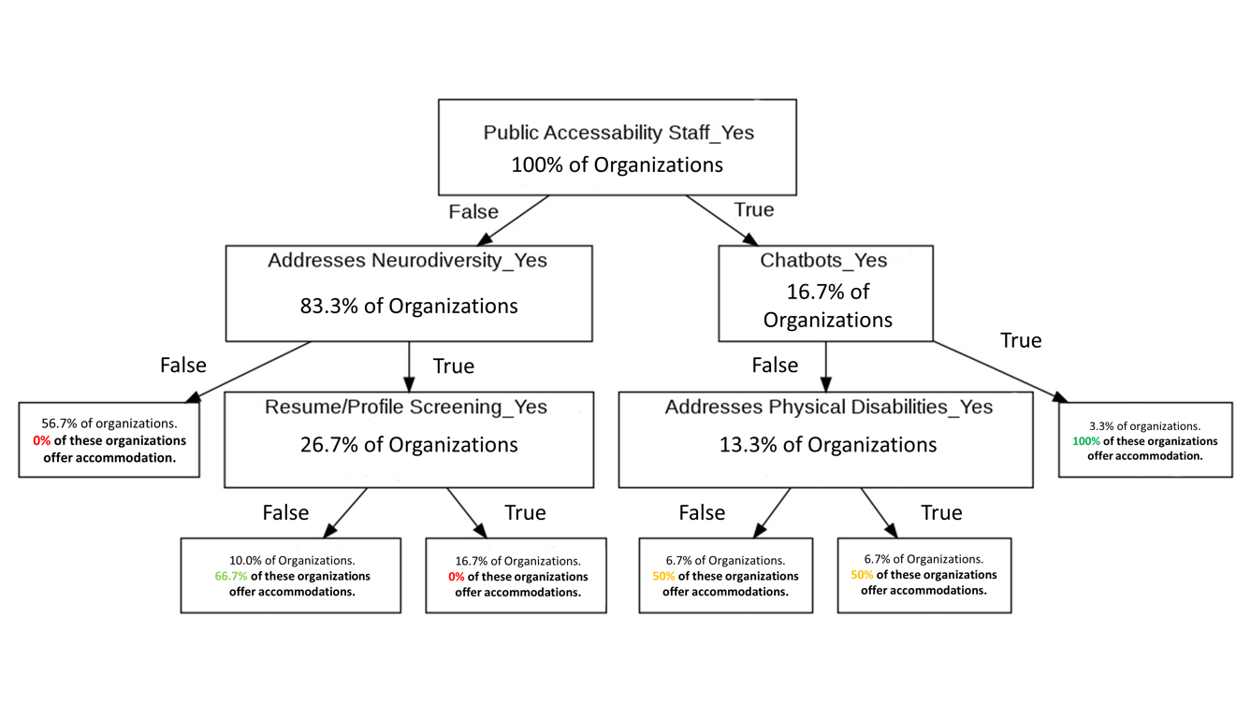

Figure A.2: Decision Tree with Offers Accommodation_Yes as the target

There are a couple of interesting insights to draw from this decision tree shown in Figure A.2. Only 16.7% of Organizations have public evidence of accessibility staff on the organization’s website or LinkedIn and if these organizations have Chatbots also, then 3.3% of the total sample offer accommodations. Another surprising insight is that 83.3% of Organizations have public evidence of accessibility staff on the organization’s website or LinkedIn, and if the organization’s website addresses ways to assist and/or the benefits of hiring neurodivergent candidates also, then 56.7% of the total sample do not offer accommodations.

APPENDIX B