
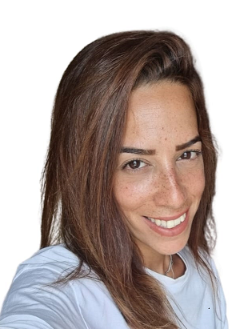  profile  Year of birth: 1988  family status: Single female  Lives in: Beer Sheva, israel  Military service: full service  2006-2008 Computer Network Manager  Matriculation: increased full  Contact info  Phone:  054-6936610  Email:  Aharonihen@gmail.com  hobbies  Learning new fields  Current affairs and politics  Reading books and articles  languages  Hebrew- native  English- Advanced level  Italian intermediate level  computer skills  OFFICE – Full Control  PHOTOSHOP- Full Control  Full control- ILLUSTRATOR |  | hen aharoni  Office manager, customer experience and customer service  education  - Matriculation2000-2006  2006-2007 - Computer network management cours and Vbs  2012-2014 - Fashion design course at miriam colleg  - Graphic design course at Etgar College 2017  Work Experience  District Court, Beer Sheva. Receptionist  2020 -2023  Handling all administrative aspects of legal cases. Monitoring, control and supervision of the conduct of the legal case  Implementation of judicial decisions in the various cases.  Responding to detainees and the security forces with a reception in the court and promoting administrative processes to improve the provided service.  Beer Sheva Municipality customer service 106  2013-2020  Opening and accompanying and malfunctions for the citizens. Guiding the teams handling public inquiries in the field. Managing several events at the same time, working in day and night shifts as needed.  Operation of classified computer systems.  Cellcom service and support representative  2009–2012  Responding to the company's private customers in the stationary world, solving problems and using creativity to improve the feeling of service and the customer experience.  The job includes receiving calls and making proactive calls to customers.  skills  Reliable  Verbal skills  task management  responsibility  straight  leadership  organized

