
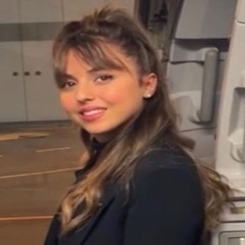


Mais Beke
Date of birth: 17/12/1999 Nationality: Israeli Gender: Female

CONTACT
3081000 Sakhnin, Israel
(Home) Meso.19991712@gmail.com (+972) 505168114

ABOUT ME
Greetings, my name is Mais Beke, a 24-year-old girl; Just finished my Bachelor's Degree in "English Linguistics" at Bar-Ilan University. I am actively seeking opportunities to apply and enhance my skills. Excited about sharing my experiences and learning from others; I am eager to explore opportunities that will contribute to my continual growth in knowledge and experience.

EDUCATION AND TRAINING
01/10/2021 – 30/03/2024 Tel-Aviv, Israel
B.A- English Linguistics Bar-Ilan university

01/10/2023 – 30/03/2024 Kassel, Germany
B.A- English Linguistics Kassel University
I was part of a Student Exchange Program (Erasmus +). I studied in Germany at Kassel University for 6 months and finished with good reference letters.

WORK EXPERIENCE
20/05/2022 – 25/09/2023 Tel-Aviv, Israel
Flight attendant Israir Airlines
- Customer service specialist - Provided exceptional service to passengers, resolving issues and ensuring satisfaction.
- Safety advocate - Eﬀectively communicated safety procedures and enforced compliance with airline regulations.
- Team player - Collaborated with crew members to ensure seamless operation and deliver a positive customer experience.
- Multilingual ﬂuency - Utilized language skills to communicate with diverse passengers and enhance their travel experience.

15/01/2021 – 20/03/2022 Tel-Aviv, Israel
University research assistant Bar-Ilan university
As a research assistant in ISL( Israeli sign language) research, I specialize in data coding, transcription, video editing, and video translating. I meticulously analyze and categorize data, transcribe audio content, and enhance visual materials through video editing. Additionally, my linguistic skills extend to translating video content, contributing to eﬀective cross-cultural communication.

19/07/2019 – 20/09/2020 Sakhnin, Israel
Waitress Toleeb
- Strong communication skills, eﬀectively engaging with customers and team members.

SKILLS
Time management Language analysis Language teaching Research
Critical thinking Transcription Translation Communication Writing
Linguistic analysis Multilingualism

LANGUAGE SKILLS
MOTHER TONGUE(S): Arabic
OTHER LANGUAGE(S): Englsih, Fluent Hebrew, Fluent Turkish, Basic

