
Suleiman Khasheboun
Student, Intern
Contact Information:
Phone: +972549834998 Email: suli.tempmail2022@gmail.com
Address: Israel, Raanana, Haifa, Nazareth (Willing to relocate)
LinkedIn: https://www.linkedin.com/in/suliman-khasheboun-a098472a6

Github: https://github.com/SulimanKh87/
Objective:
Second-year Information Systems and Data Science student with full-stack development and DevOps certification, including proficiency in C and C++.Currently taking courses in Artificial Intelligence and Machine Learning. Seeking an internship to contribute to security projects through robust software development, comprehensive system integration, and effective DevOps practices.
Education:
- Second year student at The Max Stern Yezreel Vally College.
B.Sc. Information Systems and Data Science (Expected 2025)
- GPA: 90~.
Top Skills: System Design, SQL Database, Java, Python.
- IBM Professional Certificates:
- Full-Stack JavaScript Developer (May 2024) - GPA: 95.
Skills: HTML5, CSS, JavaScript, JSON, Node.js, Express, React, Containers, Docker, Kubernetes, NoSQL MongoDB, Microservices, Serverless computing, GitHub, Cloud applications.
- DevOps and Software Engineering (currently have 8 of 13 courses certification - Expected to obtain all by 2024).
Skills: Agile Project Management, Test Cases, Test-Driven Development, Test Automation, Behavior-Driven Development, Software Testing, Application Development, Web Applications, Flask, Python Programming, GitHub, Git, Bash, Linux commands, Communication, Time Management, Shell Scripting, ZenHub, Advanced Troubleshooting, Debugging.
- University of Illinois at Urbana-Champaign (Jan 2024):
- Object-Oriented Data Structures in C++ certificate.
- Grade: 99.
- University of Haifa & Technion, Israel:
- C programming language Certificate (2022) – Grade 83
- Bachelor of Nursing (2014-2018) - GPA: 83.
Languages:
Fluent in English, Hebrew, and Arabic.
Projects:
Backend Development Project (2024):
-Developed a backend web application for exchanging household items
-Implemented secure authentication, continuous integration, and deployment practices.
-Key Skills: MongoDB, React.js, Node.js, RESTful APIs, Kubernetes.
Work Experience:
Volunteer, Local Emergency Medical Clinic (2023) - Provided emergency medical assistance and mentoring to students in medical emergencies.
Mentor, College and Schools (2022-2024) - Mentored college and school students in various subjects including medical and software development.
Registered Nurse, Holy Family Hospital (2019-2023) - Provided medical care in emergency and respiratory departments and ensured adherence to protocols.
Soft Skills:
Strong problem-solving abilities, positive attitude, quick learner, team player, proficient in job and people management, uphold professional ethics.

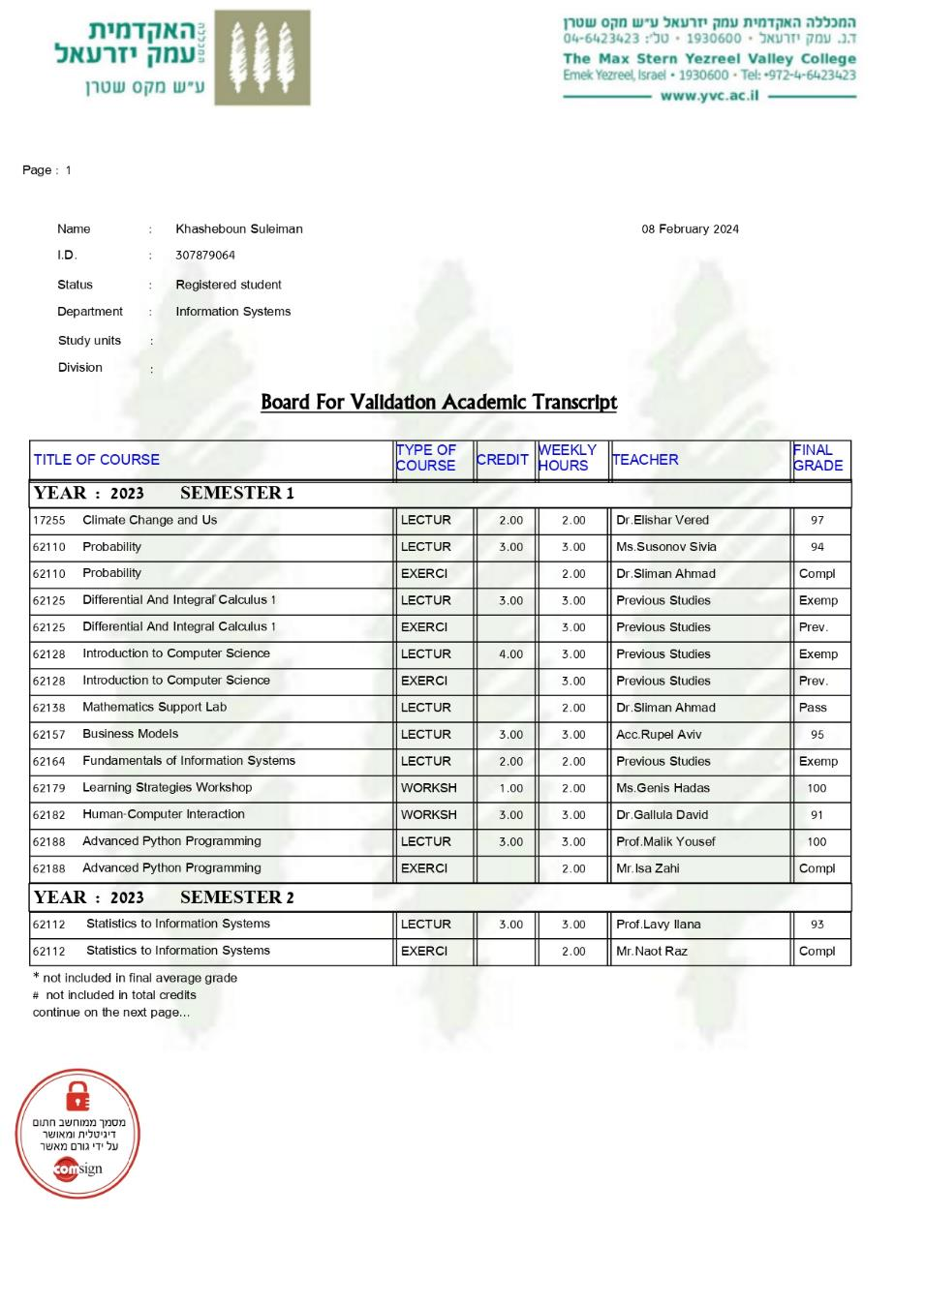

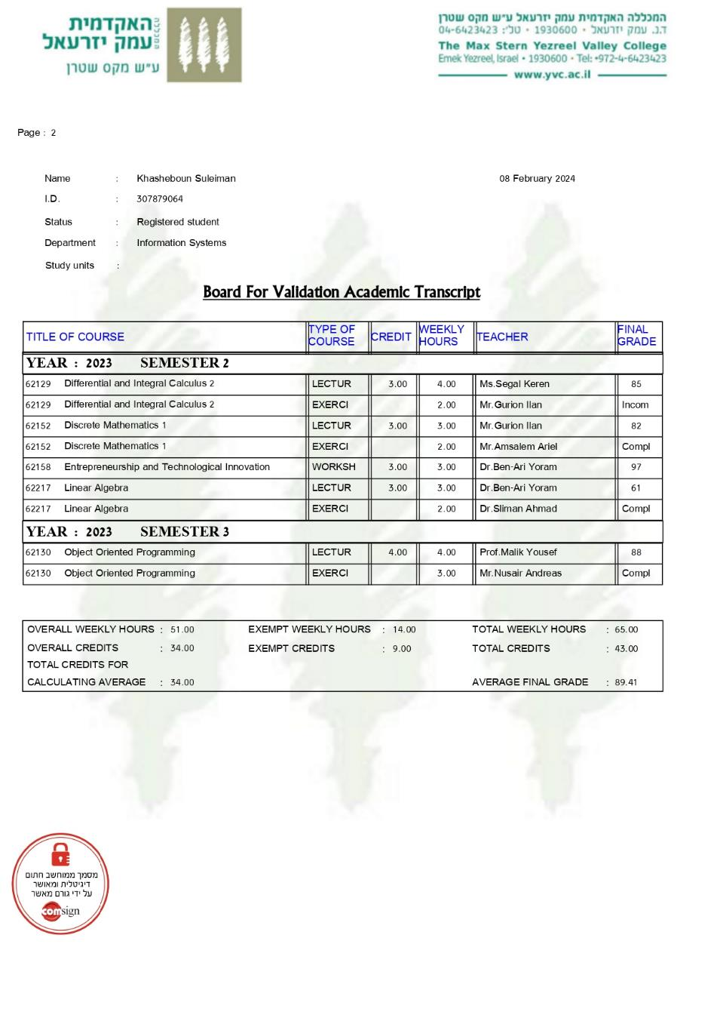

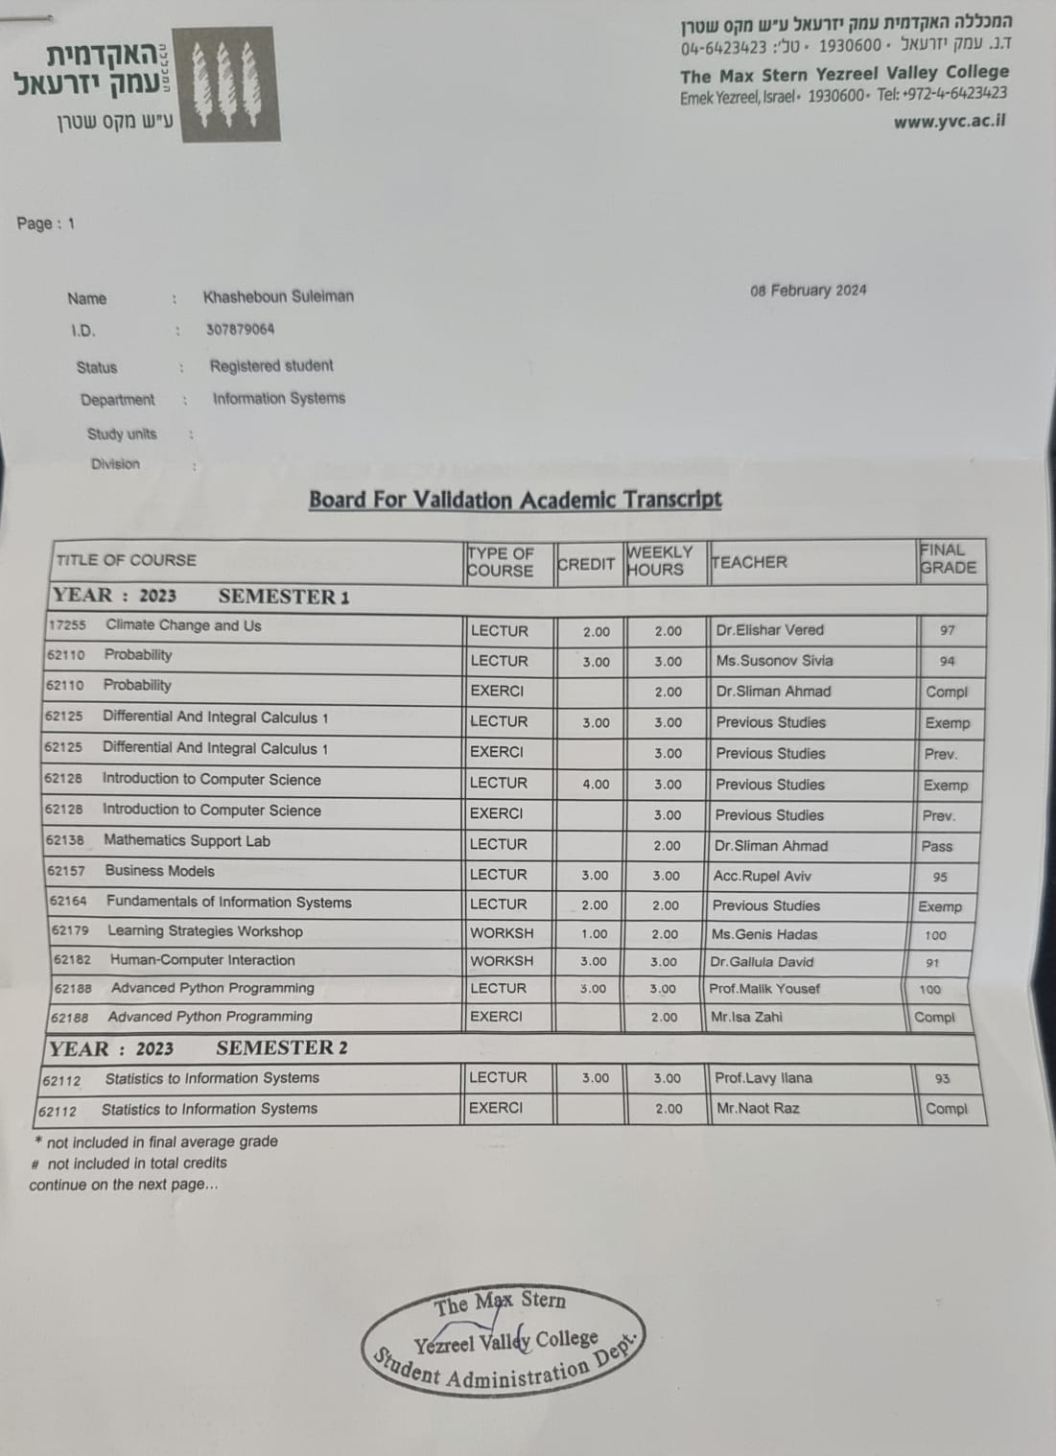
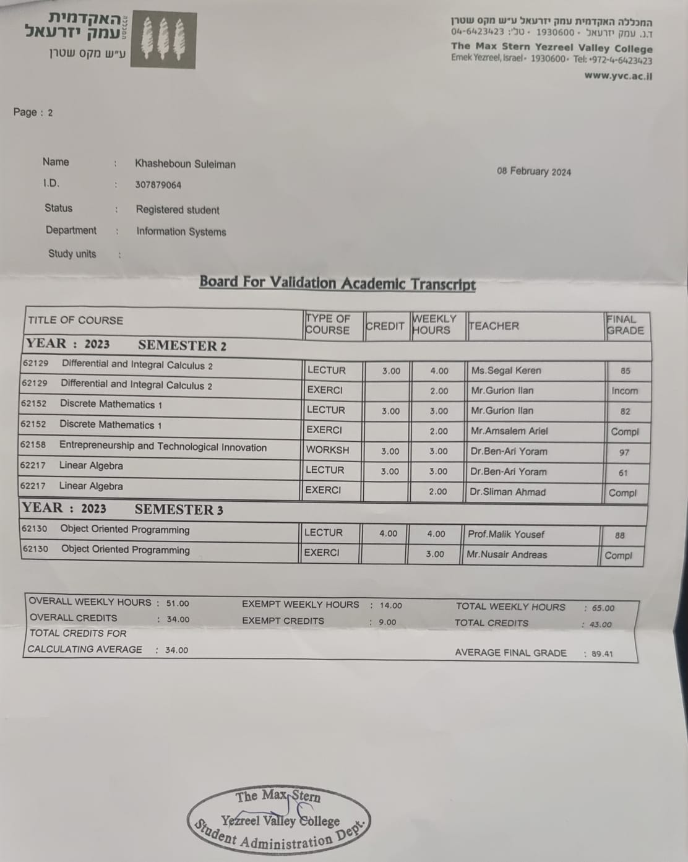

Certifications & Grade sheet (included in my Linkedin profile):

Introduction to Containers w/ Docker, Kubernetes & OpenShift by IBM (2024 May); Credit URL:

https://www.coursera.org/account/accomplishments/records/NC4KDJ2JDDY2

Skills acquired: REST APIs, Representational State Transfer (REST) , Cloud Applications , Cloud , OpenShift , Microservices , Serverless Framework.

Introduction to Containers w/ Docker, Kubernetes & OpenShift by IBM (2024 April); Credit URL:

https://www.coursera.org/account/accomplishments/records/QPWHZJ2PDQ52

Skills acquired: OpenShift, Docker, Kubernetes, Containers, Cloud Native.

Developing Back-End Apps with Node.js and Express by IBM (2024 April); Credit URL:

https://www.coursera.org/account/accomplishments/records/TYCT6W3YF4WG

Skills acquired: Node.js · JavaScript · Express · Server Side JavaScript · Server Side Programming · npm · asynchronous callback · Web Development · Back-End Web Development.

JavaScript Programming Essentials by IBM (2024 April); Credit URL:

https://www.coursera.org/account/accomplishments/records/TYCT6W3YF4WG

Skills acquired: AJAX · JSON · JavaScript

Introduction to HTML, CSS, & JavaScript by IBM (2024 April); Credit URL:

https://www.coursera.org/account/accomplishments/records/N2XH6GJXLAKH

Skills acquired: HTML · Cascading Style Sheets (CSS) · JavaScript · HTML5

Developing AI Applications with Python and Flask by IBM (2024 Feb); Credit URL: https://www.coursera.org/account/accomplishments/records/J2CYEFKF5PEH

Skills acquired: Application Development, Artificial Intelligence (AI) , Web Applications, PEP8, Flask, Python programming, creating packages , Matplotlib ,unittest.

Python for Data Science, AI & Development by IBM (2024 Jan); Credit URL: https://www.coursera.org/account/accomplishments/records/3HN8P2ZSTZYP

Skills acquired: Panda, NumPy, Python programming

Getting Started with Git and GitHub by IBM (2024 Jan); Credit URL: https://www.coursera.org/account/accomplishments/records/2B8EJ39EBXRM Skills acquired: Github, Git, Bash

Object-Oriented Data Structures in C++(2024 January): Issued by University of Illinois at Urbana-Champaign ; Credit URL: https://www.coursera.org/account/accomplishments/records/7URT5K7X59MH

Skills acquired: C++ programming, Ubuntu, WSL, PowerShell, Windows, Operation System, Bash, Terminal commands.

Troubleshooting and Debugging Techniques (2024 January): Issued by Google; Credit URL: https://www.coursera.org/account/accomplishments/records/CGRM2QFFL23A

Skills acquired: Python debugging, Linux commands, Bash, Understanding Errors, Advanced Troubleshooting, Improving Software Performance, Debugging: using print, assert, try catch, pdb debugging, breakpoints, Communication and Documentation During Incidents, Time management, Eisenhower Decision Matrix, Rubber duck.

Hands-on Introduction to Linux Commands and Shell Scripting (2024 January): Issued by IBM; Credit URL: https://www.coursera.org/account/accomplishments/records/PZVSU7D8TEFH

Skills acquired: Shell Scripting, Bash, Linux, Linux commands Shell.

Introduction to Agile Development and Scrum (2024 January): Issued by IBM; Credit URL: https://www.coursera.org/account/accomplishments/records/DAXKPKAKWWGS

Skills acquired: ZenHub, GitHub, Agile Project Management, Test Cases, Scrum Test-Driven Development, Test Automation Behavior-Driven Development (BDD), Software Testing.

Introduction to DevOps (2024 January): Issued by IBM; Credit URL: https://www.coursera.org/account/accomplishments/records/4CQUHK29KCD5

Introduction to Cloud Computing (2024 January): Issued by IBM; Credit URL: https://www.coursera.org/account/accomplishments/records/NRSW6YBUL2VB

