

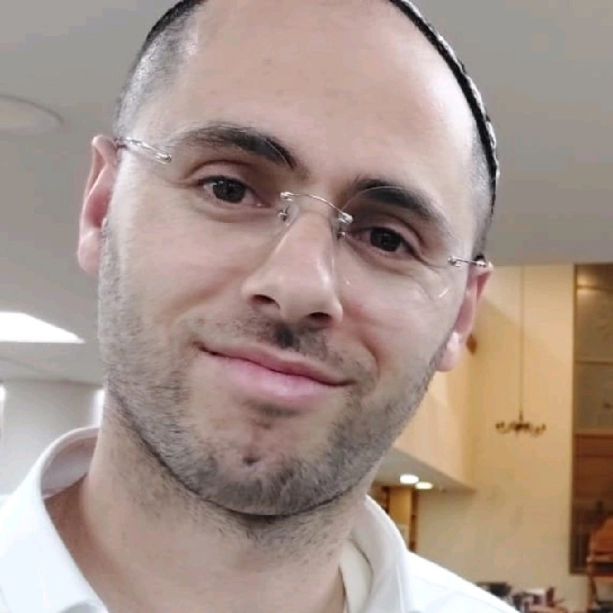 | Eliran B.  Senior Full Stack Developer

Tel | 0585884444
Email | cv2024@zoro.33mail.com
LinkedIn | https://www.linkedin.com/in/eliran-b-0792a95b
GitHub | https://github.com/elyran
StackOverflow | https://stackoverflow.com/users/286260

Technical skills
Languages: JavaScript / TypeScript, HTML, CSS, PHP, C++
Frontend | ||||||||||||||||||||||||||||||||||||||||||||| | 9.5 / 10
Backend | |||||||||||||||||||||||||||||||||||||||| | 8 / 10
DevOps & Cloud | ||||||||||||||||||||||||| | 5 / 10
Frontend: JavaScript / TypeScript; ReactJS, React Native; Bootstrap & Material Design; Responsive design; SCSS, Tailwind; State management; APIs & Social networks integration; Browser extensions;
Backend: NodeJS; Express, Nest; SQL / NoSQL, MongoDB;
DevOps & Cloud: AWS; Docker; Automation, Puppeteer, Selenium;

Education
Languages: Hebrew (native), English (professional)
Certificates: 2005 Microsoft Certified Solutions Associate (MCSA)

About myself
A highly caffeinated full stack developer ahead! With years and thousands of hours of experience in building web and mobile applications, I'm the superhero your team needs to save the day!
By day, I'm a master of Node, crafting servers and APIs that make users go "Whoa, how did they do that?!". By night, I'm a React, Redux, and React Native ninja, building seamless user experiences that make people wonder if I'm secretly a coding wizard.
I'm a team player, a problem-solver, and a lifelong learner. If you're looking for someone who can bring your vision to life with cutting-edge tech, a healthy dose of humor, and a passion for innovation, let's collaborate and build something amazing together! Let's code like the future of the internet depends on it (because it does)!

Professional experience
Currently: Full Stack Developer
- Working with various tech and startup companies
- Both as consultant and as an hands on developer
- React.js + Node.js
2021-2022: Frontend Developer at Assured Allies
- Achievement: Developed a complex React.js frontend (states, routes, media [audio, video]) from zero to demo-level within about a year
- React.js (TypeScript), Storybook + Chromatic visual testing, testing suits
2020-2020: Senior Full Stack Developer at Israel Hayom
- Achievement: Developed a functional publishing system core, from idea to product
- Next.js, React.js and Elementor (a prominent WordPress page builder plugin)
- Creatively solved system design challenges in the process of integrating the above mentioned technologies, while keeping performance and long term maintenance in mind
2018-2019: Senior Full Stack Developer at StoreSuccess
- Achievement: End to end development from idea to production in less than half a year
- Including backend (Node.js + Express), frontend (React.js) and a 3rd-party JavaScript library that integrates with Shopify, so store owners can enhance user experience and earn more
2017-2018: Senior Frontend Developer at excced.ai
- Achievement: From zero to almost production-level
- Lead Frontend (React.js) developer
2012-2013: Senior Full Stack Developer at driivz
- Lead Frontend developer
- Backbone.js + Cordova for Mobile version
2011-2012: Backend Developer at Teleclal
- Backend developer
- PHP + MySQL
2011-2011: Frontend Developer at AtlasCT
- JavaScript + HTML
2008-2008: IT instructor at HackerU
- Teached students for the Microsoft Certified Solutions Expert (MCSE) certification
Thank you for taking the time to review my application. Looking forward to hearing from you!

