

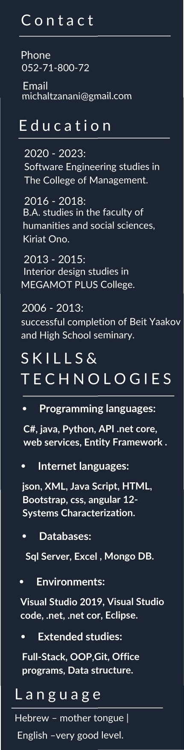
Michal Levi

SOFTWARE DEVELOPER

PROFILE
Highly motivated to succeed, autodidactic, analytical abilities, very responsible and persevering, high work ethic. Great interpersonal communication skills and excellent at teamwork.

WORK EXPERIENCE

2023

Final project:
"Perfect"- a website for a bakery_
The site offers advanced management of the "Perfect" boutique confectionery which enables purchasing products and ordering a personal designed products online, The site was created by using a smart code and a smart characterization and was planned along with personal design and concept. This was done according to the client's request to increase revenue and streamline the business. Server-side development: C#, client-side: Angular, database connection: SQL. Using REST APIs and JWT for information security, website registration, user experience, and validation tests.
2021-2023
Projects created during studies
- development of a Tic Tac Toe Game.
- Built a website for a travel agency.
Both projects included analyzing the system and breaking down the project in steps. Complete control in ANGULAR, JSON and BOOTSTRAP were required to carry out the projects.

2018 - today:
- planning security systems in the technologies and projects division at "G1", a protection and security company.
2016 - 2017:
- Draftsman in "Zaid Orniv" company.
- Volunteering at Sheba Hospital
2010 - 2016:
Counselor in schools and in HAMASCIL organization.

2009 - 2011 :
Counselor in a youth organization.

