
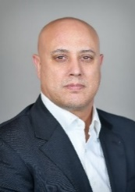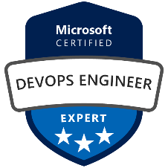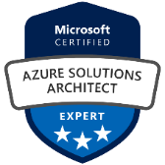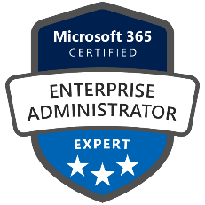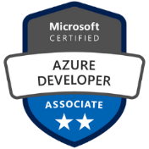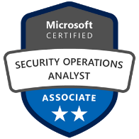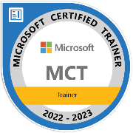
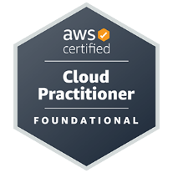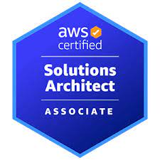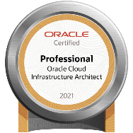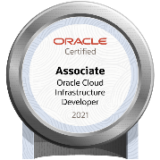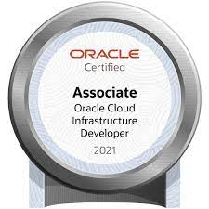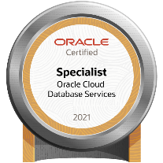

About me:

Name: Meir Assulin
Mobile: +972 53 5900092
Email: meia4299@gmail.com
Home: Kfar-Yona, Israel
Date of Birth: 28.01.1976, Married+2
Linkedin : https://www.linkedin.com/in/meir-assulin-191269166/

Profile:
Cyber Security Consultant in Cyber Risk Advisory and DevOps engineer (recently) more than 4 years’ experience in the Networking ,3 Microsoft Cloud Expertise, & 1 Specialty, MCT (Microsoft Certified Trainer)
IaC (Infrastructure as Code) Tools such Terraform, ARM Templates Information Security and Hacking. Diploma in Cyber security Practitioner With specialization in Cyber Security Defense, also Certified Ethical Hacker C|EH V10. Azure Administrator Associate.

Experience:

UplandSoftware – Cloud Security & Operation Engineer (AWS)

12/2021-Today

My last project was migrating our entire infrastructure from a physical datacenter to AWS, including QA, Staging, Pilot and Production, a total of over 200 servers.
After the migration I maintain a healthy environment on a day to day basis.
On AWS I specialize in VPC, EC2, S3, FSx, Route53, RDS, and Cloudwatch.

Sapiens – Cloud & SRE

5/2021-Today

Providing architectural guidance to the cloud engineers & DevOps organization. Responsible for architecting, building, and migrating enterprise high scale applications within Oracle Cloud Infrastructure, Microsoft Azure and AWS. Kubernetes (eks/aks) - managed container service to run and scale Kubernetes applications in the cloud or on-premises.

12/2019-12/2020
Cloud Cyber Risk Services | Consultant
Filled a meaningful role in Azure cloud security controls / Azure DevOps and Assessment project for US Base Projects. Reviewing Azure security architecture, Azure Identity architecture/design, Azure RBAC roles and design, Azure management group structure. Azure cloud security and cloud cyber risk consulting for US based customers
- Oracle Cloud Database Services 2021 Specialist (1Z0-1093-21)
- Oracle Cloud Infrastructure Certified Cloud Operations 2021 Associate (1Z0-1067-21)
- Oracle Cloud Infrastructure Developer 2021 Associate (1Z0-1084-21)
- Oracle Cloud Infrastructure Architect 2021 Associate (1Z0-1072-21)
- Oracle Cloud Infrastructure Architect 2021 Professional [1Z0-997-21]
- Oracle Autonomous Database 2021 Specialist (1Z0-931-21)
- Certified in Cloud Security Knowledge V4 by CSA.
- LE-1:Linux Essentials ,LPI
- Microsoft Azure Administrator Associate –Microsoft.
- AWS-Certified Cloud Practitioner.
- Microsoft Azure Security Engineer Associate.
- MCT-Microsoft Certified Trainer , 2022-2023.
- Microsoft Azure Solution Architect Expert
- Microsoft Azure DevOps Engineer Expert
- Microsoft 365 Certified: Teams Administrator Associate (MS-700)
- Microsoft 365 Certified: Enterprise Administrator Expert
- Specialty: Microsoft Certified: Azure for SAP Workloads Specialty
- Terraform
- Microsoft Azure Developer Associate

Israel Main Hotelier School Ltd. TADMOR
05/2017-03/2020

SysAdmin - Cloud Technologies and Security, Vulnerability Analysis, Server 2012/2016, Windows , Good knowledge in Linux, Risk-Assessment, Basic Programing and scripting - html, python, bash JavaScript, SQL, Networking- Firewalls (Checkpoint ,Fortinet),Antivirus (Eset).
Active directory- Active Directory stores data, objects. Object -single element, such as a user, group, application or device, such as a printer. Define as either resources - such as printers or computers -or security principals - such as users or groups.

Providing Active Directory Security Best Practices:
- Clean up the Domain Admins Group
- Use least two accounts (Regular and admin account)
- Secure the domain administrator account.
- Disable the Local Administrator Account (on all computers)
- Use Local Administrator Password Solution (LAPS)
- Use a Secure Admin Workstation (SAW)
- Enable Audit policy Settings with Group Policy
- Monitor Active Directory Events for Signs of Compromise
- Password Complexity Sucks (Use Passphrases Instead)
- Use Descriptive Security Group Names
- Continues Patch Management & Vulnerability Scanning

Education:
- INT College -2017-2019, MCSA- 2017-2018,Cyber Security Practitioner
- Certified Ethical Hacker C|EH v10 , 2020
- CCSK V.4 by CSA (In Progress), 2020
- Microsoft Azure Security Engineer Associate,2020
- Microsoft Azure Solution Architect Expert,2020
- Microsoft Azure DevOps Engineer Expert,2020
- Microsoft 365 Certified: Enterprise Administrator Expert,2021

Technical Skills:
- Kali Linux, Ubuntu , Windows 7/8/10 , Microsoft Servers -2008/2012/2016/2019
- Servers 2012- 2016 Microsoft (active Directory).
- JavaScript, HTML, SQL.
- Methodology And Procedure in Cyber Security Defense
- Network Security
- AWS Security solutions (Guard Duty , AWS Shield)

