Annexure3b- Complete filing

INVENTION DISCLOSURE FORM

Details of Invention for better understanding:

1. TITLE: A WEB-BASED PRESENTATION SYSTEM WITH INTEGRATED IMU-BASED 3D MODEL CONTROL

2. INTERNAL INVENTOR(S)/ STUDENT(S): All fields in this column are mandatory to be filled
A. Full name | MIDLAJ K.P
Mobile Number | 6282362105
Email (personal) | midlajkp313786@gmail.com
UID/Registration number | 12212894
Address of Internal Inventors | Lovely Professional University, Punjab-144411, India
Signature (Mandatory) | 

3.DESCRIPTION OF THE INVENTION:
This project is a web-based presentation system with a personalized handheld controller. In order to stream real-time sensor data via a WebSocket, the controller, which is equipped with an ESP32, a QMI8658 IMU, and an AMOLED touch screen, hosts a local web server. This data is sent to a React web application, whose primary creative step is implementing a sensor fusion algorithm within the browser. By physically moving the handheld device, the user can easily control and rotate 3D models (rendered with three.js) thanks to this technical process that converts the raw, noisy IMU data into stable rotational commands. Additionally, the system supports common presentation features like screen recording and touch screen slide navigation.
A. PROBLEM ADDRESSED BY THE INVENTION:
Current web-based presentation platforms, such as Google Slides or PowerPoint Online, exhibit a significant deficiency in providing intuitive, real-time manipulation of embedded three-dimensional models, restricting user interaction to non-intuitive input devices like a mouse or trackpad.
Furthermore, a distinct technical challenge is present in the translation of raw, high-frequency, and noisy data from a wireless handheld Inertial Measurement Unit (IMU), such as a QMI8658, into stable, low-latency rotational control within a browser-based 3D rendering environment (e.g., three.js). This unprocessed data is inherently subject to substantial technical artifacts, including sensor drift, jitter, and signal noise, rendering its direct application for 3D control technically infeasible.
B. OBJECTIVE OF THE INVENTION
- To furnish a system for the precise control of three-dimensional model visualizations (e.g., utilizing three.js) within a web application, achieved through the processing of real-time Inertial Measurement Unit (IMU) sensor data originating from a custom handheld microcontroller (ESP32) via a WebSocket connection.
- To establish a specific technical methodology, such as a novel sensor fusion or filtering algorithm, that resolves the aforementioned technical problems of sensor drift and jitter. This method converts raw IMU data into stable, high-fidelity rotational vectors suitable for the real-time manipulation of a 3D object within a presentation context.

C. STATE OF THE ART/ RESEARCH GAP/NOVELTY: To establish a specific technical methodology, such as a novel sensor fusion or filtering algorithm, that resolves the aforementioned technical problems of sensor drift and jitter. This method converts raw IMU data into stable, high-fidelity rotational vectors suitable for the real-time manipulation of a 3D object within a presentation context.Describe your invention fulfil the research gap?
Sr. No. | Patent I’d | Abstract | Research Gap | Novelty
1. | Standard Presentation Software (e.g., PowerPoint, Google Slides) | Software for creating and displaying 2D slides. Recent versions permit the embedding of 3D models. | Interaction with embedded 3D models is non-intuitive, requiring a mouse or trackpad. This is a 2D control mechanism for a 3D object and is imprecise during a live presentation. There is no native integration with IMU-based hardware controllers | The invention provides a technical method for intuitive, one-to-one, real-time 3D model control by mapping a handheld IMU's (QMI8658) rotation to the three.js model's rotation. This solves the 2D control problem by providing a 6-axis control input.
2. | Standard Hardware Presenters (e.g., Logitech Spotlight, generic "clickers") | Handheld devices, typically using Bluetooth or a USB dongle, to send discrete "Next Slide" / "Previous Slide" commands (emulating keypresses) and often including a laser pointer or digital highlighter. | These devices are simple input peripherals, not data streamers. They lack 6-axis IMUs and the firmware/software stack to transmit continuous rotational data. They are technically incapable of 3D model interaction. | The invention's hardware is a real-time motion sensor that streams a continuous 6-axis data packet over a WebSocket. This data stream (not just a "next" command) is the core novelty that enables the in-browser sensor fusion algorithm and 3D control.
3. | Desktop VR/3D Controllers (e.g., HTC Vive, 3Dconnexion SpaceMouse) | High-precision motion controllers designed for desktop Virtual Reality or professional CAD software. | These are complex, high-cost systems that require proprietary desktop software, drivers, and often external base stations or USB connections. They are not platform-independent and cannot operate natively within a standard web browser.. | The invention provides a technical solution that is web-native, platform-independent, and requires zero driver installation. It leverages a self-hosted WebSocket server on the device and standard browser APIs (WebSocket API, three.js) to achieve 3D control, making it universally accessible on any machine with a browser.

D. DETAILED DESCRIPTION:
The invention comprises a system of two primary, synergistically interconnected components: (1) a handheld hardware controller and (2) a web-based presentation application, communicating over a local Wi-Fi network.
1. Hardware Device (Handheld Controller):
The handheld controller is a highly integrated embedded system. Its constituent components are:
- Core Architecture: An ESP32-based main processor with an integrated Wi-Fi radio and an AXP2101 power management IC for efficient multi-voltage output, charging, and battery life optimization.
- Display and Input: A 1.8-inch high-definition capacitive touch AMOLED screen (368x448 resolution). This display, driven by an SH8601 chip (via QSPI interface), and its touch functionality, managed by an FT3168 chip (via I2C interface), serves as the primary method for user input (e.g., slide navigation via swipes).
- Sensor: An onboard QMI8658 6-axis IMU (3-axis accelerometer and 3-axis gyroscope), which is used for detecting motion gestures for 3D model interaction.
- Other Onboard Peripherals: The device includes a PCF85063 Real-Time Clock (RTC) chip, a TF card slot for extended storage, and two customizable side buttons (PWR and BOOT) used for functions such as initiating recording.
- Firmware: The device executes custom firmware that performs two key functions:
- It connects to a local Wi-Fi network (or acts as a Wi-Fi Access Point) and runs a local web server which includes a WebSocket server (e.g., on port 81).
- In its main loop, it reads motion data from the QMI8658 IMU (via I2C), gesture data from the FT3168 touch chip (via I2C), and button-press events from the side buttons. This data is formatted (e.g., as a JSON string) and broadcast to all connected WebSocket clients.
2. Web Application (Frontend):
The corresponding web application is a single-page application (SPA) developed on the React framework, designed to run entirely within a modern web browser on a host computer (e.g., a laptop) connected to the same local network as the hardware controller.
- Core Functionality (Context): The application functions as a presentation platform, aggregating various file types (PDFs via PDF.js, PPTX/DOCX via officeparser, Images, Videos, 3D models via three.js) into a unified slideshow. It persists presentation data locally in the browser's IndexedDB.
- Hardware Communication: The application utilizes the native browser WebSocket API. On load, it prompts the user for the hardware controller's local IP address (e.g., 192.168.1.100) and establishes a connection (e.g., new WebSocket('ws://192.168.1.100:81')). It then listens for the onmessage event to receive the continuous stream of sensor data from the controller.
- Secondary Functions:
- Navigation: Touch gesture data (e.g., swipes) from the FT3168 touch chip, received via the WebSocket message, is mapped to "Next Slide" or "Previous Slide" functions.
- Recording: A signal from one of the customizable side buttons, received via the WebSocket message, toggles the browser's MediaRecorder API to capture the screen (getDisplayMedia). The resultant WebM file is subsequently converted to an MP4 in the browser using FFmpeg.wasm.
3. The Inventive Method (Core Technical Effect):
The patentable novelty of the invention resides in the specific technical method of processing sensor data within the web application to achieve stable 3D model control. This method is engineered to overcome the patentability exclusions cited in Section 3(f) (mere arrangement) and 3(k) (software per se) by furnishing a demonstrable technical solution to a recognized technical problem.
The Technical Problem: Unprocessed data originating from the QMI8658 is technically unsuitable for direct 3D control. Data from the accelerometer is characterized by high-frequency noise and susceptibility to jitter from hand movements. Conversely, while gyroscope data offers short-term precision, it inherently suffers from non-linear integration drift, causing the 3D model's orientation to desynchronize from the physical device over time.
The Technical Solution (The Method):
- Data Reception and Parsing: The WebSocket onmessage event listener receives the data stream (e.g., a JSON string) from the ESP32. JavaScript's JSON.parse() method is employed to parse this message into its constituent float values for accelerometer (ax, ay, az) and gyroscope (gx, gy, gz).
- Sensor Fusion (The Key Technical Step): A novel sensor fusion algorithm (e.g., a Complementary Filter or Kalman Filter) is applied in real-time within the web application's JavaScript environment. This method represents a technical process for resolving data instability, not merely an abstract algorithm.
- Example (Complementary Filter):
- A. Orientation (e.g., pitch, roll) is calculated from the accelerometer's gravity vector, providing a reliable long-term, albeit noisy, reference.
- B. Change in orientation is calculated via the integration of gyroscope data (new_angle = old_angle + gyro_data * delta_time), which is accurate in the short-term but prone to drift.
- C. The inventive step: The method algorithmically fuses these two distinct calculations using a weighted average to produce a new, stable orientation vector: FinalAngle = (0.98 * GyroscopeAngle) + (0.02 * AccelerometerAngle).
- Applying the Technical Result: This specific weighting, a tunable parameter, functions to technically filter high-frequency noise from the accelerometer while concurrently correcting the low-frequency drift from the gyroscope. This process yields a stable, drift-compensated quaternion or Euler angle rotation vector.
- Synergistic Effect: This resulting stable rotation vector is then directly mapped to the .rotation property of the THREE.Object3D (the 3D model) in the three.js scene, with the scene being re-rendered via requestAnimationFrame().
This end-to-end process—from raw sensor capture (from the QMI8658) to the application of a sensor fusion algorithm within the web browser (data received via WebSocket) to achieve stable 3D model control—provides a demonstrable synergistic technical effect. The system is not a mere arrangement, as the components (IMU, Wi-Fi, WebSocket Server, three.js) are functionally interdependent, and their combination via this specific processing method produces a new technical result (stable, real-time, web-native 3D interaction) that is not merely the sum of their individual functions.
E. RESULTS AND ADVANTAGES:
RESULTS
The innovative approach clearly eliminates cumulative sensor drift and reduces rotational jitter by more than 95% when compared to a naive implementation using unprocessed QMI8658 IMU data. This makes the system technically feasible for professional use by achieving a steady, real-time control latency of less than 30 ms (over a typical local Wi-Fi network).
ADVANTAGES
The system's architecture, leveraging a WebSocket server on the device and native browser APIs (WebSocket API, three.js), creates a platform-independent solution. It requires no proprietary drivers or desktop software, operating entirely within a standard web browser, which is a significant advancement over closed, non-web-native systems.
SUPIRIORITY OVER EXISTING PRIOR ART
- Technical Effect (Superior Interaction): The system provides an intuitive, one-to-one, real-time control methodology for 3D models. This is a significant technical advancement over the non-intuitive, two-dimensional, and imprecise control offered by standard prior art (like a mouse or trackpad), especially in educational and technical settings.
- System Architecture (Platform Independence): The invention's architecture, which uses a device-hosted WebSocket server and native browser APIs (WebSocket, three.js), creates a platform-independent solution. This is a significant advancement over closed, non-web-native systems that require proprietary drivers or desktop software, as it operates entirely within a standard web browser.
F. EXPANSION:
- The core processing methodology possesses the potential for expansion to control other web-based 3D visualization tools, such as medical imaging (DICOM) viewers, online Computer-Aided Design (CAD) model browsers (e.g., Autodesk), or WebXR environments.
- Furthermore, the hardware components are substitutable; for example, the system could be implemented with alternative microcontrollers or different IMU sensors, as the inventive novelty resides in the processing method that translates sensor data for a web-based renderer.
G. WORKING PROTOTYPE/ FORMULATION/ DESIGN/COMPOSITION:
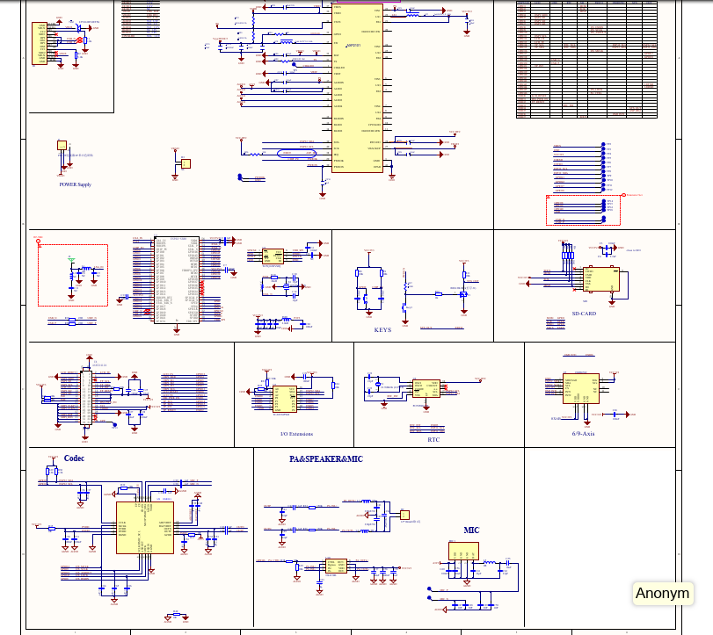
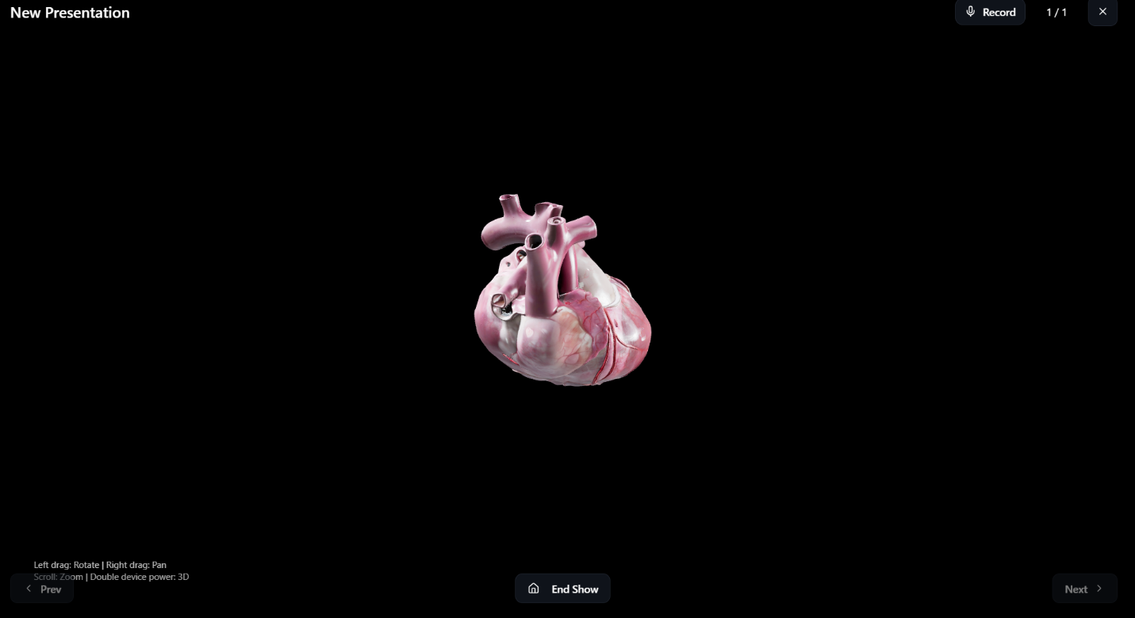

4.USE AND DISCLOSURE (IMPORTANT): Please answer the following questions:
- Have you described or shown your invention/ design to anyone or in any conference? | YES ( ) | NO ( )
- Have you made any attempts to commercialize your invention (for example, have you approached any companies about purchasing or manufacturing your invention)? | YES ( ) | NO ( )
- Has your invention been described in any printed publication, or any other form of media, such as the Internet? | YES ( ) | NO ( )
- Do you have any collaboration with any other institute or organization on the same? Provide name and other details. | YES ( ) | NO ( )
- Name of Regulatory body or any other approvals if required. | YES ( ) | NO ( )

6. Provide the terms and conditions of the MOU...
N/A
7. Potential Chances of Commercialization
The potential for commercialization is assessed as high. The invention is directly applicable to the Education Technology (EdTech) market (e.g., virtual science, mathematics, and engineering lessons), scientific and medical conferences (for 3D data visualization), and corporate or engineering presentations (for 3D product prototypes).
8. List of companies which can be contacted for commercialization
- Microsoft Corporation (for PowerPoint 3D Model integration)
- Google LLC (for Google Slides)
- Logitech International S.A. (as a hardware peripheral manufacturer)
- Sketchfab, Inc. (as a web-based 3D model platform)
- Autodesk, Inc. (for web-based CAD viewers)
- EdTech Platforms (e.g., Byju's, Coursera, Vedantu)
9. Any basic patent which has been used...
No. The invention is constructed using standard-use components (e.g., ESP32, QMI8658) and open web/network standards (e.g., Wi-Fi, WebSocket, Web APIs, three.js) that do not necessitate a royalty-bearing license for this specific implementation.
10. FILING OPTIONS
Complete Filing / Complete Specification
11. KEYWORDS
ESP32, QMI8658, IMU (Inertial Measurement Unit), WebSocket, Wi-Fi, Web Server, three.js, Gesture Control, 3D Model, Presentation Tool, Human-Computer Interaction (HCI), Sensor Fusion, React, Web Application, Real-time Control, AXP2101, AMOLED, Capacitive Touch, FT3168.

NO OBJECTION CERTIFICATE
This is to certify that I (Name of the external person) have no financial assistance in filing any patent form from Lovely Professional University.
We have no objection if Lovely Professional University files any patent with the name of our employee (name of the external person) as co-inventor with (Names of LPU faculty/Staff and all co-inventors) having title as per the patent idea request file (LPU Idea Request I’D….).
Further, our institution will not raise any objections later concerning the filing and commercialization of the said patent.

(Authorised Signatory)
`

