RETAIL STORE
PERFORMANCE & PROFITABILITY
Findings, Business Insights and Recommendations
A business-focused report interpreting a simulated 1,000-transaction retail dataset across products, categories, stores, cities, sales channels and discount bands.
Reporting period | 1 January – 31 December 2025
Dataset | 1,000 synthetic order records
Tools | Microsoft Excel, Power Query, Microsoft Power BI, DAX MS Word
Purpose | Case study and practice in business analysis

Important data note
All figures in this report are calculated from the supplied synthetic dataset and are for portfolio demonstration only. The currency symbol follows the current dashboard formatting; confirm the intended currency basis before using this report outside the practice project.

Prepared as a decision-support report, not an audited financial statement.

1. Executive Summary
This report reviews the performance of a simulated multi-store retailer during calendar year 2025. The analysis focuses on net sales, gross profit, margin, products and categories, store and city performance, sales channels, customer segments, discount levels and monthly trends. The goal is to translate the Power BI visuals into clear findings and practical actions that management could test.
Headline conclusion
The retailer generated $2.962 million in net sales and $985.74 thousand in gross profit, producing a gross profit margin of 33.28%. The most important follow-up areas are discount governance, Grocery category economics, and understanding why the leading store by sales is not the leading store by gross profit.

Performance Scorecard
KPI | 2025 Result | How to interpret it
Gross Sales | $3,150,369.78 | Sales before discounts
Discount Amount | $188,781.84 | Discounts reduced gross sales by 5.99% overall
Net Sales | $2,961,587.94 | Revenue after discounts; primary sales measure
Cost of Goods Sold (COGS) | $1,975,852.02 | Product cost assigned to the transactions
Gross Profit | $985,735.92 | Net Sales less COGS
Gross Profit Margin | 33.28% | Gross Profit divided by Net Sales
Orders | 1,000 | All order IDs are unique in the source file
Units Sold | 2,226 | Average 2.23 units per order
Unique Customers | 369 | Distinct customer IDs in the dataset
Average Order Value | $2,961.59 | Net Sales divided by Orders

Key messages for management
- Electronics is the largest category by net sales, but Fashion has the strongest category gross margin.
- Karachi Clifton generates the highest gross profit even though Lahore Central leads by net sales.
- Transactions discounted by more than 10% have a materially lower observed margin than transactions with no discount.
- Online sales are a smaller share of the business, while the observed gross margins of Online and In-Store are similar.
- Monthly sales fluctuate sharply; the July peak and August low merit investigation before the next planning cycle.

2. Product and Category Findings

Finding 1 — Electronics leads sales, Fashion leads margin.
Electronics generated $817,753.32 in net sales, equal to 27.61% of the retailer’s total sales, and delivered $267,450.30 in gross profit. Fashion generated $715,101.91 in sales and achieved the highest category gross margin at 36.61%. Grocery had the lowest margin category at 28.65%.
Category | Net sales | Sales share | Gross profit | Margin
Electronics | $817,753 | 27.61% | $267,450 | 32.71%
Fashion | $715,102 | 24.15% | $261,810 | 36.61%
Grocery | $591,145 | 19.96% | $169,360 | 28.65%
Home & Lifestyle | $450,135 | 15.20% | $160,370 | 35.63%
Stationery | $387,453 | 13.08% | $126,746 | 32.71%

Business interpretation: sales leadership and margin leadership are different. Electronics is the largest sales contributor, while Fashion retains a larger proportion of sales as gross profit. Grocery deserves a focused cost, pricing and discount review; its lower margin does not by itself prove that the category should be reduced.

Finding 2 — A high-selling product can still have a weak margin.
Product | Net sales | Gross profit | Margin | Analytical note
Backpack | $259,634 | $94,108 | 36.25% | Top product by sales and gross profit
Bluetooth Speaker | $232,161 | $76,877 | 33.11% | Second-highest sales in this dataset
Running Shoes | $230,903 | $89,786 | 38.88% | High sales with a strong margin
Casual T-Shirt | $224,565 | $77,916 | 34.70% | High sales and broad transaction volume
Basic Grocery Basket | $186,561 | $40,331 | 21.62% | High sales relative to margin; review economics
Printer Paper Pack | $162,564 | $42,543 | 26.17% | Below-average margin; review cost and discount mix

Finding 3 — Low sales alone is not a reason to discontinue a product.
Notebook A5 had the lowest net sales of the 20 products at $67,143.40, but its gross margin was approximately 35.00%, and it appeared in 94 orders. Coffee Mug generated $69,079.82 in sales and had the highest product margin in the dataset at 41.30%. These examples demonstrate why sales ranking should be considered alongside unit volume, order frequency, margin, inventory turnover and strategic role before changing the product assortment.
Recommended interpretation
Use the Bottom 10 chart to identify products for review, not automatic delisting. The current dataset does not contain inventory turnover, shelf-space costs, supplier terms or product substitution data.

3. Store, Geography and Customer Findings

Finding 4 — The sales leader is not the gross-profit leader.
Lahore Central led the eight stores by net sales at $466,254.53, representing 15.74% of total sales. Karachi Clifton generated the highest gross profit at $155,495.32 and also achieved the highest store-level gross margin at 34.22%. Rawalpindi Saddar recorded the lowest store margin at 32.30%. The spread from the highest to lowest store margin is 1.92 percentage points.
Store | Net sales | Gross profit | Margin | Orders | AOV
Lahore Central | $466,255 | $152,465 | 32.70% | 163 | $2,860
Karachi Clifton | $454,443 | $155,495 | 34.22% | 157 | $2,895
Lahore DHA | $424,833 | $139,687 | 32.88% | 129 | $3,293
Islamabad Blue Area | $407,668 | $134,792 | 33.06% | 149 | $2,736
Gujranwala GT Road | $324,353 | $109,685 | 33.82% | 114 | $2,845
Faisalabad City | $309,408 | $102,939 | 33.27% | 109 | $2,839
Rawalpindi Saddar | $303,798 | $98,126 | 32.30% | 96 | $3,165
Multan Cantt | $270,830 | $92,548 | 34.17% | 83 | $3,263

Business interpretation: Karachi Clifton is a useful benchmark candidate for margin and gross-profit practices, while Lahore Central is a benchmark for sales scale. The data does not show why their results differ. Compare product mix, discount intensity, channel mix and customer mix before attributing performance to store management.

Finding 5 — Sales are concentrated in the North region and Lahore city.
Region | Net sales | Sales share | Gross profit | Margin | Orders
North | $1,602,554 | 54.11% | $525,069 | 32.76% | 537
South | $725,273 | 24.49% | $248,043 | 34.20% | 240
Central | $633,761 | 21.40% | $212,624 | 33.55% | 223

Lahore, which contains Lahore Central and Lahore DHA, generated $891,087.72 in net sales (30.09% of company-wide sales). Use city-level totals for market-level comparisons and store-level totals for branch management; they answer different questions.

Finding 6 — Online is smaller in scale, not clearly weaker in gross margin.
Channel | Orders | Net sales | Sales share | Gross profit | Margin | AOV
In-Store | 801 | $2,405,016 | 81.21% | $801,190 | 33.31% | $3,003
Online | 199 | $556,572 | 18.79% | $184,546 | 33.16% | $2,797

Online represents 18.79% of sales, but its observed gross margin (33.16%) is close to In-Store (33.31%). This suggests an opportunity to investigate online growth, while recognizing that fulfillment, delivery, returns and digital acquisition costs are not captured in gross profit.

Finding 7 — Consumer leads revenue; Business has higher order value.
Segment | Orders | Net sales | Sales share | AOV | Units/order | Margin
Consumer | 822 | $2,176,041 | 73.48% | $2,647 | 2.02 | 33.09%
Business | 178 | $785,547 | 26.52% | $4,413 | 3.16 | 33.82%

Business transactions have approximately 66.7% higher average order value than Consumer transactions and include more units per order. Consumer remains the larger revenue segment because it accounts for 822 of 1,000 orders.

4. Discount and Monthly Trend Findings

Finding 8 — Higher discount bands are associated with lower gross margins.
Observed gross margin declines across the discount bands in this dataset. The margin for transactions discounted above 10% is 25.64%, compared with 36.67% for transactions with no discount gap of 11.03 percentage points. The 6–10% band generated the largest amount of sales ($1.058 million), but its margin was lower than that of the no-discount and 1–5% groups.
Discount band | Orders | Net sales | Sales share | Gross profit | Margin | Actual discount rate
0% | 219 | $698,450 | 23.58% | $256,154 | 36.67% | 0.00%
1–5% | 314 | $961,962 | 32.48% | $335,468 | 34.87% | 4.14%
6–10% | 366 | $1,058,300 | 35.73% | $331,845 | 31.36% | 8.63%
>10% | 101 | $242,876 | 8.20% | $62,269 | 25.64% | 16.30%

Caution on causality
This is a descriptive relationship, not proof that discounts alone caused the margin difference. Product mix, customer type, store, sales channel and baseline cost may differ between discount groups. Test discount changes with product-level controls or a controlled pilot.

Finding 9 — Monthly sales are volatile, with a sharp July–August movement.
Month | Net sales | Gross profit
January | $276,604 | $92,510
February | $257,249 | $86,719
March | $244,721 | $82,601
April | $206,096 | $71,931
May | $237,059 | $78,053
June | $239,285 | $79,685
July | $330,353 | $108,204
August | $188,298 | $63,733
September | $295,688 | $99,213
October | $230,582 | $81,407
November | $250,277 | $77,931
December | $205,376 | $63,750

July was the strongest month of sales ($330,353.02), and August was the weakest ($188,297.65). Sales fell approximately 43.0% from July to August and then rebounded approximately 57.0% in September. Before changing plans, review promotions, stock availability, product/category mix and any calendar effects for these months. December sales were 25.8% below January sales, but a single year is not enough to establish a repeatable seasonal pattern.

5. Recommendations and Action Plan
Recommendations are prioritized by the apparent opportunity and the ability to validate an action. Each should be tracked with a measurable baseline and reviewed after an agreed period. Because the dataset is simulated and does not include operating costs or inventory data, recommendations are hypotheses for further testing—not final operational decisions.

Priority 1 — Introduce discount guardrails and margin monitoring.
Evidence: Gross margin is 36.67% for orders with no discount and 25.64% for orders with discounts above 10%. The latter group includes 101 orders and contributes 8.20% of net sales.
Recommended action: Require a documented reason or manager approval for discounts above 10%. Before restricting such discounts, segment the results by product, category, store and channel. Where possible, test the proposed rule in a limited pilot against a comparable control group.
Success measures: Gross profit per order, margin by discount band, units sold, conversion rate, net sales uplift and total gross profit. Do not judge success on revenue alone.

Priority 2 — Review Grocery and low-margin products
Evidence: Grocery has the lowest category gross margin (28.65%). Basic Grocery Basket contributes $186,561.06 in sales but has a margin of 21.62%; Printer Paper Pack has a margin of 26.17%.
Recommended action: Review purchase costs, supplier terms, selling prices, discount levels and product-level mix. Consider a small, controlled price or sourcing test instead of a blanket price increase or immediate assortment reduction. Consider whether Basic Grocery Basket plays a strategic traffic-driving role.
Success measures: Product gross margin, gross profit per unit, units sold, sales volume, repeat purchase and any available inventory/stockout measures.

Priority 3 — Benchmark Karachi Clifton and Lahore Central
Evidence: Lahore Central leads store sales ($466,254.53), while Karachi Clifton leads stores in gross profit ($155,495.32) and store gross margin (34.22%). The store margin observed range observed is modest at 1.92 percentage points.
Recommended action: Compare product/category mix, average order value, discount rates, channel composition, unit volumes and transaction mix between these stores. Document what differs before recommending that one store’s practices be replicated elsewhere.
Success measures: Store gross profit, gross margin, sales per order, profit per order and sales/profit by category. Add rent, labor, utilities and other operating expenses before making a true store-profitability comparison.

6. Additional Recommendations and Measurement Plan

Priority 4 — Test targeted Online growth.
Evidence: Online accounts for 18.79% of sales ($556,571.60) and has a gross margin of 33.16%, close to the In-Store margin of 33.31%. Online AOV is $2,796.84, versus $3,002.52 In-Store.
Recommended action: Test product bundles, improved product discovery and targeted retention/marketing campaigns. Before scaling, include channel-specific delivery, fulfillment, returns, payment and acquisition costs; these are not present in the current dataset.
Measures: Online share of sales, conversion rate, order value, gross profit per order, cost to serve, return rate and repeat purchase rate.

Priority 5 — Investigate monthly volatility and improve planning.
Evidence: July sales are $330,353.02, compared with $188,297.65 in August, followed by a September recovery to $295,688.12.
Recommended action: Review inventory availability, stockouts, discount campaigns, category mix, holidays and any business calendar changes across July–September. If records become available, compare them with the same months in a second year before labeling the movement as seasonal.
Measures: Monthly units sold, net sales, gross profit, margin, promotion exposure, on-shelf availability and stockout rate.

Priority 6 — Evaluate low-sales products using a balanced scorecard.
Evidence: Notebook A5 has the lowest product sales ($67,143.40), yet its margin is approximately 35.00%, and it appears in 94 orders. Coffee Mug has only $69,079.82 in sales but the highest product margin (41.30%).
Recommended action: Do not discontinue products on sales ranking alone. Combine sales, units, gross profit, margin, order frequency, inventory turnover, stock availability and strategic role. The latter inventory metrics should be added to the dataset before a final assortment decision.
Measures: Net sales, units sold, gross profit, margin, stock turns, sell-through and attach/companion sales where available.

Action plan at a glance
# | Action | Suggested owner | Timing | Primary measures
1 | Discount guardrails | Commercial/Sales + BI | Pilot; review monthly | Margin, gross profit/order, conversion
2 | Grocery/product economics | Merchandising + Procurement | Cost/pricing review in 30 days | Product margin, units, sales
3 | Store benchmark | Retail Operations + BI | Store comparison in 30 days | Store gross profit, margin, mix
4 | Online growth test | E-commerce + Finance | Pilot in 30–60 days | Online share, cost to serve, AOV
5 | Monthly volatility review | Planning + Store Operations | Before next planning cycle | Availability, sales, units, promotions
6 | Assortment review | Merchandising | After inventory data is added | Margin, stock turns, sell-through

7. Methodology, Definitions and Reporting Guidance

Dataset and quality checks
The source workbook contains 1,000 order records for 1 January–31 December 2025, covering 8 stores, 7 cities, 3 regions, 5 categories, 20 products and 369 distinct customers. Each record has a unique Order ID. The inspected source columns contain no blank values, and the key financial identities reconcile for all rows:
- Net Sales = Gross Sales − Discount Amount.
- Gross Profit = Net Sales − COGS.
- Overall Profit Margin = Total Gross Profit ÷ Total Net Sales.
Analysis was calculated from the provided workbook. Power BI visuals were used to explore performance, and results should be checked again after any transformations or measure changes made in the PBIX file.

Metric definitions
Metric | Definition
Gross Sales | Quantity × Unit Price before discount.
Discount Amount | Gross Sales × Discount %.
Net Sales | Gross Sales − Discount Amount.
COGS | Quantity × Unit Cost.
Gross Profit | Net Sales − COGS excludes operating expenses.
Gross Profit Margin | Total Gross Profit ÷ Total Net Sales for the relevant filter context.
Orders | Distinct count of Order ID. Each row in this dataset is one order.
Average Order Value (AOV) | Total Net Sales ÷ Distinct Orders.
Actual Discount Rate | Total Discount Amount ÷ Total Gross Sales.

Limitations and interpretation safeguards
- The records are synthetic and do not represent an actual retailer. Treat all business recommendations as portfolio examples.
- The dataset covers one year only; year-over-year trends and repeatable seasonality cannot be established.
- Gross profit is not net or operating profit. Store rent, staffing, delivery, payment fees, marketing, returns and other costs are unavailable.
- Discount band differences are descriptive and do not prove causation; mix differences may explain part of the gap.
- Inventory quantities, stockouts, supplier terms, web traffic, conversion and customer acquisition costs are not provided.

A reusable formula for writing business insights
Observation → Evidence → Interpretation → Action → Validation
Example: “Transactions discounted above 10% show a 25.64% gross margin, compared with 36.67% for transactions with no discount (an 11.03 percentage-point gap). This pattern may indicate margin pressure, although product and channel mix could contribute. Review high-discount products and test an approval threshold in a controlled pilot. Judge the pilot using total gross profit and conversion—not revenue alone.”

Appendix A — Executive Overview
This page summarizes headline KPIs and provides entry points into monthly, category, store, product and regional performance.
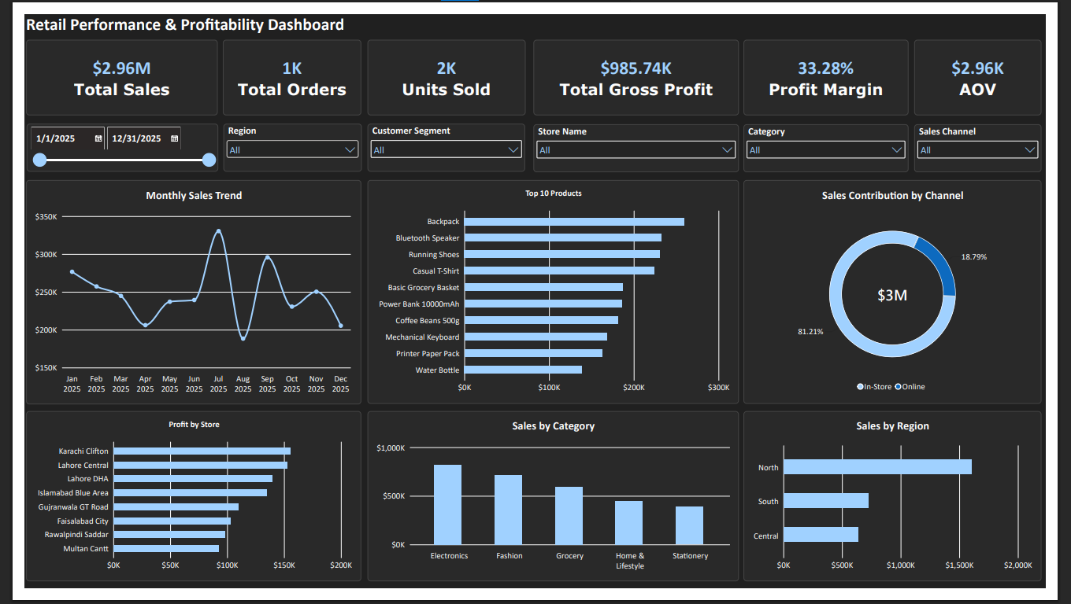
Figure A1. Executive Overview dashboard built in Power BI.
Note: The dashboard screenshots are provided as visual evidence of the report pages. Check the latest PBIX values and slicer behavior in Power BI before presenting the results.

Appendix B — Product & Category Analysis
This page compares category sales, profit and margin; ranks of products; and explores product-level sales/profit relationships and discount bands.
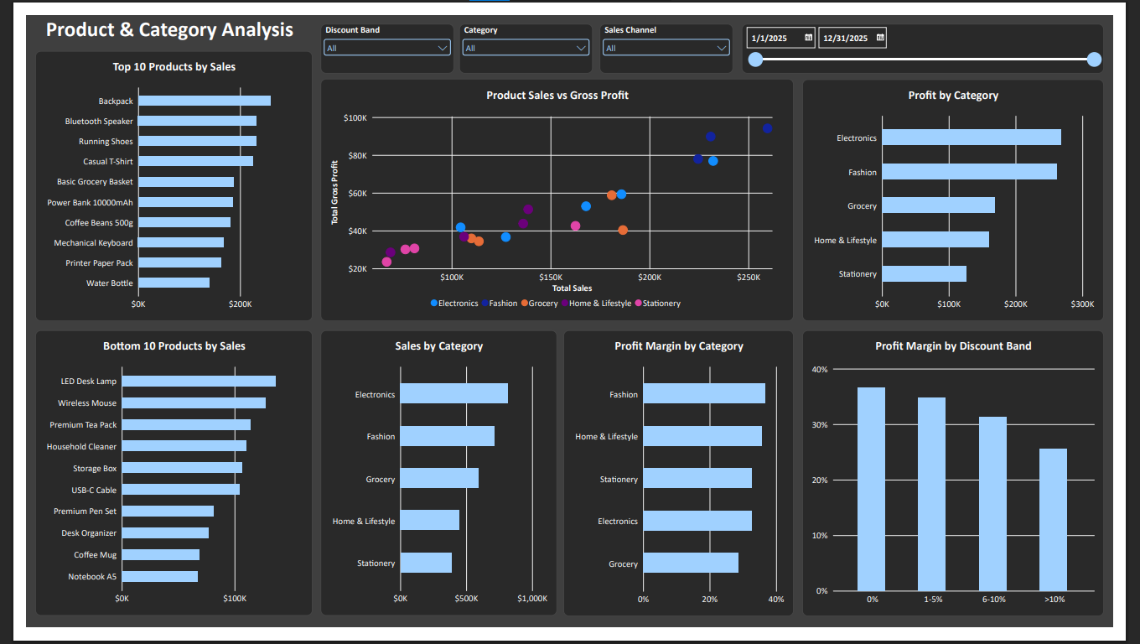
Figure B1. Product & Category Analysis dashboard built in Power BI.
Note: The dashboard screenshots are provided as visual evidence of the report pages. Check the latest PBIX values and slicer behavior in Power BI before presenting the results.

Appendix C — Store Performance
This page compares individual stores, cities, monthly sales trends and the relationship between store sales and gross profit.
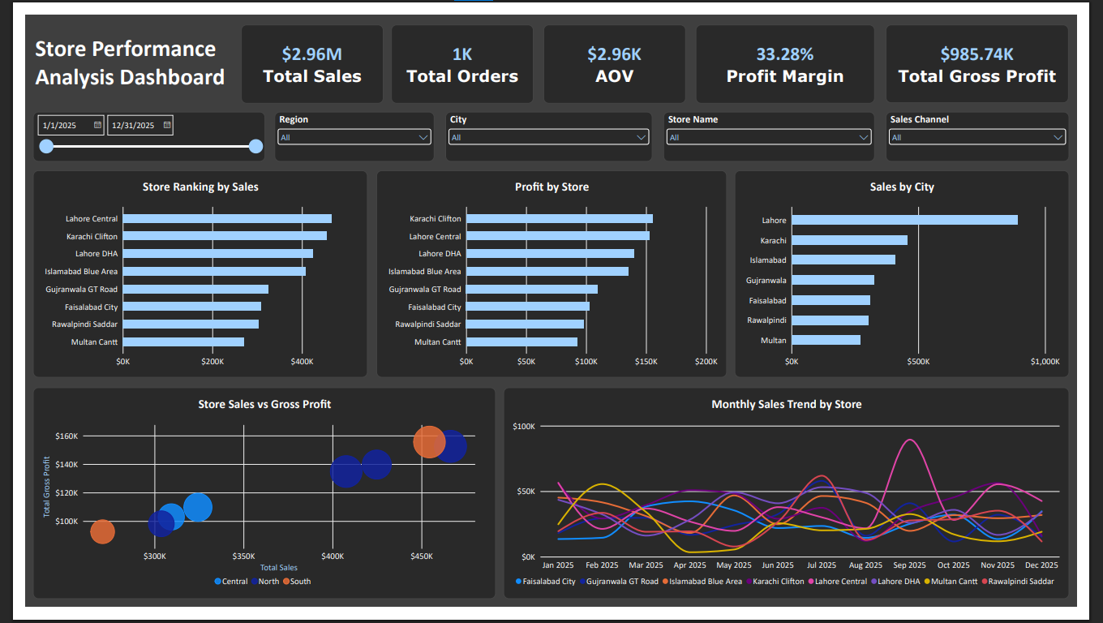
Figure C1. Store Performance dashboard built in Power BI.
Note: The dashboard screenshots are provided as visual evidence of the report pages. Check the latest PBIX values and slicer behavior in Power BI before presenting the results.

