**Pre-Quiz**

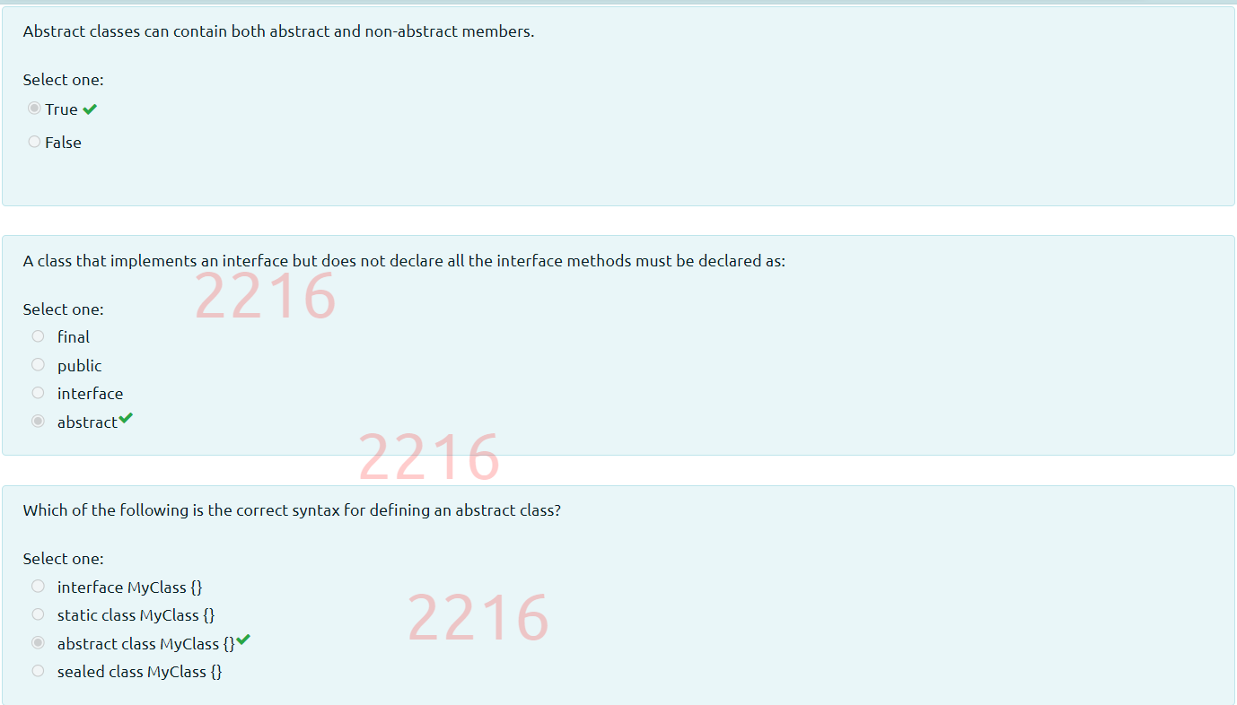

**Post-Quiz**



