**Sailor Information**



**The Black Pearl Info**



**Boat Details**



**Boat Details based on Seating Capacity**



**Sailor Details based on Condition**

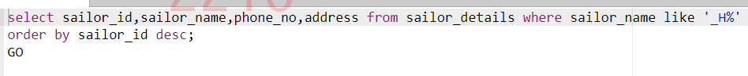

**Boat Details based on Type & Seating Capacity**



**Sailor Details using a Function**



**Sailor Ride Confirmation Details**



**Password Generation**



**Deluxe & Super Deluxe Boats**

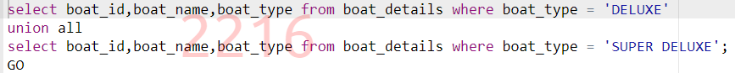

**Sailor Contact Information**



**Sailors Contact Details**



**Ride Details**



**Sailor Details based on Experience**



**Display Sailor Details & Experience**

**Sailor Details based on Address & DOJ**

**No of Boats based on Boat Type**



**Sailor Details & Rides**



**Total Number of Passengers Travelled**



**Boat Type with Seat Details**



**No of Rides based on the Count**

