import java.io.*;

public class ChandyMisraHaas

{

public static int flag=0;

public static void main(String args[])throws Exception

{

BufferedReader ob=new BufferedReader(new InputStreamReader(System.in));

int init,aa,bb,x=0,end=5;

File input=new File("Dependencies.txt");

BufferedReader in=new BufferedReader(new InputStreamReader(new FileInputStream(input)));

String line;int[][] a=new int[end][end];

line=in.readLine();line=in.readLine();

while((line=in.readLine())!=null)

{aa=3;bb=4;

for(int y=0 ; y<end ; y++)

{

a[x][y]=Integer.parseInt(line.substring(aa,bb));

aa+=2;bb+=2;

}

x++;

}

System.out.println("____________________________________________________________");System.out.println();

System.out.println(" CHANDY-MISRA-HAAS DISTRIBUTED DEADLOCK DETECTION ALGORITHM");System.out.println();

System.out.println("\tS1\tS2\tS3\tS4\tS5");

for(int i=0 ; i<end ; i++)

{

System.out.print("S"+(i+1)+"\t");

for(int j=0 ; j<end ; j++)

{

System.out.print(a[i][j]+"\t");

}

System.out.println();

}

System.out.println();System.out.print("Enter Initiator Site No. : ");

init=Integer.parseInt(ob.readLine());

int j=init-1;

System.out.println();System.out.println();

System.out.println(" DIRECTION\tPROBE");System.out.println();

for (int k=0 ; k<end; k++)

{

if(a[j][k]==1)

{

System.out.println(" S"+(j+1)+" --> S"+(k+1)+" ("+init+","+(j+1)+","+(k+1)+")");

aman(a,j,k);

}

}

if(flag==0){System.out.println();System.out.println(" NO DEADLOCK DETECTED");}

System.out.println("____________________________________________________________");

ob.readLine();

}

public static void aman(int[][] a,int init,int k)

{int end=5;

for(int x=0 ; x<end ; x++)

{

if(a[k][x]==1)

{

if(init==x)

{

System.out.println(" S"+(k+1)+" --> S"+(x+1)+" ("+(init+1)+","+(k+1)+","+(x+1)+")"+" --------> DEADLOCK DETECTED");

flag=1;break;

}

System.out.println(" S"+(k+1)+" --> S"+(x+1)+" ("+(init+1)+","+(k+1)+","+(x+1)+")");

aman(a,init,x);

}

}

}

}

Deadlock Detected

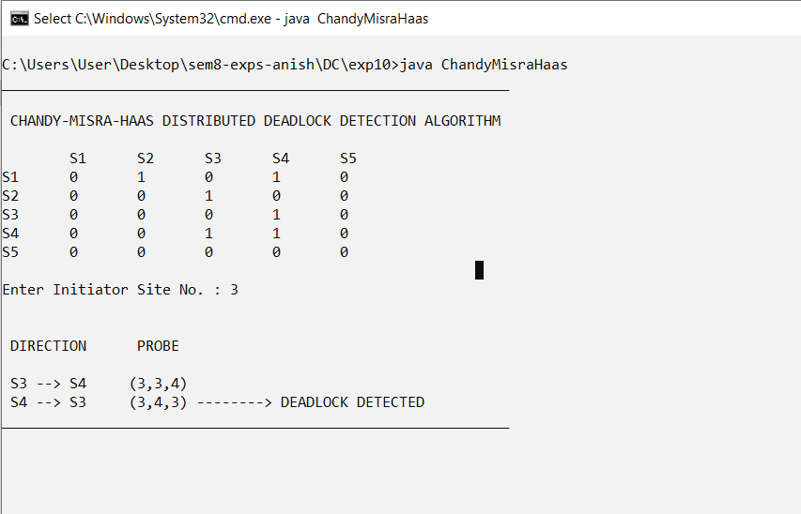

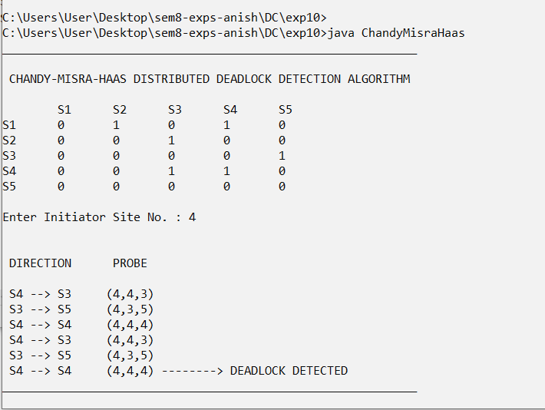

No Deadlock Detected

