Client Server Program to sort an array provided at client side

**Server.java**

import java.io.*;

import java.net.*;

import java.util.*;

class Server

{

public static void main (String args[]) throws Exception

{

ServerSocket ss = new ServerSocket(5000);

Socket s=ss.accept();

System.out.println("connected..........");

DataInputStream din=new DataInputStream(s.getInputStream());

DataOutputStream dout=new DataOutputStream (s.getOutputStream());

int r, i=0;

int n=din.readInt();

int a[]=new int[n];

System.out.println ("data :");

int count=0;

System.out.println ("Receiving Data....");

for(i=0;i<n;i++)

{

a[i] =din.readInt ();

}

System.out.println("Data Received is ....");

for(i=0;i<n;i++)

{

System.out.println(a[i]+" ");

}

Arrays.sort(a);

System.out.println("Data Sorted");

System.out.println("Sending Data........");

for(i=0;i<n;i++)

{

dout.writeInt(a[i]);

System.out.print(a[i]+" ");

}

System.out.println("\nData Sent successfully");

s.close();

ss.close ();

}

}

**Client.java**

import java.io.*;

import java.net.*;

import java.util.Scanner;

public class Client {

public static void main(String[] args) throws Exception

{

Socket s=new Socket("127.0.0.1",5000);

if(s.isConnected())

{

System.out.println("Connected to server");

}

System.out.println("Enter size of array:");

Scanner scanner=new Scanner(System.in);

int n=scanner.nextInt ();

int a[]=new int[n];

System.out.println("Enter element to array:");

DataOutputStream dout=new DataOutputStream(s.getOutputStream());

dout.writeInt(n);

for(int i=0;i<n;i++)

{

int r=scanner.nextInt();

dout.writeInt(r);

}

System.out.println("Data Sent");

DataInputStream din=new DataInputStream(s.getInputStream());

int r;

System.out.println("Receiving Sorted Data....");

for(int i=0;i<n;i++)

{

r=din.readInt();

System.out.print(r+" ");

}

s.close ();

}

}

**Step1 : Compile the java files**

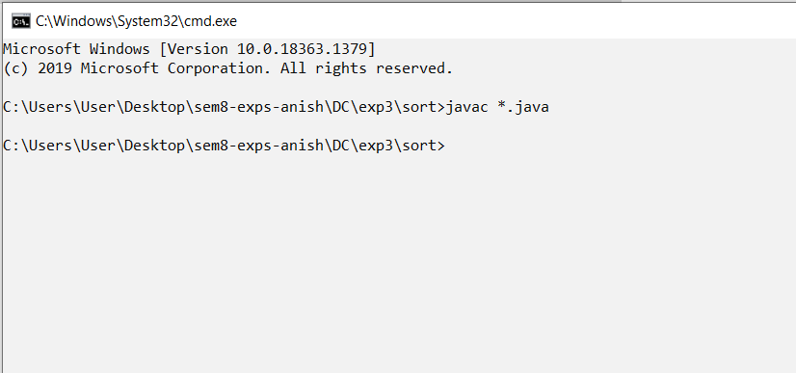

**Step2 : Run Server**

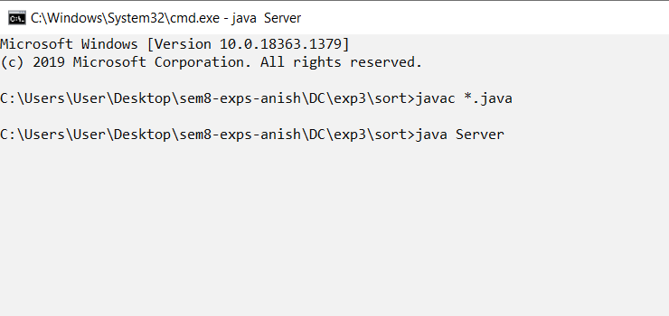

**Step3 : Run Client**

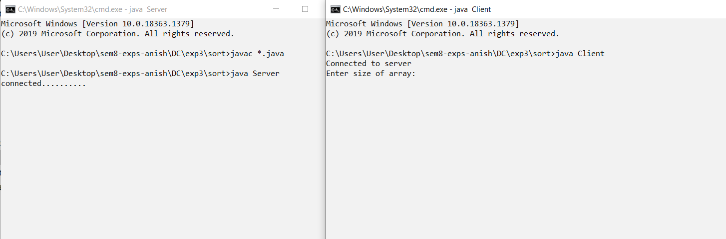

**Output**

Client Side

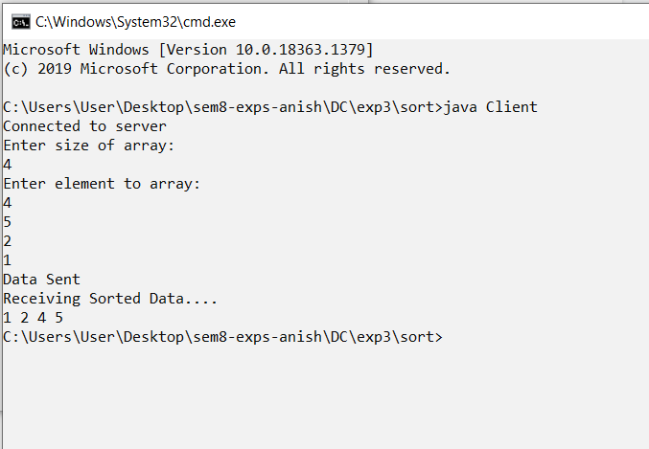

Server Side

