*************************************************************************************************************

**Server.java**

import java.io.BufferedReader;

import java.io.InputStreamReader;

import java.io.PrintWriter;

import java.net.ServerSocket;

import java.net.Socket;

import java.util.Vector;

public class Server {

private static Vector<PrintWriter> writers = new Vector<PrintWriter>();

public static void main(String[] args) throws Exception {

ServerSocket listener = new ServerSocket(9001);

System.out.println("The server is running at port 9001.");

while (true)

new Handler(listener.accept()).start();

}

private static class Handler extends Thread {

private Socket socket;

public Handler(Socket socket) {

this.socket = socket;

}

public void run() {

try {

BufferedReader in = new BufferedReader(new InputStreamReader(socket.getInputStream()));

PrintWriter out = new PrintWriter(socket.getOutputStream(), true);

out.println("SUBMITNAME");

String name = in.readLine();

System.out.println(name+" joined");

writers.add(out);

while (true) {

String input = in.readLine();

for (PrintWriter writer : writers)

writer.println("MESSAGE " + name + ": " + input);

}

} catch (Exception e) {System.err.println(e);}

}

}

}

************************************************************************************************************

************************************************************************************************************

**master.java**

import java.io.BufferedReader;

import java.io.InputStreamReader;

import java.io.PrintWriter;

import java.net.Socket;

import java.util.Scanner;

public class master

{

public static void main(String[] args) throws Exception {

Scanner sc = new Scanner(System.in);

Socket socket = new Socket("localhost", 9001);

BufferedReader in = new BufferedReader(new InputStreamReader(socket.getInputStream()));

PrintWriter out = new PrintWriter(socket.getOutputStream(), true);

System.out.print("Enter your name: ");

String name = sc.nextLine();

while (true) {

String line = in.readLine();

if (line.startsWith("SUBMITNAME")) out.println(name);

else if (line.startsWith("MESSAGE"))

System.out.println(line.substring(8));

if(name.startsWith("master")){

System.out.print("Enter a message: ");

out.println(sc.nextLine());

}

}

}

}

*******************************************************************************************************

***********************************************************************************************************

**slave1.java**

import java.io.BufferedReader;

import java.io.InputStreamReader;

import java.io.PrintWriter;

import java.net.Socket;

import java.util.Scanner;

public class slave1

{

public static void main(String[] args) throws Exception {

Scanner sc = new Scanner(System.in);

Socket socket = new Socket("localhost", 9001);

BufferedReader in = new BufferedReader(new InputStreamReader(socket.getInputStream()));

PrintWriter out = new PrintWriter(socket.getOutputStream(), true);

System.out.print("Enter your name: ");

String name = sc.nextLine();

while (true) {

String line = in.readLine();

if (line.startsWith("SUBMITNAME")) out.println(name);

else if (line.startsWith("MESSAGE"))

System.out.println(line.substring(8));

if(name.startsWith("master")){

System.out.print("Enter a message: ");

out.println(sc.nextLine());

}

}

}

}

*************************************************************************************************************

******************************************************************************************************

**slave2.java**

import java.io.BufferedReader;

import java.io.InputStreamReader;

import java.io.PrintWriter;

import java.net.Socket;

import java.util.Scanner;

public class slave2

{

public static void main(String[] args) throws Exception {

Scanner sc = new Scanner(System.in);

Socket socket = new Socket("localhost", 9001);

BufferedReader in = new BufferedReader(new InputStreamReader(socket.getInputStream()));

PrintWriter out = new PrintWriter(socket.getOutputStream(), true);

System.out.print("Enter your name: ");

String name = sc.nextLine();

while (true) {

String line = in.readLine();

if (line.startsWith("SUBMITNAME")) out.println(name);

else if (line.startsWith("MESSAGE"))

System.out.println(line.substring(8));

if(name.startsWith("master")){

System.out.print("Enter a message: ");

out.println(sc.nextLine());

}

}

}

}

*****************************************************************************************************

**Compiling all java files**

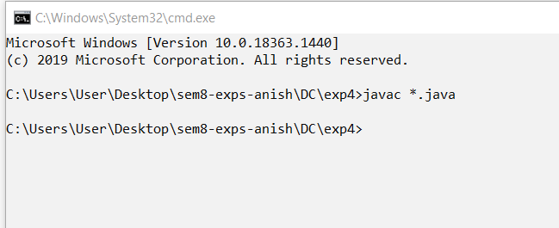

**Running Server program**

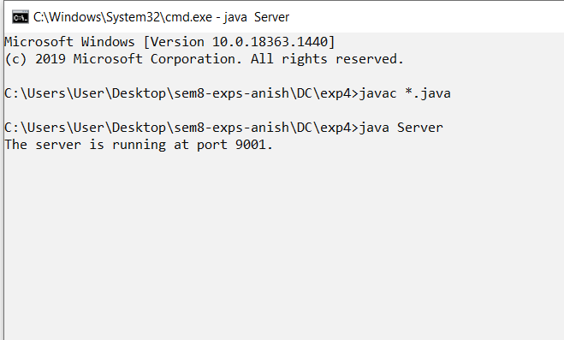

**Running master**

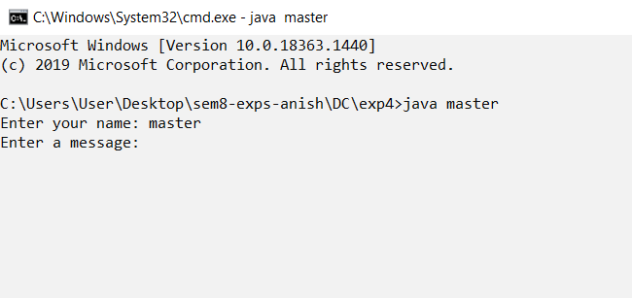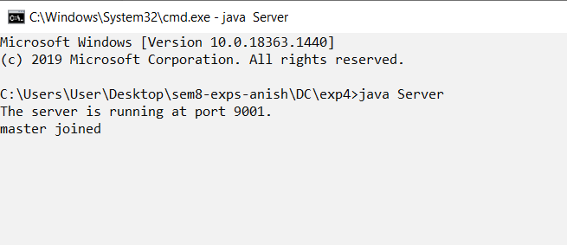

**Running slave1 and slave 2**

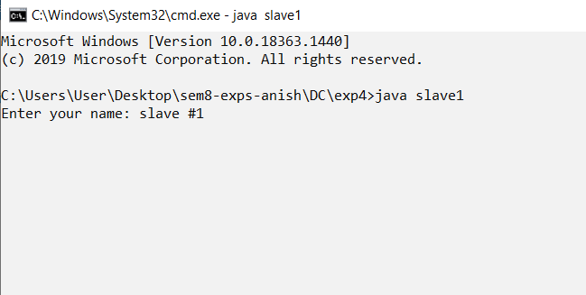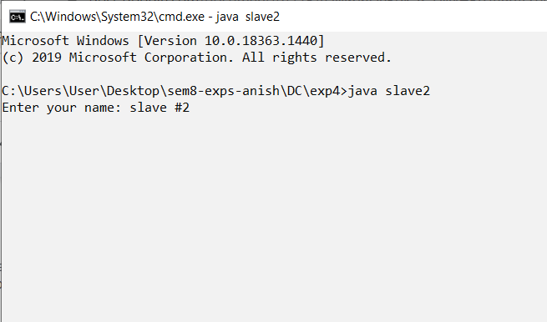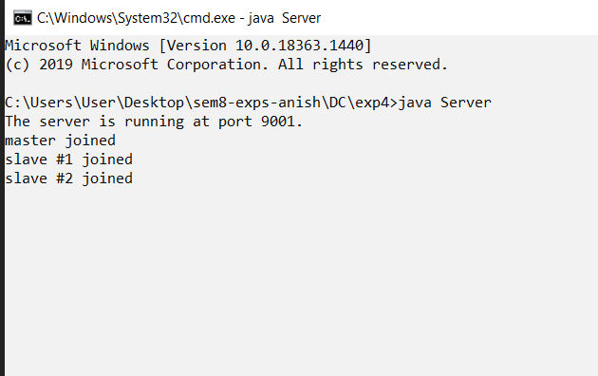

**Master broadcasts the message within the group, which will be delivered at slave1 and slave2 terminals**

