**Java Program for load balancing in distributed systems**

import java.util.*;

public class LoadBalancing{

static void printLoad(int nodes, int processes) {

int each=processes/nodes;

int extra=processes%nodes;

int total=0;

int i=0;

for(i=0; i<extra; i++) {

System.out.println("Node "+(i+1)+" has "+(each+1)+" Processes");

}

for(;i<nodes;i++) {

System.out.println("Node "+(i+1)+" has "+each+" Processes");

}

}

public static void main(String[] args) {

Scanner sc=new Scanner(System.in);

System.out.print("Enter the number of Nodes: ");

int nodes=sc.nextInt();

System.out.print("Enter the number of Processes: ");

int processes=sc.nextInt();

while(true) {

printLoad(nodes, processes);

System.out.println("1.Add Nodes 2.Remove Nodes 3.Add Processes 4.Remove Processes 5.Exit ");

switch(sc.nextInt()) {

case 1:

System.out.println("How many nodes you want to add ? ");

nodes+=sc.nextInt();

break;

case 2:

System.out.println("How many nodes you want to remove ? ");

nodes-=sc.nextInt();

break;

case 3:

System.out.println("How many Processes you want to add ? ");

processes+=sc.nextInt();

break;

case 4:

System.out.println("How many Processes you want to remove ? ");

processes-=sc.nextInt();

break;

case 5:

return;

}

}

}

}

**Output**

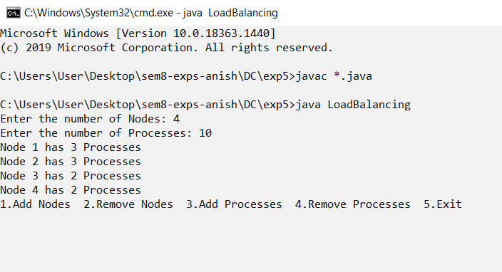

**Adding Nodes**

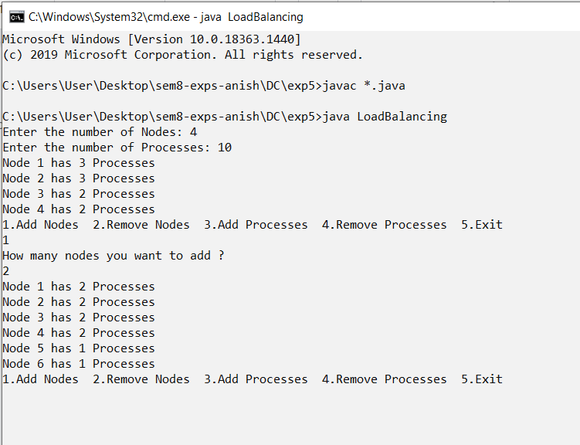

Removing Nodes

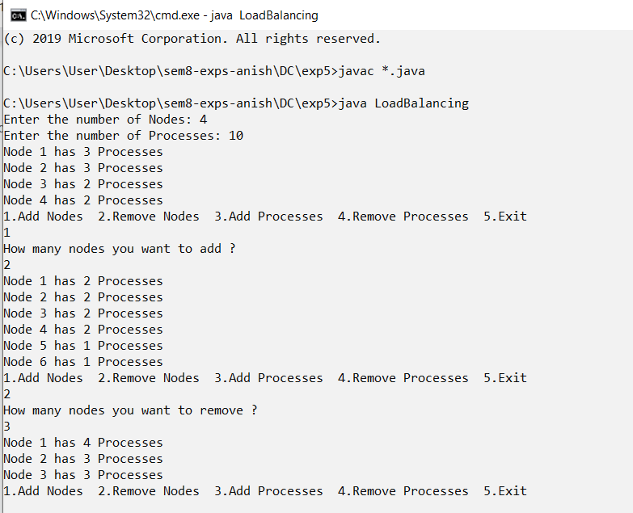

**Adding Processes**

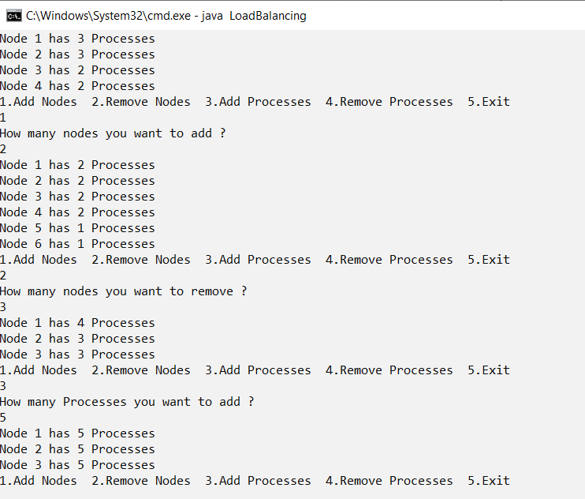

**Removing Processes**

