**OUTPUT**

**Word Tokenize**

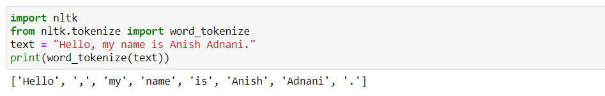

**Sentence Tokenize**

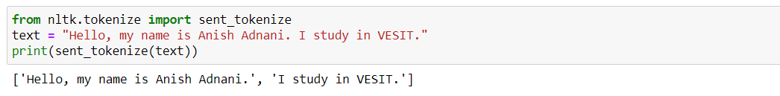

**Special Character Elimination**

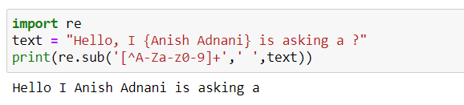

**Trying out in Hindi language**

**Word Tokenization**

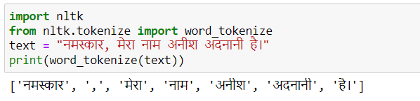

**Word Tokenization using INLTK Library**

