**Program**

from nltk.stem import PorterStemmer

from nltk.tokenize import word_tokenize

import nltk

from nltk.stem import WordNetLemmatizer

from nltk.corpus import stopwords

print("--> Applying PorterStemmer Algorithm \n")

porter = PorterStemmer()

sentence = """He is dancing and singing at same time.

He has bad habit of eating after dancing for long hours in the Sun.""" word_list = nltk.word_tokenize(sentence)

Filtered_sentence = []

for word in word_list:

Filtered_sentence.append(porter.stem(word))

print("Sentence before applying porter stemmer: ")

print(word_list)

print()

print("Sentence after applying porter stemmer: ")

print(Filtered_sentence)

print()

print()

print("--> Applying Lemmatization \n")

Lemmatizer = WordNetLemmatizer()

punctuations = "?:!.,;"

Filtered_sentence = []

for word in word_list:

if word not in punctuations:

Filtered_sentence.append(Lemmatizer.lemmatize(word))

print("Sentence before applying Lemmatization: ")

print(word_list)

print()

print("Sentence after applying Lemmatization: ")

print(Filtered_sentence)

print()

print()

print("--> Applying Stopword Removal \n")

stop_words = set(stopwords.words('english'))

Filtered_sentence = [word for word in word_list if word not in stop_words]

print("Sentence before Removing Stopwords: ")

print(word_list)

print()

print("Sentence after Removing Stopwords: ")

print(Filtered_sentence)

print()

print()

**Output**

**Applying porter stemmer algorithm**

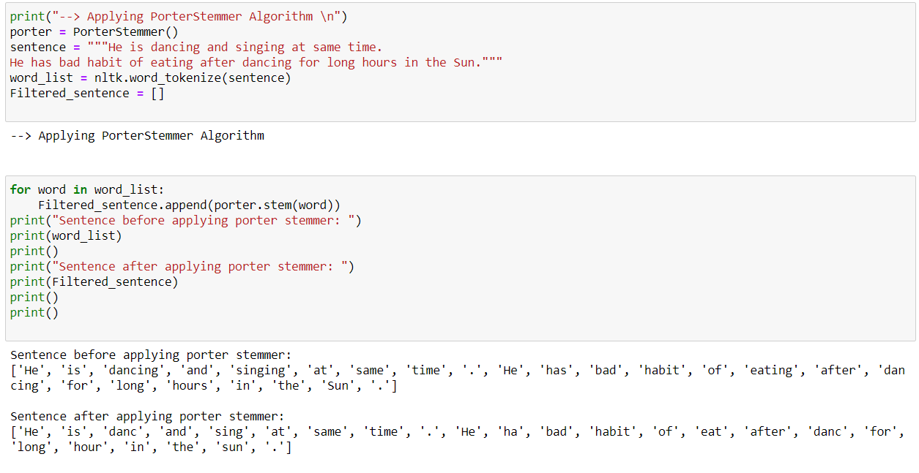

**Applying lemmatization**

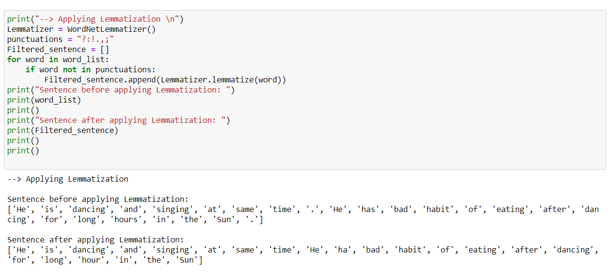

**Applying stop word removal**

