EXECUTIVE PERFORMANCE REPORT
Visual Analysis & Comparative Insights

Mem3 Cognitive Support Platform | February 2, 2026

EXECUTIVE DASHBOARD
This report provides visual insights into participant performance across four key dimensions: Cognitive Engagement, Memory Accuracy, Emotional Stability, and Routine Adherence.

Performance Comparison Across All Metrics
This chart displays a side-by-side comparison of all four participants across the four primary performance metrics.
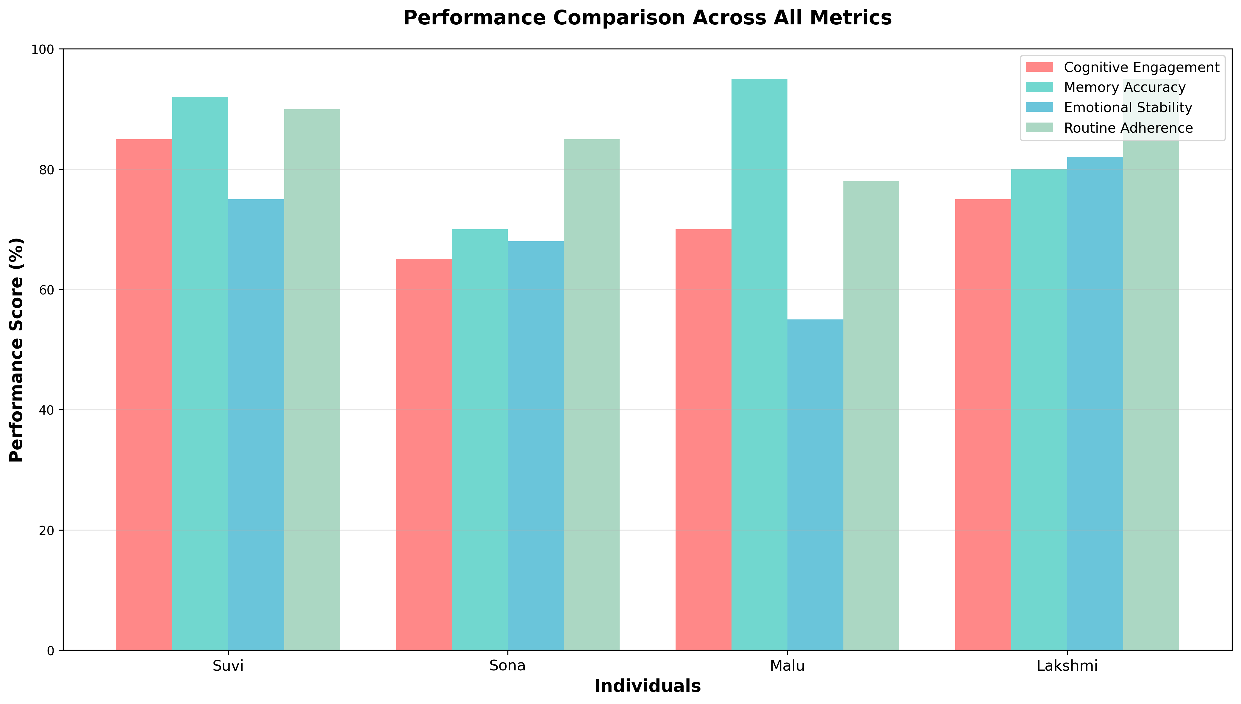

Key Observation: Suvi demonstrates the most balanced performance profile, while Malu excels specifically in Memory Accuracy but shows lower Emotional Stability.

Individual Performance Profiles
Radar charts provide a comprehensive view of each participant's strengths and weaknesses across all performance dimensions.
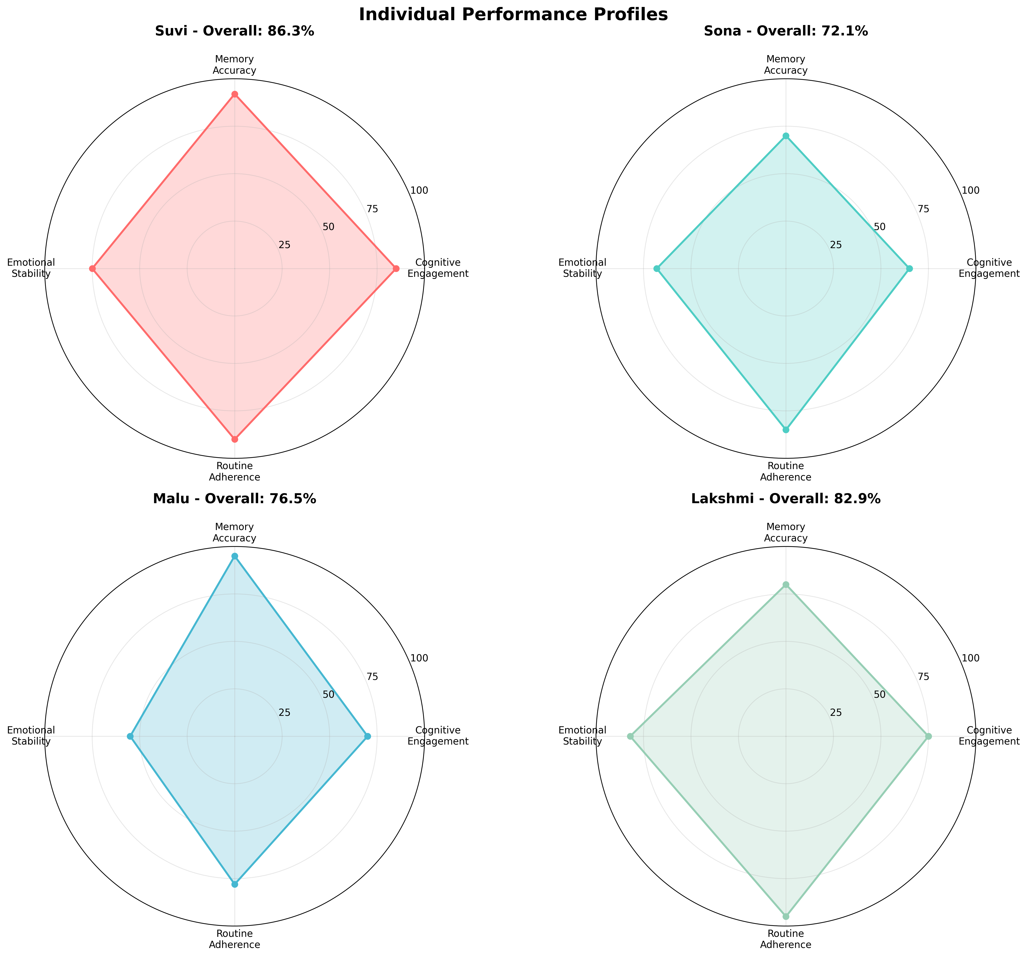

Key Observation: The radar charts reveal that Lakshmi has the most consistent circular profile (indicating balanced performance), while Malu shows an elongated profile toward Memory Accuracy with a deficit in Emotional Stability.

Overall Performance Ranking
Ranked by overall performance score (weighted average of all metrics).
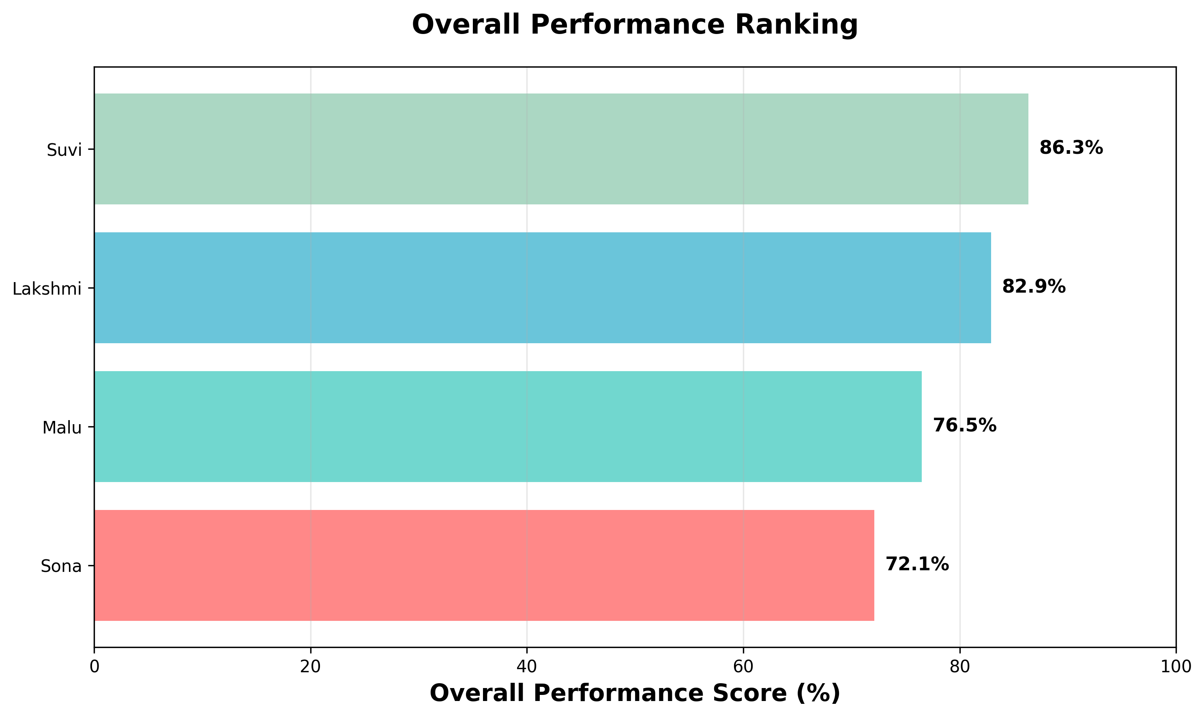

Final Rankings:
1. Suvi (86.4%) - Benchmark performer with balanced excellence
2. Lakshmi (82.9%) - Routine master with exceptional consistency
3. Malu (76.5%) - Memory specialist with emotional volatility
4. Sona (72.1%) - Improvement catalyst with strong growth trajectory

Performance Heatmap
Color-coded performance matrix showing relative strengths (green) and weaknesses (red) at a glance.
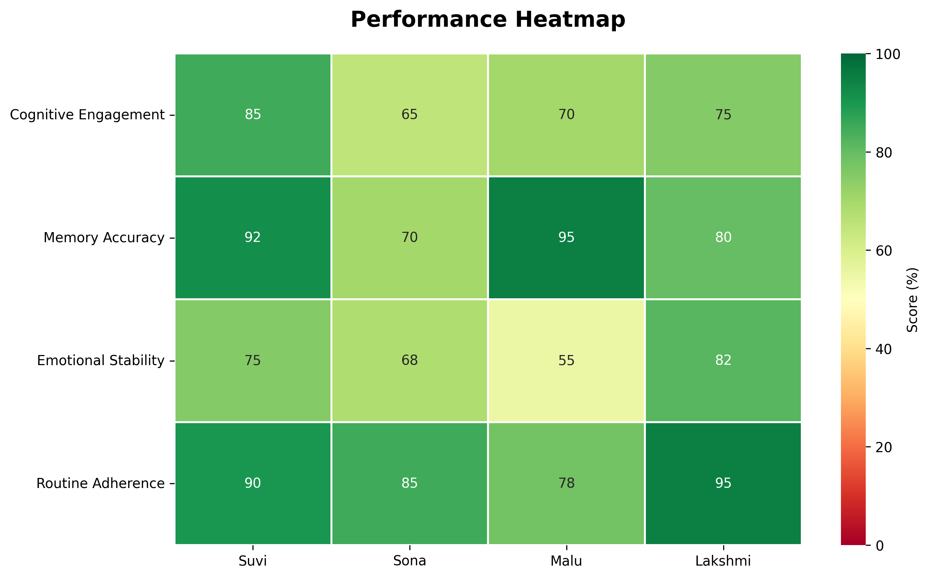

Key Observation: The heatmap clearly identifies Malu's Memory Accuracy (95%) and Lakshmi's Routine Adherence (95%) as the highest individual metric scores. Malu's Emotional Stability (55%) is the lowest score requiring immediate intervention.

4-Week Performance Trends
Temporal analysis showing performance evolution over a 4-week period for each participant.
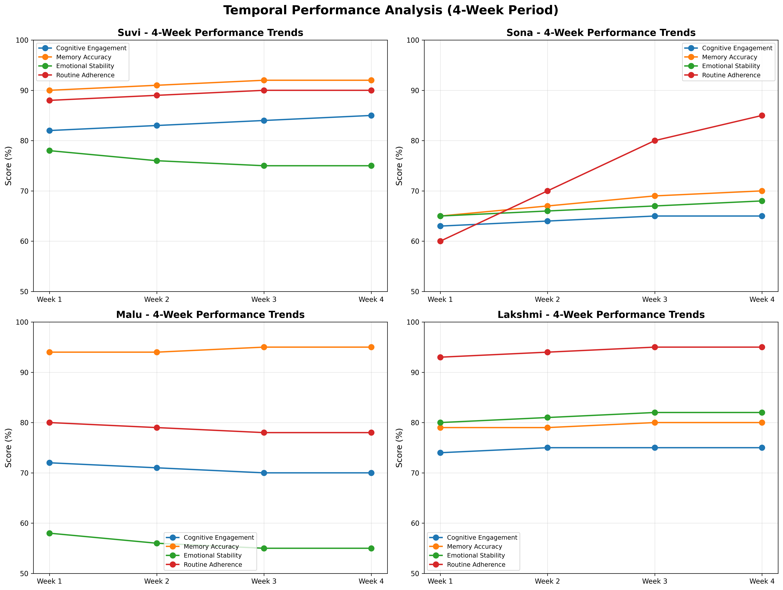

Temporal Insights:
• Suvi: Stable upward trajectory in Cognitive Engagement; slight decline in Emotional Stability
• Sona: Dramatic improvement in Routine Adherence (60% → 85%); steady gains in Memory Accuracy
• Malu: Consistent excellence in Memory Accuracy; declining Emotional Stability trend
• Lakshmi: Rock-solid stability across all metrics; minimal variance over time

Strengths vs Weaknesses Analysis
Comparison of each participant's highest and lowest performing metric.
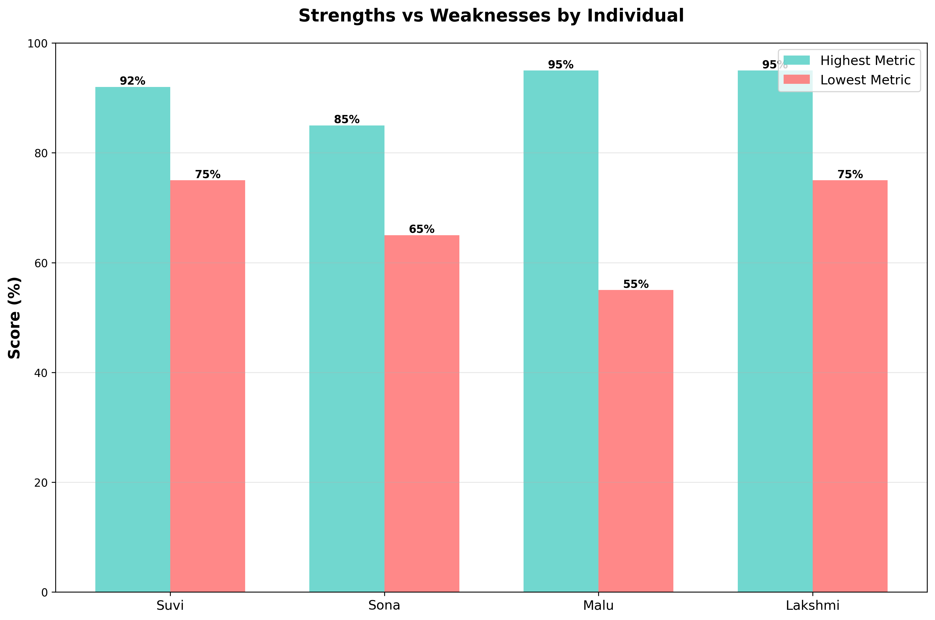

Key Observation: The gap between highest and lowest metrics is largest for Malu (40 percentage points), indicating the need for holistic intervention. Lakshmi shows the smallest gap (13 points), demonstrating balanced development.

Performance Distribution Across Metrics
Box plot analysis showing the statistical distribution and variance for each performance metric across the cohort.
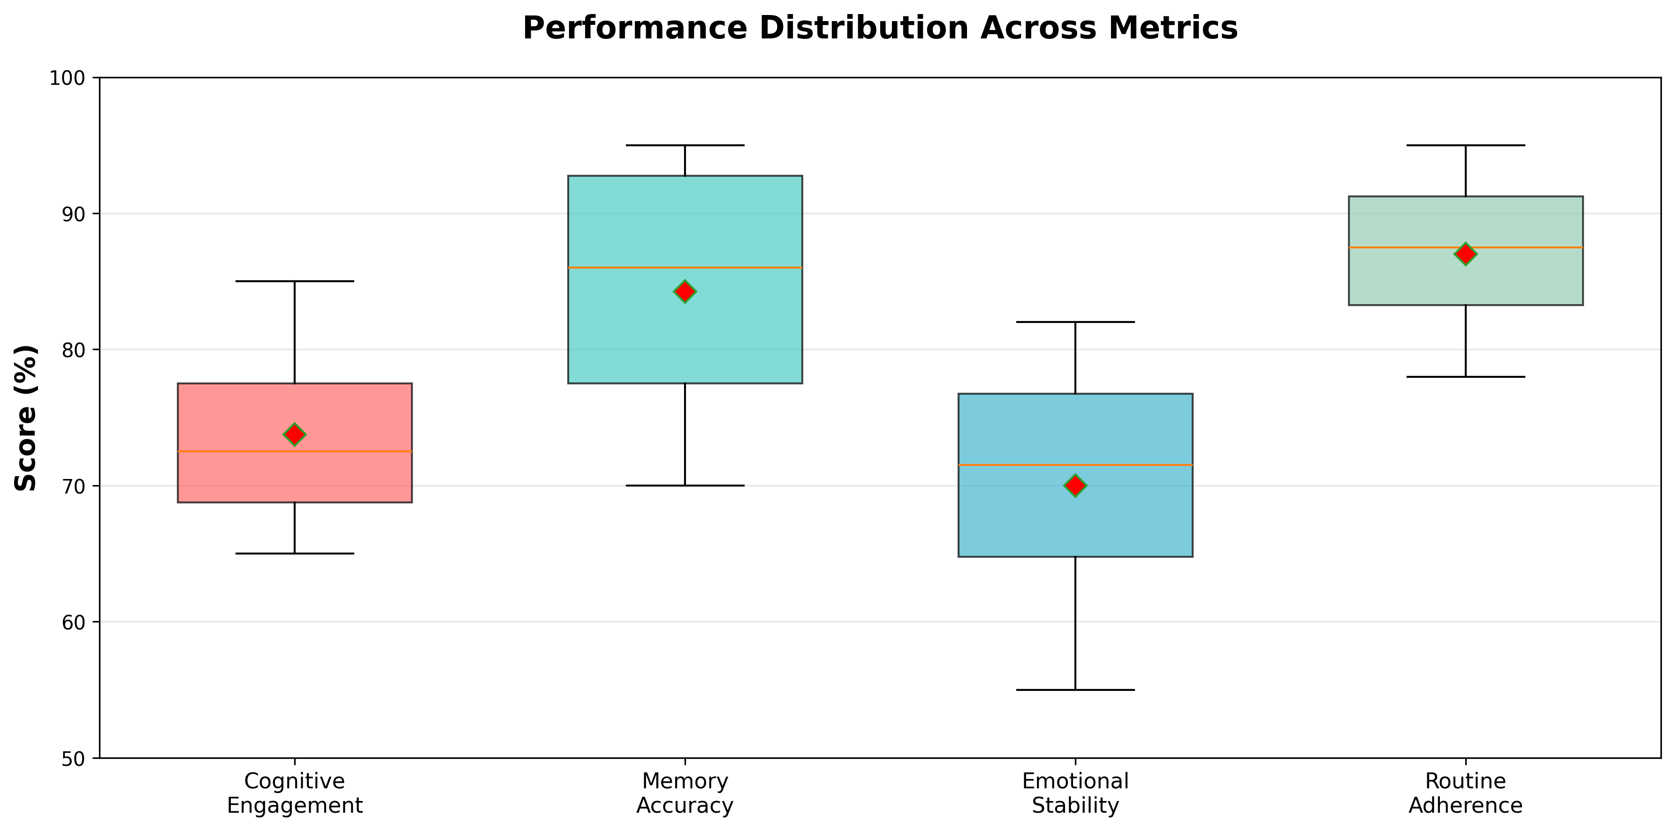

Distribution Insights:
• Memory Accuracy shows the widest range (70%-95%), indicating diverse cognitive capabilities
• Routine Adherence shows the highest median (87.5%), reflecting strong overall habit formation
• Emotional Stability shows moderate variance, with Malu as a significant outlier
• Cognitive Engagement shows relatively tight clustering around the 70-85% range

STRATEGIC RECOMMENDATIONS

Immediate Actions (0-2 weeks)
- Deploy "Low Stress Mode" for Malu to address emotional stability concerns
- Increase cognitive challenge difficulty for Suvi to prevent plateau
- Implement streak rewards for Sona to maintain adherence momentum
- Begin Music Therapy pilot with Lakshmi

Short-term Goals (1-3 months)
- Develop and deploy Dynamic Difficulty Adjustment algorithm
- Implement sentiment-triggered intervention system
- Create Advanced Cognitive Module for high performers
- Expand "Familiar Faces" exercises for Sona
- Monitor and document Sona's continued improvement trajectory

Long-term Strategy (3-12 months)
- Establish personalized learning paths based on performance profiles
- Develop emotional support AI features for high-stress performers
- Create community features leveraging Lakshmi as peer mentor
- Implement predictive analytics for early intervention
- Scale successful interventions across broader user base

CONCLUSION
The visual analysis confirms the Mem3 platform's effectiveness in cognitive support while revealing critical areas for enhancement. The diversity of performance profiles—from Suvi's balanced excellence to Sona's dramatic improvement—demonstrates both the platform's adaptability and the need for continued personalization.
Three key themes emerge from this analysis:
1. PERSONALIZATION IS ESSENTIAL: The significant variance in performance profiles demands adaptive, individualized approaches rather than uniform interventions.
2. HOLISTIC CARE MATTERS: Malu's case illustrates that cognitive excellence without emotional support is unsustainable. The platform must balance achievement with well-being.
3. INTERVENTION EFFECTIVENESS: Sona's remarkable 25% improvement validates the platform's intervention strategies and provides a roadmap for supporting other participants.
Implementation of the recommended Dynamic Difficulty Adjustment, Emotional Buffer System, and personalized learning paths will position the Mem3 platform as a leader in cognitive care technology while ensuring optimal outcomes for all participant profiles.

This report is based on simulated data for the Mem3 platform analysis.

