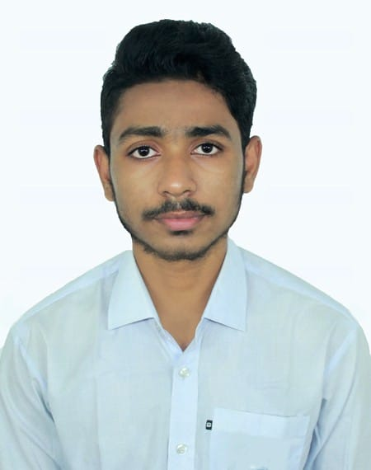
Md. Sadman Siam

Savar, Dhaka | sadmansiam1110@gmail.com | 01521733045

LinkedIn: https://www.linkedin.com/in/md-sadman-siam-3b41a136a/

Github: https://github.com/midnightfireflies

Career Objective

Computer Science and Engineering student focused on cybersecurity, networking, AI automation, and software development. With hands-on CTF experience, programming fundamentals, Linux knowledge, and workflow automation projects, I enjoy solving practical problems and building reliable systems. I am currently strengthening my networking skills through Cisco learning, developing bug bounty skills, and building AI-assisted automations, while seeking opportunities to contribute, learn, and grow.

Professional Experience
Freelance Video Editor
Self-employed · Remote
Jan 2018 – Present
- Edited promotional, educational, and short-form video content using tools like Adobe Premiere Pro, CapCut, and DaVinci Resolve.
- Worked with small clients and content creators to deliver engaging visual content optimized for social media.
- Developed basic motion graphics and synced audio to enhance viewer experience.
Private Tutor – Physics & Mathematics Basics
Freelance · In-person
Jan 2019 – Dec 2023
- Provided one-on-one tutoring for high school students in math and basic computer skills.
- Designed custom learning materials to simplify difficult concepts and improve student understanding.
- Improved student performance and confidence through regular practice sessions and assessments.
Freelance Photographer
Event & Portrait Photography · Local Clients
September 2020 – December 2023
- Captured photos for small events, portraits, and social content using DSLR and mobile.
- Edited and retouched images using Lightroom and Snapseed for high-quality delivery.
- Managed client communications, file delivery, and schedule coordination.
Event Manager – Campus Activities BIAM Model School and College, Bogura & Govt. Azizul Haque College, Bogura. 2016 – Present
- Managed and directed various student-organized events, supporting logistics, photography, and media documentation.
- Assisted in organizing promotional content and technical setup during programs.

Extracurricular

Member

Programming Club, Harvard University (CS50)

Jan 2024- present

- Actively learning the fundamentals of Mathematics and Programming, Software, Application and Game Development.

- Participating in lab discussions, project observations, and skill-building sessions to prepare for future development roles.

Co-ordinator

Cultural Classicists

Jan 2021- Mar 2022

- Organized and coordinated cultural events, performances and team activities, ensuring smooth execution and strong group participation.

Volunteer
July students community

September 2024

- Took part in the revolution and regular cleaning activities to maintain a clean and hygienic environment.
- Learned teamwork, responsibility, and the importance of community service through hands-on participation.

Volunteer
BMSC, Bogura & Govt. AH College, Bogura.

Jan 2024- present

- Engaged in Workshops and group activities focused on leadership, decision making and self-growth.

Organizer
National Capture The Flag - DIU_CYBERCON-2025

Oct 2025

- Engaged in strategic group activities to foster professional growth and effective collaboration within the organizing team.
- Applied leadership frameworks to real-world scenarios in preparation for the upcoming national cyber conference.

1st Runner Up

Cyber Security Awareness Day 2026 - In-House Capture The Flag (CTF) Competition

Jan 2026
- Secured 2nd place (1st Runner Up) in the Cyber Security Awareness Day 2026 CTF competition at the Cyber Security Center, Daffodil International University, demonstrating rapid problem-solving and technical proficiency.
- Solved time-bound cybersecurity challenges involving security fundamentals, analytical thinking, and practical exploitation concepts.

Education

- Bachelor of Science in CSE
Daffodil International University, Dhaka, Bangladesh
2025- Present
- HSC - 5.00
Govt. Azizul Haque College, Bogura, Bangladesh
2023
- SSC - 5.00
BIAM Model School and College, Bogura, Bangladesh
2021

Skills
- Programming Skills: C, C++, Python, Java (foundational)
- Soft Skills: Communication, Collaboration, Time Management, Project Management, Marketing.
- Automation & Productive Tools: n8n, Google Workspace, Microsoft Office Suite, Canva.
- Creative Tools: Adobe Premiere Pro, Davinci Resolve, Adobe After Effects, Photoshop, Illustrator, Capcut, Lightroom.
- Cybersecurity & Technical Skills: Linux, cybersecurity fundamentals, networking (Cisco coursework - in progress), bug bounty (learning), web development, AI automation.

Certifications
- DIU_Cybercon2025 - Organizer - 2025
- AI 100: Fundamentals - 2025
- Practical Security Fundamentals - 2025
- Linux 100: Fundamentals - 2025
- Programming 100: Fundamentals - 2025
- AgentX Prompting – Microsoft (Netcom Learning) – 2025
- CS50x: Introduction to Computer Science – Harvard University (edX) – 2024
- The Complete 2023 Web Development Bootcamp by Angela Yu – Udemy – 2023

Awards

- 1st Runner Up - Cyber Security Awareness Day 2026 In-House CTF, DIU Cyber Security Center
- Organizer - National Capture the Flag - DIU_CYBERCON2025
- Young Innovator Recognition – July Students Community, 2024
- General Scholarship – HSC (Higher Secondary Certificate), 2023
- General Scholarship – SSC (Secondary School Certificate), 2021
- Best Cultural Coordinator Award – Cultural Classicists, 2021
- 1st Place – 100m Sprint – Annual Sports Day, BIAM Model School and College, 2019
- General Scholarship – JSC (Junior School Certificate), 2018
- Volunteer Excellence Award – BIAM Model School and College, 2018

Languages
- Bangla : Native Proficiency.
- English : Full Professional Proficiency.

Professional Development

- Completed: AI 100: Fundamentals - 2025
Gained foundational knowledge in AI, AI Automation and AI Agent Development.

- Completed: Practical Security Fundamentals - 2025
Gained foundational knowledge in security protocols, cyber security, and security fundamentals.

- Completed: Linux 100: Fundamentals - 2025
Gained foundational knowledge in linux, linux terminal and linux commands.

- Completed: Programming 100: Fundamentals - 2025
Gained foundational knowledge in basic structured programming, python programming and programming fundamentals.

- Completed: CS50x – Introduction to Computer Science (Harvard University, 2024)
Gained foundational knowledge in programming, algorithms, and problem solving.
- Completed: The Complete 2023 Web Development Bootcamp – Dr. Angela Yu
Built real-world web projects using HTML, CSS, JavaScript, Node.js, and more.
- In Progress: Cisco Networking & Cybersecurity Bug Bounty - Cisco networking fundamentals and practical web-security/bug-bounty learning.
- AI Automation Projects: n8n workflows with Forms, Sheets, Gmail, and AI logic for lead scoring and automated follow-up.

References

Sanjoy Kumar Anik,
Assistant Professor,
Govt. Azizul Haque College, Bogura,
Phone: 01710455531
Email: sanjoy33edu@gmail.com

Angshuman Rashid,
Lecturer,
Daffodil International University,
Phone: 01680133775
Email: angshumanrashid.cse@diu.edu.bd
Declaration

I hereby confirm that all the information provided in this CV is accurate and true to the best of my knowledge.

Regards,

Sadman Siam

