# Hector

sudo apt-get install ros-melodic-hector-slam

sudo apt-get install ros-melodic-map-server

………………………………………………………………………………………………………………………………………

roscd hector_mapping/launch/

sudo nano mapping_default.launch

Replace

<arg name=”base_frame” default=”base_footprint”/>  
<arg name=”odom_frame” default=”nav”/>

to

<arg name=”base_frame” default=”base_link”/>  
<arg name=”odom_frame” default=”base_link”/>

Add this line at the end before closing ‘launch’ tag:

<node pkg="tf" type="static_transform_publisher" name="base_to_laser_broadcaster" args="0 0 0 0 0 0 base_link laser 100"/>

………………………………………………………………………………………………………………………………………

cd

roscd hector_slam_launch/launch/

sudo nano tutorial.launch

Replace

<param name="/use_sim_time" value="true"/>

to

<param name="/use_sim_time" value="false"/>

Now, go to terminal and do ‘catkin build’:

$ catkin build

Once build complete, then source the bash file.

$ source devel/setup.bash

# Demo time

In first terminal, run this:

roslaunch rplidar_ros rplidar.launch

In the second terminal, run this:

roslaunch hector_slam_launch tutorial.launch

It will show results like this:

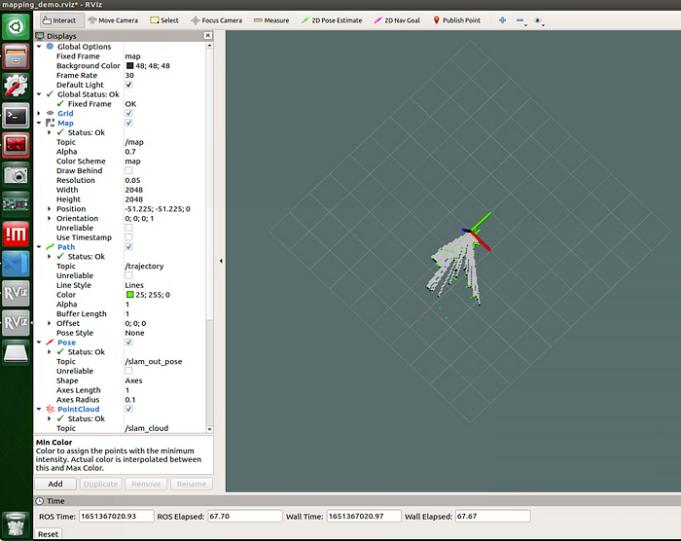

Now, when we go to 1st terminal and we find that we get such error:

Writing image with file /home/username/hector_slam_ws/src/hector_slam/hector_geotiff/maps/hector_slam_map_01:07:54.tif failed with error Unsupported image format

For solving such issue, run this in the terminal:

$ sudo apt-get install qt5-image-formats-plugins

Now run both launch files again as above and now there will be no error.

# Bonus point

To save the map:

Once the mapping is completed then run following command:

$ rostopic pub syscommand stmsgs/String "savegeotiff"

Now go to the directory to see the saved map:

$ cd ~  
$ cd hector_slam_ws/src/hector_slam/hector_geotiff/maps/

There will be 2 files saved:

hector_slam_map_10:13:37.tfw  
hector_slam_map_10:13:37.tif  
* P.S.: filename will be different for each cases

or

rosrun map_server map_saver -f map01

sudo apt install gimp