Career Prediction System for Computer Science Students
Related Works — Career Prediction Module Methodology
[Author Names]

1. Related Works
Our goal in this paper is to build a full career recommendation and guidance system for computer science students, integrating personality traits, hard skills, and soft skills into a unified prediction framework. The following section reviews current studies and establishes the basis for our proposed multimodal ensemble approach.

1.1 Literature Review
Career recommendation systems have explored a wide range of approaches, from machine learning and deep learning to fuzzy logic, expert systems, and NLP-driven consultation models [1]. Among these, a growing subset of studies recognizes that both personality traits and technical skills contribute meaningfully to career outcomes, with some systems incorporating personality indicators alongside skill and aptitude features [1]. This convergence toward multi-signal approaches reflects a broader understanding that neither personality nor skills alone fully characterizes a student's career fit — a principle that forms the foundation of our system. We extend this direction by training independent calibrated models on each modality separately and combining their outputs through weighted probability fusion, preserving the distinct predictive structure of each signal rather than merging them into a single feature space.
Among ML-based approaches, feature engineering has proven to be a decisive factor in prediction accuracy. Treating all skills as equally informative degrades classifier performance, as irrelevant or universally distributed features introduce noise rather than signal. Yaqoob et al. [2] demonstrated this concretely by applying a combined Random Forest and Linear Regression feature ranking method followed by PCA reduction, selecting the top 12 out of 24 features for a hybrid MLP classifier, achieving approximately 95% accuracy on a student career dataset. Their findings confirm that structured, discriminative feature selection consistently outperforms models built on unfiltered feature sets, a principle that directly informs our feature schema design, in which skills appearing uniformly across all career classes are explicitly excluded.
Most directly related to our work, Faruque et al. [3] addressed career prediction specifically for computer science and software engineering students — the same population our system targets. Using NLP-based text vectorisation on a student skills survey dataset, they evaluated multiple ML and DL classifiers, with SVM achieving the best performance at 88.63% accuracy across six career categories. While their work establishes a strong baseline on this dataset, it treats career prediction as a single-modality problem, relying solely on skill-based text features without incorporating personality dimensions, structured feature grouping, model calibration, or ensemble fusion. Our Model 2 is trained on the same dataset with a fundamentally different approach, surpassing their reported benchmark.
Ferdous and Chowdhury [6] proposed a Digital Twin-based assistance system for CS students that combines ML-driven career suggestion with accelerometer-based activity recognition. For career prediction, they evaluated six models on a synthetically generated dataset of 35,000 students using academic course grades as features, with Logistic Regression achieving the best performance at 98% accuracy and 95% precision. While their results demonstrate the discriminative power of structured academic data, the system relies on a rule-based labelling process in which career labels are assigned programmatically based on grade thresholds, which the classifier then recovers — inflating accuracy without necessarily reflecting genuine career fit. Furthermore, their feature space is limited exclusively to course grades, with no personality dimension, no self-assessed skill proficiency, and no ensemble mechanism to integrate complementary signals. Our system addresses both limitations: the XGBoost model captures structured skill-group features derived from self-rated competency levels, while the LightGBM model incorporates Big Five personality dimensions that academic performance alone cannot capture.
The limitation of single-modality approaches is further highlighted by research demonstrating that combining heterogeneous signals — particularly personality and skill-based features — through weighted model fusion consistently outperforms unimodal baselines. Jain et al. [4] showed this in an employment context by fusing two deep learning models operating on different data types — video and transcript — through weighted combination, achieving 92.12% accuracy in personality-based job matching. Critically, their work demonstrates that when two modalities encode complementary information about the same individual, late fusion through weighted averaging extracts signal that neither model captures alone — the core principle underlying our ensemble design.
The theoretical foundation for this fusion strategy is established by Large et al. [5], who demonstrated through extensive experimentation across 235 classification datasets that building small heterogeneous ensembles — classifiers using different learning algorithms — and combining their probability estimates through cross-validated accuracy weighting consistently outperforms both individual classifiers and homogeneous ensembles. Importantly, this advantage is most pronounced on smaller training sets, precisely the condition that characterizes our personality-based model trained on real survey data. Their framework, CAWPE, directly informs our weighted probability averaging design, in which each model's contribution is scaled by the relative quality of its training data.

2. System Overview

2.1 System Architecture
This paper introduces a career recommendation system that combines two different machine learning models using a weighted average approach. When using the system, users first select which technical skills they possess from a master list of 78 sub-skills, and then rate their proficiency in those chosen skills on a 1 to 10 scale. Personality traits and human values are entered as scores between 0.0 and 1.0. This information feeds into two separate models: Model 1 is a LightGBM classifier trained on 14 features, combining 10 personality scores with 4 core academic subject proficiency ratings; Model 2 is an XGBoost classifier that evaluates 27 broader career-relevant feature groups, dynamically calculated based on the sub-skills the user selected and rated. The system blends the prediction probabilities from both models through a weighted average to produce a stable, well-rounded career recommendation.
Figure 1 provides an overview of the system components.
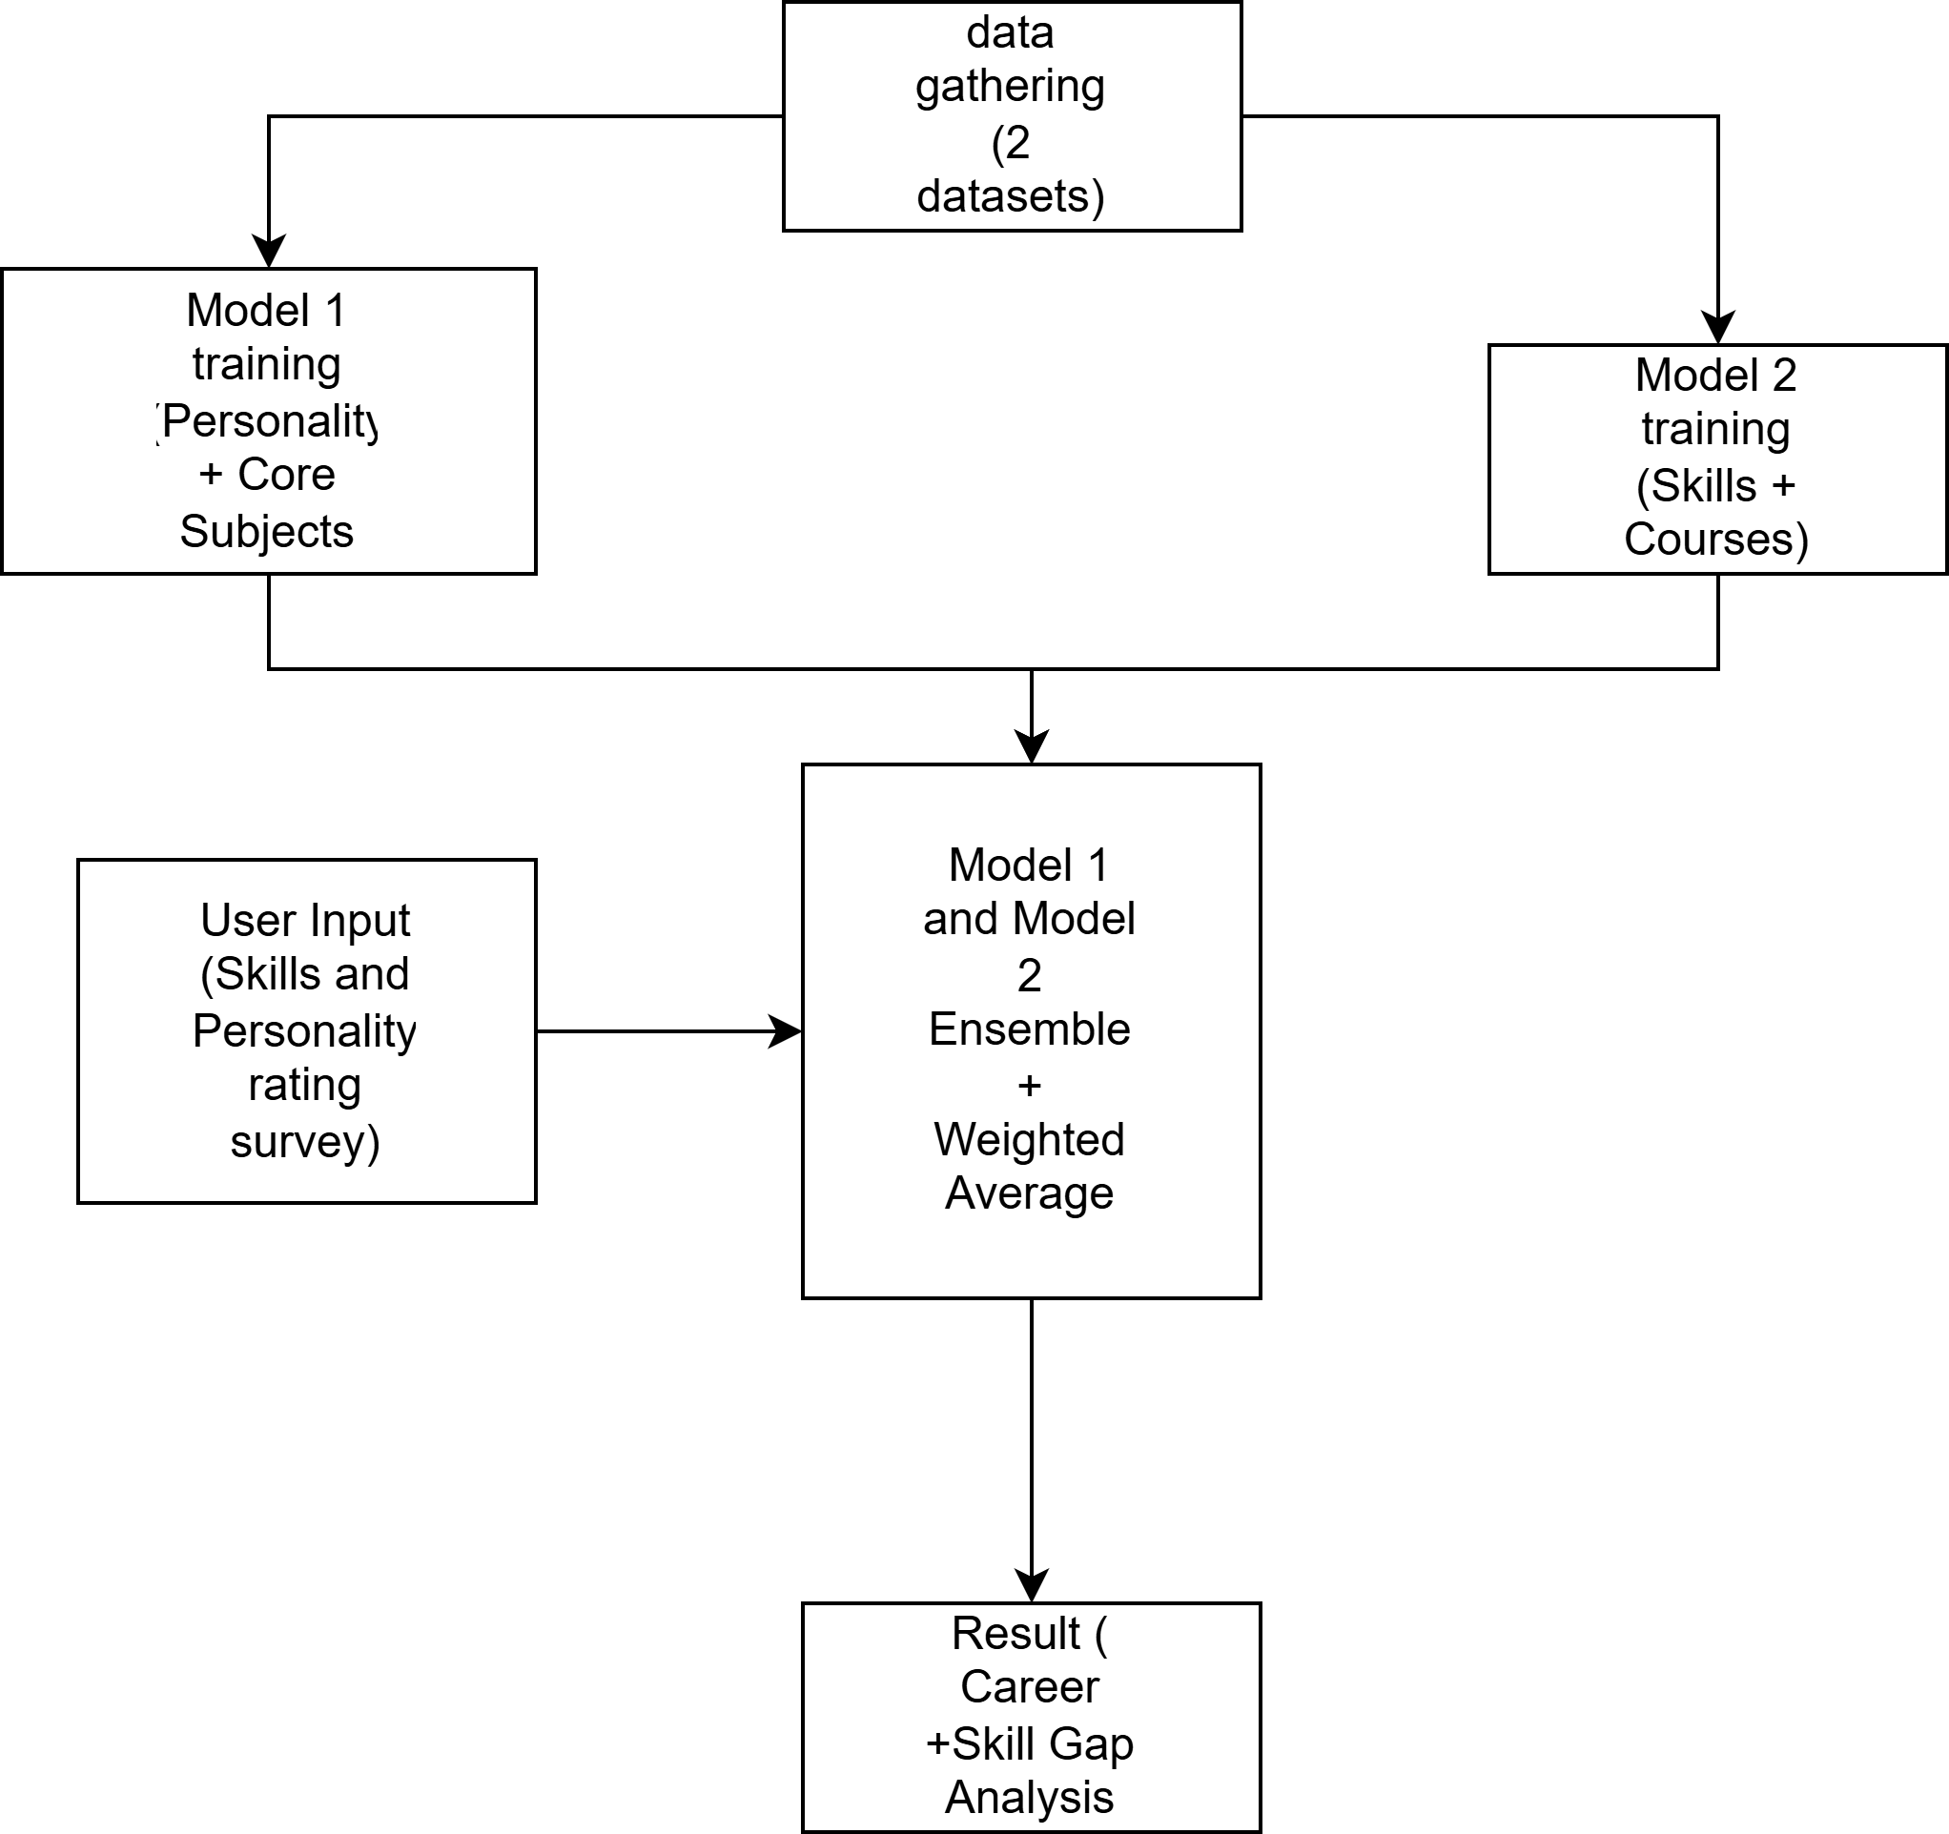

2.2 Data Gathering
Two datasets were collected from independent sources. Dataset 1 was obtained from Kaggle (CareerMap dataset [1]), consisting of 9,180 rows, 27 feature columns, and 16 target career labels. It combines psychological trait scores with technological skill proficiency ratings, making it suitable for a personality-augmented classification task. Dataset 2 was obtained from Faruque et al. [3], consisting of 4,077 rows and two categorical features — "Skill" and "Career" — representing the skills associated with each of the six CS/SWE career categories used in their NLP-based prediction system.

2.3 Data Preprocessing

2.3.1 Dataset 1 Preprocessing
For Dataset 1, correlation analysis revealed that a large number of subject-related features produced weak signals and introduced noise into the model. As shown in Figure 2, the correlation heatmap indicated low predictive relevance for most academic subject columns. These features were removed, retaining only four core academic features for reference alongside 11 personality features, resulting in a final feature set of 15 columns.
[Figure 2: Correlation heatmap of numerical features in Model 1]
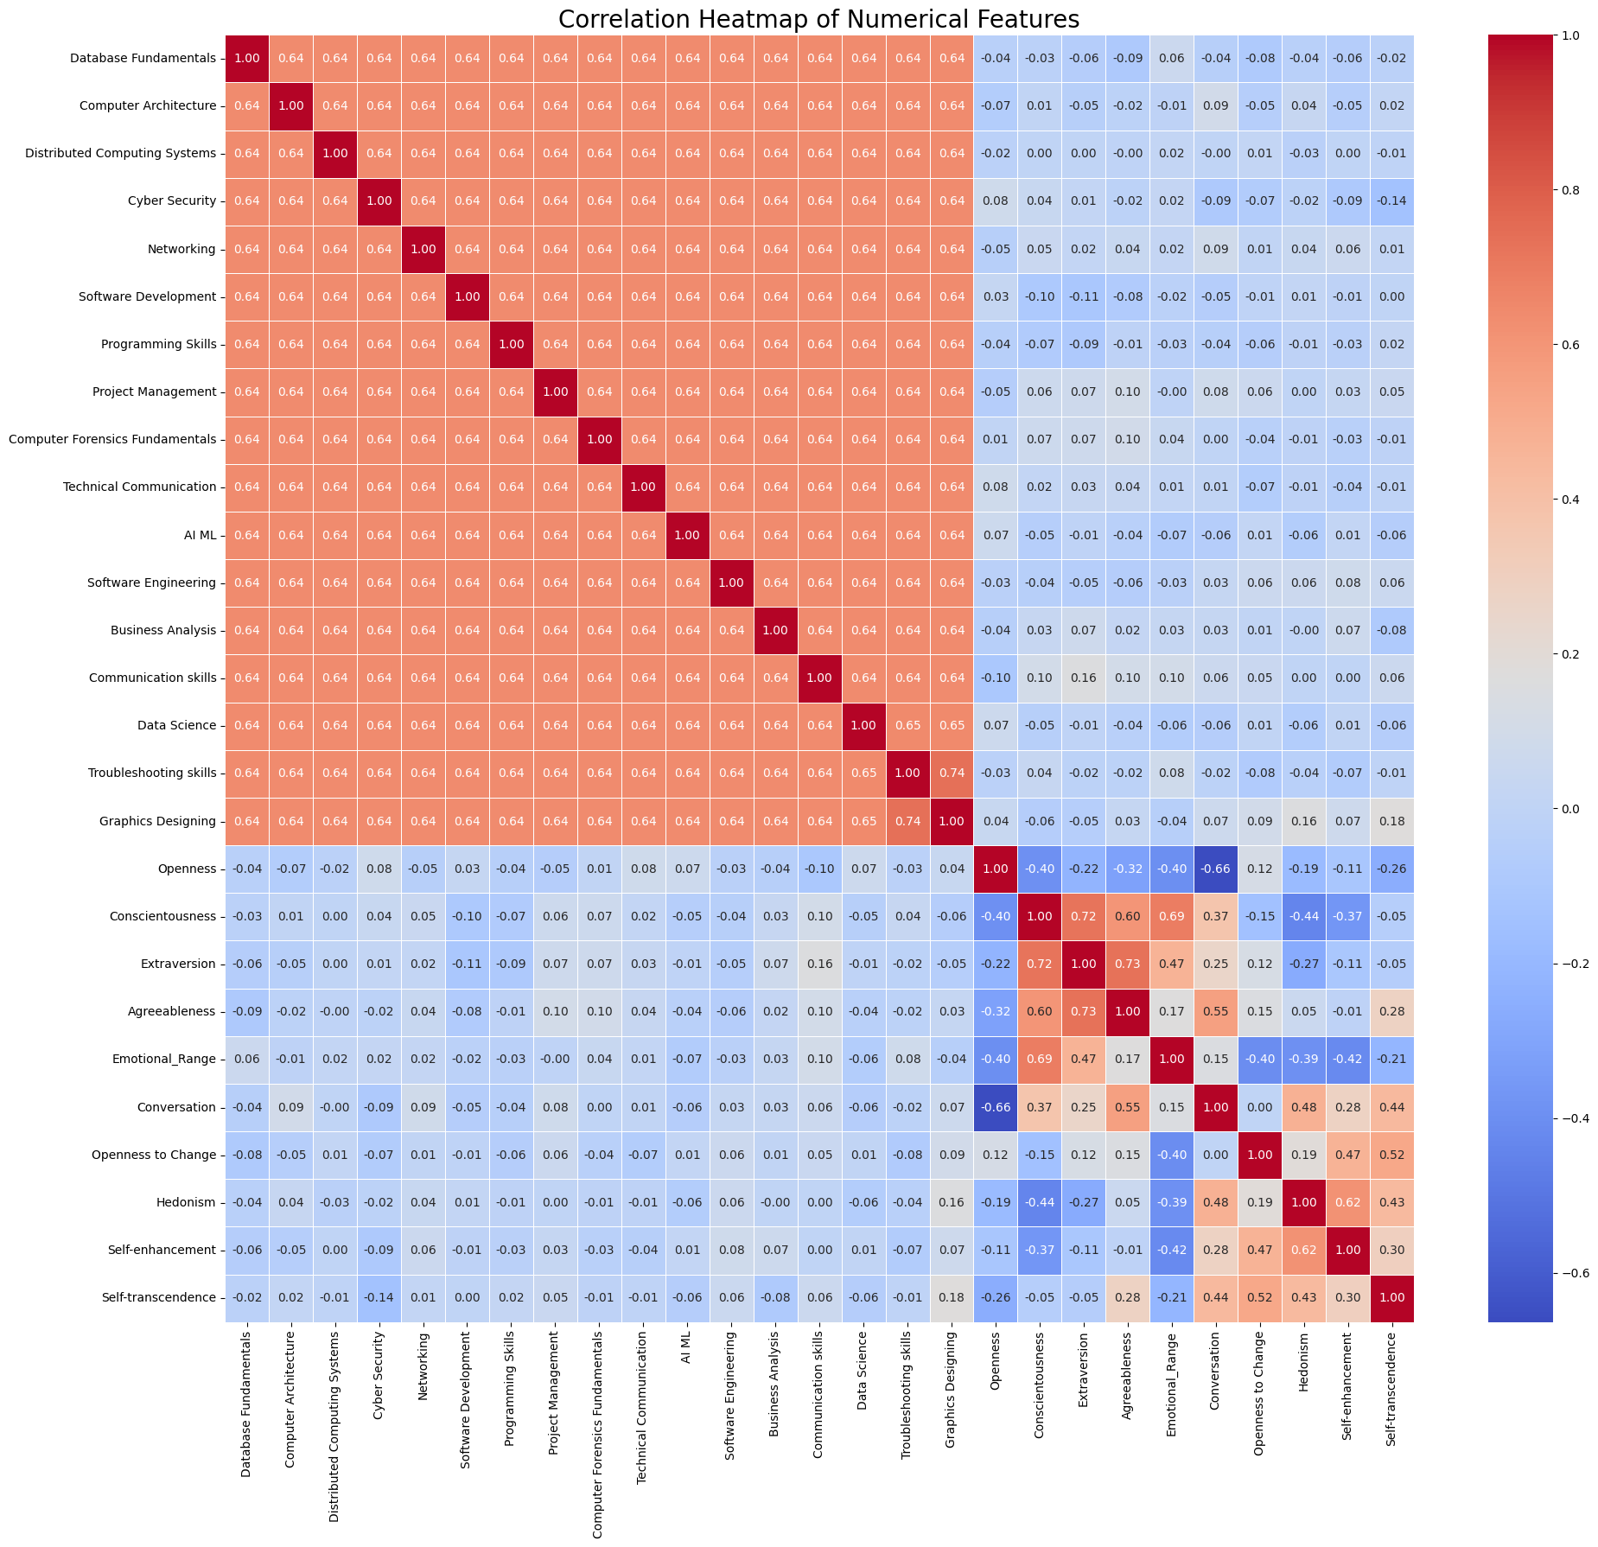

A significant class imbalance was identified in the target variable distribution. SMOTE (Synthetic Minority Oversampling Technique) was applied to address this imbalance. Figures 3 and 4 show the target feature distribution before and after applying SMOTE, respectively.
[Figure 3: Target feature distribution before SMOTE]
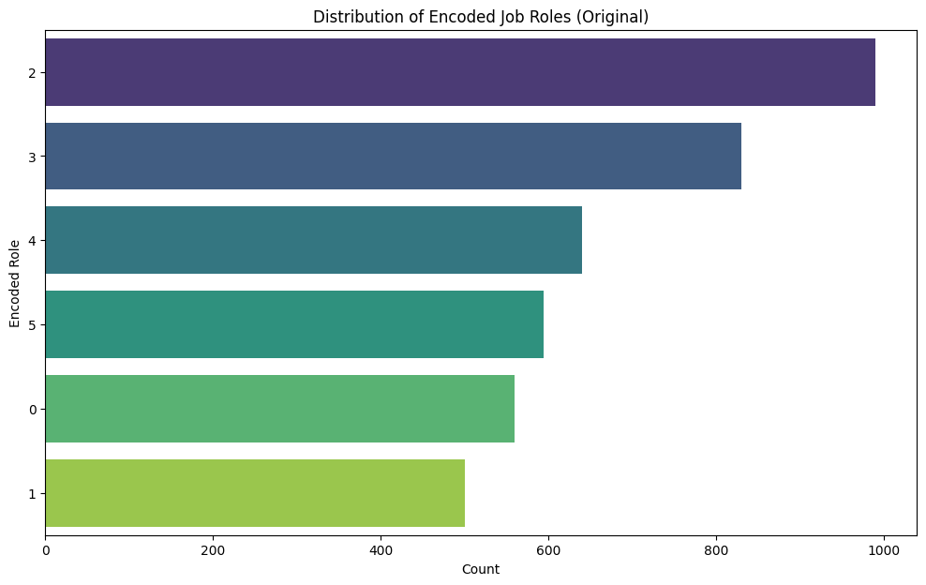

[Figure 4: Target feature distribution after SMOTE]
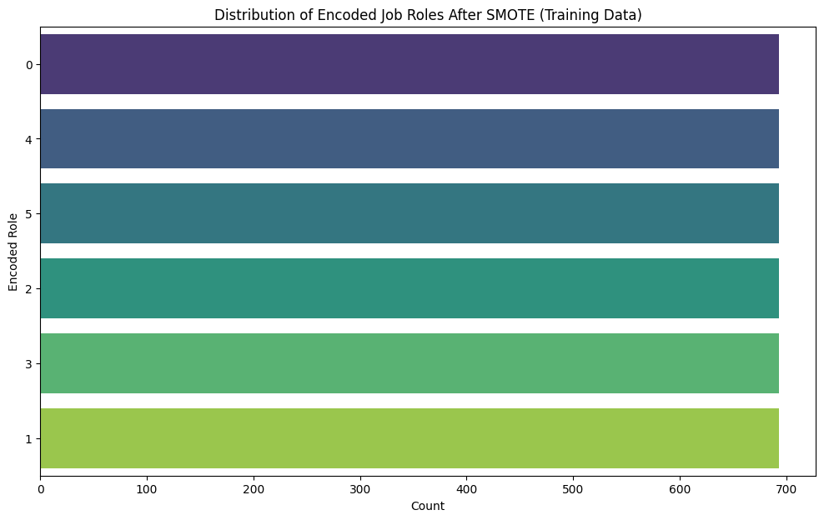

Finally, the original 16 target career labels were mapped to 6 unified classes to align with the target space of Model 2, and StandardScaler was applied to standardise all numerical features. The mapping was determined based on academic and professional proximity between the original and unified categories. Table 1 presents the full mapping.
[Figure 5: Final dataset structure of Model 1]
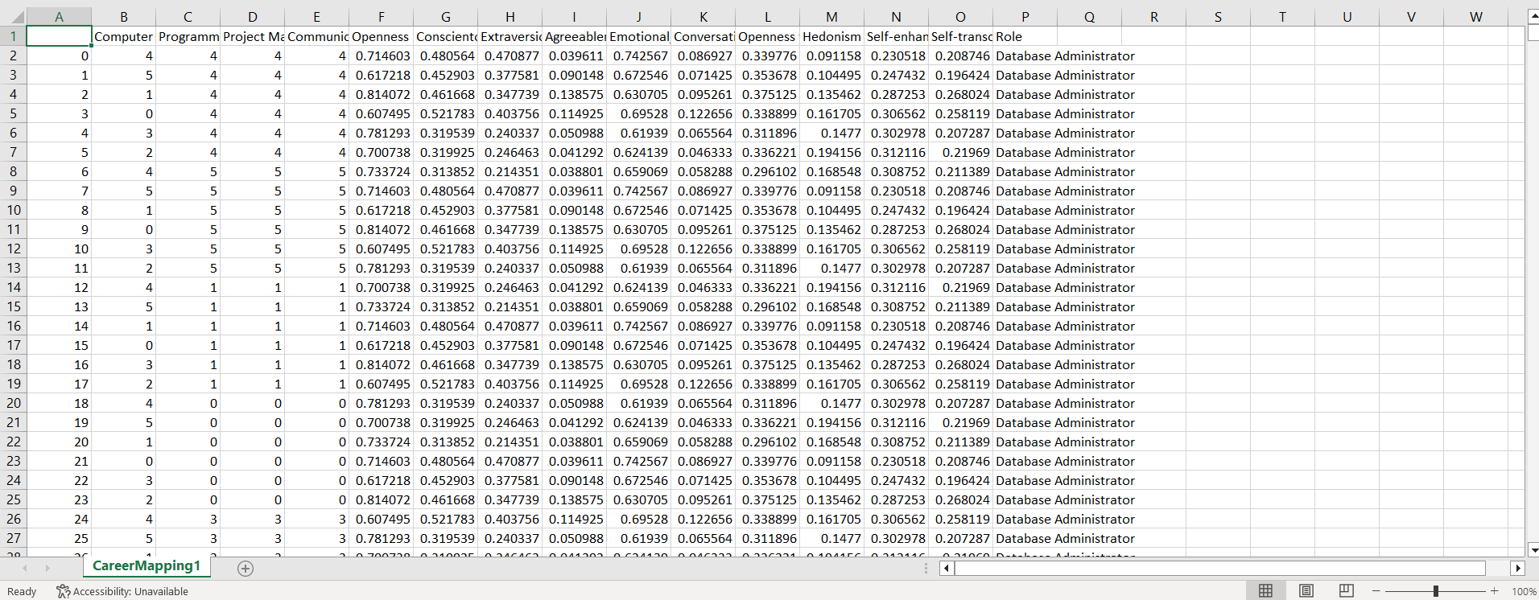

Table 1. Career label mapping from 16 original labels to 6 unified classes.
Unified Career Label | Original Target Labels
Artificial Intelligence | AI ML Specialist, Hardware Engineer
Web and Application Development | API Specialist, Software Developer
Software Development and Engineering | Application Support Engineer, Software Tester, Project Manager
Data Science & Analytics | Database Administrator, Business Analyst
Security | Cyber Security Specialist, Information Security Specialist, Networking Engineer, Helpdesk Engineer
User Experience (UX) and User Interface (UI) Design | Technical Writer, Customer Service Executive, Graphics Designer

2.3.2 Dataset 2 Preprocessing
Dataset 2 originally consisted of two features — "Career" and "Skills" — containing 1,780 unique skill entries. This raw skill list contained noisy entries, inconsistently named skills belonging to the same conceptual group, and duplicate skills expressed with different wording. The preprocessing pipeline proceeded in three stages. First, the FuzzyWuzzy algorithm was applied to identify and consolidate skills with inconsistent wording into canonical skill names. Second, TF-IDF analysis was used to identify the most informative skills, reducing the list to 75 unique skills. Third, a structured feature schema was constructed by grouping the 75 skills into 27 discriminative feature groups, each representing a meaningful career-relevant capability cluster.
Subsequently, a skill gap mapping was constructed by assigning an ordinal score to each feature group based on the sub-skills the user possesses. Rows containing fewer than two active skills were removed to ensure minimum input quality. Figures 6 and 7 show the dataset before and after preprocessing, respectively.
[Figure 6: Dataset 2 before preprocessing]
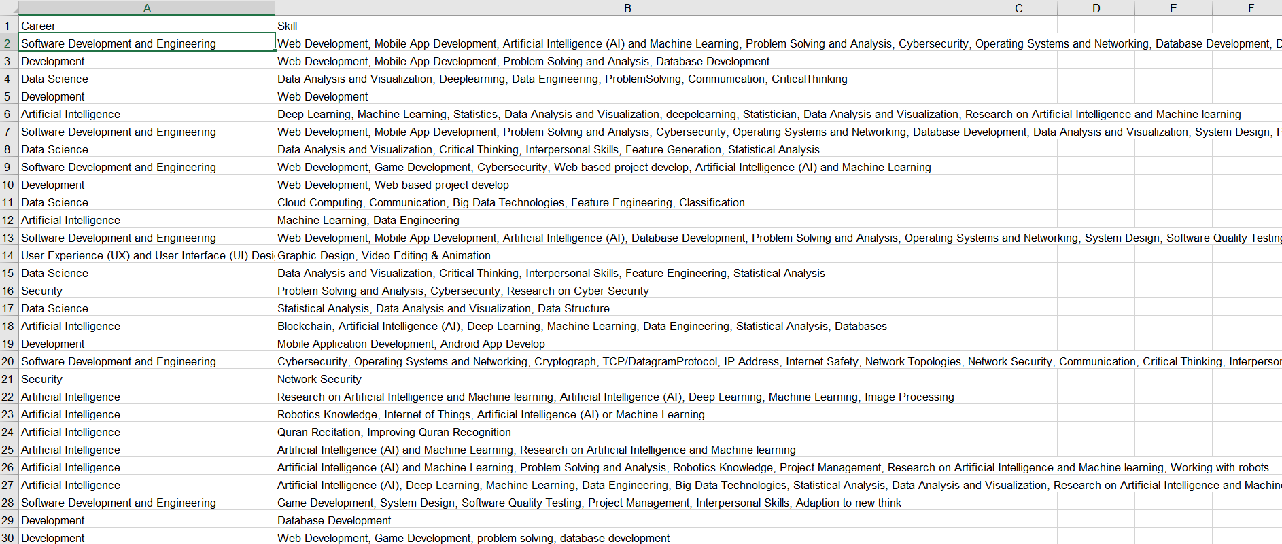
[Figure 7: Dataset 2 after preprocessing]
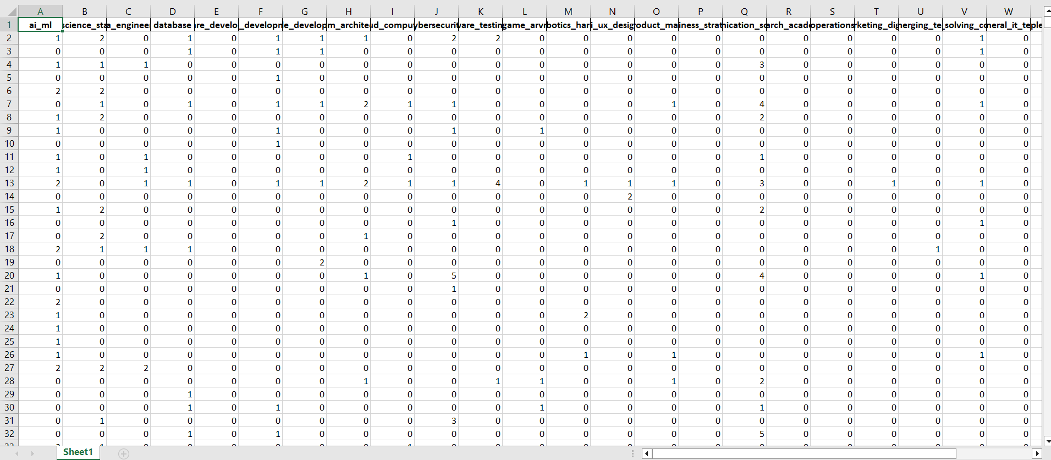
2.4. Model training
We split model 1 into 70 percent training set and 30 percent testing set, and model 2 80 percent training and 20 percent testing. And tested different models in both datasets. Then applied Optuna to finetune the models to get the highest possible accuracy. The way Optuna works, first, we define the parameters that can change and define the scores to maximize or minimize. Then Optuna chooses the hyperparameters to use, train the model, then check performance and learn from previous trials, making it efficiently choose the best hyperparameters for the model.
In model 1, the models, Light Gradient Boosting, Decision Tree, SVM, KNN, Random Forest, and Naïve Bayes, were tested and, the model yielding the highest accuracy and f1-score was LGBM model at 0.79 accuracy and 0.8 f1-score and after finetuning it using Optuna, it reached 0.81 accuracy and 0.81 f1-score. Figure 8 shows the accuracy and f1- score comparison of the different models.
[Figure 8: Accuracy and f1-score comparison of different models in model 1]
 | Validation set accuracy | Test set accuracy | Validation set f1-score | Test set f1-score
Decision Tree | 0.786062 | 0.779935 | 0.786777 | 0.780249
Naïve Bayes | 0.290113 | 0.315534 | 0.281995 | 0.296384
KNN | 0.487844 | 0.491909 | 0.488554 | 0.494591
SVM | 0.515397 | 0.555016 | 0.514941 | 0.553896
LGBM | 0.792545 | 0.804207 | 0.792778 | 0.804060
Random Forest | 0.794165 | 0.799353 | 0.794660 | 0.800238

In model 2, the models, XGBoost, Logistic Regression and Random Forest, and random forest, were tested and the model that yielded the highest accuracy at 0.917 after Optuna finetuning optimization was Random Forest. Figure 9 shows the comparison table of the 3 different models after Optuna finetuning.
[Figure 9: Accuracy comparison of different models in model 2]
 | Test set accuracy | Test set f1-score
XGBoost | 0.917 | 0.917
Logistic Regression | 0.917 | 0.918
Random Forest | 0.734 | 0.897

[Figure 10: best model in model 1 hyperparameters]
Hyperparameter | Value | Description
n_estimators | 100 | Number of boosting trees
max_depth | 11 | Maximum depth of each tree
learning_rate | 0.0831 | Step size shrinkage used in boosting
num_leaves | 115 | Maximum number of leaves in one tree
subsample | 0.9085 | Fraction of training samples used for each tree
colsample_bytree | 0.5370 | Fraction of features used for each tree
min_child_samples | 21 | Minimum number of samples required in a leaf
reg_alpha | 0.1159 | L1 regularization term
reg_lambda | 1.7262 | L2 regularization term

[Figure 11: best model in model 2 hyperparameters]
Hyperparameter | Value | Description
n_estimators | 300 | Number of trees in the forest
max_depth | 20 | Maximum depth of each decision tree
min_samples_split | 4 | Minimum number of samples required to split a node
min_samples_leaf | 1 | Minimum number of samples required at a leaf node
max_features | log2 | Number of features considered when looking for the best split

2.5 Career Ensemble
After training both models independently, their predictions are combined using a multimodal ensemble. Rather than selecting one model over the other, the ensemble takes the calibrated probability output from each model and computes a weighted average across the six career classes. This approach, known as late fusion, ensures that both the personality signal from Model 1 and the skill signal from Model 2 contribute to the final prediction.
Both models are calibrated using Platt scaling before fusion. Calibration is a necessary step here because uncalibrated classifiers can produce overconfident or underconfident probability scores, which would ruin the weighted average. With calibration applied, the probability outputs from both models represent reliable estimates of class membership and can be meaningfully combined.
Because the two models were trained on datasets of different quality — Model 1 generated reference data and Model 2 on real survey data — their contributions to the ensemble are not treated equally. Model 2 (Random Forest) is assigned a weight of 0.65 and Model 1 (LightGBM) a weight of 0.35, reflecting the higher discriminative power of the skill-profile model at this stage. These weights are designed to be updated as real data is collected for Model 2, at which point equal weighting can be applied.
Since the two models were trained on different datasets, a class alignment layer is applied before the weighted average is computed. The two models’ label encoders map career names to integers independently, meaning the same integer can refer to different careers across models. To resolve this, both probability vectors are projected onto a shared canonical set of six career classes before any combination takes place. This ensures the weighted sum is always computed between matching classes.
The final predicted career is the class with the highest ensemble probability. A confidence threshold of 0.35 is applied: if no class exceeds this threshold, the system returns an uncertain result rather than forcing a low-confidence prediction. In addition to the career prediction, the ensemble produces a skill gap report derived from Model 2’s career profiles, which were built during training by identifying skills that appeared in at least 40% of the training samples for each career. The report identifies skills the user is missing entirely as well as skills they possess but at an insufficient proficiency level for the predicted career path.
[Figure 12: Ensemble prediction weighted average mathematical formula]
P_ensemble(c) = w1 × P_M1(c) + w2 × P_M2(c)
Where w1 + w2 =1.0

References
- Pati, R., Pimplikar, A., Singh, A., Shah, A. and Puthran, S. (2024) Review of approaches towards building AI-based career recommender and guidance systems. ScienceOpen Preprints.
- Yaqoob, S., Noor, A., Noor, T.H., Khan, M.Z., Ejaz, A., Alam, M.I., Rana, N. and Ejaz, K. (2025) Enhancing student career guidance and sentimental analysis: a performance-driven hybrid learning approach with feature ranking. PLOS ONE, 20(1). Available at: https://doi.org/10.1371/journal.pone.0321108
- Faruque, S.H., Khushbu, S.A. and Akter, S. (2024) Unlocking futures: a natural language driven career prediction system for computer science and software engineering students. arXiv preprint arXiv:2405.18139. Available at: https://arxiv.org/abs/2405.18139
- Jain, D., Sangwan, S.R. and Kumar, A. (2024) Hyper-personalized employment in urban hubs: multimodal fusion architectures for personality-based job matching. Neural Computing and Applications, 37, pp. 23651–23666. Available at: https://doi.org/10.1007/s00521-024-10587-3
- Large, J., Lines, J. and Bagnall, A. (2019) A probabilistic classifier ensemble weighting scheme based on cross-validated accuracy estimates. Data Mining and Knowledge Discovery, 33(6), pp. 1674–1709. Available at: https://doi.org/10.1007/s10618-019-00638-y
- Ferdous, T. and Chowdhury, M. (2025) A machine learning and digital twin-based assistance system for computer science students' career prediction and activity recognition. FinTech and Sustainable Innovation, 00(00), pp. 1–12. Available at: https://doi.org/10.47852/bonviewFSI52024688

