Software Requirements Specification

Version 1.0

MAY 5, 2015

2048 Game Solver

Prabakaran(11mse1108)
Sainadh(11mse114)

Table of Contents

Table of Content
1.1. Purpose
1.2. Scope of the Project
1.3. Glossary
1.4. Overview of Document
1.5. References
2.0 Overall Description
2.1. Reliability Model
2.2. Process Model
2.2. Tools
2.3. Project Code Meter
2.4. JProfiler

1.0. Introduction

1.1. Purpose
The purpose of this document is to present a detailed description of the 2048 Game Solver. It will explain the purpose and features of the software reliability models, the software process of the system, finally explain the tools used for software quality and reliability.

1.2. Scope of Project
The scope of the project is to identify the quality and reliability factors for 2048 game solver.
.

1.3. Glossary
Term | Definition
Failure | The departure of program operation from user requirements.
Faulty | A defect in a program that causes failure.
Software Reliability | The probability of failure-free operation of a computer program for a specified time under a specified environment.
Failure Intensity | The expected number of failures experienced in a given time interval.

1.4. References
IEEE. IEEE Std 830-1998 IEEE Recommended Practice for Software Requirements Specifications. IEEE Computer Society, 1998.

1.5. Overview of Document
The next chapter, the Overall Description section, of this document gives an overview of the functionality, quality, reliability of the product.
.

2.0. Overall Description

- The main idea of the game is that you have a 4×4 grid with Integer values, all of which are powers of 2.
- Zero valued cells are considered empty. At every point during the game you are able to move the values towards 4 directions Up, Down, Right or Left.
- When you perform a move all the values of the grid move towards that direction and they stop either when they reach the borders of the grid or when they reach another cell with non-zero value.
- If that previous cell has the same value, the two cells are merged into one cell with double value.
- At the end of every move a random value is added in the board in one of the empty cells and its value is either 2 with 0.9 probability or 4 with 0.1 probability.
- The game ends when the player manages to create a cell with value 2048 (win) or when there are no other moves to make (lose).

2.1 Reliability Model
- Software Metric Model
Prediction Model
- This model uses historical data.
- They analyze previous data and some observations.
- They usually made prior development and regular test phases.
- The model follow the concept phase and the predication from the future time.

2.2 Process Model
- Agile Model

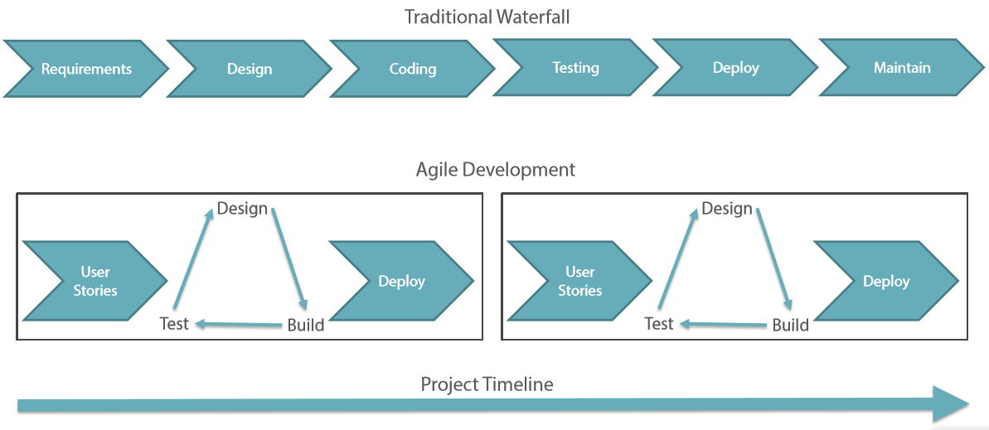

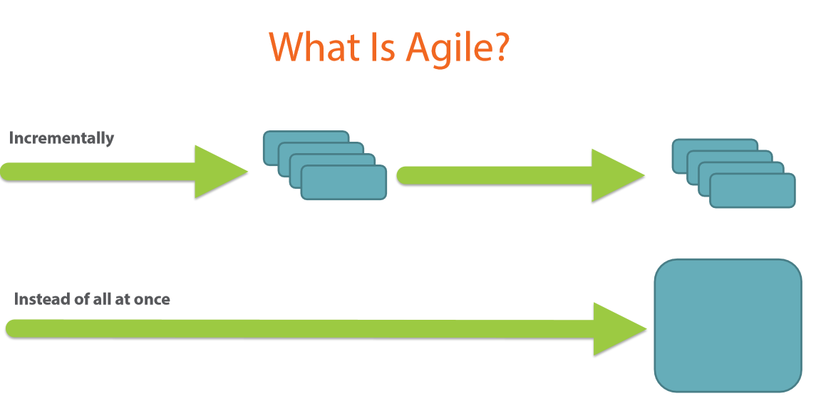
- Agile teams are software development teams first and members of a department second.
- A team should have a product or domain expert.
- A team has members with cross functional skills
- A team should have some form of leadership role
- A team can benefit from an agile coach or mentor.
Pros:
- Customer satisfaction by rapid, continuous delivery of useful software
- People and interactions are emphasized rather than process and tools
- Continuous attention to technical excellence and good design
- Regular adaptation to changing circumstances
- Early return on investment
- Feedback from real customers
- Build the right products
Cons:
- Difficult to assess the effort required at the beginning of the software development life cycle
- Can be very demanding on the users time
- Potential for scope creep
- Harder for new starters to integrate in the team
2.3 Project Code Meter
- Professional software tool for project managers to measure and estimate the Time, Cost, Complexity, Quality and Maintainability of software projects as well as Development Team Productivity by analyzing their source code.
- By using a modern software sizing algorithm called Weighted Micro Function Points (WMFP) a successor to solid ancestor scientific methods as COCOMO, COSYSMO, Maintainability Index, Cyclomatic Complexity, and Halstead Complexity

Screen Shots
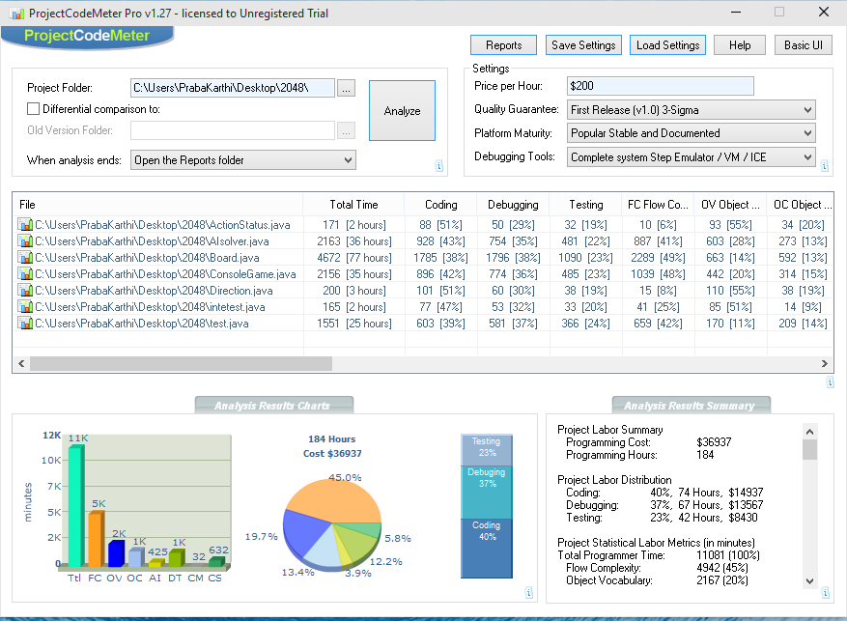

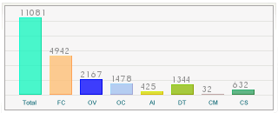ces more accurate results than traditional software sizing tools, while being faster and simpler to configure.

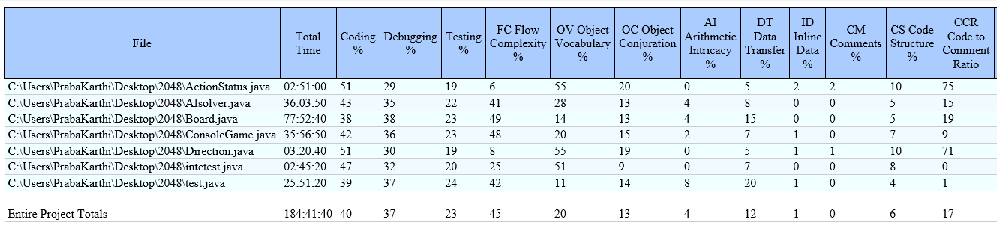

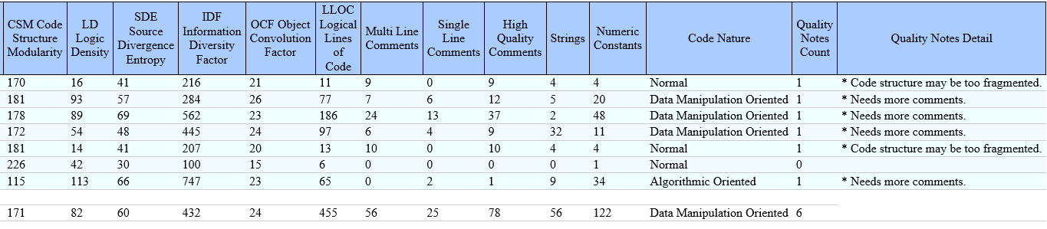

2.4 JProfiler
- JProfiler organizes profiling data into view sections which collect similar or connected views. Each view section may contain a number of views. The view selector is located on the left side of JProfiler's main window.
  - Memory views
the memory view section contains views which are concerned with the details of object allocations.
  - Heap walker
the heap walker view section allows you to take a snapshot of the heap and analyze it in detail.
  - CPU views
The CPU view section contains views which are concerned with method calls and time measurements.
  - Thread views
the thread view section contains views which are concerned with the details of thread statuses and the life cycle of threads.
  - Monitor views
the monitor view section contains views which are concerned with the details of monitor contentions and wait states.
  - Telemetry views
the telemetry view section contains views which are concerned with historical characteristics of cumulated virtual machine variables.
  - Databases
the databases section contains views which record database operations for JDBC operations as well as a number of NoSQL databases.
  - JEE & Probes
the probes section contains views which record data from higher-level subsystems of the JRE. You can define your own custom probes as well.
- 2048.jar add in Profiler
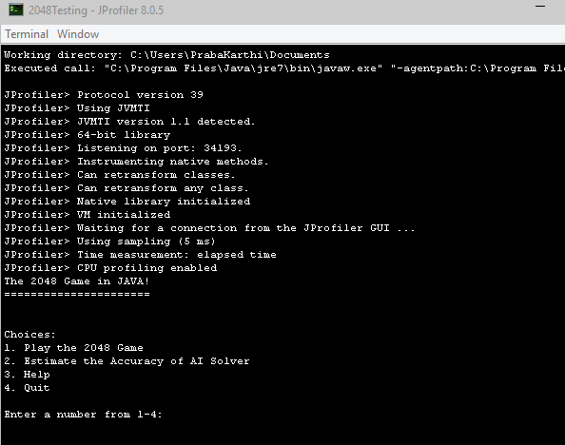
- All Object memory usage.

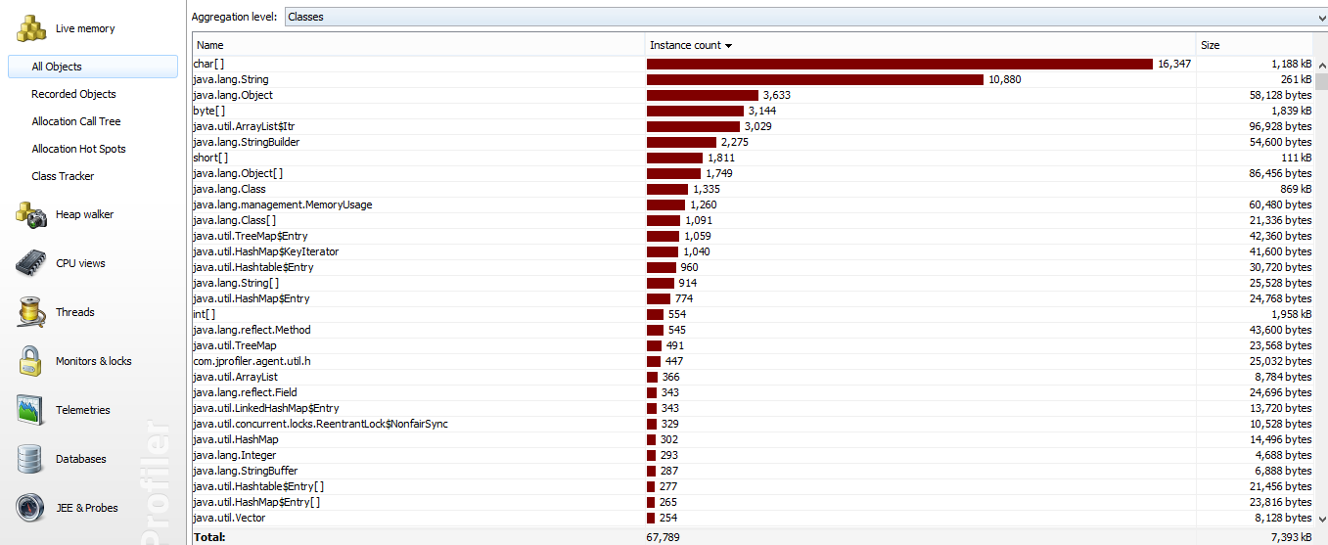

- Ram memory usage

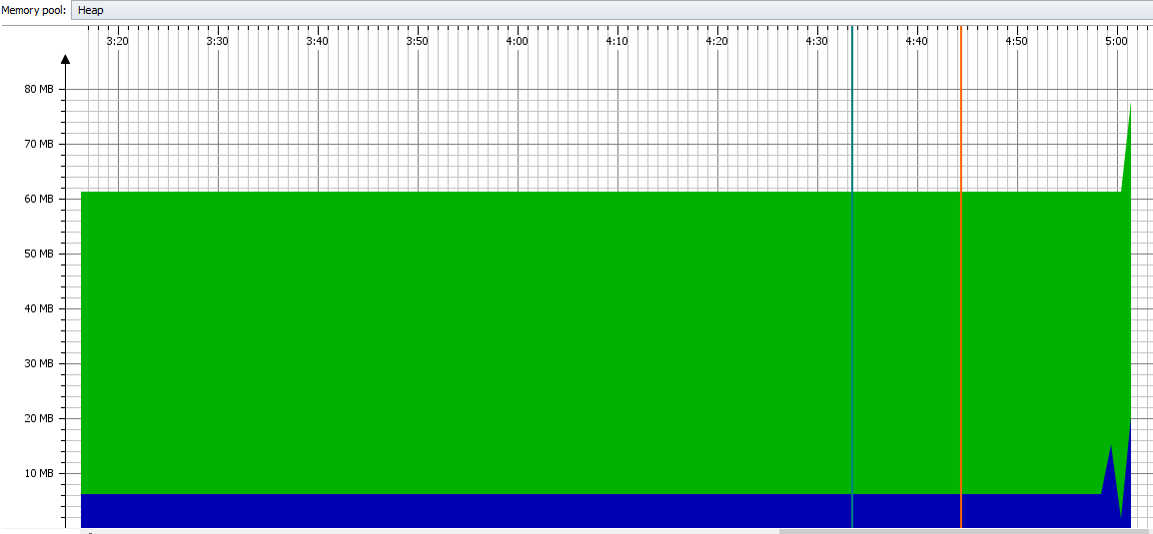

- AI Solver Memory Usage
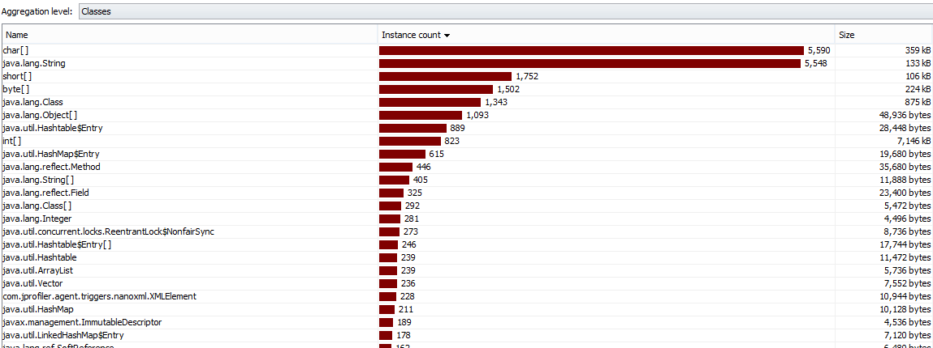
- AI Solver ram Usage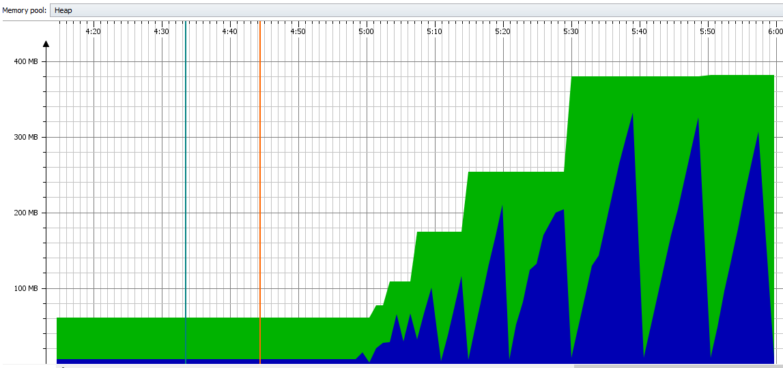
- Object Memory usage
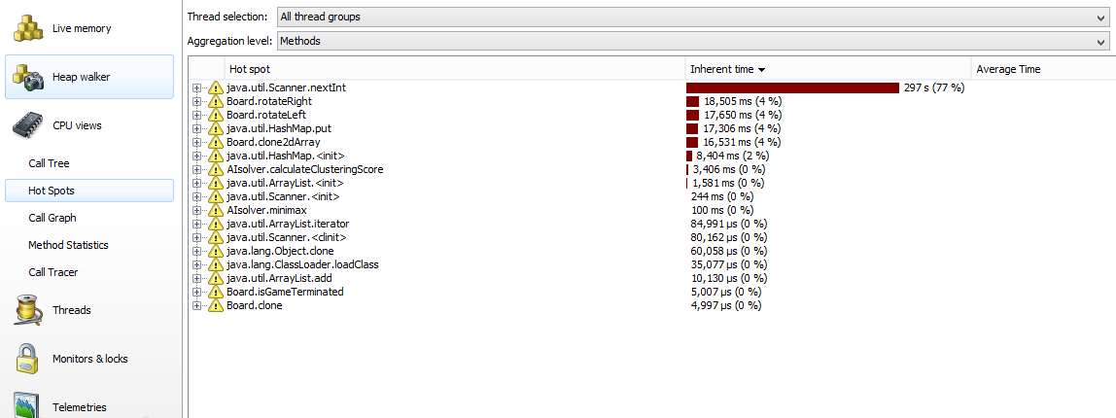

- Classes memory usgae

