ai Online shopping System

By

Asmaa Mohamed Elmaghraby 19200036

Mariam Sherif Amin 202000655

Mohamed Tarek Saad Mohamed Atta 202001053

Yara Abd Elghany Mahfouz 202001787

Yusuf Abd-El Azim 202000575

Table of Contents

1. introduction 3

1.1 Purpose of the document 3

1.2 Scope of the project 3

1.3 Technologies Used 4

1.4 Intended Audience 4

1.5 Overview of the document 4

2. Overall description 6

2.1. Product prespective 6

2.2. Product functions 6

2.3. User characterestics 7

2.4. Operating environment 7

2.5. Constraints 7

2.6. Assumptions and dependencies 7

3. External interface requiremnets 8

3.1. User interface……………………………………………………………………………8

3.2. Software interface...……………………………………………………………………10

4. Functional requirements.........................................................................................................11

4.1. User Class 1 - The User…………………………………………………………………..11

4.2. User Class 2 - The Seller……………………………………………………………….12

5. Non-Functional Requirements………………………………………………………………12

5.1. Safety……………………………………………………………………………………..12

5.2. Availability………………………………………………………………………………12

5.3. Security…………………………………………………………………………………12

5.4. Quality…………………………………………………………………………………..12

5.5. Recoverability…………………………………………………………………………13

5.6. Performance……………………………………………………………………………13

6. Diagrams…………………………………………………………………………………14

6.1. Use case diagram……………………………………………………………………….14

6.2. Sequence diagram………………………………………………………………………28

6.3.ERD diagram……………………………………………………………………………29

6.4.UML diagram……………………………………………………………………………29

# introduction

## 1.1 Purpose of the document

The purpose of the document is to provide a description for a web-based AI shopping system. It will describe the importance of the system, the purpose of its features, the database design, and the user interface. A description of the functionalities of the system and how the user will interact with them will also be provided. The document will also describe the constraints which the system must operate under and how it will behave with external stimuli.

## 1.2 Scope of the project

The online shopping website, Electronica, is an internet-based business that serves as a platform for the selling of electronic products. It also provides a platform for retailers and sellers to reach a global audience.

The user will first create an account by registering their information, then they will be able to login anytime onwards. The system will have a searching tool to assist in looking through the large number of products. Each customer will have their own personal cart to store their products to be purchased, and they will be able to order them for home delivery. Furthermore, A key feature to our shopping system will be secure money transaction along with time bound product delivery.

One of the shopping website's aims is to increase sales; this will be achieved through the website’s AI-based recommendation system, in which the system will keep track of the customers’ inputs and their most visited products and recommend other products belonging to the same categories for them.This will contribute to facilitating the shopping experience and making the website more user friendly, thus increasing website traction and profitability.

## 1.3 Technologies Used

* Python for the backend system.
* MySQL for database.
* Html, CSS, and JavaScript for the frontend system.

## 1.4 Intended Audience

The document will be of use to:

**Product owner**: To make sure that the design and requirements for their product are well understood by the project team, and to follow up with any needed changes in either.

**Software developers:** To facilitate implementation and maintenance of the system.

**Software QA and Testers:** To make sure that the system is working as intended by developing the right test cases, and to enhance the system’s quality.

**Project Manager:** To analyze the cost, time, and work structure needed for the project, for developing the appropriate plan and assigning the suitable team.

## 1.5 Overview of the document

The SRS's remaining sections go into great depth into the AI shopping website unique requirements and provides an overview of the website's capabilities. This document's following chapter provides a summary of the product's features, its needs, and intended audience. It also provides project limitations and user characteristics. Additionally, it outlines the unofficial criteria and serves as a backdrop for the technical requirements specification in the next chapter. Moreover, the Requirements Specification chapter is largely created for developers and provides technical descriptions of the website details in terms of interface properties and the functionality of the system.

# Overall description

## Product prespective

The user and seller subsystems are both part of the online system. It provides an excellent means of connecting merchants and buyers together on an internet platform to sell and buy in an efficient and safe manner, regardless of the distance between the two. It is a platform for people to purchase things online without having to physically visit a store or meet a seller, and a platform for vendors to sell their wares online without having to physically meet the customers or have a real store set up for their products. Customers may shop for millions of goods online using this approach. The merchant uploads his listing to the system, and buyers explore and purchase products from it.

Uploads listing

## Product functions

All key functions handled by the online shopping system, as well as the user classes, are given below.

* **For customer and seller:**
  + Register
  + Login
  + Logout
  + View account details
  + Edit account details
* **For customer:**
  + Search item
  + View item
  + View shopping cart
  + Add item to cart
  + Remove item from cart
  + Delivery and payment
  + Place order
  + Cancel order
  + Return item
  + View orders and returns
  + Recommendations
* **For seller:**
  + List items and sales
  + Upload items
  + Update items
  + Remove items

## User characterestics

Enlisted below are essentially two types of users can interact with the system: customer and seller. Both have different views of the system.

Customer : is a verified user of the system who is intended to buy a product sold by a seller using the system. The functions used by customer are register, view account, login, browse item, view item, buy item now, add to cart, view cart, proceed to buy, enter delivery address, enter mode of payment, make payment, place order, view orders, track package, cancel order, return item, logout.

Seller : is a verified user of the product who is intended to sell items over the system. The product functions used by sellers are register, view account, login, upload items, remove items, update items, and list sales.

## Operating environment

The software will run as a web application. Web apps are available for Windows via Google Chrome, Mozilla Firefox, and Microsoft Edge, and for Mac OS X via Apple Safari.

## Constraints

* The Internet is a basic need for accessing the system.
* Python for the backend system.
* MySQL for database.
* Html, CSS, and JavaScript for the frontend system.

## Assumptions and dependencies

It is assumed that only one customer may place an order at a given time but will attempt to expand the scope. The recommendation system is assumed to be dependent on the server and its functionalities though relevant to customers will be more clearly defined by the server.

# External interface requiremnets

# 3.1. user interface

# The store's home page will be the first page. There is a display of every item. Only after the user is logged into their account will the "Add to Cart" button add the product in the amount indicated in the text box to the cart. When a user clicks on a particular product, the product view window opens and the product's details are displayed. Additionally, there are suggestions for items the user may enjoy; as in Figure 01 and Figure 02.

# The user should be able to open the Sign-Up page if they are not logged into the system. So that they may access the system's services, they will register an account; as in Figure 03 and

# Figure 04.

# The products in the cart can also be seen and purchased by a logged-in user. There are pages that present the information appropriately.

# 

Figure 1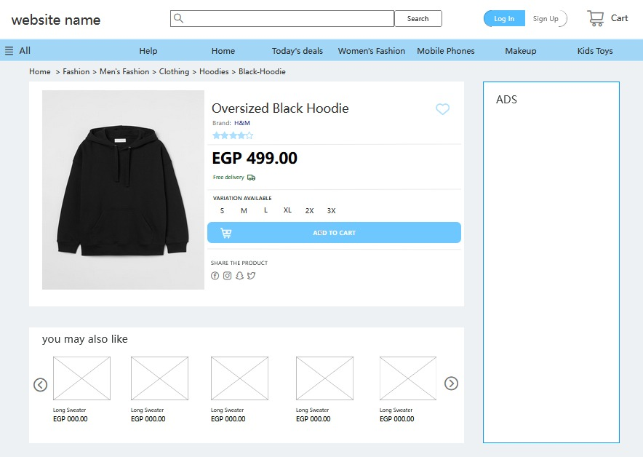

Figure 2

# 

Figure 3

# 

Figure 4

# 3.2. Software interface

# Electronica, the AI-powered online store, will be designed to operate on Windows, Linux, and Mac operating systems environments. The frontend will be developed using the Vue JavaScript framework. The frontend server will send and receive requests from the backend server. Flask, a Python framework will be used to provide API for the frontend and communicate with the database. The Python backend system will also include the recommender system. The system shall interact with MySQL server to execute database queries.

# 4.FUNCTIONAL REQUIREMENTS

## 4.1 User Class 1 - The CUSTOMER

### 4.1.1 Functional requirements

Title: Register.  
 Desc: The System shall allow the customer to register their information to login later.

### 4.1.2 Functional requirements

Title: Login.  
 Desc: The System shall allow the registered customer to login by entering their email and password.

### 4.1.3 Functional requirements

Title: Logout.  
 Desc: The System shall allow customer to logout of the system.

### 4.1.4 Functional requirements

Title: View account details.  
 Desc: The System shall allow the customer to view their account details.

### 4.1.5 Functional requirements

Title: Edit account details.  
 Desc: The System shall allow the customer to edit their account details.

### 4.1.6 Functional requirements

Title: Search item.  
 Desc: The System shall allow the customer to search for a specific item by entering the key words into a search bar then having the system display all the items that contains the key words.

### 4.1.7 Functional requirements

Title: view item.  
 Desc: The System shall allow the customer to view an item.

### 4.1.8 Functional requirements

Title: Add items to cart.  
 Desc: The System shall allow the customer to add items to their cart.

### 4.1.9 Functional requirements

Title: place order.  
 Desc: The System shall allow the customer to place order.

### 4.1.10 Functional requirements

Title: Track order.  
 Desc: The System shall allow the customer to track their orders.

### 4.1.11 Functional requirements

Title: view past order.  
 Desc: The System shall allow the customer to view their past orders.

### 4.1.12 Functional requirements

Title: cancel order.  
 Desc: The System shall allow the customer to cancel their order.

### 4.1.13 Functional requirements

Title: return item.  
 Desc: The System shall allow the customer to return an item.

## 4.2 User Class 2 - The Seller

### 4.2.1 Functional requirements

Title: Login.  
 Desc: the system shall allow the seller to login to the system to manage the system’s information.

### 4.2.2 Functional requirements

Title: Logout.  
 Desc: the system shall allow the seller to logout from the systems.

### 4.2.3 Functional requirements

Title: view user’s past orders.  
 Desc: the system shall allow the seller to view a user’s past orders

### 4.1.4 Functional requirements

Title: manage customers

Desc: the system shall allow seller to view customer information and manage it.

### 4.1.5 Functional requirements

Title: manage items.  
 Desc: the system shall allow seller to view items information and manage them.

**5.NON-FUNCTIONAL REQUIREMENTS**

**5.1 SAFETY REQUIREMENTS**

The system must take concrete measures to ensure that customers can trust the service being provided to them. Site seals on web sites are visual indicators that the website is safe and secure.

**5.2 AVAILABILITY REQUIREMENTS**

The system should be able to run for 24 hours a day and 7 days a week.

**5.3 SECURITY REQUIREMENTS**

System must keep security for customer data to avoid data corruption and hacking attacks. To make the system reliable we will use the following:

* The customer’s web browser must never display a customer’s password or credit card details.
* The system’s back-end servers must never display a customer’s password and these servers must only be accessible to authenticated selleristrators.
* These databases must be encrypted and within the company's perimeter.

**5.4 QUALITY REQUIREMENTS**

The system must work without any compromise in performance and quality in the web application.

**5.5 RECOVERABILITy REQUIREMENTS**

System must recover after a breakdown within approximately 4 hours.

**5.6 PERFORMANCE REQUIREMENTS**

The system must ensure that the right product should be available at the right time and adequate quality. Loading pages shouldn't exceed 4 seconds.

# 6.DIAGRAMS

**6.1 Use Case Diagram**

**6.1 Use Case Diagram**

|  |  |
| --- | --- |
|  | |
|  | |
| ***Name*** | ***Register*** |
| ***Actors*** | ***Customer*** |
| ***Main success scenario:*** | ***1- system shows registration page and prompts user to enter their information (name, email, password, phone number, location...etc.)***  ***2- the user inputs their information then clicks sign up button***  ***3- system checks if there is no account already registered with the email***  ***4- systems creates account by saving user’s data into the system*** |
| ***Exceptions*** | ***2a. user does not enter every needed information before clicking button***  ***3a. there is an account already registered*** |
| ***Actions*** | ***2.1 system prevents sign up and warns user of required information***  ***2.2 user enter required information***  ***3.1 system warns user that the email is already registered***  ***3.2 user logs in with the email or enters a new email*** |
| ***Pre-condition*** | * ***User can visit the website*** |
| ***Post condition*** | * ***User is successfully registered into the system*** * ***Number of system users increased by 1*** * ***Login information stored in database*** |

**Use case 01**

**Use case 02**

|  |  |
| --- | --- |
|  | |
|  | |
| ***Name*** | ***login*** |
| ***Actors*** | ***customer/seller*** |
| ***Main success scenario:*** | ***1- system shows login page and prompts customer/seller for email and password***  ***2- the customer/seller inputs their information then clicks log in button***  ***3- system checks if log in information is correct***  ***4- customer/seller logs into their accounts*** |
| ***Exceptions*** | ***2a. customer/seller does not enter every needed information before clicking button***  ***3a.***  ***customer/seller enters invalid login information*** |
| ***Actions*** | ***2.1 system prevents log in and warns user of required information***  ***2.2 customer/seller enter required information***  ***3.1 system warns user that information is incorrect***  ***3.2 customer/seller tries again or stops trying*** |
| ***Pre-condition*** | * ***customer/seller are registered into the system*** |
| ***Post condition*** | * ***system customer functionalities are available to customers*** * ***system seller functionalities are available to seller*** |

**Use case 03**

|  |  |
| --- | --- |
|  | |
|  | |
| ***Name*** | ***logout*** |
| ***Actors*** | ***Seller/customer*** |
| ***Main success scenario:*** | ***1-seller/user clicks on “Logout”***  ***2-The system will move the user session and the seller/customer will be logged out.*** |
| ***Post condition*** | ***System logs out customer/seller from the website*** |

**Use case 04**

|  |  |
| --- | --- |
|  | |
|  | |
| ***Name*** | ***View account details*** |
| ***Actors*** | ***customer*** |
| ***Main success scenario:*** | ***1- customer clicks on their account item on the top banner***  ***2- system displays a list of options (account details, account settings, log out...etc.)***  ***3- customer chooses account details option***  ***4- system displays customer account details*** |
| ***Pre-condition*** | * ***user logged into the system*** |
| ***Post condition*** | * ***system displays user’s account information*** |

**Use case 05**

|  |  |
| --- | --- |
|  | |
|  | |
| ***Name*** | ***Edit account details*** |
| ***Actors*** | ***customer*** |
| ***Main success scenario:*** | ***1- customer visits their account details page***  ***2- customer clicks the edit account details hyperlink***  ***3- system displays editable forms for each piece of information (email, password, phone number...etc.)***  ***4- user enters the new information then clicks update button***  ***5- system checks if new information is valid***  ***6- customer’s information are updated*** |
| ***Exceptions*** | ***4a. user does not enter any new information***  ***5a. user enters invalid new information*** |
| ***Actions*** | ***4.1 system issues a warning that no information was entered***  ***4.2 customer enters new information or cancels***  ***5.1 system issues a warning that information is invalid***  ***5.2 customer tries again with new information or doesn’t try*** |
| ***Pre-condition*** | * ***user logged into the system*** |
| ***Post condition*** | * ***user’s account details is updated in the database*** |

**Use case 06**

|  |  |
| --- | --- |
|  | |
|  | |
| ***Name*** | ***Search item*** |
| ***Actors*** | ***Customer*** |
| ***Main success scenario:*** | ***1- Customer enters a keyword***  ***2- system searches for a keyword***  ***3- system displays items that has keyword in it*** |
| ***Exceptions*** | ***2a keyword is not found after searching*** |
| ***Actions*** | ***2.1 systems display message that keyword is not found in database***  ***2.2 user tries a different keyword*** |
| ***Pre-condition*** | * ***user logged into the system*** * ***user must enter something in search*** |
| ***Post condition*** | * ***system displays items based on keyword*** |

**Use case 07**

|  |  |
| --- | --- |
|  | |
|  | |
| ***Name*** | ***View item*** |
| ***Actors*** | ***customer*** |
| ***Main success scenario:*** | ***1- customer chooses a category of product or just surfs the homepage***  ***2- customer click on a certain item***  ***3- system displays item to customer*** |
| ***Pre-condition*** | * ***user can visit the website*** |
| ***Post condition*** | * ***system displays product successfully*** |

**Use case 08**

|  |  |
| --- | --- |
|  | |
|  | |
| ***Name*** | ***Add items to cart*** |
| ***Actors*** | ***customer*** |
| ***Main success scenario:*** | ***1- customer looks at items to choose from***  ***2- customer clicks on desired item***  ***3- system displays item details***  ***4- customer chooses desired variation of item***  ***5- customer clicks on add to cart button***  ***6- system adds item to cart*** |
| ***Pre-condition*** | ***Customer is logged in to the system*** |
| ***Post condition*** | ***Cart items are updated in database*** |

**Use case 09**

|  |  |
| --- | --- |
|  | |
|  | |
| ***Name*** | ***Place order*** |
| ***Actors*** | ***Customer*** |
| ***Main success scenario:*** | ***1- customer finishes adding items to cart***  ***2- customer clicks on proceed to buy button***  ***3- system displays a form for address information***  ***4- customer enters address information***  ***5- system displays a form for payment method***  ***6- customer chooses payment method then enters more information if required***  ***7- system displays complete order details***  ***8- customer reviews details then click confirm order button*** |
| ***Exceptions*** | ***2a. cart is empty***  ***4a. customer does not enter address information***  ***6a. customer enters invalid payment information*** |
| ***Actions*** | ***2.1 system displays a warning that no items have been added to cart***  ***2.2 user adds items to cart or cancels operation***  ***4.1 system displays a warning that address information must be entered***  ***4.2 user add address information or cancels***  ***6.1 system displays a warning that invalid payment information was entered***  ***6.2 user enters valid payment information or cancels*** |
| ***Pre-condition*** | * ***user logged into the system*** |
| ***Post condition*** | * ***user’s order details is updated in the database*** |

**Use case 10**

|  |  |
| --- | --- |
|  | |
|  | |
| ***Name*** | ***Track order*** |
| ***Actors*** | ***customer*** |
| ***Main success scenario:*** | ***1-The customer visits their past orders page***  ***2- customer goes to their latest orders***  ***3- customer clicks on track order button***  ***2- the system shows at which stage the order is at.*** |
| ***Pre-condition*** | * ***user must be logged in*** * ***The user must place an order*** |
| ***Post condition*** | ***The system shows what stage the order is currently at successfully.*** |

**Use case 11**

|  |  |
| --- | --- |
|  | |
|  | |
| ***Name*** | ***View past orders*** |
| ***Actors*** | ***Customer*** |
| ***Main success scenario:*** | ***1-The Customer visits account details page***  ***2-the customer chooses past orders option***  ***3-the system displays all past orders*** |
| ***Pre-condition*** | * ***the user must login to the system*** |
| ***Post condition*** | * ***the system displays all past orders*** |

|  |  |
| --- | --- |
|  | |
|  | |
| ***Name*** | ***Cancel order*** |
| ***Actors*** | ***customer*** |
| ***Main success scenario:*** | ***1- customer visits past order page***  ***2- customer click on the latest order details***  ***3- system displays latest order information***  ***4-Customer clicks on cancel order button***  ***5- system displays questionnaire for cancelling reason***  ***6- customer responds to questionnaire***  ***5- system displays confirmation message for cancelling the order***  ***6- customer confirms cancellation***  ***7- system cancels order*** |
| ***Exceptions*** | ***5a customer does not respond to questionnaire*** |
| ***Pre-condition*** | ***5.1 system sends warning to user to respond to questionnaire***  ***5.2 user responds to questionnaire or cancels operation*** |
| ***Post condition*** | ***System cancels order and order status is set to cancelled*** |

**Use case 12**

|  |  |
| --- | --- |
|  | |
|  | |
| ***Name*** | ***Return item*** |
| ***Actors*** | ***Customer*** |
| ***Main success scenario:*** | ***1- customer visits their past orders page***  ***2- customer clicks on their latest order***  ***3- system view latest order items details***  ***4- customer chooses which items to return***  ***5- system displays a questionnaire for return reasons***  ***6- customer enters reason for return***  ***7- system accept return request to be processed late*** |
| ***Exceptions*** | ***5a. customer does not respond to questionnaire*** |
| ***Actions*** | ***5.1 system issues a warning for user to respond to questionnaire***  ***5.2 user responds to questionnaire or cancels*** |
| ***Pre-condition*** | * ***user is logged into the system*** * ***user has made an order from the website before*** |
| ***Post condition*** | * ***Return request is accepted to be processed later*** |

**Use case 13**

**Use case 14**

|  |  |
| --- | --- |
|  | |
|  | |
| ***Name*** | ***View past orders*** |
| ***Actors*** | ***seller*** |
| ***Main success scenario:*** | ***1- seller will go to customer’s data view***  ***2- seller will search for customer’s email and click on it***  ***3- system will display customer’s order history and past order details*** |
| ***Exceptions*** | ***2a. customer’s email not found in database*** |
| ***Actions*** | ***2.1 system will issue a warning that email is not found***  ***2.2 seller will try again with a different email or cancel operation*** |
| ***Pre-condition*** | * ***seller must be logged in to the system*** |
| ***Post condition*** | * ***the system displays all past orders of a user*** |

**Use case 15**

**Use case 16**

|  |  |
| --- | --- |
|  | |
|  | |
| ***Name*** | ***Manage Products*** |
| ***Actors*** | ***seller*** |
| ***Main success scenario:*** | ***1- seller goes to products data view page***  ***2-the seller views, updates, adds, or delete a product’s record.***  ***3-the seller closes the product data view.*** |
| ***Pre-condition*** | ***1-The product’s record exists for editing/view.***  ***2-The seller is logged in.*** |
| ***Post condition*** | ***System saves any modifications made by seller in database*** |

|  |  |
| --- | --- |
|  | |
|  | |
| ***Name*** | ***Manage Customers*** |
| ***Actors*** | ***seller*** |
| ***Main success scenario:*** | ***1- seller goes to customers data view page***  ***2-the seller views, updates, adds, or delete Customer’s record.***  ***3-the seller closes the Customer data view.*** |
| ***Pre-condition*** | * ***The Customer’s record exists for editing/delete*** * ***The seller is logged in*** |
| ***Post condition*** | ***System saves any modifications made by seller in database.*** |

**6.2 Sequence diagrams**

**6.2.1 Place order**

Place order

**6.2.2 Cancel order**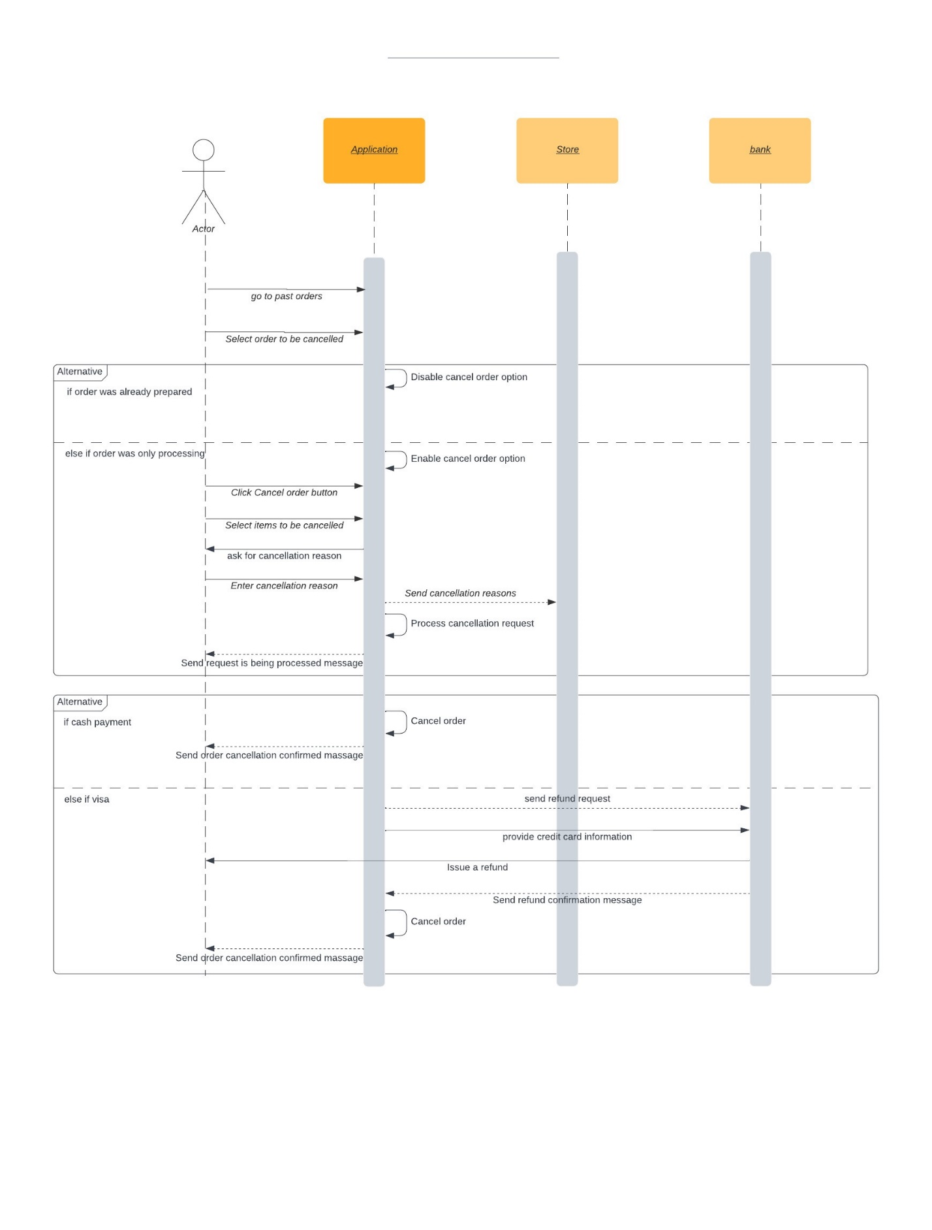

Cancel order

customer

**6.3 ERD diagram**

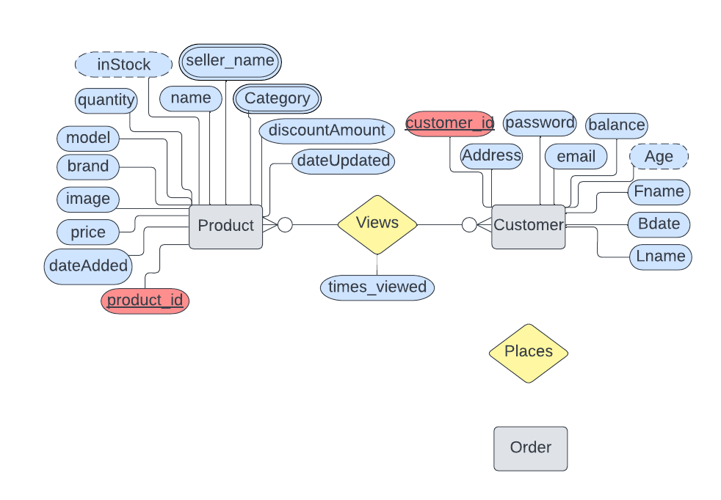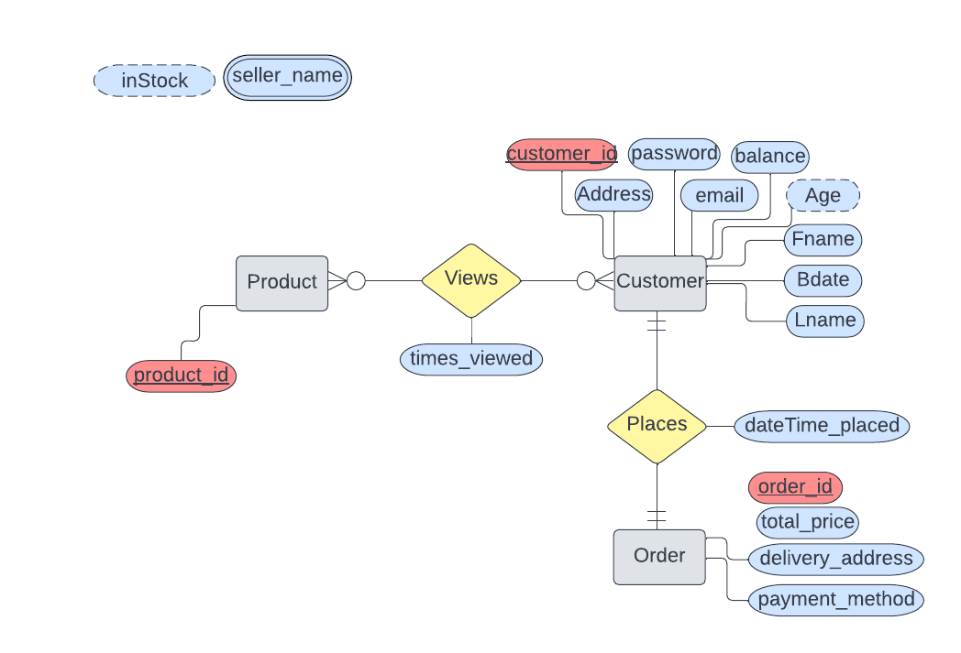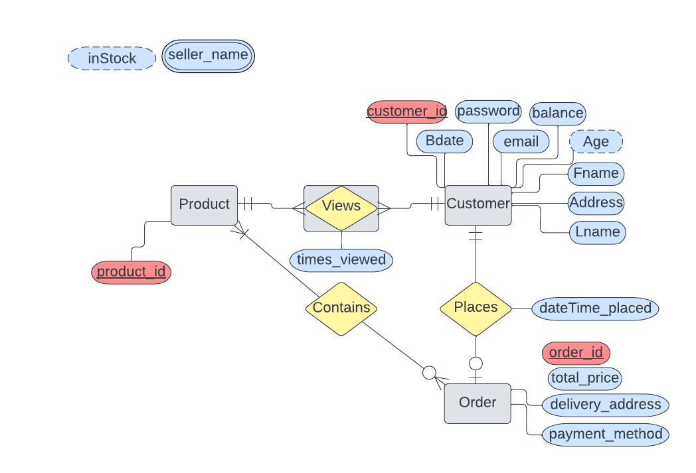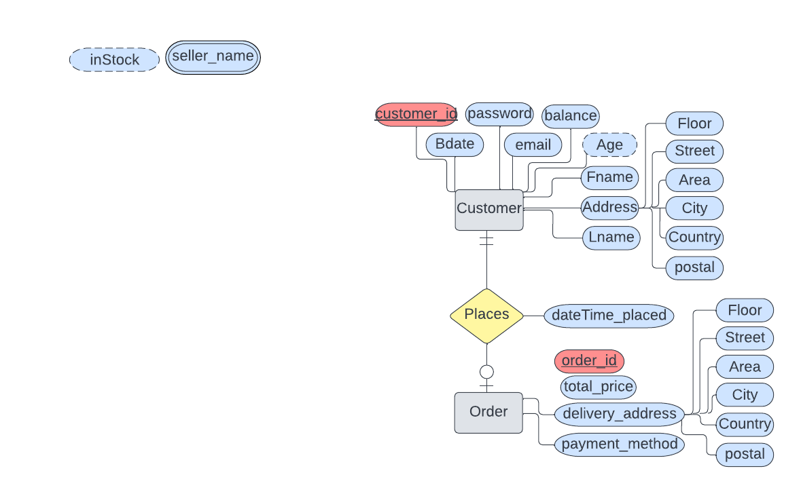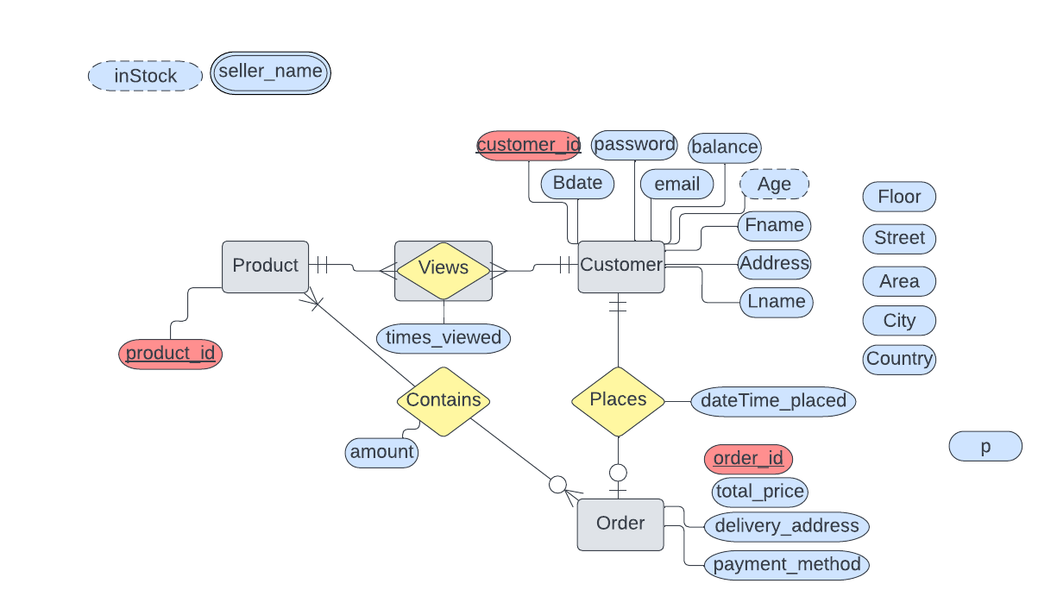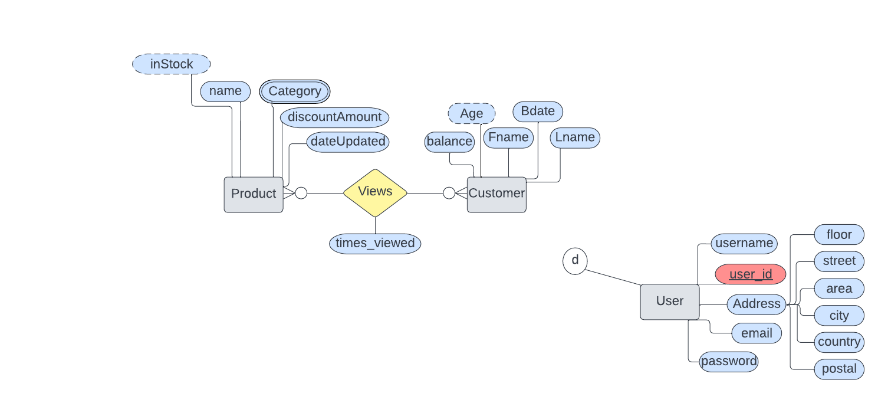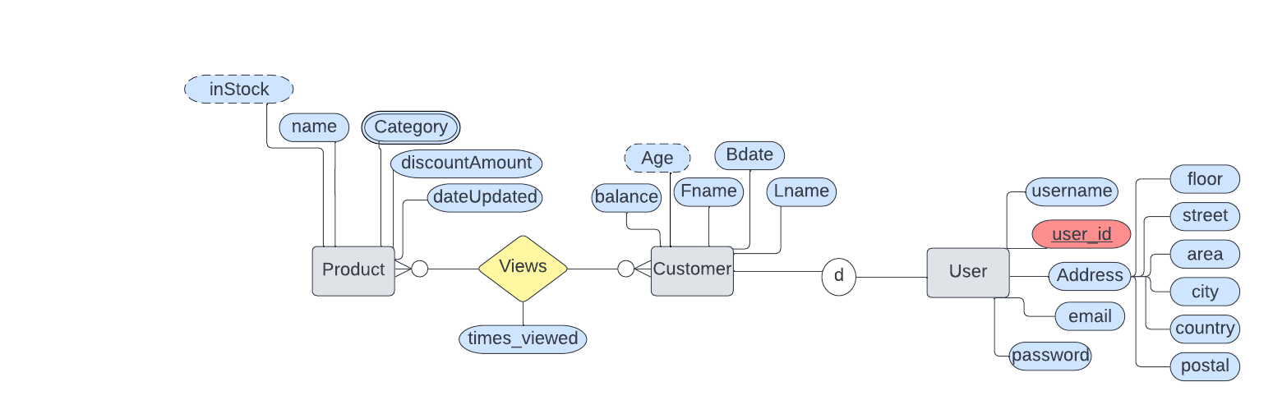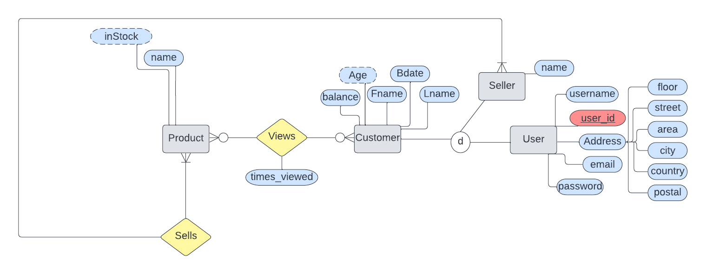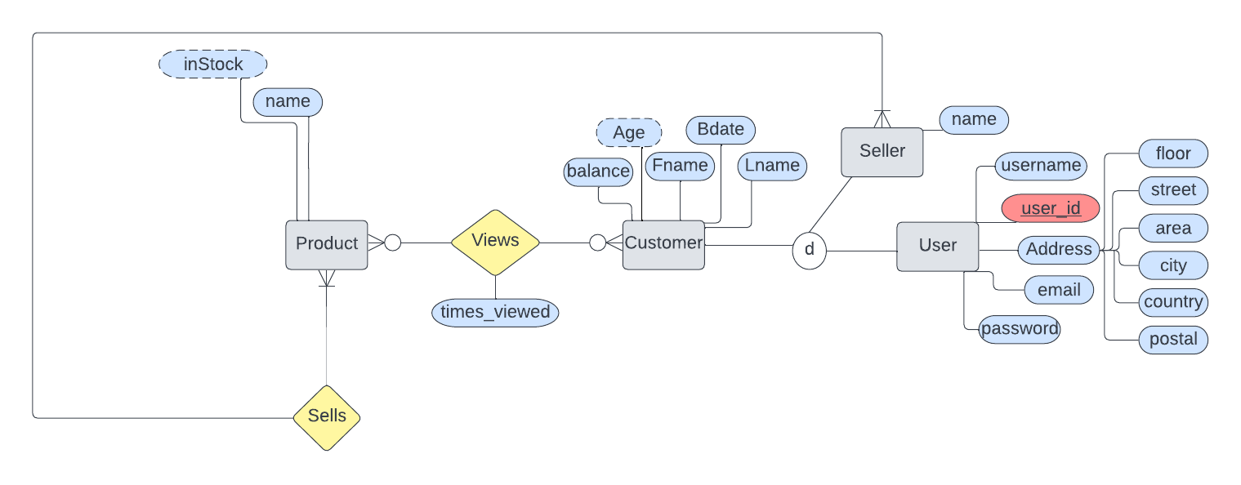

**6.4 UML diagram**

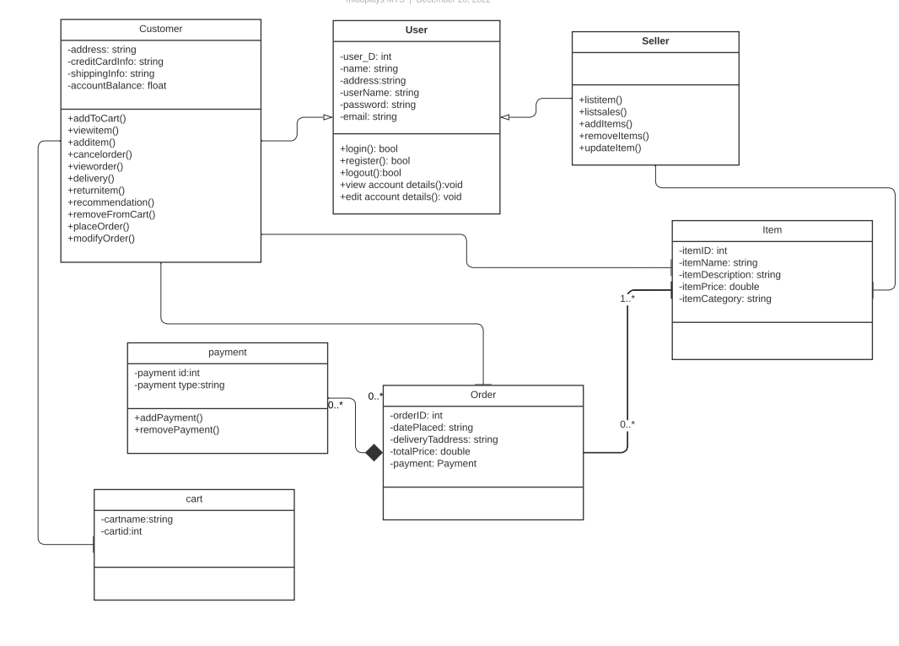

**6.2 Test cases**

|  |  |  |  |  |  |
| --- | --- | --- | --- | --- | --- |
| **ID** | Name | Precondition | Input | Expectation | Postcondition |
| 1 | **Login** | User has valid email and password | Valid email:  examole@gmail.com  Valid password:  1234 | User is navigated to home page with successful login | User is validated with database and successfully login to account. The account session details are logged in database. |
| 2 | **Register** | ***User can visit the website*** | ***the user inputs their information (username, email, password, phone number)*** | ***systems create account by saving user’s data into the system*** | ***1.User is successfully registered into the system***  ***Number of 2. system users increased by 1*** |
| 3 | **View account details** | ***user logged into the system*** | Valid email:  examole@gmail.com  Valid password:  1234 | ***Customer able to view the account details*** | ***system displays user’s account information*** |
| 4 | **Cancel order** | ***1 system sends warning to user to respond to questionnaire***  ***2 user responds to cancels operation*** | Valid email:  examole@gmail.com  Valid password:  1234 | ***Customer able to cancel order*** | ***System cancels order and order status is set to cancelled*** |
| 5 | **logout** | User is already logged into the system |  | User should be logged out of the system and navigated into the login page | User is successfully logged out. Number of system users decrements by 1. Logout time stored in database |

|  |  |  |  |  |  |  |  |
| --- | --- | --- | --- | --- | --- | --- | --- |
| **Test Case** | | | | | | | |
| **ID:** 1 | | | | **Designed by:** Mohamed Tarek Saad | | | |
| **Priority:** High | | | | **Test Designed date:** 24/12/2022 | | | |
| **Module Name:** Login | | | | **Test executed by:** Mohamed Tarek Saad | | | |
| **Title:** Verify login with valid email and password | | | | **Test execution date:** 24/12/2022 | | | |
| **Description:** Test the website’s login page | | | |  | | | |
| **Pre-conditions:** User has valid username and password | | | | | | | |
| **Dependencies:** | | | | | | | |
| **Step** | **Test steps** | **Test data** | **Expected result** | | **Actual result** | **Status** | **Notes** |
| 1 | Navigate to login page | URL: localhost8081/login | Login page shows | | Login page shown | Pass |  |
| 2 | Provide valid email | User: [example@gmail.com](mailto:example@gmail.com) | Email can be typed in its input field | | Email is typed in its input field | Pass |  |
| 3 | Provide valid password | Password: 1234 | Password can be typed in its input field | | Password is typed in its input field | Pass |  |
| 4 | Click on Login button |  | User should be able to login using the data in the input fields | | User is navigated to dashboard with successful login | Pass |  |
| **Post-conditions:** User is validated with database and successfully login to account. The account session details are logged in database. | | | | | | | |

|  |  |  |  |  |  |  |  |
| --- | --- | --- | --- | --- | --- | --- | --- |
| **Test Case** | | | | | | | |
| **ID:** 2 | | | | **Designed by:** Asmaa Mohamed | | | |
| **Priority:** High | | | | **Test Designed date:** 24/12/2022 | | | |
| **Module Name:** Register | | | | **Test executed by:** Asmaa Mohamed | | | |
| **Title:** Verify Register with valid email and password | | | | **Test execution date:** 24/12/2022 | | | |
| **Description:** Test the website’s registration | | | |  | | | |
| **Pre-conditions: *User can visit the website*** | | | | | | | |
| **Dependencies:** | | | | | | | |
| **Step** | **Test steps** | **Test data** | **Expected result** | | **Actual result** | **Status** | **Notes** |
| 1 | Enter data in all fields | Username:  Asmaa mohamed  email: [example@gmail.com](mailto:example@gmail.com)  Password: 1234 | Register user | | Register user | Pass |  |
| 2 | Data missing in any fields | Password: 1234 | Missing field message | | Missing field message | Pass |  |
| 4 | Click on sign up button |  | User should be able to register using the data in the input fields | | User registration is successfully | Pass |  |
| ***User is successfully registered into the system***. ***Number of system users increased by 1***. ***Login information stored in database*** | | | | | | | |

|  |  |  |  |  |  |  |  |
| --- | --- | --- | --- | --- | --- | --- | --- |
| **Test Case** | | | | | | | |
| **ID:** 3 | | | | **Designed by:** Asmaa Mohamed | | | |
| **Priority:** High | | | | **Test Designed date:** 24/12/2022 | | | |
| **Module Name:** view account details | | | | **Test executed by:** Asmaa Mohamed | | | |
| **Title:** view customer account details | | | | **Test execution date:** 24/12/2022 | | | |
| **Description:** view accounts details | | | |  | | | |
| ***Precondition: customer logged into the system*** | | | | | | | |
|  | | | | | | | |
| **Step** | **Test steps** | **Test data** | **Expected result** | | **Actual result** | **Status** | **Notes** |
| 2 | ***1- customer clicks on their account item on the top banner***  ***2- system displays a list of options (account details, account settings, log out...etc.)***  ***3- customer chooses account details option***  ***4- system displays customer account details*** | Username:  Asmaa mohamed  email: [example@gmail.com](mailto:example@gmail.com)  Password: 1234 | ***system displays user’s account information*** | | ***system displays user’s account information*** | Pass |  |
| **Post-conditions:** ***order system displays user’s account information*** | | | | | | | |

|  |  |  |  |  |  |  |  |
| --- | --- | --- | --- | --- | --- | --- | --- |
| **Test Case** | | | | | | | |
| **ID:** 4 | | | | **Designed by:** Asmaa Mohamed | | | |
| **Priority:** High | | | | **Test Designed date:** 24/12/2022 | | | |
| **Module Name:** cancel order | | | | **Test executed by:** Asmaa Mohamed | | | |
| **Title:** cancel order | | | | **Test execution date:** 24/12/2022 | | | |
| **Description:** customer can cancel order | | | |  | | | |
| **Pre-conditions: *system sends warning to user to respond to questionnaire. Customer responds to cancels operation*** | | | | | | | |
| **Dependencies:** | | | | | | | |
| **Step** | **Test steps** | **Test data** | **Expected result** | | **Actual result** | **Status** | **Notes** |
| 2 | ***1- customer visits past order page***  ***2-Customer clicks on cancel order button***  ***5- system displays questionnaire for cancelling reason***  ***6- customer responds to questionnaire***  ***5- system displays confirmation message for cancelling the order*** | Username:  Asmaa mohamed  email: [example@gmail.com](mailto:example@gmail.com)  Password: 1234 | ***Canceled order*** | | ***Canceled order*** | Pass |  |
| **Post-conditions:** ***customer able to cancel order system displays user’s account information*** | | | | | | | |

|  |  |  |  |  |  |  |  |
| --- | --- | --- | --- | --- | --- | --- | --- |
| **Test Case** | | | | | | | |
| **ID:** 5 | | | | | **Designed by:** Mohamed Tarek Saad | | |
| **Priority:** Medium | | | | | **Test Designed date:** 24/12/2022 | | |
| **Module Name:** Logout | | | | | **Test executed by:** Mohamed Tarek Saad | | |
| **Title:** Logout | | | | | **Test execution date:** 24/12/2022 | | |
| **Description:** Test whether the system can sign the user out correctly | | | | |  | | |
| **Pre-conditions:** User is already logged into the system | | | | | | | |
| **Dependencies:** Login | | | | | | | |
| **Step** | **Test steps** | **Test data** | **Expected result** | **Actual result** | | **Status** | **Notes** |
| 1 | Click on Logout button |  | User should be logged out of the system and navigated into the login page | User is not logged out, page not changed | | Fail | Logout functionality requires debugging |
| **Post-conditions:** User is successfully logged out. Number of system users decrements by 1. Logout time stored in database. | | | | | | | |