CANADA – BRAZIL TRADE
Data Quality Report
Technical Documentation
Statistics Canada Export Dataset | 2024 – 2025

Project Overview
The goal of this project is to build an automated Power BI dashboard that updates whenever new data is added. The dashboard will focus on the business relationship between Canada and Brazil, especially the flow of merchandise imports and exports.

Using data from Statistics Canada and other relevant sources, the goal is to turn data into something easier to understand. This dashboard is meant for anyone curious about the two markets: investors, entrepreneurs, or just people exploring the topic. Instead of going through spreadsheets with raw data, users can check the main trends, compare changes over time, and notice anything interesting that might help with decision-making.

1.1 Dataset

All data was collected from Statistics Canada, which publishes detailed records of Canadian imports and exports broken down by period, province, commodity, and country.

Although the dashboard focuses on Brazil–Canada trade, analyzing Brazil in isolation would give an incomplete picture. To properly understand Brazil’s position, pricing patterns, and competitiveness, it is also necessary to examine other countries exporting to or importing from Canada. For this reason, the dataset includes all countries for which Canada reports trade activity, not only Brazil.

 | Exports | Imports
Source | Statistics Canada — provincial export records | Statistics Canada — provincial import records
Period | January 2024 – December 2025 | January 2024 – December 2025

Each row represents one trade record: Period, Commodity (HS code), Province, Country, State (US only), Value ($), Quantity, Unit of measure.

1.2 Programming Language and Libraries Used

This project was developed using Python, which was selected for its readability, ease of use and rich ecosystem of libraries tailored for data manipulation, analysis, and visualization.

Key libraries used include:
- pandas – for reading, cleaning, and summarizing tabular data
- numpy – for numerical calculations and array operations
- matplotlib.pyplot – for creating clear, customizable charts
- seaborn – for enhanced, visually appealing plots
- os – for navigating directories and handling files

1.3 Combining Dataset
Before starting all data from multiple CSV files were stored in a folder, combining everything into one dataset. There is a dedicated file to generate the dataset in parquet format, and also csv: Concat Dataset (https://colab.research.google.com/drive/1mbhQLwU-ZsCStizQmynJWUv2OBascgNu?usp=sharing)
In the file, the function read_and_combine_data will:
# Load and combine all CSV files from a folder
def read_and_combine_data(folder_path):
all_files = [f for f in os.listdir(folder_path) if f.endswith(".csv")]
df = pd.concat([pd.read_csv(f) for f in all_files])
df["trade_type"] = "Export" # or "Import"
return df

- Look through all folders to find CSV files.
- Cleans the data to ensure consistency and accuracy:
  - Fixes column names
  - Converts dates and numbers into the correct format
  - Removes invalid or incomplete records
- Adds columns:
  - Where the data came from (file name)
  - Type of trade (e.g., import/export)
Next, several checks were performed to make sure the dataset was correctly loaded, structured and ready to use.

1.4 HS Code Levels: HS6 vs HS8
Every product in international trade is identified by an HS code — a standardized numbering system used worldwide. The code can be read at different levels of detail:

Level | Example | Meaning
HS2 | 84 | Industrial machinery — broad chapter
HS6 | 841221 | Hydraulic power engines — more specific
HS8 | 84122100 | Hydraulic power engines, linear acting (cylinders) — most specific
HS10 | 8412210000 | Further sub-classification

Because exports use HS8 and imports use HS10, the only level that allows direct comparison between the two is HS6. All comparative analyses in this project will use HS6 as the standard level.

Data Dictionary
Each row in the dataset represents one trade transaction. The table below describes every column.

Column | Type | Description | Example
Period | Date | Month and year of the transaction | 2024-01-01
Commodity | Text | HS code and product description | 8412.21.00 - Hydraulic engines
Province | Text | Canadian province of origin (exports) or destination (imports) | Ontario
Country | Text | Trading partner country | Brazil
State | Text | US state — only filled for US transactions. Empty for all other countries. | N/A
Value ($) | Number | Transaction value in Canadian dollars | $45,200
Quantity | Number | Amount traded, in the commodity's unit of measure | 1,500
Unit of measure | Text | Unit used for quantity (kg, litres, number of units, etc.) | Weight in kilograms
trade_type | Text | Whether this is an Export or Import — added during processing | Export
HS_code | Text | HS code extracted from Commodity (e.g. "8412.21.00") | 8412.21.00
HS2 | Text | First 2 digits of HS code — broad product chapter | 84
year | Number | Year extracted from Period, used for grouping | 2024

Data Overview
The following analysis can be found in the Data Quality Analysis file: https://colab.research.google.com/drive/1Ek_qE1VoHMb7AlT2wAVT7YHJolQGWsA1?usp=sharing

3.1 First and Last rows
Checking the first and last rows of the dataset is a quick sanity check to confirm the data loaded correctly and looks as expected.
# Show first 5 rows
df.head()

# Show last 5 rows
df.tail()

3.2 Summary Statistics
The table below shows the key statistics for the two main numeric columns: Value ($) and Quantity. These numbers cover the full combined dataset (exports + imports).
# Summary statistics for Value and Quantity
stats = df[["Value ($)", "Quantity"]].agg(["max", "min", "mean", "median"])
stats["missing"] = df[["Value ($)", "Quantity"]].isnull().sum()
stats["zeros"] = (df[["Value ($)", "Quantity"]] == 0).sum()

Statistic | Value ($) | Quantity
Maximum | $5493.9M | 810.9M
Minimum | $0 | 0
Mean | $299.2K | 62K
Median | $6.1K | 2
Total zeros | 1.1K | 3.5M

Data Quality Checks
Data quality checks verify that the dataset is complete, consistent, and ready for analysis. Four main checks were performed.

4.1 Missing Values
A missing value is a field that should have data but is empty. The code below counts how many values are missing in each column.
# Count missing values per column
df.isnull().sum()

Column | Missing values | % of total
Period | 0 | 0%
Commodity | 0 | 0%
Province | 0 | 0%
Country | 0 | 0%
State | 4526309 | 52.9%
Value ($) | 0 | 0%
Quantity | 0 | 0%
Unit of measure | 0 | 0%
The "State" column is empty because it is only filled in for transactions with the United States. For all other countries, this field is intentionally left blank. This is expected behaviour, not a data error

4.2 Duplicates

# Check for duplicate rows
df.duplicated().sum()

No duplicate rows were found in the dataset. Each trade record is unique

4.3 Zero Values in Quantity and Value
To identify and quantify missing and zero values in key numeric columns (Value ($) and Quantity) it was run a script that evaluates data is distributed across commodities and identify potential data quality issues, the data were grouped at commodity level to compute the frequency of records and the occurrence of zero quantities.
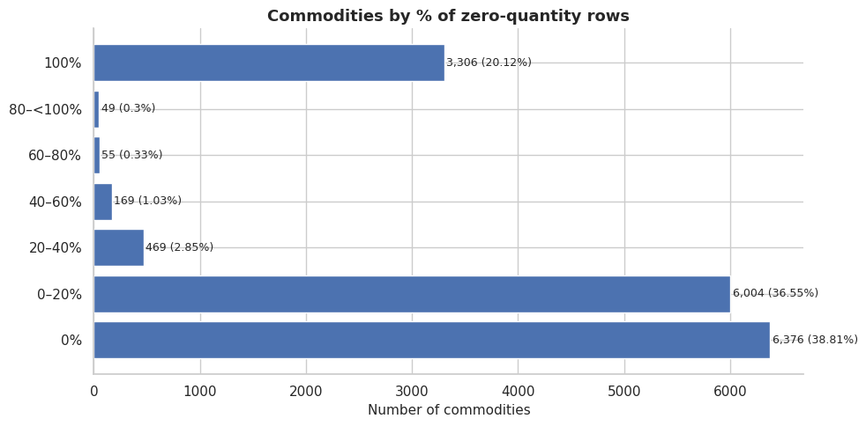
To analyse the group these commodities belong, it was extracted the HS2 code and extracted the Zeros_pct. This can help to understand if the zeros were something punctual, or a standard for the group.
- When extracting the HS2 code from the commodity code, it groups a set of similar commodities together. In the appendix there is a list of commodities by HS2 Chapter, and the name given to each of this group.
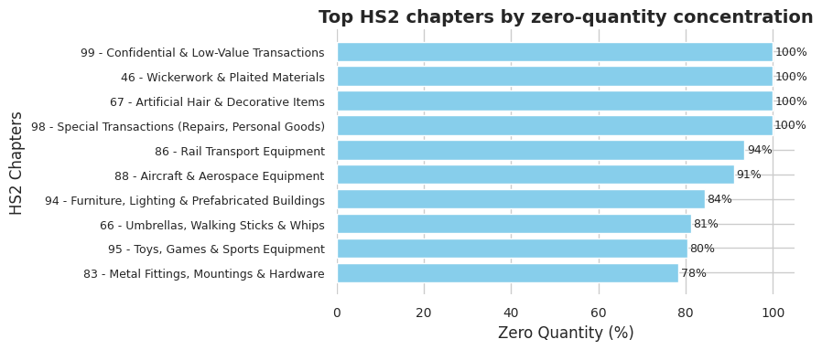

Distribution Analysis

After identifying where zero quantities are concentrated, the next step is to understand how the values and quantities are distributed across the top commodities. This helps identify anomalies and understand what "normal" looks like for each product.

5.1 Distribution Analysis — Commodity, Country, and Period

Two charts are used together for each commodity:
• Scatter plot (Qty vs Value): shows every transaction as a dot. The position of the dot tells us both the quantity and the value of that shipment.
• Box plot: summarises the spread of values in a compact visual. It shows the middle 50% of values (the box), the typical range (the whiskers), and anything unusual (dots outside the whiskers).

5.2 Four distribution patterns identified
After reviewing the top commodities, four recurring distribution patterns were identified. Understanding which pattern a commodity follows is important, it determines which analysis method is appropriate.

1. Diagonal pattern
Quantity and value scale together.
Typical of standardized commodities sold at a predictable price per unit
CV Qty ≈ CV
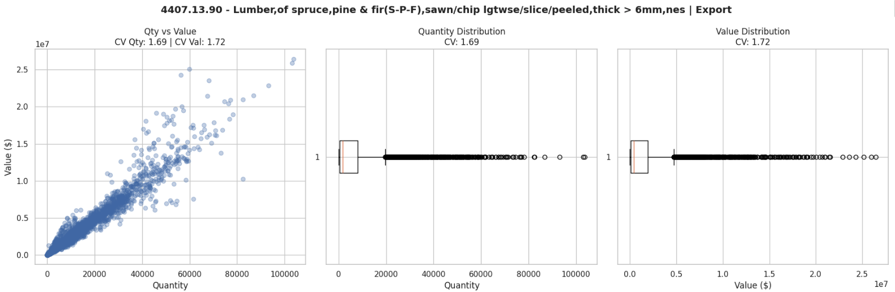
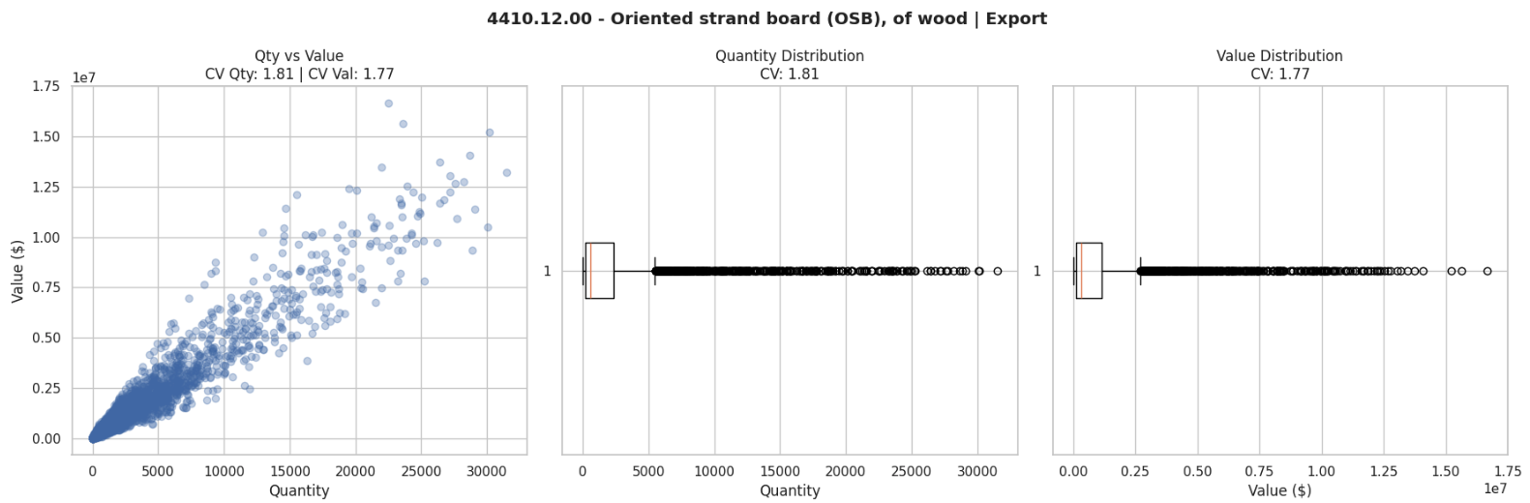

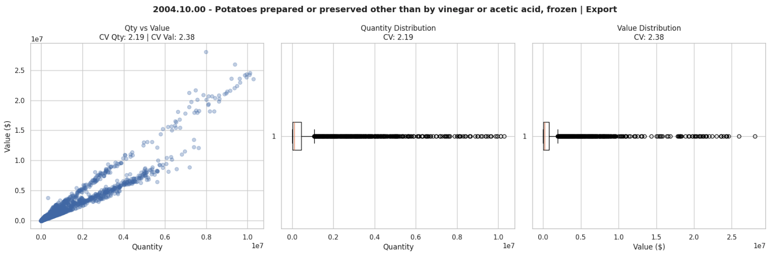
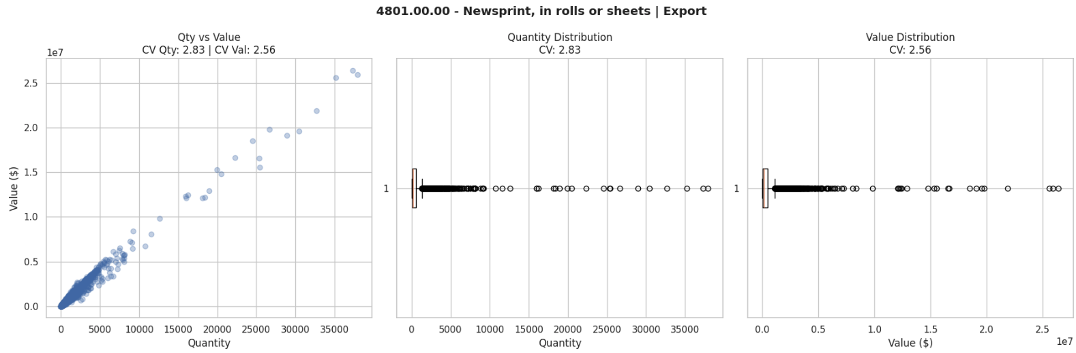
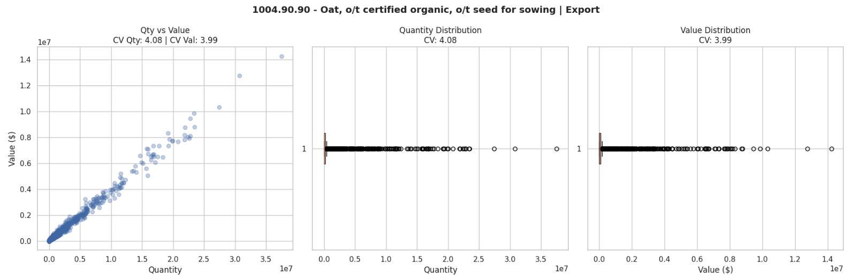

2. Two Population
Dense cluster at low qty/value + separate sparse cloud at high qty/value, gap in between
CV Qty >> 6, bimodal box plot

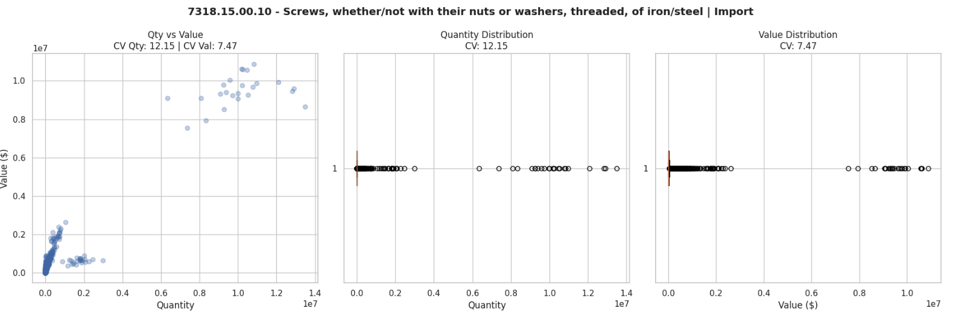
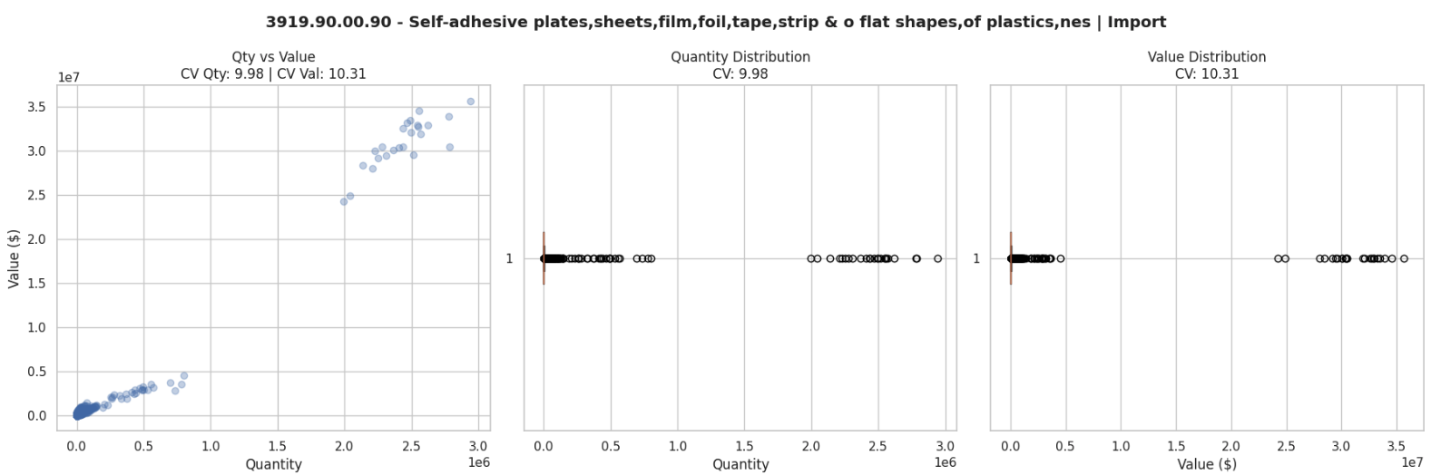
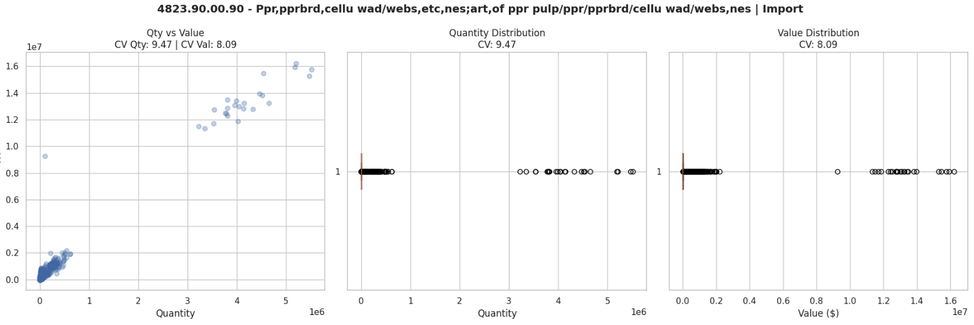

3. Vertical cluster pattern
High value variability, low quantity. The commodity is sold in very small quantities but at very high and variable unit prices. Typical of high-value industrial equipment sold per unit.
CV Qty >> CV Val
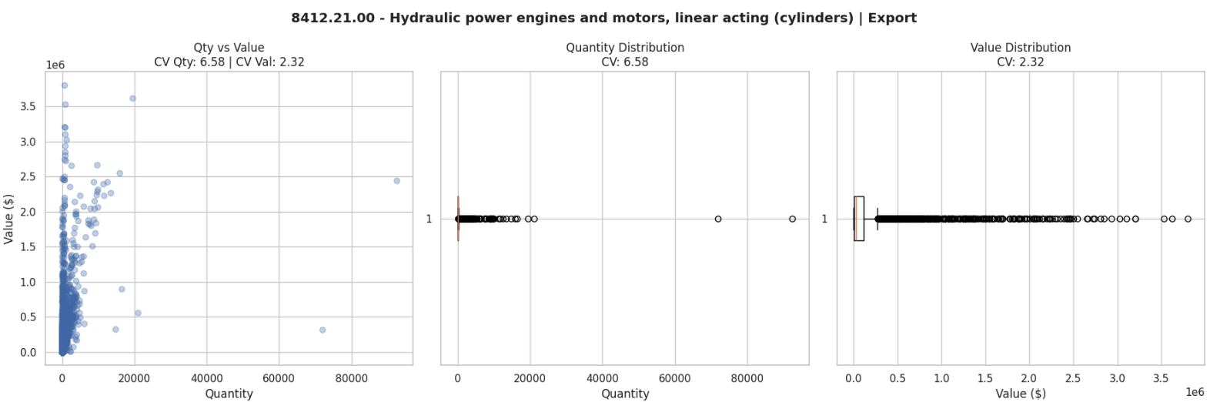
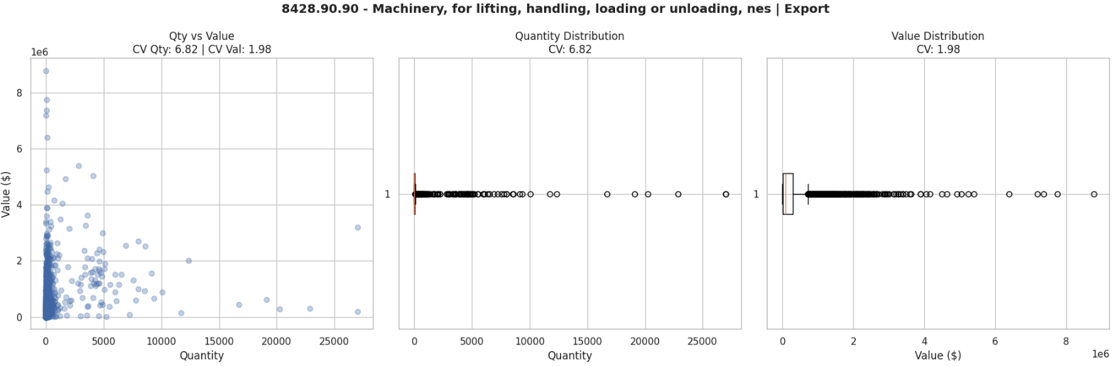

5. horizontal fan / unstructured
Wide range of quantities, but value does not follow. Unit price is highly inconsistent, usually because the HS code groups very different products together.
Near-zero correlation, both CVs high, no pattern
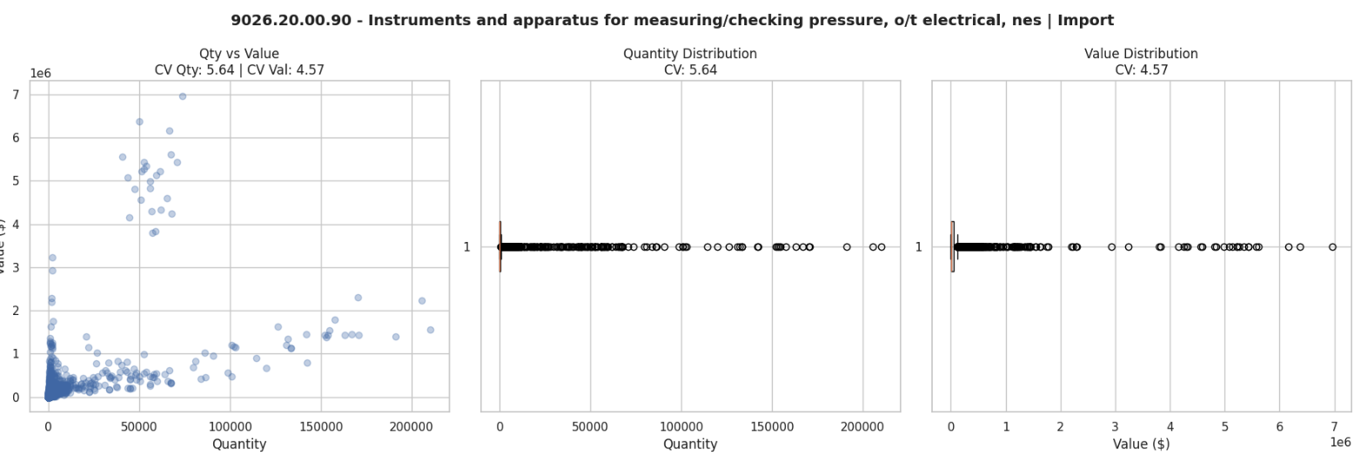
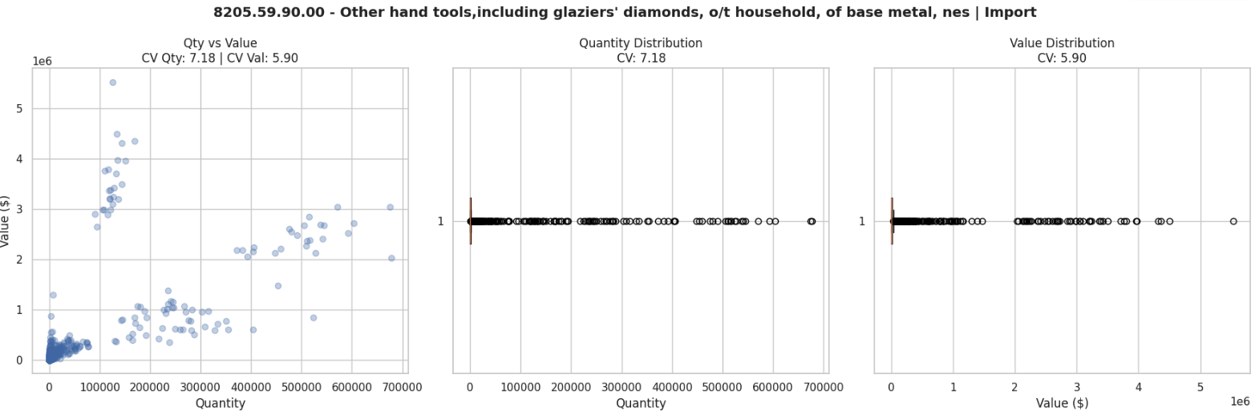
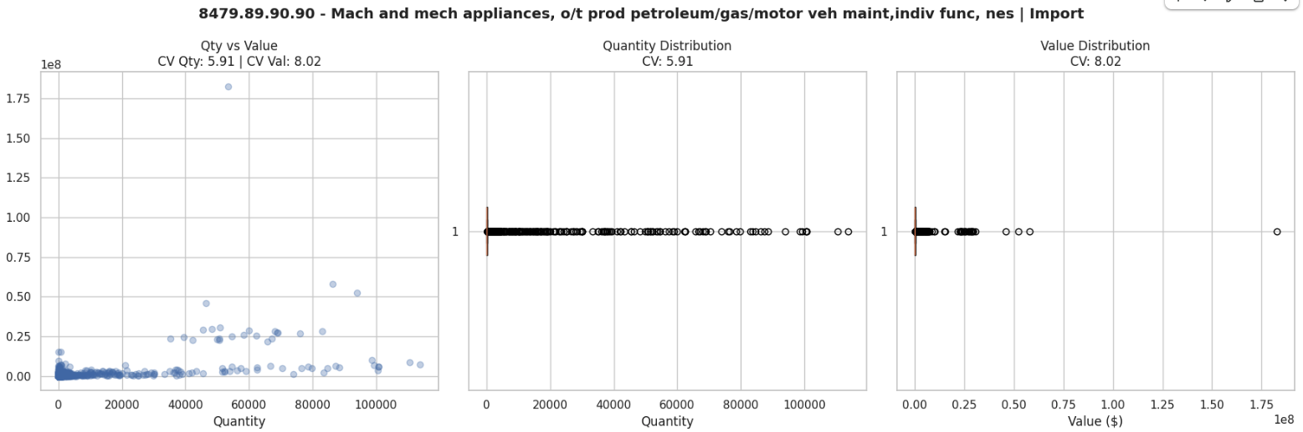

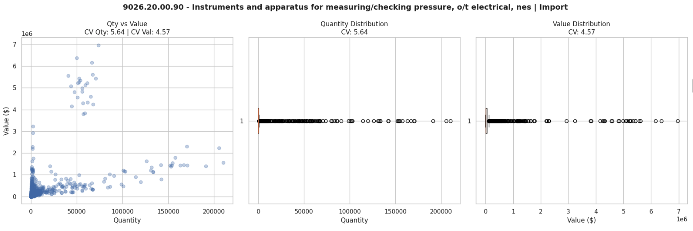
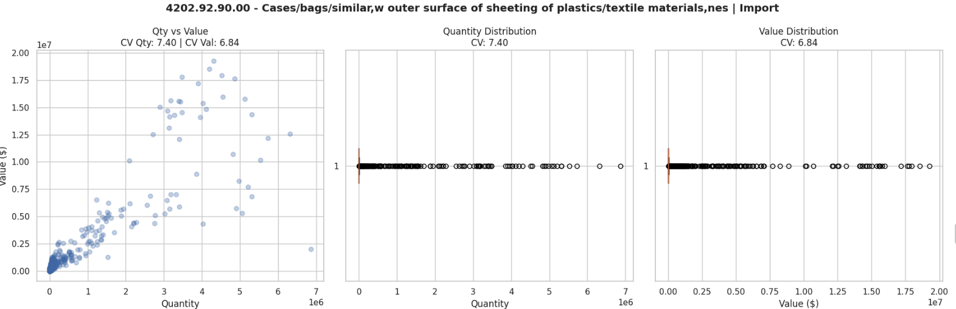

Dataset Preparation for Looker Studio
With the data quality checks completed and the distribution patterns identified, the next step was to prepare a clean dataset ready for use in Looker Studio. The goal was to move from the raw combined dataset to a structured file where all calculated metrics are pre-computed, column names are standardised, and every field needed by the dashboard exists as a ready-to-use column.
This was done through a dedicated Python script: Export_Looker.py https://colab.research.google.com/drive/1CrBNOTEuZXde-Z_pvsFPT157A1uBqYLK?usp=sharing). The script processes the original Dataset.parquet file in sequential steps and exports the output file: looker_dataset.csv. The CSV uses UTF-8 BOM encoding to ensure correct character rendering when imported into Looker Studio or opened in Excel.

6.1 Step 1 — Load the Dataset
The script begins by reading the combined dataset from the parquet file produced in the concatenation step. The number of rows and columns are printed immediately as a sanity check to confirm the file loaded correctly before any transformations are applied.
df = pd.read_parquet(FILE_PATH)

6.2 Step 2 — Standardise Column Names
Column names in the raw dataset contain spaces, brackets, and special characters that are not compatible with Looker Studio field naming conventions. All column names are converted to lowercase, with spaces and symbols replaced by underscores. The most important rename is the value column: Value ($) becomes value_cad, making it explicit that amounts are in Canadian dollars.

In addition, the trade_type and country columns are standardised to title case (Export / Import, Brazil) so that filters and comparisons in the dashboard work consistently regardless of how the source files were labelled.

6.3 Step 3 — Date Columns
Looker Studio requires an explicit Date type field to enable time-based filters, monthly trend charts, and year-over-year comparisons. The original Period column contains date strings that are converted to a proper date type and stored in a new column called period_date. From this column, four additional breakdowns are derived:

Column | Description
period_date | Full date — used as the primary date dimension in Looker
year | Year only — used for annual grouping and YoY calculations
month | Month number (1–12) — used for monthly trend charts
quarter | Q1 / Q2 / Q3 / Q4 — used for quarterly aggregations
year_month | Period formatted as YYYY-MM — used for monthly time series

6.4 Step 4 — HS Code Hierarchy
The original Commodity column contains both the HS code and the product description in a single string, formatted as XXXX.XX.XX — Product name. To support filtering and aggregation at different levels of detail in the dashboard, the HS code is extracted and split into four hierarchy columns.
As documented in section 1.4, exports use HS8 codes and imports use HS10 codes. The only level that allows direct comparison between the two datasets is HS6. All cross-dataset analyses in the dashboard are performed at the HS6 level.
Column | Description
hs_code | Full HS code as it appears in the source, e.g. 8412.21.00
hs2 | First 2 digits — broad product chapter, e.g. 84
hs6 | First 6 digits, formatted as XXXX.XX — used as the common join key
hs2_label | Chapter description mapped from the HS2 reference table, e.g. Industrial Machinery
commodity_name | Product description only, with the HS code prefix removed

6.5 Step 5 — Calculated Columns
The columns are added at the row level based on simple calculations over existing fields.
Column | Description
unit_price | Value divided by Quantity. Null when Quantity is zero, to avoid division-by-zero artifacts. Used to identify pricing anomalies and outliers.

6.6 Step 6 — Export
The cleaned dataset is exported. The CSV file uses UTF-8 BOM encoding, which ensures that special characters in commodity names are displayed correctly when the file is opened in Excel or imported directly into Looker Studio via Google Drive.
df.to_csv(out_csv, index=False, encoding='utf-8-sig')

6.7 Trade Balance
Trade balance is defined as total exports minus total imports for a given grouping. It is calculated at the Province, Country, HS6, and year-month level by pivoting exports and imports into separate columns, computing the difference.
A positive trade balance means Canada exported more than it imported for that group. A negative value means imports exceeded exports. This file is stored as balance_summary.csv.

6.8 Dataset Before and After: Column Comparison
The table below compares the original dataset columns with the columns available in the Looker-ready dataset. Columns marked as Original were already present. Columns marked as New were added by the preparation script.
Column | Type | Status | Purpose in Dashboard
period | Date string | Original | Source date field — replaced by period_date
province | Text | Original | Geographic dimension
country | Text | Original | Partner country dimension
state | Text | Original | US sub-national dimension
commodity | Text | Original | Full HS code + description
hs_code | Text | Original (derived) | Raw HS code extracted from commodity
hs2 | Text | Original (derived) | Chapter level — broad category
value_cad | Number | Original (renamed) | Transaction value in Canadian dollars
quantity | Number | Original | Amount traded
unit_of_measure | Text | Original | Unit of measure

Column | Type | Status | Purpose in Dashboard
period_date | Date | New | Primary date dimension in Looker
year | Number | New | Annual grouping and YoY joins
month | Number | New | Monthly trend charts
year_month | Text | New | Monthly time series (YYYY-MM)
trade_type | Text | New | Filter: Export / Import
is_brazil | Boolean | New | Quick filter for bilateral view
commodity_name | Text | New | Description only, without HS prefix
hs6 | Text | New | Standard join key for cross-dataset analysis
hs2_label | Text | New | Chapter name from reference table
unit_price | Number | New | Value divided by Quantity
trade_balance | Number | New | Exports minus imports by group
yoy_value | Number | New | Prior-year value for the same group and month
yoy_pct | Number | New | Year-over-year percentage change

The original dataset contained 8 columns from the source files, plus 4 columns added during the combination step (trade_type, HS_code, HS2, year), for a total of 12 columns. The Looker-ready dataset contains 29 columns. The 17 new columns cover date breakdowns, HS code hierarchy, calculated metrics, and quality flags — all pre-computed so that Looker Studio can access them directly without requiring formula fields inside the dashboard.

Dashboard Design and KPI Mapping
With the dataset cleaned, enriched, and loaded into BigQuery, the next step was to define the scope and structure of the Looker Studio dashboard. This section documents the decisions made about which KPIs and visualisations to include, which filters and controls to expose to the user, and how each metric maps to the available data. It also validates that the looker_dataset table contains all the fields required to support the dashboard as designed.
The dashboard focuses exclusively on Canada’s overall trade flow across all partner countries. It is organised into three sections: Overview, Product Performance, and Geographic Insights, reflecting the structure of the dashboard draft.

7.1 Dashboard Scope and Filters
The dashboard covers the full period available in the dataset and allows the user to narrow the view using four global filters. These filters apply to all charts and KPI tiles on the page simultaneously.
Filter | Field in Dataset | Values
Date range | period_date | Month-level date picker — default shows full available range
Trade Type | trade_type | Export / Import / Both
Province | province | All Canadian provinces and territories
Commodity | hs2_label | HS2 chapter labels — broad product categories
Country | country | Top 10 export partners + Top 10 import partners

The Country filter is pre-scoped to the top trading partners identified during the dataset preparation step, covering up to 20 unique countries. This keeps the dashboard performant while still representing the vast majority of Canada’s total trade value.

7.3 KPI Tiles
KPI tiles are the scorecards displayed at the top of each section. Each tile shows a single aggregated number and, where possible, a comparison to the prior year. The table below lists each tile planned for the dashboard, the calculation required, and the field or combination of fields needed to produce it.
KPI Tile | Section | Calculation | Required Fields | Available?
Total Canada Exports | Overview | SUM(value_cad) where trade_type = Export | value_cad, trade_type | Yes
Total Canada Imports | Overview | SUM(value_cad) where trade_type = Import | value_cad, trade_type | Yes
Trade Balance | Overview | Total Exports − Total Imports | value_cad, trade_type (via balance_summary) | Yes — auxiliary table
YoY % Change — Exports | Overview | (Current year − Prior year) / Prior year × 100 | value_cad, year, trade_type | Yes — Looker calculated field
YoY % Change — Imports | Overview | Same as above for imports | value_cad, year, trade_type | Yes — Looker calculated field
Top HS2 Chapter — Exports | Product Performance | HS2 chapter with highest SUM(value_cad) where trade_type = Export | value_cad, hs2_label, trade_type | Yes
Top HS2 Chapter — Imports | Product Performance | HS2 chapter with highest SUM(value_cad) where trade_type = Import | value_cad, hs2_label, trade_type | Yes
Fastest Growing Commodity — Exports | Product Performance | Commodity with highest positive YoY % in current year | value_cad, year, commodity_name, trade_type | Yes — Looker calculated field
Fastest Growing Commodity — Imports | Product Performance | Same logic applied to imports | value_cad, year, commodity_name, trade_type | Yes — Looker calculated field
Top Province — Exports | Geographic Insights | Province with highest SUM(value_cad) where trade_type = Export | value_cad, province, trade_type | Yes
Top Province — Imports | Geographic Insights | Province with highest SUM(value_cad) where trade_type = Import | value_cad, province, trade_type | Yes

7.4 Charts and Visualisations
The table below maps each planned chart to its data requirements. All charts respond to the global filters described in section 8.1.
Chart | Section | Chart Type | X / Dimension | Y / Metric | Required Fields
Monthly Trade Trend — All Partners | Overview | Grouped bar + line | year_month | SUM(value_cad) by trade_type; Balance on secondary axis | value_cad, trade_type, year_month (balance_summary)
Top Trade Partners — Export Value | Overview | Horizontal bar | country | SUM(value_cad) where trade_type = Export | value_cad, country, trade_type
Top Trade Partners — Import Value | Overview | Horizontal bar | country | SUM(value_cad) where trade_type = Import | value_cad, country, trade_type
Top 10 HS2 Chapters by Total Value | Product Performance | Horizontal bar | hs2_label | SUM(value_cad) | value_cad, hs2_label
Top 10 Commodities by YoY Growth — Export | Product Performance | Line | year | % Growth | value_cad, year, commodity_name, trade_type
Top 10 Commodities by YoY Growth — Import | Product Performance | Line | year | % Growth | value_cad, year, commodity_name, trade_type
Export Value by Province — Pie | Geographic Insights | Pie chart | province | SUM(value_cad) where trade_type = Export | value_cad, province, trade_type
Province Origin of Exports — Bar | Geographic Insights | Horizontal bar | province | SUM(value_cad) where trade_type = Export | value_cad, province, trade_type
Province Origin of Imports — Bar | Geographic Insights | Horizontal bar | province | SUM(value_cad) where trade_type = Import | value_cad, province, trade_type

Appendix — HS2 Chapter Reference
The table below lists all HS2 chapter codes used in the dataset, with their standard descriptions. These chapters group products at the broadest level of the Harmonized System classification

Code | Description | Code | Description
01 | Live Animals | 51 | Wool & Animal Hair Fabrics
02 | Meat & Edible Offal | 52 | Cotton & Cotton Fabrics
03 | Fish & Seafood | 53 | Flax, Hemp & Other Vegetable Fibres
04 | Dairy, Eggs & Honey | 54 | Synthetic Filaments & Fabrics
05 | Animal Products (Bones, Ivory, etc.) | 55 | Synthetic & Artificial Staple Fibres
06 | Live Plants, Bulbs & Cut Flowers | 56 | Wadding, Felt, Nonwovens, Rope & Nets
07 | Fresh & Frozen Vegetables | 57 | Carpets & Textile Floor Coverings
08 | Fresh & Frozen Fruits | 58 | Specialty Woven & Embroidered Fabrics
09 | Coffee, Tea & Spices | 59 | Coated, Impregnated & Technical Textiles
10 | Cereals & Grains | 60 | Knitted & Crocheted Fabrics
11 | Milling Products (Flour, Starch) | 61 | Knitted Apparel & Clothing
12 | Oil Seeds, Fodder & Industrial Plants | 62 | Woven Apparel & Clothing
13 | Vegetable Gums, Resins & Extracts | 63 | Textile Made-Up Articles & Worn Clothing
14 | Vegetable Plaiting Materials | 64 | Footwear
15 | Animal & Vegetable Fats & Oils | 65 | Headgear
16 | Prepared Meat & Seafood | 66 | Umbrellas, Walking Sticks & Whips
17 | Sugars, Syrups & Confectionery | 67 | Artificial Hair & Decorative Items
18 | Cocoa & Chocolate Products | 68 | Stone, Cement & Abrasive Articles
19 | Baked Goods, Pasta & Cereals | 69 | Ceramic Products
20 | Preserved Fruits & Vegetables | 70 | Glass & Glassware
21 | Miscellaneous Food Preparations | 71 | Precious Stones, Metals & Jewellery
22 | Beverages (Water, Beer, Spirits) | 72 | Iron & Steel
23 | Animal Feed & Food Industry Residues | 73 | Iron & Steel Articles
24 | Tobacco & Nicotine Products | 74 | Copper & Copper Articles
25 | Salt, Cement & Construction Minerals | 75 | Nickel & Nickel Articles
26 | Ores & Mineral Concentrates | 76 | Aluminium & Aluminium Articles
27 | Petroleum, Fuels & Related Products | 82 | Hand Tools & Cutting Tools
28 | Inorganic Chemicals & Compounds | 83 | Metal Fittings, Mountings & Hardware
29 | Organic Chemicals | 84 | Industrial Machinery & Mechanical Equipment
30 | Pharmaceutical Products | 85 | Electrical Equipment & Electronics
31 | Fertilizers | 86 | Rail Transport Equipment
32 | Paints, Varnishes & Dyes | 87 | Motor Vehicles & Parts
33 | Cosmetics, Perfumes & Toiletries | 88 | Aircraft & Aerospace Equipment
34 | Soaps, Cleaning & Polishing Prep. | 89 | Ships & Watercraft
35 | Adhesives, Enzymes & Modified Starches | 90 | Optical, Measuring & Scientific Instruments
36 | Explosives, Fireworks & Matches | 91 | Clocks, Watches & Timepieces
37 | Photographic Film & Materials | 92 | Musical Instruments
38 | Specialty Chemicals & Preparations | 93 | Arms, Ammunition & Military Weapons
39 | Plastics & Plastic Articles | 94 | Furniture, Lighting & Prefab Buildings
40 | Rubber & Rubber Products | 95 | Toys, Games & Sports Equipment
41 | Raw Hides, Skins & Leather | 96 | Miscellaneous Manufactured Articles
42 | Leather Goods, Luggage & Handbags | 97 | Art, Antiques & Collectibles
43 | Furskins & Artificial Fur | 98 | Special Transactions (Repairs, Gifts)
44 | Wood & Wood Products | 99 | Confidential & Low-Value Transactions
45 | Cork & Cork Products
46 | Wickerwork & Plaited Materials
47 | Wood Pulp & Paper Waste
48 | Paper & Paperboard Products
49 | Printed Matter & Books
50 | Silk & Silk Fabrics

HS Group - Main titles included:
HS Group: 99
- 9901.00.00 - Low value export transactions and confidential commodities
- 9999.99.99.00 - Low value couriers' shipments
- 9902.00.00.00 - Repairs
- 9901.00.00.00 - Low value import transactions and confidential commodities

HS Group: 67
- 6704.19.00 - False beards, eyebrows, eyelashes & the like, o/t wigs, of synthetic tex mat,nes
- 6701.00.00 - Skins & other parts of birds w feathers/down,feathers & pts,down & articles t/o
- 6702.10.00 - Artificial flowers, foliage, fruit and parts and articles thereof, of plastics
- 6704.20.00 - Wigs, false beards, eyebrows, eyelashes, switches and the like,of human hair,nes
- 6704.11.00 - Complete wigs, of synthetic textile materials
- 6704.90.00 - Wigs,false beards,eyebrows,eyelashes,switches & the like,of other materials,nes
- 6702.90.00 - Artificial flowers, foliage, fruit and parts and articles thereof,of o materials
- 6703.00.00 - Human hair,worked; wool/animal hair and other textile mat,prepared for wigs/like
- 6701.00.90.00 - Skins and o pts of bird,w feather/down, pts of feather,art t/o,o/t good No 05.05
- 6702.90.90.00 - Artifical flowers, foliage, fruit and parts and articles thereof,of other mat,nes

HS Group: 46

array(['4602.90.00 - Basketwork, wickerwork and other article made up from other plaited materials',
'4602.19.00 - Basketwork,wickerwork,o art made up from plaited veg mat; art of loofah, nes',
'4602.11.00 - Basketwork, wickerwork and other articles made from plaiting materials,of bamboo',
'4601.29.00 - Mats, matting and screens, of vegetable materials, nes',
'4601.21.00 - Mats, matting and screens, of vegetable materials, of bamboo',
'4602.12.00 - Basketwork, wickerwork and other articles made from plaiting materials,of rattan',
'4601.94.00 - Products of veg plaiting materials, o/t mats, matting and screens, nes',
'4601.99.00 - Products of plaiting materials, nes',
'4601.92.00 - Products of veg plaiting materials, o/t mats, matting and screens, of bamboo',
'4602.11.99.00 - Basketwork, wickerwork & other articles made up from bamboo, nes'],
dtype=object)
HS Group: 98

array(["9806.10.00 - Settlers/migrants' personal and household effects, valued at $2,000 CDN or more",
'9802.00.00 - Repairs', '9807.00.00 - Private donations and gifts',
'9812.00.00 - Commercial samples, o/t those of No 98.01',
'9806.20.00 - All goods valued at $2,000 CDN/more, acquired by all categories of travellers',
"9810.00.00 - Contractors equipment to be ret'd to Canada/re-exp after completion of contract",
'9811.00.01 - U.S. special transactions, trade',
'9811.00.58 - U.S. special transactions, trade',
'9811.00.10 - U.S. special transactions, trade',
'9811.00.20 - U.S. special transactions, trade'], dtype=object)
HS Group: 86

array(['8607.19.00 - Axles and wheels and parts',
'8609.00.00 - Cargo containers designed to be carried by one or more modes of transport',
'8607.99.00 - Railway rolling stock parts nes',
'8607.91.00 - Locomotive parts nes',
'8607.30.00 - Coupling devices and parts for railway rolling stock',
'8604.00.00 - Railway maintenance-of-way service vehicles',
'8608.00.00 - Signalling devices for railways, waterways and airports and parts thereof',
'8607.21.00 - Air brakes and parts for railway rolling stock',
'8607.29.00 - Brakes nes and parts thereof for railway rolling stock',
'8607.12.00 - Bogies and bissel-bogies nes'], dtype=object)
HS Group: 88

array(['8807.30.00 - Parts, nes, of aeroplanes, helicopters or unmanned aircraft',
'8807.20.00 - Parts, of aircraft under-carriages and parts thereof, incl for unmanned aircraft',
'8807.10.00 - Parts,of aircraft propellers and rotors and parts thereof,incl unmanned aircraft',
'8804.00.00 - Parachutes, paragliders and parts and accessories thereof',
'8802.30.00 - Aircft & o airft,o/t unmanned aircft hd 88.06,unladen wt >2,000kg but <=15,000kg',
'8807.90.00 - Parts, of balloons, dirigibles, gliders, spacecraft, satellites, etc, nes',
'8805.10.00 - Aircraft launching and deck-arrestor gear and parts thereof',
'8806.22.00 - Aircft,unman,o/t f carriage pass,f rmt-cntl flight,max take-off wt >250 g <=7 kg',
'8805.21.00 - Air combat simulators and parts thereof',
'8805.29.00 - Ground flying trainers and parts thereof, nes'],
dtype=object)
HS Group: 66

array(['6603.90.00 - Parts, trimmings, accessories, of umbrellas, walking-sticks, whips, etc, nes',
'6601.10.00 - Garden and similar umbrellas',
'6602.00.00 - Walking-sticks, seat-sticks, whips, riding-crops and the like',
'6601.99.00 - Umbrellas and sun umbrellas, nes',
'6603.20.00 - Umbrella frames, including frames mounted on shafts (sticks)',
'6601.91.00 - Umbrellas and sun umbrellas, nes, having a telescopic shaft',
'6601.91.00.00 - Umbrellas nes, having a telescopic shaft',
'6601.99.00.00 - Umbrellas, nes',
'6602.00.90.00 - Walking sticks, seat-sticks, whips, riding-crops and the like, nes',
'6602.00.10.00 - Canes for use of a public hospital'], dtype=object)
HS Group: 94

array(['9403.70.10 - Furniture, plastic, nes, for domestic purposes',
'9401.80.10 - Seats, for domestic purposes, o/t those of No 94.02, nes',
'9405.99.00 - Luminaires and lighting fittings,incl searchlights and spotlights and parts, nes',
'9403.60.00 - Furniture, wooden, nes',
'9404.29.00 - Mattresses,sprung/stuffed/internally fitted w any material,e.g. cotton,wool,down',
'9401.61.90 - Seats, with wooden frames, upholstered, o/t those of No 94.02, nes',
'9401.99.00 - Parts, of seats, o/t of wood or those of No 94.02, nes',
'9403.20.90 - Furniture, metal, nes',
'9404.90.00 - Articles, of bedding/furnishing,stuffed/int fitted with any mat,w/n covered, nes',
'9401.69.90 - Seats, with wooden frames, o/t those of No 94.02, nes'],
dtype=object)
HS Group: 83

array(['8301.40.00 - Locks, of base metal, nes',
'8302.49.00 - Mountings, fittings and similar articles of base metal, nes',
'8308.20.00 - Tubular or bifurcated rivets, of base metal',
'8302.10.00 - Hinges of base metal',
'8302.41.00 - Mountings, fittings and similar articles of base metal, for buildings, nes',
'8309.90.00 - Stoppers,caps,lids,btle cap,thrd bungs,bung covers,seals,pack acces,base met,nes',
'8301.70.00 - Keys, including blanks for keys presented separately, of base metal',
'8302.50.00 - Hat-racks, hat-pegs, brackets and similar fixtures, of base metal, nes',
'8302.30.00 - Mountings, fittings and similar articles of base metal, for motor vehicles, nes',
'8310.00.00 - Letters, numbers, sign-plates & sim art of base metal, o/t those of No 94.05'],
dtype=object)
HS Group: 95

array(['9504.40.00 - Playing cards', '9507.10.00 - Fishing rods',
'9506.69.00 - Balls nes',
'9505.90.00 - Articles,festive,carnival,entertainment,conjuring tricks,nov jokes,o/t Christmas',
'9506.29.00 - Water-skis, surf-boards & other water-sport equipment, other than sailboards,nes',
'9506.99.90 - Art & equip,incl pts & access,f sports/outdoor games,nes,& swim & paddling pools',
'9504.50.00 - Video game consoles and machines, o/t those of No 9504.30',
'9506.70.00 - Ice skates and roller skates, including skating boots with skates attached',
'9508.26.00 - Water park amusements', '9503.00.90 - Toys, nes'],
dtype=object)
HS Group: 82

array(['8204.11.00 - Wrenches, hand-operated, with non-adjustable jaws, of base metal',
'8208.20.00 - Knives & cutting blades,for mach/mech appliances for wood working,of base metal',
'8207.19.00 - Rock dril/earth boring tl wrkg pts,nes,interchan,f hand/mach-tls,& pts,base met',
'8205.59.00 - Hand tools for masons, watchmakers, miners, nes, of base metal',
'8205.70.00 - Vices, clamps and the like, of base metal',
'8205.10.00 - Drilling, threading or tapping tools, of base metal',
'8204.20.00 - Wrench sockets including ratchet handles extensions and spinners, of base metal',
'8207.50.00 - Tools for drilling,o/t rock dril,interchan,for hand tools/mach-tls,of base metal',
'8208.90.00 - Knives & blades,for leather/paper/tobacco machines & o industries,of base metal',
'8207.70.00 - Tools for milling, interchangeable, for hand tools/machine-tools, of base metal'],
dtype=object)
HS Group: 97

array(["9705.29.00 - Collections and colls' pieces, o/t human/extinct/endangered species & parts t/o",
"9705.22.00 - Collections and collectors' pieces,of extinct/endangered species & parts thereof",
'9703.90.00 - Original sculpture and statuary, in any material, nes',
'9701.91.00 - Paintings, drawings and pastels, of an age less than or equal to 100 years',
'9701.21.00 - Paintings, drawings and pastels, of an age exceeding 100 years',
'9706.90.00 - Antiques, of an age exceeding 100 years, but less than of equal to 250 years',
'9703.10.00 - Original sculpture and statuary, in any material, of an age exceeding 100 years',
'9701.99.00 - Collages and similar decorative plaques, of an age less than/equal to 100 years',
'9702.90.00 - Original engravings, prints and lithographs, nes',
"9705.39.00 - Collections and collectors' pieces of numismatic interest, of an age <=100 years"],
dtype=object)
HS Group: 45

array(['4504.10.00 - Blocks,plates,sheets,strip,tiles,solid cylinders and discs,of agglomerated cork',
'4504.90.00 - Articles of agglomerated cork nes, with or without binder',
'4503.90.00 - Natural cork articles nes',
'4503.10.00 - Corks and stoppers, natural cork',
'4501.90.00 - Waste cork; crushed, granulated or ground',
'4501.10.00 - Natural cork, raw or simply prepared',
'4502.00.00 - Natural cork, debacked/roughly squared or in rectangular blocks etc',
'4504.10.00.00 - Blocks,plates,sheets,strip,tiles,solid cylinders and discs,of agglomerated cork',
'4503.90.00.00 - Natural cork articles, nes',
'4504.90.00.00 - Articles of agglomerated cork, nes, with or without binder'],
dtype=object)
HS Group: 68

array(['6806.20.00 - Exfoliated vermiculite,expanded clays,foamed slag,sim expanded mineral materials',
'6805.20.00 - Natural or artificial abrasive, powder/grain, on paper or paperboard base only',
'6805.30.00 - Natural or artificial abrasive, powder or grain, on a base of other materials',
'6810.99.00 - Articles of cement, of concrete or of artificial stone, w/n reinforced, nes',
'6810.11.00 - Building blocks and bricks, of cement, concrete or artificial stone',
'6810.19.00 - Tiles, flagstones and similar articles, of cement, concrete or artificial stone',
'6804.21.00 - Millstones,grindstones etc of agglomerated synthetic or natural diamond',
'6813.81.00 - Brake linings and pads,not mounted,of mineral substances/cellu,not cont asbestos',
'6809.11.00 - Boards,sheets,panels,tiles & sim,n orn, faced/reinforced w paper/paperboard only',
'6802.93.90 - Worked monumental/building stone, of granite & articles thereof, nes'],
dtype=object)
HS Group: 93

array(['9306.30.00 - Cartridges, nes and parts thereof',
'9306.90.00 - Munitions of war & pts thereof & other ammunitions & projectiles & pts t/o, nes',
'9307.00.00 - Swords, cutlasses, bayonets, lances & sim arms & parts, scabbards and sheaths',
'9305.91.00 - Parts and accessories, of military weapons of No 93.01',
'9301.20.00 - Rocket launchers;flame-throwers;grenade launchers;torpedo tubes & sim projectors',
'9303.30.10 - Rifles, sporting, hunting or target-shooting, single-shot',
'9303.20.20 - Shotgun, semi-auto incl comb shotgun-rifle o/tsporting, hunting/target-shooting',
'9303.20.90 - O shotgun,o/t pump action/semi-auto incl comb shotgun-rifle sport,hunt,etc, nes',
'9303.30.20 - Rifles, sporting, hunting or target-shooting, semi-automatic',
'9306.21.00 - Cartridges, shotgun'], dtype=object)
HS Group: 06

array(['0603.19.00 - Cut flowers and flower buds, for bouquets or ornamental purposes, fresh, nes',
'0602.90.90 - Plants, live, including their roots, nes',
'0601.10.00 - Bulbs, tubers, tuberous roots, corms, crowns and rhizomes, dormant',
'0604.20.90 - Foliage,branches,o pts of plants,w/o flo/buds,etc,f bouquets/orn purp,fresh,nes',
'0604.20.10 - Christmas trees, fresh',
'0603.90.00 - Cut flowers & flower buds for bouquets or ornamental purposes, o/t fresh',
'0602.20.00 - Trees, edible fruit or nut, shrubs and bushes, grafted or not',
'0604.90.00 - Foliage,branches,o pts of plants,w/o flo/buds,etc,f bouquets/orn purp,o/t fr,nes',
'0602.10.00 - Cuttings and slips, unrooted',
'0602.40.00 - Roses, grafted or not'], dtype=object)
HS Group: 40

array(['4010.31.00 - Endless transmission V-belts,of vulcanized rubber,V-ribbed,circ >60 cm <= 180 cm',
'4016.93.00 - Gaskets, washers and other seals, of vulcanized rubber',
'4010.19.00 - Conveyor belts or belting, of vulcanized rubber, nes',
'4009.11.00 - Tubes, pipes and hoses, vulcanized rubber, not reinforced, etc, without fittings',
'4012.20.00 - Pneumatic tires, used',
'4011.10.00 - Pneumatic tires,new,of rubber,for motor cars,incl station wagons and racing cars',
'4006.90.00 - Rubber, unvulcanized forms, rods, tubes, profile shapes, discs and ring,nes',
'4011.20.00 - Pneumatic tires, new, of rubber, for buses or lorries',
'4009.41.00 - Tubes, pipes and hoses vulcanized rubber reinforced, nes, without fittings',
'4016.99.00 - Articles of vulcanized rubber, nes, other than hard rubber'],
dtype=object)
HS Group: 90

array(['9028.30.00 - Electricity supply, production and calibrating meters',
'9027.90.00 - Microtomes; parts & accessories of inst & app for physical/chemical analysis,nes',
'9015.80.00 - Instruments & appl for surveying,hydrographic,ocean,hydrological,meteo/geoph,nes',
'9025.19.00 - Thermometers & pyrometers,recording/not,not combined with other instruments,nes',
'9026.20.00 - Instruments and apparatus for measuring/checking pressure',
'9027.89.00 - Instruments & apparatus, nes,o/t mass spectrometers,f physical/chemical analysis',
'9032.10.00 - Thermostats',
'9031.80.00 - Inst,app & machines,f measuring/checking,nes in this Chapter; profile projectors',
'9032.89.00 - Automatic regulating or controlling instruments and apparatus, nes',
'9030.31.00 - Multimeters,w/o recording device,meas/chk vltge/curr/etc,o/t semicon wafers/dev'],
dtype=object)
HS Group: 33

array(['3304.10.00 - Lip make-up preparations',
'3305.10.00 - Hair shampoos',
'3307.10.00 - Pre-shave, shaving or after shaving preparations',
'3301.90.00 - Conc & aqueous distls of essential oils; terpenic by-products of essential oils',
'3304.99.00 - Beauty or make-up preparations nes; sunscreen or sun tan preparations',
'3307.41.00 - Agarbatti and other odoriferous preparations, which operate by burning',
'3307.49.00 - Room perfuming or deodorizing preparations, nes',
'3302.90.00 - Mixtures of odoriferous substances, for use as raw materials in industry, nes',
'3307.20.00 - Personal deodorants & antiperspirants',
'3302.10.00 - Mixt of odoriferous subst, inc alcohlic sol, for the food or drink industries'],
dtype=object)
HS Group: 71

array(['7102.39.00 - Diamonds, non-industrial, sorted, worked, not mounted or set diamonds, nes',
'7102.10.00 - Diamonds, unsorted',
'7102.31.00 - Diamonds,non-industrial,sorted,unworked/simply sawn/cleaved/bruted,b not mtd/set',
'7117.90.00 - Imitation jewellery nes',
'7113.19.00 - Articles of jewellery & pts thereof,of o prec met,w/n plated/clad w precious met',
'7112.99.00 - Waste & scrap of prec metal/metal clad w prec metal compd,o/t goods No 85.49,nes',
'7103.91.00 - Rubies, sapphires and emeralds, otherwise worked',
'7110.19.00 - Platinum, in semi-manufactured forms, nes',
'7108.12.20 - Gold in unwrought forms non-monetary, cont by weight less than 99.95% of gold',
'7117.19.00 - Imitation jewellery, nes,of base metal,whether or not plated with precious metal'],

