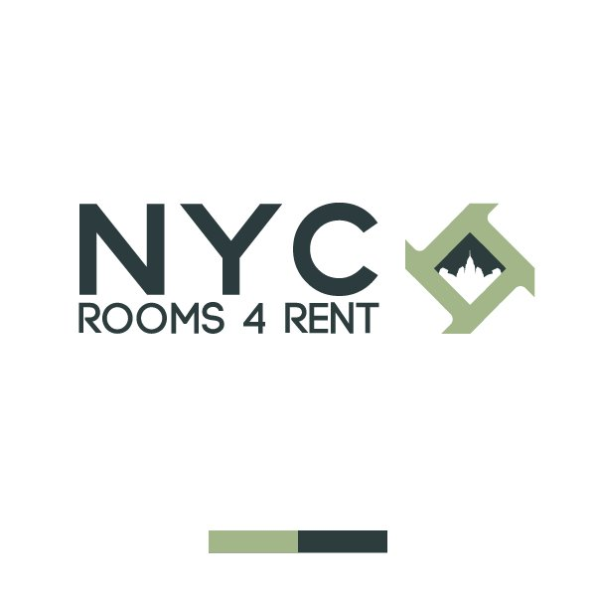

**606 WEST 145TH STREET NY NY 10031**

**212-368-2685**

**WWW.NYCROOMS4RENT.COM**

Name(s) _test user___________________________________________________________________

Contact Phone Number_____8847342781___________________________________________________

Secondary Phone Number_____773434343_________________________________________________

Emergency Contact_____773434343_______________________________________________________

Email Address________________________________________________________________

Employer/School______________________________________________________________

Address_____________________________________________________________________

Manager’s Name_____________________________________________________________

Manager’s Contact___________________________________________________________

Monthly Income_____________________________________________________________

Weekly Rent Budget _________________________________________________________

How many people will be living in the room? ________

How long are you looking to stay in the room? ___________________________________

Where did you see our advertisement?

Google _____ El Diario ____ AM NY Newspaper ____

Facebook _____ Amsterdam Newspaper _____ Other____________________

Craigslist _____` Metro Newspaper ____ Referral__________________

**Policy**

**NYC ROOMS 4 RENT INC.** is a licensed apartment sharing agency whom for a non-refundable service fee refers you to a primary tenant or landlord for viewings of available rooms. Please be on time and wear proper attire when meeting with the primary tenant or landlord. We are not responsible for any negotiations agreed between you and the landlord or primary tenant. We will assist you until you find the first room that accommodates your needs. If you wish to transfer room we will assist you **ONE** time at no extra cost within the 30 days guaranteed service policy, except you’ve been evicted for illicit behavior or have a pending balance with the landlord. Our services expire 30 days after you have found a room. **Our service fee is non-refundable under no circumstances.**

**___________________________________ _________________________**

**Signature Date**