Guichan Editor V0.4
User Manual

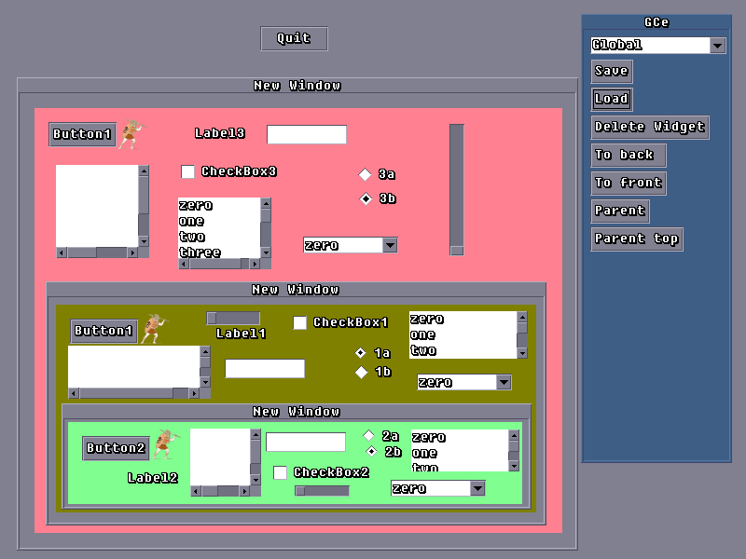
This is the first menu in GCe it has operations on Widgets and will at a later date have other global functions. Save and Load refers to the complete gui layout.
To back and to front allow the user to move widgets in front or behind other widgets, it works on the currently selected widget.
Parent and Parent top effect where the widget is in the gui's hierarchy. Say for instance we want to put a button inside a container widget, the container will be the parent of the child button, first click on the button to make it the current widget, click parent (the parent button will change to say Click!) now click on the container, the button will jump inside the container and is now “parented” to the container.

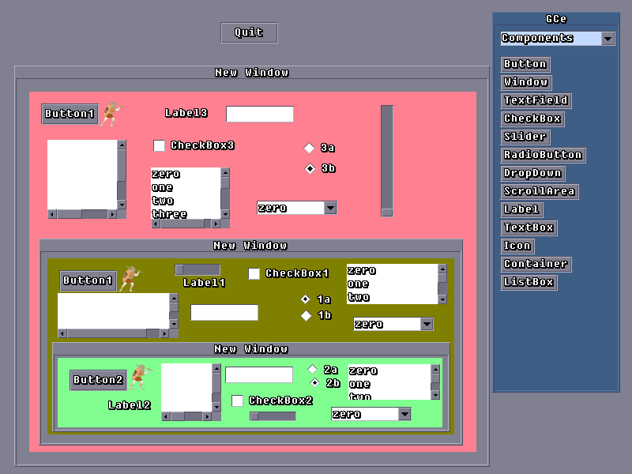
The components menu is the most straight forward, for each widget plugin loaded by the editor there is a button, click a button an the appropriate widget will be added to your gui.

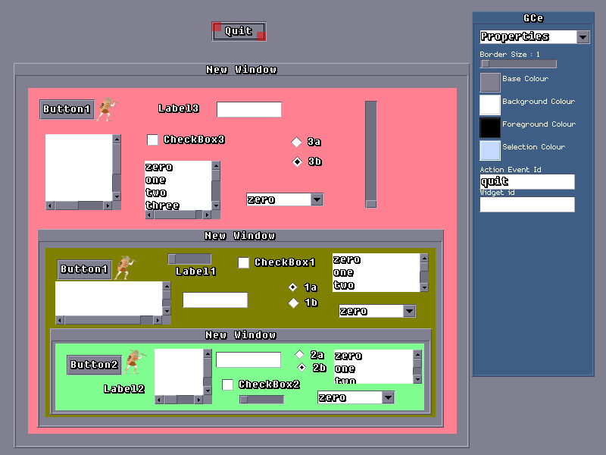
All widgets have a common set of properties one important one for instance is widget Id, you don't have to identify every widget, just ones that you'll need a pointer to, don't forget that action events provide a pointer to the source widget...
Colour properties have a coloured button which when pressed brings up a simple colour changing dialog.

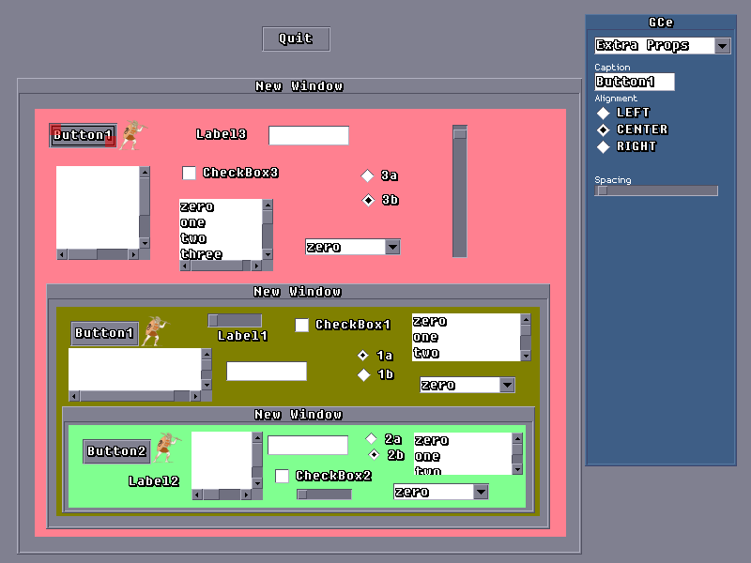
The Extra properties menu is entirely provided by each plugin, here you can see a button widget selected and the extended properties menu is showing button specific properties

Although this manual looks rather skimpy that's mainly because it really is that simple

A note about the xml structure used by GCe, initially I tried using XMLGuichan however I found it much easier to use a different xml document structure, as a result GCe is not compatible with XMLGuichan.
GCe makes use of the xml documents structure to store the hierarchy of the gui, so for instance if a container has child widgets, those child widget tags are inside the containers xml tag.

