Project Exam
Delivery II
Target audience, Personae/Storyboards and
Wireframe/Prototype

version 2.0

By: Marie Helen Berger
15.06.2019

TARGET AUDIENCE

One of the microsite's goals would not only be to wake peoples curiosity about space travel and SpaceX but also try to make the subject fun and engaging to read about.

“My idea for the target audience is mainly adults/young adults/students who are looking for an introduction to SpaceX, and the micro site will serve as a portal to “SpaceX knowledge”. They might not be familiar with the company at all, but are curious about their goals and missions.
They also want to get the information in a entertaining and engaging way. The technical skill level will probably vary, so therefore it is also important that the page is easy to navigate through, and user friendly. The information will also be basic and “easy-to-get”, not very technical and heavy. The audience will however be directed to the main website should they want to delve deeper into SpaceX.”
PERSONAE/ STORYBOARDS

Leah
“The young student that don't like working on computers.”
Name: | Leah
Age: | 22
Work: | Student
Technical skills: | Poor
Interests: | Tennis
Goals: | Find facts about Space X and their future missions for an assignment.
Usability needs: | Easy to navigate through the website, and user friendly solutions.
Device: | Computer
Other: | Leah has impaired vision. Her eyes strain when there is to much colors and small text. She is overall not very fond of working on computers, and prefer books.

David
“David is a big fan of SpaceX and wants to attend the next launch located at Cape Canaveral”.”
Name: | David
Age: | 37
Work: | Engineer
Technical skills: | Excellent
Interests: | Everything futuristic, airplanes and spacetravel.
Goals: | Gain information on when the next launch is, and learn about the mission
Usability needs: | User friendly, easy to navigate to the launch-time table.
Device: | Computer
Other: | Big fan of SpaceX, is a regular user of the site, as he tries to follow the launches closely.

Carol
“The kid dreaming about becoming an astronaut”
Name: | Carol
Age: | 20
Work: | Student
Technical skills: | Very good
Interests: | Spacetravel, astro-physics and crossfit.
Goals: | Be kept up to date on when the next Space X launch is. And being able to send her questions to Space X via web.
Usability needs: | Informative, engaging and userfriendly.
Device: | Mobile phone
Other: | Dreams about becoming a astronaut for Space X. She knows what there is to know about their Space Programs, but has some questions on what career path etc. she should choose to reach her goal.

Mark
“SpaceX? What is that?”
Name: | Mark
Age: | 32
Work: | Accountant
Technical skills: | Good
Interests: | Paragliding, Hunting and Photography
Goals: | Learn about what SpaceX is, and get an understanding of what they do and what their future plans are, without getting bored while reading about it.
Usability needs: | Informative and entertaining. Responsive, as the user is always on foot and mostly uses his tablet or phone to surf the web.
Device: | Tablet
Other: | People talked about SpaceX at Marks workplace, and he felt hes colleagues thought he was weird that he was completely unfamiliar with SpaceX.

Storyboards
1 - Leah
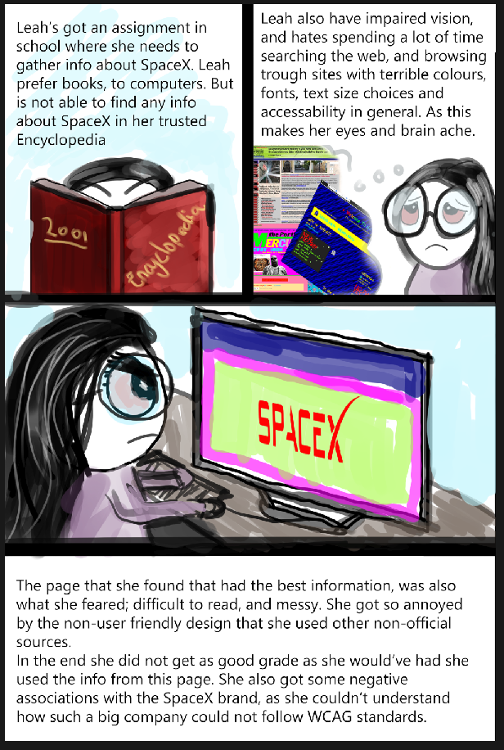
2- Mark
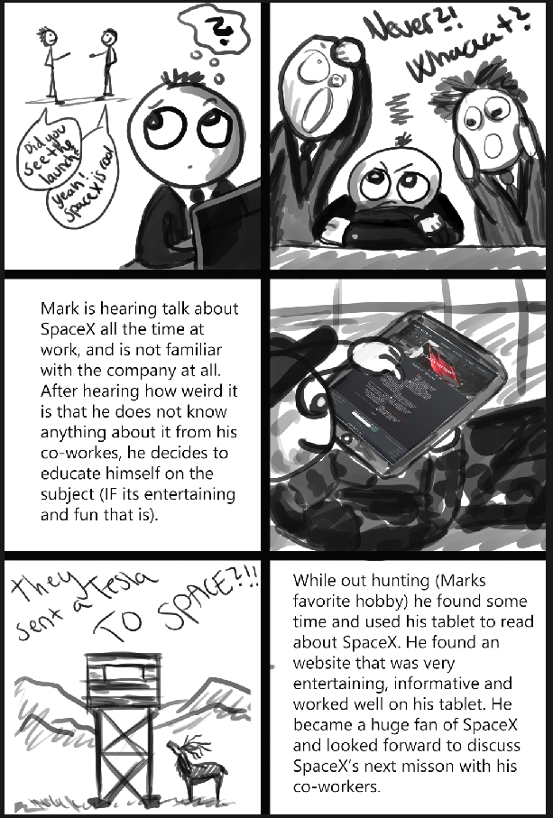
WIREFRAME/PROTOTYPE

Link to Adobe XD prototype:
- https://xd.adobe.com/view/f6b42a5c-d0dd-4492-68ca-3de1aa5e4567-8085/

General

Notes to the prototype:
- I will try to implement a type of parallax scrolling on the different pages.
- The info and text in the prototype is not the final text, it's only “filling”.
- The NAVbar will maybe be a “sticky” NAVbar.
- Will try to make the timeline animated when scrolling down.
- Not WCAG tested.

Mobile/Tablet (not created yet)

Notes to the mobile/tablet prototype:
- Will keep the parallax effect, if it turns out ok. But will have to make some changes in aspect ratio of the background images.

