Percobaan Dampak Partisi Pada Waktu Eksekusi Spark & Hadoop

Max Object = 30
Distance Type = Single Linkage

No | Ukuran Data | Jumlah Partisi | Waktu Eksekusi Spark dengan Standard Deviasi (Detik) | Waktu Eksekusi Spark Tanpa Standard Deviasi (Detik) | Ukuran Data Hasil Reduksi Spark dengan standard Deviasi (GB) | Hasil Reduksi Spark tanpa standard Deviasi (GB)
1 | 1GB | 10 | 304 detik | 319 detik | 0.67 GB | 0.54 GB
2 | 1GB | 30 | 124 detik | 131 detik | 0.67 GB | 0.54 GB
3 | 1GB | 50 | 89 detik | 101 detik | 0.67 GB | 0.54 GB
4 | 1GB | 100 | 63 detik | 62 detik | 0.67 GB | 0.54 GB
5 | 1GB | 150 | 56 detik | 56 detik | 0.67 GB | 0.54 GB

No | Ukuran Data | Jumlah Partisi | Hadoop | Hasil Reduksi Hadoop (GB)
1 | 1GB | 10 | 214 | 0.57 GB
2 | 1GB | 30 | 216 | 0.57 GB
3 | 1GB | 50 | 230 | 0.57 GB
4 | 1GB | 100 | 303 | 0.57 GB
5 | 1GB | 150 | 313 | 0.57 GB

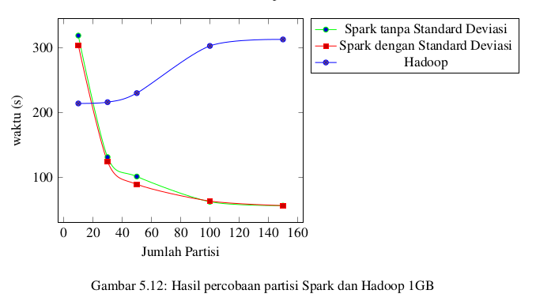

No | Ukuran Data | Jumlah Partisi | Spark Standard dengan Deviasi | Spark Tanpa Standard Deviasi | Spark SD | Spark No SD
1 | 2GB | 10 | 958 | 929 | 1.2 GB | 0.96 GB
2 | 2GB | 30 | 317 | 350 | 1.2 GB | 0.96 GB
3 | 2GB | 50 | 217 | 205 | 1.2 GB | 0.96 GB
4 | 2GB | 100 | 134 | 126 | 1.2 GB | 0.96 GB
5 | 2GB | 150 | 109 | 110 | 1.2 GB | 0.96 GB
6 | 2GB | 200 | 99 | 98 | 1.2 GB | 0.96 GB
7 | 2GB | 250 | 86 | 83 | 1.2 GB | 0.96 GB

No | Ukuran Data | Jumlah Partisi | Hadoop | Hadoop
1 | 2GB | 10 | 365 | 1GB
2 | 2GB | 30 | 355 | 1GB
3 | 2GB | 50 | 428 | 1GB
4 | 2GB | 100 | 446 | 1GB
5 | 2GB | 150 | 489 | 1GB
6 | 2GB | 200 | 545 | 1GB
7 | 2GB | 250 | 589 | 1GB

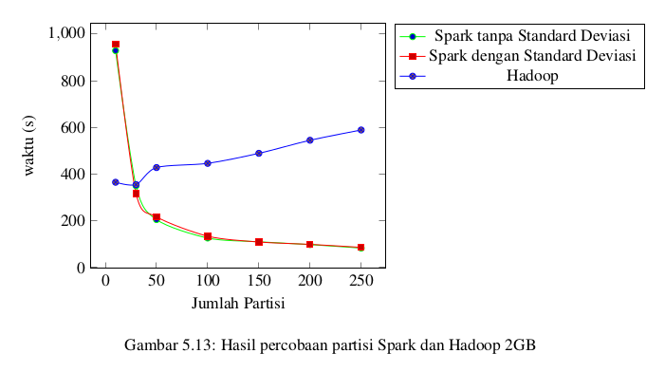

No | Ukuran Data | Jumlah Partisi | Spark Standard Deviasi | Spark Tanpa Standard Deviasi | Spark SD | Spark No SD
1 | 3GB | 10 | 1376 | 1446 | 1.5 GB | 1.2 GB
2 | 3GB | 30 | 491 | 516 | 1.5 GB | 1.2 GB
3 | 3GB | 50 | 298 | 315 | 1.5 GB | 1.2 GB
4 | 3GB | 100 | 183 | 188 | 1.5 GB | 1.2 GB
5 | 3GB | 150 | 146 | 144 | 1.5 GB | 1.2 GB
6 | 3GB | 200 | 144 | 135 | 1.5 GB | 1.2 GB
7 | 3GB | 250 | 191 | 211 | 1.5 GB | 1.2 GB
8 | 3GB | 300 | 176 | 182 | 1.5 GB | 1.2 GB
9 | 3GB | 350 | 169 | 163 | 1.5 GB | 1.2 GB
10 | 3GB | 400 | 158 | 137 | 1.5 GB | 1.2 GB

No | Ukuran Data | Jumlah Partisi | Hadoop | Hadoop
1 | 3GB | 10 | 455 | 1.2 GB
2 | 3GB | 30 | 445 | 1.2 GB
3 | 3GB | 50 | 501 | 1.2 GB
4 | 3GB | 100 | 532 | 1.2 GB
5 | 3GB | 150 | 639 | 1.2 GB
6 | 3GB | 200 | 720 | 1.2 GB
7 | 3GB | 250 | 761 | 1.2 GB
8 | 3GB | 300 | 822 | 1.2 GB
9 | 3GB | 350 | 903 | 1.2 GB
10 | 3GB | 400 | 1012 | 1.2 GB

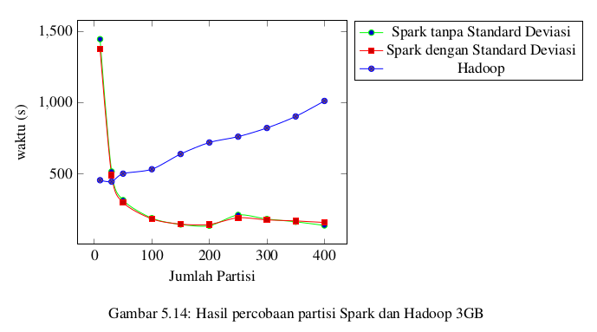

No | Ukuran Data | Jumlah Partisi | Spark Standard Deviasi | Spark Tanpa Standard Deviasi | Spark SD | Spark No SD
1 | 5GB | 10 | 4457 | 4490 | 2.6 GB | 2.1 GB
2 | 5GB | 30 | 2002 | 1637 | 2.6 GB | 2.1 GB
3 | 5GB | 50 | 891 | 995 | 2.6 GB | 2.1 GB
4 | 5GB | 100 | 590 | 524 | 2.6 GB | 2.1 GB
5 | 5GB | 150 | 431 | 343 | 2.6 GB | 2.1 GB
6 | 5GB | 200 | 288 | 315 | 2.6 GB | 2.1 GB
7 | 5GB | 300 | 526 | 519 | 2.6 GB | 2.1 GB
8 | 5GB | 400 | 399 | 422 | 2.6 GB | 2.1 GB
9 | 5GB | 500 | 370 | 359 | 2.6 GB | 2.1 GB
10 | 5GB | 600 | 326 | 319 | 2.6 GB | 2.1 GB
11 | 5GB | 700 | 306 | 259 | 2.6 GB | 2.1 GB
12 | 5GB | 800 | 256 | 255 | 2.6 GB | 2.1 GB

No | Ukuran Data | Jumlah Partisi | Hadoop | Hadoop
1 | 5GB | 10 | 817 | 2.2 GB
2 | 5GB | 30 | 759 | 2.2 GB
3 | 5GB | 50 | 906 | 2.2 GB
4 | 5GB | 100 | 952 | 2.2 GB
5 | 5GB | 150 | 1121 | 2.2 GB
6 | 5GB | 200 | 1173 | 2.2 GB
7 | 5GB | 300 | 1485 | 2.2 GB
8 | 5GB | 400 | 2261 | 2.2 GB
9 | 5GB | 500 | 1994 | 2.2 GB
10 | 5GB | 600 | 2282 | 2.2 GB
11 | 5GB | 700 | 2569 | 2.2 GB
12 | 5GB | 800 | 4463 | 2.2 GB

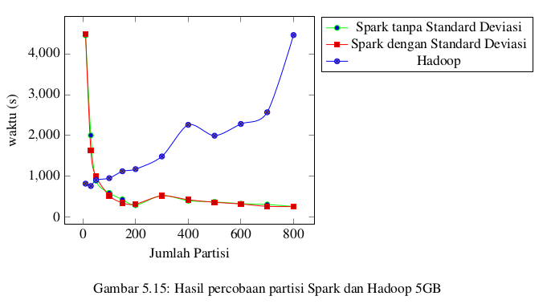

No | Ukuran Data | Jumlah Partisi | Spark Standard Deviasi | Spark Tanpa Standard Deviasi
1 | 10GB | 50 | 7236 | 7254 | 4.6 GB | 3.7 GB
2 | 10GB | 100 | 2805 | 2373 | 4.6 GB | 3.7 GB
3 | 10GB | 200 | 1718 | 1736 | 4.6 GB | 3.7 GB
4 | 10GB | 300 | 1494 | 1477 | 4.6 GB | 3.7 GB
5 | 10GB | 400 | 1207 | 1160 | 4.6 GB | 3.7 GB
6 | 10GB | 500 | 984 | 923 | 4.6 GB | 3.7 GB
7 | 10GB | 700 | 780 | 774 | 4.6 GB | 3.7 GB
8 | 10GB | 900 | 652 | 645 | 4.6 GB | 3.7 GB
9 | 10GB | 1100 | 568 | 563 | 4.6 GB | 3.7 GB
10 | 10GB | 1300 | 524 | 522 | 4.6 GB | 3.7 GB
11 | 10GB | 1500 | 504 | 459 | 4.6 GB | 3.7 GB

No | Ukuran Data | Jumlah Partisi | Hadoop
1 | 10GB | 10 | 1260 | 3.9 GB
2 | 10GB | 30 | 1446 | 3.9 GB
3 | 10GB | 50 | 1481 | 3.9 GB
4 | 10GB | 100 | 1631 | 3.9 GB
5 | 10GB | 200 | 2127 | 3.9 GB
6 | 10GB | 300 | 2583 | 3.9 GB
7 | 10GB | 400 | 3721 | 3.9 GB
8 | 10GB | 500 | 3573 | 3.9 GB
9 | 10GB | 700 | 5014 | 3.9 GB
10 | 10GB | 900 | 5529 | 3.9 GB
11 | 10GB | 1100 | 7254 | 3.9 GB
12 | 10GB | 1300 | 8989 | 3.9 GB
13 | 10GB | 1500 | 9499 | 3.9 GB

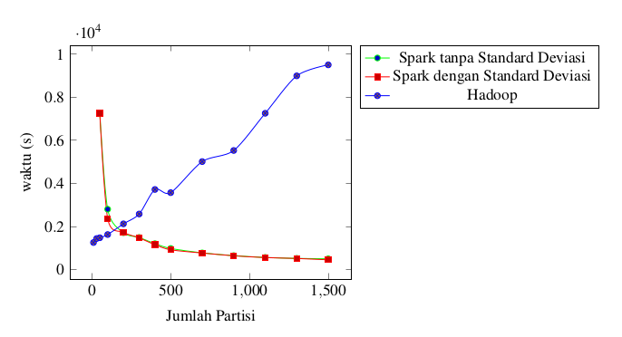

No | Ukuran Data | Jumlah Partisi | Spark Standard Deviasi | Spark Tanpa Standard Deviasi
1 | 15GB | 100 | 9294 | 9034 | 7.3 GB | 5.8 GB
2 | 15GB | 200 | 4847 | 5239 | 7.3 GB | 5.8 GB
3 | 15GB | 300 | 3761 | 3263 | 7.3 GB | 5.8 GB
4 | 15GB | 500 | 2024 | 2175 | 7.3 GB | 5.8 GB
5 | 15GB | 700 | 1696 | 1645 | 7.3 GB | 5.8 GB
6 | 15GB | 900 | 1372 | 1276 | 7.3 GB | 5.8 GB
7 | 15GB | 1200 | 1114 | 1136 | 7.3 GB | 5.8 GB
8 | 15GB | 1500 | 918 | 970 | 7.3 GB | 5.8 GB
9 | 15GB | 1800 | 863 | 834 | 7.3 GB | 5.8 GB
10 | 15GB | 2100 | 783 | 773 | 7.3 GB | 5.8 GB
11 | 15GB | 2400 | 738 | 739 | 7.3 GB | 5.8 GB

No | Ukuran Data | Jumlah Partisi | Hadoop
1 | 15GB | 10 | 2133 | 6.1 GB
2 | 15GB | 30 | 2177 | 6.1 GB
3 | 15GB | 50 | 2234 | 6.1 GB
4 | 15GB | 100 | 2474 | 6.1 GB
5 | 15GB | 200 | 3306 | 6.1 GB
6 | 15GB | 300 | 4655 | 6.1 GB
7 | 15GB | 400 | 4775 | 6.1 GB
8 | 15GB | 500 | 6644 | 6.1 GB
9 | 15GB | 700 | 8203 | 6.1 GB
10 | 15GB | 900 | 8482 | 6.1 GB

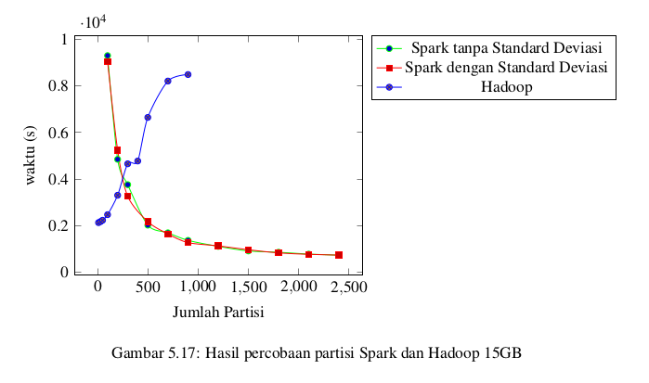

No | Ukuran Data | Jumlah Partisi | Spark Standard Deviasi | Spark Tanpa Standard Deviasi | Spark SD | No SD
1 | 20GB | 200 | 8386 | 8866 | 7.3 GB | 7.7 GB
2 | 20GB | 400 | 4342 | 4553 | 9.6 GB | 7.7 GB
3 | 20GB | 600 | 2841 | 3021 | 9.6 GB | 7.7 GB
4 | 20GB | 1000 | 2065 | 2084 | 9.6 GB | 7.7 GB
5 | 20GB | 1400 | 1598 | 1471 | 9.6 GB | 7.7 GB
6 | 20GB | 1800 | 1372 | 1298 | 9.6 GB | 7.7 GB
7 | 20GB | 2200 | 1228 | 1165 | 9.6 GB | 7.7 GB
8 | 20GB | 2600 | 1133 | 1081 | 9.6 GB | 7.7 GB
9 | 20GB | 3000 | 1010 | 1031 | 9.6 GB | 7.7 GB

No | Ukuran Data | Jumlah Partisi | Hadoop
1 | 20GB | 10 | 2763 | 8.1 GB
2 | 20GB | 30 | 2811 | 8.1 GB
3 | 20GB | 50 | 3007 | 8.1 GB
4 | 20GB | 100 | 3261 | 8.1 GB
5 | 20GB | 200 | 4360 | 8.1 GB
6 | 20GB | 400 | 6249 | 8.1 GB
7 | 20GB | 700 | 10476 | 8.1 GB
8 | 20GB | 1000 | 13839 | 8.1 GB

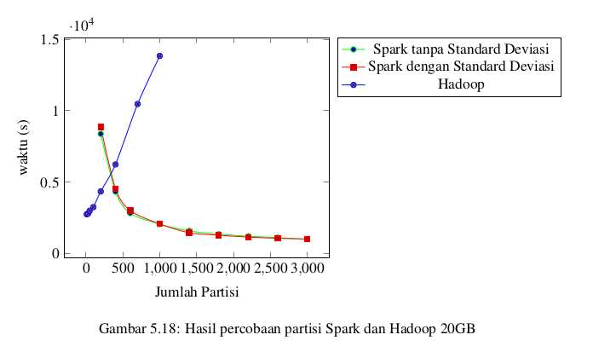

Eksperimen 2
MAX OBJ 50

No | Ukuran Data | Jumlah Partisi | Spark Standard Deviasi | Spark Tanpa Standard Deviasi | Spark SD | No SD
1 | 20GB | 1400 | 1043 | 1135 | 6.9 GB | 5.6 GB
2 | 20GB | 1800 | 911 | 961 | 6.9 GB | 5.6 GB
3 | 20GB | 2200 | 883 | 884 | 6.9 GB | 5.6 GB

No | Ukuran Data | Jumlah Partisi | Hadoop
1 | 20GB | 10 | 5462 | 5.6 GB
2 | 20GB | 20 | 5771 | 5.6 GB
3 | 20GB | 30 | 6840 | 5.6 GB

No | Ukuran Data | Jumlah Partisi | Spark Standard Deviasi | Spark Tanpa Standard Deviasi | Spark SD | No SD
1 | 15GB | 1400 | 757 | 733 | 5.2 GB | 4.2 GB
2 | 15GB | 1800 | 677 | 677 | 5.2 GB | 4.2 GB
3 | 15GB | 2200 | 633 | 675 | 5.2 GB | 4.2 GB

No | Ukuran Data | Jumlah Partisi | Hadoop
1 | 15GB | 10 | 4273 | 4.2 GB
2 | 15GB | 20 | 4319 | 4.2 GB
3 | 15GB | 30 | 4464 | 4.2 GB

No | Ukuran Data | Jumlah Partisi | Spark Standard Deviasi | Spark Tanpa Standard Deviasi | Spark SD | No SD
1 | 10GB | 1400 | 481 | 498 | 3.3 GB | 2.7 GB
2 | 10GB | 1800 | 442 | 443 | 3.3 GB | 2.7 GB
3 | 10GB | 2200 | 416 | 368 | 3.3 GB | 2.7 GB

No | Ukuran Data | Jumlah Partisi | Hadoop
1 | 10GB | 10 | 2740 | 2.7 GB
2 | 10GB | 20 | 2810 | 2.7 GB
3 | 10GB | 30 | 2821 | 2.7 GB

No | Ukuran Data | Jumlah Partisi | Spark Standard Deviasi | Spark Tanpa Standard Deviasi | Spark SD | No SD
1 | 5GB | 1400 | 261 | 277 | 1.9 GB | 1.5GB
2 | 5GB | 1800 | 262 | 250 | 1.9 GB | 1.5 GB
3 | 5GB | 2200 | 248 | 232 | 1.9 GB | 1.5 GB

No | Ukuran Data | Jumlah Partisi | Hadoop
1 | 5GB | 10 | 1546 | 1.5 GB
2 | 5GB | 20 | 1571 | 1.5 GB
3 | 5GB | 30 | 1654 | 1.5 GB

100 ==============================

No | Ukuran Data | Jumlah Partisi | Spark Standard Deviasi | Spark Tanpa Standard Deviasi | Spark SD | No SD
1 | 20GB | 1400 | 20 | 19 | 3.7 GB | 4.5 GB
2 | 20GB | 1800 | 19 | 19 | 3.7 GB | 4.5 GB
3 | 20GB | 2200 | 19 | 19 | 3.7 GB | 4.5 GB

No | Ukuran Data | Jumlah Partisi | Hadoop
1 | 20GB | 10 | 350 | 3.5 GB
2 | 20GB | 20 | 358 | 3.5 GB
3 | 20GB | 30 | 365 | 3.5 GB

No | Ukuran Data | Jumlah Partisi | Spark Standard Deviasi | Spark Tanpa Standard Deviasi | Spark SD | No SD
1 | 15GB | 1400 | 15 | 15 | 2.8 GB | 3.4 GB
2 | 15GB | 1800 | 15 | 14 | 2.8 GB | 3.4 GB
3 | 15GB | 2200 | 14 | 14 | 2.8 GB | 3.4 GB

No | Ukuran Data | Jumlah Partisi | Hadoop
1 | 15GB | 10 | 270 | 2.6 GB
2 | 15GB | 20 | 266 | 2.6 GB
3 | 15GB | 30 | 275 | 2.6 GB

No | Ukuran Data | Jumlah Partisi | Spark Standard Deviasi | Spark Tanpa Standard Deviasi | Spark SD | No SD
1 | 10GB | 1400 | 10 | 10 | 1.8 GB | 2.2 GB
2 | 10GB | 1800 | 9 | 9 | 1.8 GB | 2.2 GB
3 | 10GB | 2200 | 9 | 9 | 1.8 GB | 2.2 GB

No | Ukuran Data | Jumlah Partisi | Hadoop
1 | 10GB | 10 | 181 |  | 1.7 GB
2 | 10GB | 20 | 182 |  | 1.7 GB
3 | 10GB | 30 | 184 |  | 1.7 GB

No | Ukuran Data | Jumlah Partisi | Spark Standard Deviasi | Spark Tanpa Standard Deviasi | Spark SD | No SD
1 | 5GB | 1400 | 6 | 6 | 1.2 GB | 1 GB
2 | 5GB | 1800 | 5 | 5 | 1.2 GB | 1 GB
3 | 5GB | 2200 | 5 | 5 | 1.2 GB | 1 GB

No | Ukuran Data | Jumlah Partisi | Hadoop
1 | 5GB | 10 | 101 | 0.962 GB
2 | 5GB | 20 | 103 | 0.962 GB
3 | 5GB | 30 | 106 | 0.962 GB

30 core ==============================

No | Ukuran Data | Jumlah Partisi | Spark Standard Deviasi | Spark Tanpa Standard Deviasi | Spark SD | No SD
1 | 5GB | 1400 | 192 | 203 | 2.6 | 2.1
2 | 5GB | 1800 | 180 | 166 | 2.6 | 2.1
3 | 5GB | 2200 | 154 | 161 | 2.6 | 2.1

No | Ukuran Data | Jumlah Partisi | Hadoop
1 | 5GB | 10 | 283 | 2.2
2 | 5GB | 20 | 279 | 2.2
3 | 5GB | 30 | 286 | 2.2

No | Ukuran Data | Jumlah Partisi | Spark Standard Deviasi | Spark Tanpa Standard Deviasi | Spark SD | No SD
1 | 10GB | 1400 | 349 | 342 | 4.6 GB | 3.7 GB
2 | 10GB | 1800 | 308 | 295 | 4.6 GB | 3.7 GB
3 | 10GB | 2200 | 264 | 259 | 4.6 GB | 3.7 GB

No | Ukuran Data | Jumlah Partisi | Hadoop
1 | 10GB | 10 | 441 | 4.6 GB
2 | 10GB | 20 | 492 | 4.6 GB
3 | 10GB | 30 | 515 | 4.6 GB

No | Ukuran Data | Jumlah Partisi | Spark Standard Deviasi | Spark Tanpa Standard Deviasi | Spark SD | No SD
1 | 15GB | 1400 | 520 | 477 | 7.3 GB | 5.8 GB
2 | 15GB | 1800 | 451 | 437 | 7.3 GB | 5.8 GB
3 | 15GB | 2200 | 393 | 391 | 7.3 GB | 5.8 GB

No | Ukuran Data | Jumlah Partisi | Hadoop
1 | 15GB | 10 | 660 | 7.3
2 | 15GB | 20 | 729 | 7.3
3 | 15GB | 30 | 799 | 7.3

No | Ukuran Data | Jumlah Partisi | Spark Standard Deviasi | Spark Tanpa Standard Deviasi | Spark SD | No SD
1 | 20GB | 1400 | 720 | 723 | 9.6 GB | 7.7 GB
2 | 20GB | 1800 | 631 | 613 | 9.6 GB | 7.7 GB
3 | 20GB | 2200 | 557 | 553 | 9.6 GB | 7.7 GB

No | Ukuran Data | Jumlah Partisi | Hadoop
1 | 20GB | 10 | 879 | 9.6 GB
2 | 20GB | 20 | 916 | 9.6 GB
3 | 20GB | 30 | 1135 | 9.6 GB

50 core ==============================

No | Ukuran Data | Jumlah Partisi | Spark Standard Deviasi | Spark Tanpa Standard Deviasi | Spark SD | No SD
1 | 5GB | 1400 | 156 | 157 | 2.6 | 2.1
2 | 5GB | 1800 | 133 | 137 | 2.6 | 2.1
3 | 5GB | 2200 | 126 | 116 | 2.6 | 2.1

No | Ukuran Data | Jumlah Partisi | Hadoop
1 | 5GB | 10 | 206 | 2.6
2 | 5GB | 20 | 234 | 2.6
3 | 5GB | 30 | 252 | 2.6

No | Ukuran Data | Jumlah Partisi | Spark Standard Deviasi | Spark Tanpa Standard Deviasi | Spark SD | No SD
1 | 10GB | 1400 | 266 | 248 | 4.6 GB | 3.7 GB
2 | 10GB | 1800 | 231 | 221 | 4.6 GB | 3.7 GB
3 | 10GB | 2200 | 198 | 198 | 4.6 GB | 3.7 GB

No | Ukuran Data | Jumlah Partisi | Hadoop
1 | 10GB | 10 | 300 | 4.6 GB
2 | 10GB | 20 | 320 | 4.6 GB
3 | 10GB | 30 | 334 | 4.6 GB

No | Ukuran Data | Jumlah Partisi | Spark Standard Deviasi | Spark Tanpa Standard Deviasi | Spark SD | No SD
1 | 15GB | 1400 | 372 | 356 | 7.3 GB | 5.8 GB
2 | 15GB | 1800 | 318 | 336 | 7.3 GB | 5.8 GB
3 | 15GB | 2200 | 290 | 291 | 7.3 GB | 5.8 GB

No | Ukuran Data | Jumlah Partisi | Hadoop
1 | 15GB | 10 | 526 | 7.3
2 | 15GB | 20 | 563 | 7.3
3 | 15GB | 30 | 635 | 7.3

No | Ukuran Data | Jumlah Partisi | Spark Standard Deviasi | Spark Tanpa Standard Deviasi | Spark SD | No SD
1 | 20GB | 1400 | 525 | 507 | 9.6 GB | 7.7 GB
2 | 20GB | 1800 | 460 | 439 | 9.6 GB | 7.7 GB
3 | 20GB | 2200 | 412 | 392 | 9.6 GB | 7.7 GB

No | Ukuran Data | Jumlah Partisi | Hadoop
1 | 20GB | 10 | 715 | 9.6 GB
2 | 20GB | 20 | 827 | 9.6 GB
3 | 20GB | 30 | 1134 | 9.6 GB

