Laboratory Activity – Week 14
Push Notifications Integration

Course: Mobile Application Development

Student Name: Meneses, Vonn Christian Miel P.
Date: 5/16/26

Activity Objectives
The primary objective of this laboratory activity is to successfully integrate Firebase Cloud Messaging (FCM) into a Flutter application. This involves configuring the Firebase project, retrieving a unique device registration token, and properly handling push notifications across different application states (foreground and background) to engage users with real-time alerts.

Tools & Environment
- IDE: Visual Studio Code (VS Code)
- Framework: Flutter SDK
- Backend Services: Firebase Console (Firebase Core & Firebase Messaging)
- Testing Environment: Android Emulator / Physical Device

Laboratory Deliverables & Implementation

A. Working Application Setup
The application has been successfully configured and linked to the Firebase project.
- The google-services.json file was downloaded and placed inside android/app/
- firebase_core and firebase_messaging were added to pubspec.yaml
- Firebase.initializeApp() was called inside the main() function

B. Code 1 Main.Py – Token Retrieval & Permission Request
The following snippet demonstrates how the FCM Device Token is retrieved after requesting notification permissions. When a notification is received while the app is in the foreground, it is handled via the onMessage stream:

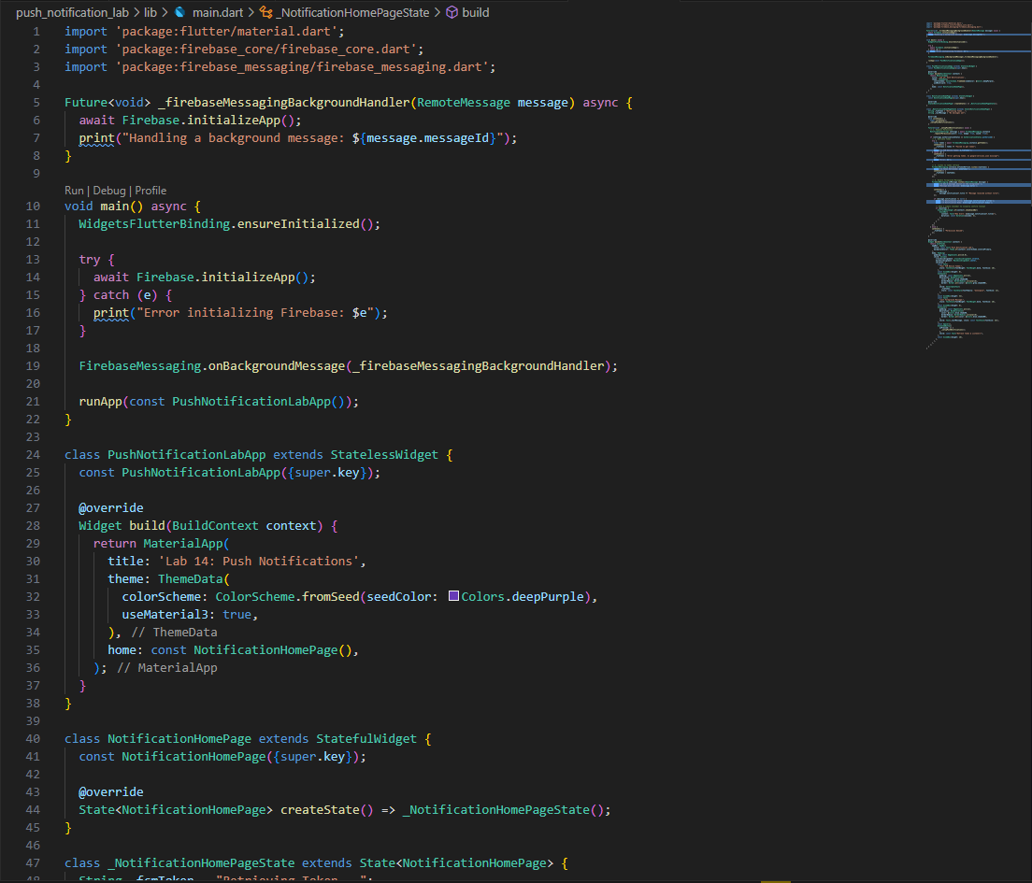
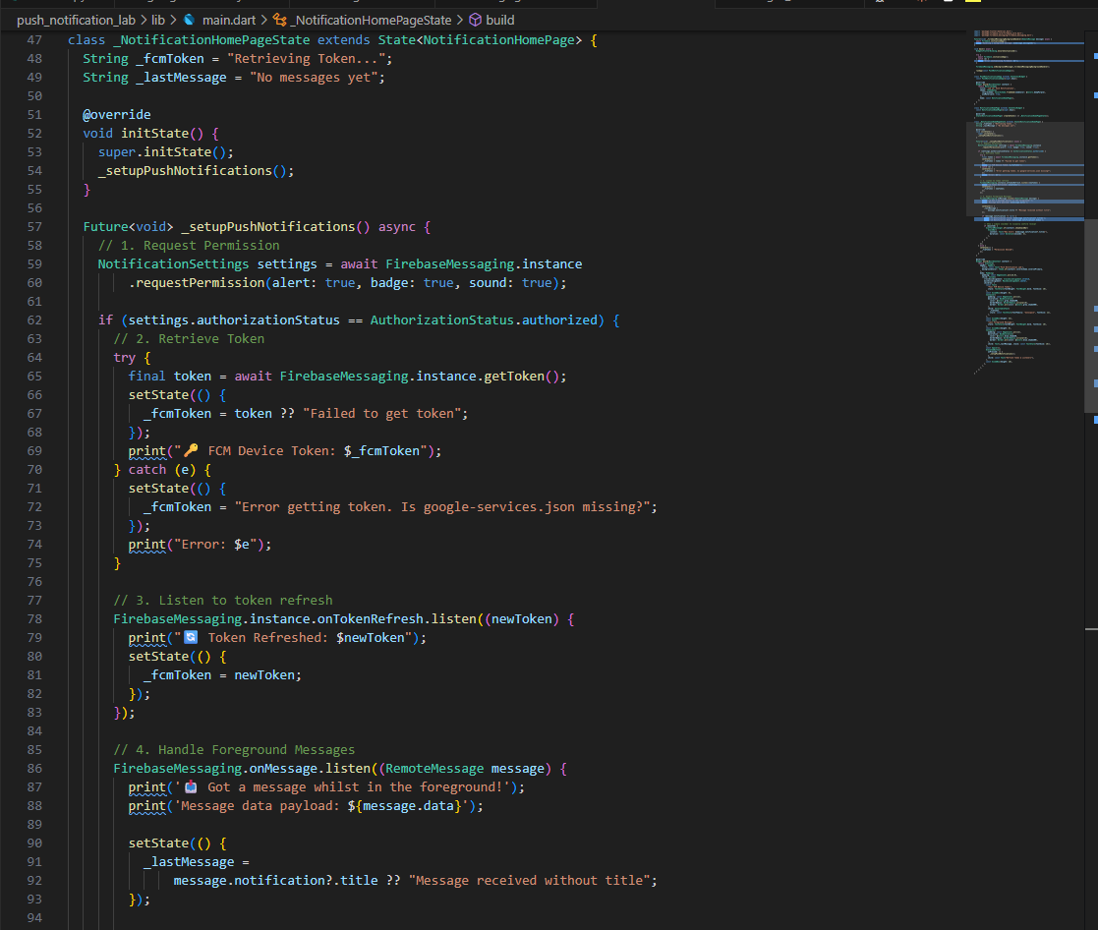

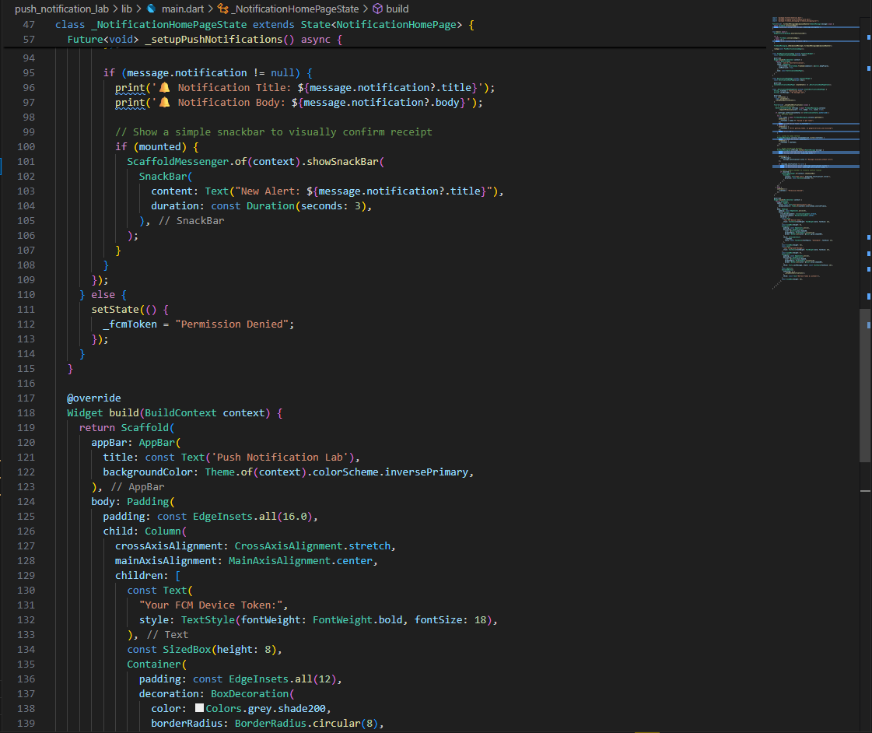

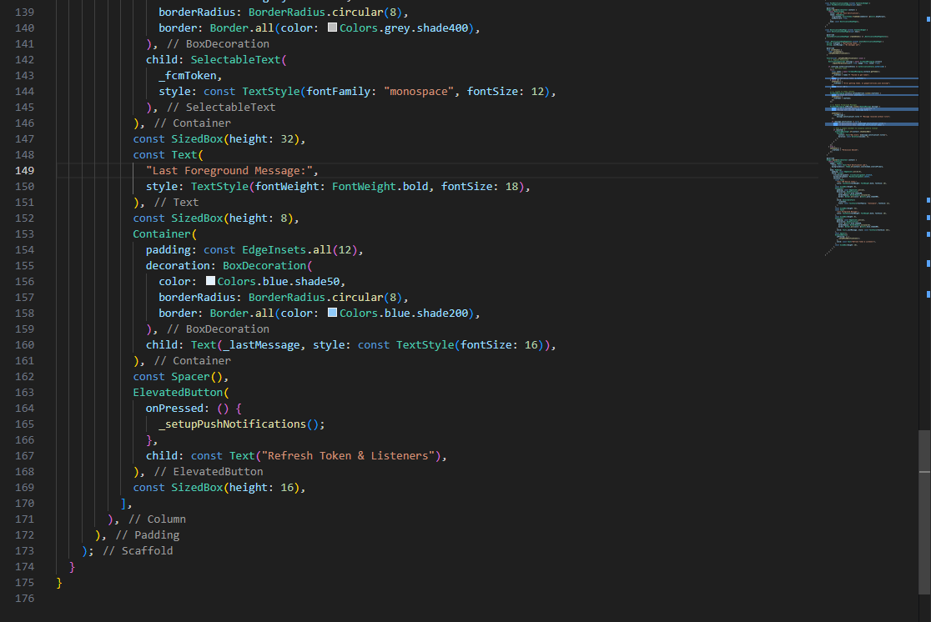

4. Visual Evidence & Execution

FCM Device Token
Target Device Token: [c7snaFvcTyCZaI0LjRJ3T7:APA91bFyS-RUbvlR7B-fGFpy84VTA3yuZ2GVk3wvfuRe8p3kqPEWRC6HhyZFWmnc1fqy2E4fUjm3hPsnsezT4JG9JMSPPvAgQP7TASSprtsf1w63cvWAg0c]

Screenshot 1 – Sent Notification (Firebase Console)
Screenshot of the Firebase Console showing the notification configuration, target token, and Published status.
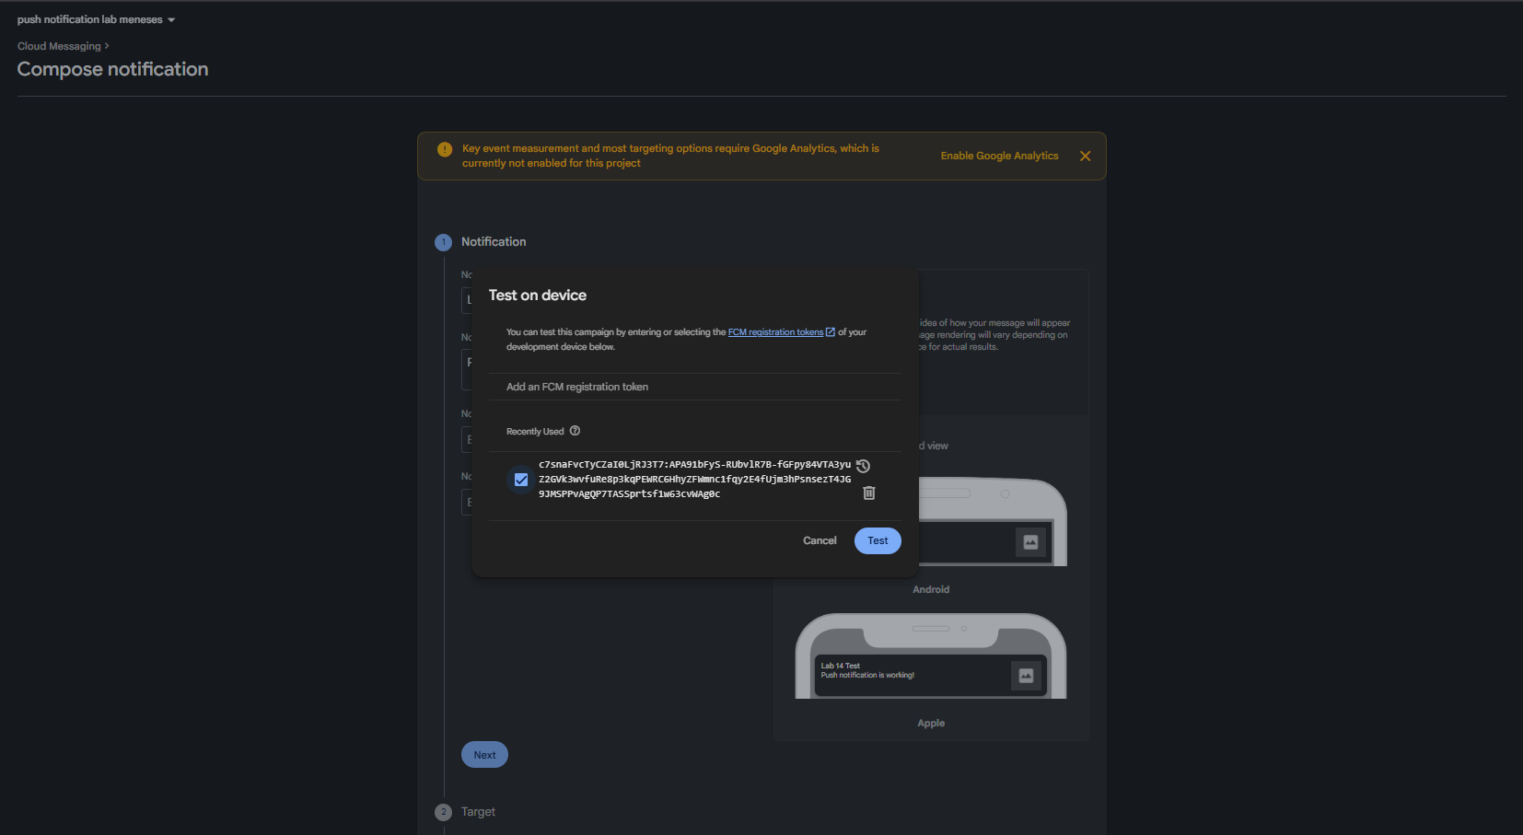

Screenshot 2 – Received Notification (Device/Emulator Tray)
Screenshot of the push notification successfully appearing in the device/emulator notification tray.
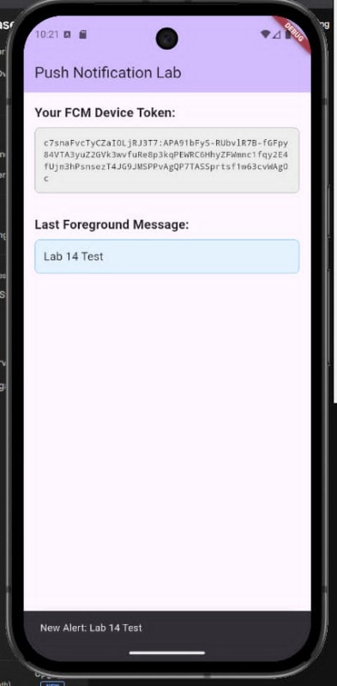

Screenshot 3 – Working App Console Output
Screenshot showing the Flutter app running with the FCM token and incoming message printed to the debug console.

