Pediatric Anemia Diagnosis Aide - Current-State Product Specification
As-built scope, clinical evidence, functional behavior, data model, algorithm, architecture, verification, and production gaps
Authoritative as-built baseline for product, clinical, engineering, quality, regulatory, research, and diligence review

PREPARED FOR | Nick Miethe
DATE | 2026-07-16
STATUS | Specification v1.0 for app v0.2.0 plus the Algorithm Explorer enhancement; research prototype
SCOPE | Current implemented behavior and production gaps; future commercialization strategy is documented separately

Important: This specification documents the current research prototype. It does not establish clinical validation, regulatory status, production security, or suitability for live patient care.

Document control
Field | Value
Specification version | 1.0
Specification date | 2026-07-16
Application package version | 0.2.0
Knowledge-base version | 0.1.0-2026-07-15
Evidence reviewed through | 2026-07-15
Algorithm Explorer update | Applied to current working build; adds explanatory content and live walkthrough, not new clinical rules
Status | Research prototype; not clinically validated; not cleared or approved as a medical device
Intended audience for this specification | Product, clinical, informatics, engineering, quality, regulatory, research, and diligence teams

SCOPE OF THIS FILE
This is an as-built specification. Future commercial recommendations are in the separate commercialization strategy report. Items labeled production gaps are not current capabilities.

1. Product overview
The Pediatric Anemia Diagnosis Aide is a deterministic, evidence-linked clinical decision-support research prototype for licensed clinicians evaluating pediatric anemia. It collects demographic, CBC, history, examination, smear, and targeted laboratory inputs; derives normalized clinical facts; executes inspectable JSON rules; merges and ranks diagnostic patterns using fixed ordinal priority; and returns safety alerts, rationale, adaptive questions, suggested confirmatory workup, citations, and a reproducible rule audit.
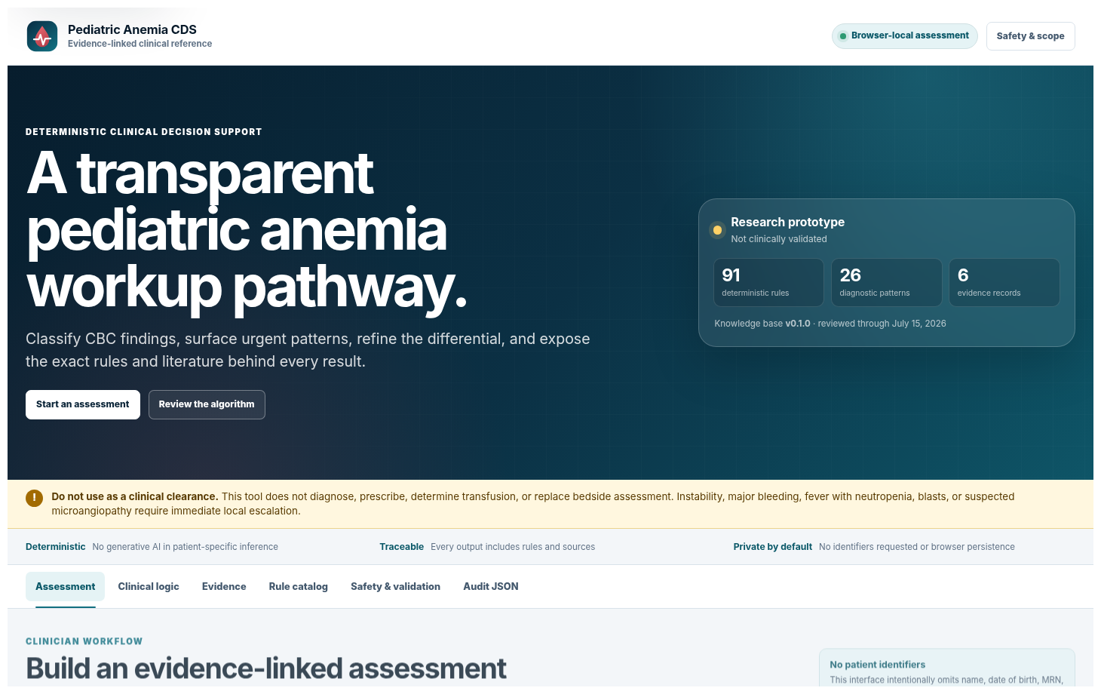
Figure 1. Current clinician workspace: public, browser-local assessment with explicit research-prototype and no-identifiers warnings.

1.1 Product goals
- Help clinicians classify pediatric anemia using local or age/sex fallback reference intervals.
- Surface high-risk findings before etiologic refinement.
- Guide a morphology- and reticulocyte-based differential through explicit deterministic logic.
- Keep missing data visible and ask high-yield follow-up questions.
- Expose the exact rules, evidence IDs, and reasoning behind each result so a clinician can independently review it.
- Provide a reproducible, versioned assessment artifact without generative AI in patient-specific inference.

1.2 Explicit non-goals
- Autonomous diagnosis or replacement of bedside assessment.
- Treatment selection, medication dosing, iron prescription, transfusion instruction, or order placement.
- A validated probability, likelihood ratio, calibrated confidence, sensitivity, or specificity estimate.
- General neonatal anemia classification below 6 months using static fallback thresholds.
- Adult anemia interpretation without supplied adult/local laboratory ranges.
- Persistent patient record, EHR integration, production PHI handling, or enterprise audit service.

2. Intended use, users, and clinical scope
Dimension | As-built specification
Intended user | Licensed healthcare professional; the interface is not designed as independent patient or caregiver CDS.
Intended purpose | Review CBC and related findings and provide transparent diagnostic patterns, alerts, questions, and confirmatory options for clinician consideration.
Patient population | Built-in fallback ranges for age 6 months to <18 years.
Young infant behavior | Age <6 months is routed outside the static general-pediatric classification and requires neonatal/young-infant specialist and local reference data.
Adult behavior | Age >=18 requires adult/local laboratory limits; the pediatric fallback table is not applied.
Care setting | Research/demo use in outpatient, urgent, emergency, education, or referral contexts; no validated deployment setting.
Inference type | Deterministic, rule-based, inspectable, reproducible.
Output type | Ranked diagnostic patterns and follow-up options, not a guaranteed diagnosis.

CLINICAL BOUNDARY
The current software may display emergency or urgent flags, but it is not validated for autonomous time-critical triage, and the UI instructs users to use local escalation for instability, bleeding, fever with neutropenia, blasts, and suspected microangiopathy.

3. Clinical evidence baseline
The evidence review prioritized publications from 2021 through July 2026, with older material retained only when foundational and not replaced in the focused review. The current evidence registry contains six records.
Evidence ID | Source | Role in current logic
AAP2026_IDA | AAP Pediatrics clinical report, 2026 [C1] | Age/sex CBC fallback intervals; ferritin thresholds; inflammation caveats; iron, thalassemia, and inflammatory differentiation.
WHO2024_HB | WHO hemoglobin cutoff guideline, 2024 [C2] | Age/population-aware cutoff governance and transparent provenance.
BLOOD2022_PED_ANEMIA | Blood review, 2022 [C3] | Morphology and reticulocyte framework; broad pediatric differential; smear, hemolysis, marrow, nutrient, renal, endocrine, infectious, inherited causes.
CDC2025_LEAD | CDC lead guidance, updated 2025 [C4] | 3.5 micrograms/dL reference value, capillary confirmation, escalation tiers, and iron deficiency consideration.
FDA2026_CDS | FDA CDS guidance, 2026 [R1] | Transparency, intended-use, specificity, time-criticality, and clinician independent-review design constraints.
BSH2020_G6PD | BSH G6PD laboratory guideline, 2020 [C5] | Quantitative testing and false-normal timing/transfusion cautions; labeled foundational exception.

3.1 Encoded fallback CBC intervals
Local laboratory ranges take precedence. The following AAP-derived fallbacks are used only within the encoded age scope and when the required demographic input is available. [C1]
Age | Female Hb lower | Male Hb lower | Female MCV (fL) | Male MCV (fL) | Female RDW upper | Male RDW upper
6 to <24 mo | 11.0 | 11.0 | 73.3-83.2 | 71.1-82.2 | 15.4 | 15.9
2 to <6 y | 11.0 | 11.0 | 75.2-85.0 | 74.1-84.3 | 14.5 | 14.7
6 to <12 y | 11.2 | 11.3 | 78.3-87.7 | 77.8-86.5 | 13.9 | 13.7
12 to <18 y | 11.4 | 12.4 | 80.5-91.8 | 80.4-90.1 | 14.6 | 13.7

Hemoglobin is in g/dL, MCV in fL, and RDW in percent. Ferritin is interpreted against <=20 ng/mL for children 6 months to <12 years and <=30 ng/mL for adolescents and all menstruating patients, with inflammation caveats. [C1]

4. Functional capabilities
ID | Capability | As-built behavior
FR-001 | Scope and warning display | Prominently identifies research-prototype status, licensed-clinician intent, no clinical clearance, and local escalation needs.
FR-002 | Core patient and CBC capture | Captures age, sex assigned at birth, menstruation, transfusion, altitude, Hb, MCV, RDW, RBC, WBC, ANC, platelets, flags, and local ranges.
FR-003 | Immediate safety screen | Captures instability, major bleeding, respiratory/cardiac/neurologic symptoms, fever, jaundice, dark urine, fatigue, and pallor.
FR-004 | Reticulocyte and iron/inflammation capture | Captures response or absolute reticulocytes, ferritin, CRP, transferrin saturation, TIBC/transferrin, serum iron, and sTfR/ferritin index.
FR-005 | Specialized laboratory capture | Captures hemolysis, DAT, lead/specimen, hemoglobin analysis, globin tests, G6PD timing, nutrients, renal, thyroid, and liver interpretation.
FR-006 | History/exposure questionnaire | Captures dietary, bleeding, inflammatory, renal, infectious, medication, toxin, travel, inherited, congenital, and prior-response factors.
FR-007 | Smear and exam capture | Captures target cells, spherocytes, schistocytes, bite/blister cells, sickle cells, stippling, hypersegmentation, blasts, teardrops, nucleated RBCs, elliptocytes, organomegaly, lymphadenopathy, petechiae, and bruising.
FR-008 | Reference-range selection | Uses supplied local limits first; otherwise selects encoded AAP age/sex fallback when in scope.
FR-009 | Fact derivation | Normalizes input into anemia presence, morphology, RDW, reticulocyte, iron, inflammation, hemolysis, cytopenia, lead, and other rule facts.
FR-010 | Rule execution | Evaluates every machine-readable condition and records matched/not-matched state.
FR-011 | Pattern merge and rank | Merges rule support into 26 diagnostic patterns and sorts by deterministic level and points; ranking is explicitly not probability.
FR-012 | Safety output | Returns emergency, urgent, and important alerts before the differential.
FR-013 | Adaptive follow-up | Returns the highest-priority unanswered questions according to the active branch.
FR-014 | Evidence and rationale | Shows supporting/conflicting findings, rule IDs, evidence chips, and suggested confirmatory steps.
FR-015 | Audit export | Exposes normalized input, result, KB version, and evaluated rule trace as JSON; supports copy/download.
FR-016 | Worked examples | Loads six de-identified example cases spanning IDA, thalassemia, inflammation, hemolysis, lead, and marrow red flags.
FR-017 | Algorithm Explorer | Expands six algorithm stages with data points, expressions, thresholds, studies, examples, branches, and live walkthrough.
FR-018 | Evidence and rule catalog | Displays evidence registry and searchable deterministic rules.
FR-019 | Print/copy summary | Provides print and copy controls for the clinician-facing result.
FR-020 | Prototype REST API | Exposes health, knowledge-base summary, and deterministic assessment endpoints.

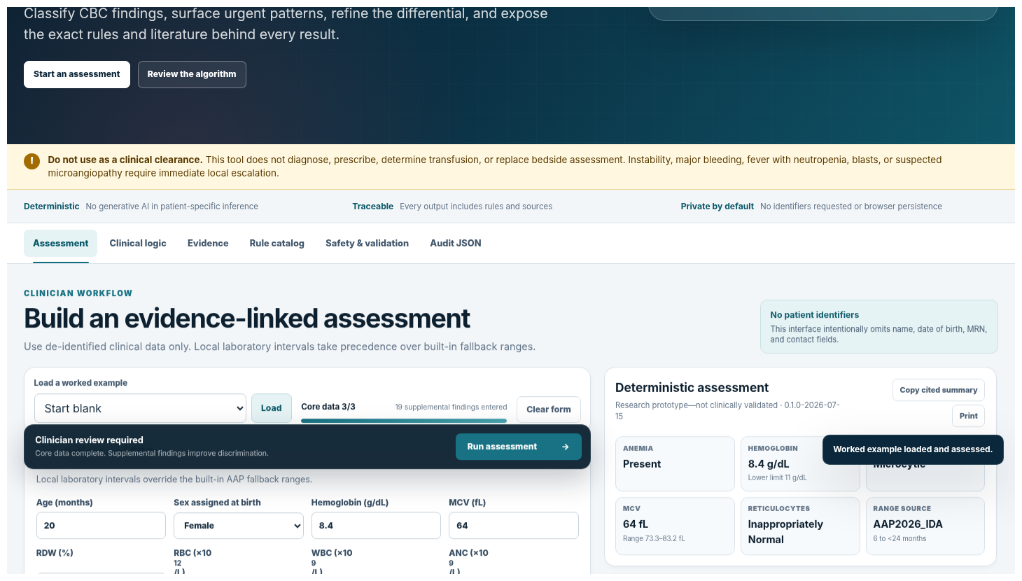
Figure 2. Current worked assessment output: classification, safety, ranked pattern differential, rationale, citations, and next questions.

5. Input data model
The JSON input contract contains eight top-level sections. Most fields are optional so the engine can represent incomplete assessments, although the current symptom/history/exam maps use booleans and therefore do not yet distinguish false from unknown unless the UI/context does so explicitly.
Section | Representative fields
patient | ageMonths; sexAtBirth; menstruating; recentTransfusion; highAltitude
cbc | hemoglobin; mcv; rdw; rbc; wbc; anc; platelets; rbcInterpretation; localRanges; localFlags
reticulocytes | response; absolute
symptoms | instability; respiratory distress; syncope; altered mental status; chest pain; heart failure signs; bleeding; fever; neurologic/renal symptoms; jaundice; dark urine; fatigue; pallor
history | diet/milk; prematurity; malabsorption; menstrual/GI/nasal/other loss; inflammatory/renal/liver/thyroid/infectious disease; viral illness; travel; family/known hemoglobinopathy or hemolysis; medication/toxin/lead; congenital anomalies; prior iron response
exam | splenomegaly; hepatomegaly; lymphadenopathy; petechiae; unexplained bruising
labs | ferritin/CRP/TSAT/TIBC/iron/index; bilirubin/LDH/haptoglobin/DAT; lead and specimen; HbA2/Bart/sickling/globin tests; G6PD; B12/folate/copper; creatinine; TSH; liver tests
smear | target cells; spherocytes; schistocytes; bite/blister cells; sickle cells; basophilic stippling; hypersegmented neutrophils; blasts; teardrops; nucleated RBCs; elliptocytes

5.1 Data quality behavior
- Local ranges override fallback ranges.
- Assay-dependent tests often use local interpretation states (low/normal/high/unknown) rather than hard-coded universal numbers.
- Recent transfusion, acute hemolysis, inflammation, and assay timing can generate interpretive cautions.
- Outside-scope ages are not forced through pediatric fallback thresholds.
- Current production gap: replace boolean maps with explicit present/absent/unknown/not-assessed and include source, timestamp, method, and provenance.

6. Deterministic algorithm specification
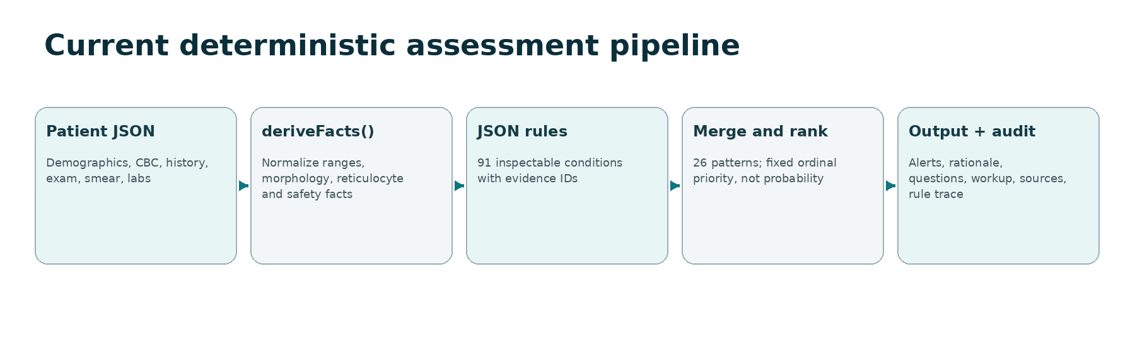
Figure 3. Current software pipeline. The same input and knowledge-base version produce the same result.

6.1 Stage sequence
Stage | Logic | Representative output
1. Establish scope and urgency | Validate age/units/ranges; evaluate instability, bleeding, cytopenias, blasts, schistocytes, lead urgency, and other safety rules | Out-of-scope note or tiered alert.
2. Confirm anemia | Compare Hb to local lower limit or applicable AAP fallback | Present / absent / indeterminate and effective lower limit/source.
3. Classify morphology | Compare MCV and RDW to local or fallback ranges | Microcytic / normocytic / macrocytic / indeterminate; RDW status.
4. Classify marrow response | Use clinician-entered reticulocyte response or available absolute count/context | High / low / inappropriately normal / unknown pathway.
5. Apply morphology-specific rules | Use iron/inflammation, globin, lead, loss/hemolysis, production, nutrient/endocrine/liver, smear, history, and exam facts | Matched candidate rules and adaptive questions.
6. Merge, rank, and expose provenance | Merge candidate evidence; keep highest evidence label; sort by fixed points; attach evidence, knowns/unknowns, and workup | Ranked pattern list and complete rule audit.

6.2 Iron-deficiency rule core
ferritin threshold = 30 ng/mL if menstruating or age 12 to <18 years
else 20 ng/mL for age 6 months to <12 years
anemia + ferritin at/below threshold -> iron deficiency anemia pattern
no anemia + ferritin at/below threshold -> iron deficiency without anemia pattern
CRP elevated + ferritin not low -> iron deficiency remains not excluded
sTfR/log10(ferritin) > 2 -> supports iron deficiency
sTfR/log10(ferritin) < 1 + inflammation -> supports anemia of inflammation

The app does not automatically prescribe iron, infer adherence, or use a normal/high ferritin during inflammation to exclude iron deficiency. [C1]

6.3 High-reticulocyte hemolysis core
- Ask about overt or occult blood loss.
- A general biochemical hemolysis pattern requires at least two of elevated indirect bilirubin, elevated LDH, or low haptoglobin.
- DAT positive supports immune hemolysis; spherocytes with DAT negative support hereditary spherocytosis; bite/blister cells plus oxidant exposure support G6PD pathway; schistocytes trigger microangiopathic/mechanical concern; sickling evidence supports sickling hemoglobinopathy; fever plus malaria exposure supports an infectious pathway. [C3; C5]

6.4 Low-reticulocyte and macrocytic core
- Renal dysfunction, inflammation, viral context, age, other cell lines, blasts, organomegaly, and congenital findings route among production-limited and marrow pathways.
- Macrocytosis with high reticulocytes redirects toward loss/hemolysis; low/inappropriate reticulocytes plus B12/folate/copper, hypersegmentation, TSH, liver tests, medication, or congenital features refine the branch. [C3]

6.5 Ranking semantics
Label | Meaning
Meets defined pattern | An explicit biochemical, molecular, or source-defined criterion was met.
Strongly supported | A relatively specific combination of findings was met.
Supported | Multiple compatible findings are present, but meaningful alternatives remain.
Possible | A lower-specificity pattern warrants a question or test.
Not excluded | A confounder or missing value prevents exclusion.

IMPORTANT
The internal point total only sorts candidates within deterministic levels. It has no probabilistic interpretation.

7. Knowledge-base inventory
Artifact | Count / status
Deterministic rules | 91 total: 55 differential, 17 adaptive-question, 13 safety, 6 interpretive-note
Safety severities | 5 emergency, 4 urgent, 4 important
Diagnostic patterns | 26
Evidence records | 6
Worked clinical examples | 6
Automated engine tests | 10

7.1 Diagnostic-pattern catalog
# | Pattern
1 | Iron deficiency anemia
2 | Iron deficiency without anemia
3 | Anemia of inflammation / inflammatory iron restriction
4 | Thalassemia trait or other globin-production pattern
5 | Beta-thalassemia pattern
6 | Alpha-thalassemia pattern
7 | Lead exposure-associated anemia
8 | Sideroblastic or iron-loading microcytosis
9 | Blood loss
10 | Hemolysis, etiology not yet specified
11 | Autoimmune hemolytic anemia
12 | Hereditary spherocytosis
13 | G6PD deficiency
14 | Microangiopathic hemolysis
15 | Sickling hemoglobinopathy
16 | Malaria or parasitic hemolysis
17 | Renal anemia
18 | Transient erythroblastopenia of childhood
19 | Parvovirus aplastic crisis
20 | Marrow failure or infiltration
21 | Vitamin B12 or folate deficiency
22 | Copper deficiency
23 | Thyroid-, liver-, or medication-associated macrocytosis
24 | Inherited marrow failure
25 | Mixed anemia or transfusion effect
26 | Iron-refractory iron deficiency anemia / rare iron handling disorder

8. User interface and workflow
Tab / area | Current behavior
Assessment | Six-stage intake, worked examples, live de-identified snapshot, input-depth indicator, sticky run action, independent results pane.
Clinical logic / Algorithm Explorer | Six expanded stages with explanations, data fields, expressions, thresholds, evidence links, examples, morphology branches, and live engine walkthrough.
Evidence | Displays evidence registry, source metadata, review recency, and links.
Rule catalog | Searchable 91-rule catalog with IDs, categories, output behavior, priorities, and evidence references.
Safety and validation | Research status, limitations, clinical boundaries, and production gate.
Audit JSON | Normalized input, deterministic output, KB version, matched/evaluated rules, copy and download.
Responsive behavior | Desktop sidebar/two-column workflow and compact mobile navigation; print-friendly result.

8.1 Algorithm Explorer six stages
- Establish scope and urgency.
- Confirm anemia.
- Classify red-cell morphology.
- Classify marrow response.
- Apply morphology-specific rules.
- Rank and expose provenance.
The Explorer update changes educational and explanatory presentation only. It does not alter the 91-rule clinical knowledge base.

9. Technical architecture
Layer / file | Responsibility
index.html; styles.css; site-overrides.css | Responsive clinician SPA, tabs, forms, cards, print layout, warnings.
src/app.js | UI state, field mapping, examples, assessment rendering, copy/print/audit actions.
src/algorithmExplorer.js | Expanded algorithm explanations and live walkthrough.
src/facts.js | Input normalization and derived clinical facts.
src/ruleEngine.js | Generic JSON condition evaluator, candidate merge, deterministic sorting.
src/engine.js | Assessment contract and evidence-linked result assembly.
src/referenceRanges.js | AAP fallback interval selection and range provenance.
src/evidence.js | Evidence registry loading and citation resolution.
data/rules.json | 91 deterministic rules.
data/candidates.json | 26 merged pattern definitions and default next steps.
data/evidence.json | Versioned source metadata.
data/reference-ranges.json | Machine-readable fallback ranges.
data/algorithm-explainers.json | Educational stage explanations, examples, equations, and source IDs.
schemas/*.json | Patient input, assessment output, rule, and candidate contracts.
server.mjs; openapi.yaml | Static server and prototype REST API.
scripts/; tests/ | Static build, knowledge-base validation, smoke test, and deterministic engine tests.

9.1 Runtime behavior
- The browser downloads static JavaScript and JSON assets and runs the assessment locally.
- The browser interface does not call the included API and does not automatically persist entered data.
- The Node API mirrors the deterministic engine for integration testing and returns results without intentional body logging or persistence.
- Opening index.html directly from disk fails because browsers block local fetch of JSON; use the included server or static host.
- Node.js 20 or later is specified for local server/build/test scripts.

9.2 REST API
Method | Path | Purpose
GET | /health | Health and knowledge-base version.
GET | /api/v1/knowledge-base | Evidence registry and rule/pattern counts.
POST | /api/v1/assess | Validate and execute a deterministic assessment.

10. Deployment and security posture
Mode | As-built support | Limitations
Static hosting | Publish dist/ to Cloudflare Pages, GitHub Pages, Netlify, Vercel, S3/CloudFront, or equivalent | No API; security headers depend on host; public site must not be treated as approved PHI environment.
Node server | Static site plus prototype REST endpoints | No authentication, tenant isolation, durable audit, production observability, BAA, or PHI governance.
Docker | Containerized Node server | Containerization alone does not establish security, privacy, compliance, or clinical readiness.
Browser-local | No automatic server transmission or persistence from assessment UI | Browser/device, extensions, screenshots, printing, and hosting still require a threat model.

10.1 Existing privacy-oriented design
- No name, date of birth, medical record number, or contact fields in the interface.
- No third-party fonts, scripts, analytics, or trackers in the packaged site.
- robots.txt requests that search engines not index the prototype.
- Assessment values remain browser-local in the current UI and are not automatically saved.

10.2 Production security gaps
- Authentication, SSO, RBAC, MFA, tenant isolation, authorization, key management, encryption-at-rest, audited access, retention/deletion, backup/restore, incident response, vulnerability management, and penetration testing are not implemented.
- No HIPAA or FTC applicability assessment has been completed for a production business model. [R7-R8]
- No production secure-SDLC, SBOM governance, quality system, or regulated change-control process is implemented.

11. Verification status
Check | Current result
Engine tests | 10 of 10 passed.
Knowledge-base validation | 91 rules, 26 candidates, and 6 evidence records validated.
Static build | Passed; current Algorithm Explorer assets included.
Live server/API smoke test | Passed; expected health and deterministic assessment response.
Browser testing | Desktop and mobile interaction checks previously passed for example loading, assessment rendering, citations, navigation, print, and audit.
Interpretation | Verifies software behavior and packaging only; does not establish clinical validity, safety, diagnostic accuracy, or utility.

11.1 Current test scenarios
- AAP fallback interval by age and sex.
- Local ranges override built-in ranges.
- Iron deficiency anemia example reaches the defined pattern.
- Beta-thalassemia example ranks a beta-thalassemia pattern.
- Inflammatory example ranks anemia of inflammation.
- DAT-negative spherocytic hemolysis includes hereditary spherocytosis.
- Marrow red flags trigger emergency and urgent alerts.
- Elevated capillary lead triggers confirmation and lead pathway.
- Young infant is not forced through built-in thresholds.
- Identical input produces identical output.

12. Known limitations and production gates
Limitation | Required production gate
No clinical validation | Dual specialist review, multi-site retrospective validation, prospective silent mode, and controlled rollout.
Incomplete neonatal logic | Dedicated neonatal research, postnatal/gestational model, local ranges, and specialist validation before inclusion.
Assay and lab dependence | UCUM units, method metadata, laboratory medicine review, site-specific mapping and validation.
Boolean missingness | Explicit tri-state or four-state answers, source, timestamp, and completeness checks.
Rare disease resolution | Specialist confirmation and explicit limits for marrow, molecular, membrane, enzyme, and hemoglobinopathy diagnoses.
No probability model | Retain ordinal language unless a separately validated probabilistic model is developed and calibrated.
Regulatory status unknown | Final intended-use/claims analysis, specialized counsel, and possible FDA interaction. [R1]
No production content operations | Exact source passages, evidence grade, dual approval, expiry, surveillance, semantic diffs, signed releases, rollback.
No production security/privacy | Enterprise security architecture, contracts, threat model, controls, testing, and legal assessment. [R7-R8]
Content reuse rights not resolved | Copyright and license review for guideline tables, excerpts, and derived content.

RELEASE PROHIBITION
Do not use the current prototype for live patient care or market it as clinically validated until the production gates are completed and documented.

13. Recommended acceptance criteria for the next controlled release
- Every rule has exact source passage, page/section, applicability, effective date, review date, and two clinical approvals.
- Every rule has at least one positive and one negative activation test; every numeric cutoff has boundary tests; dangerous pathways have explicit miss tests.
- All clinical booleans use explicit present/absent/unknown/not-assessed semantics.
- The knowledge package is immutable, signed, reproducible, semantically diffed, and rollback-capable.
- An external pediatric hematologist, general pediatrician, and laboratory medicine reviewer approve the module.
- Retrospective and silent-mode protocol, reference standard, statistical plan, subgroup plan, and incident process are approved.
- Intended use, labeling, privacy/security architecture, and regulatory assessment are approved for the target deployment.

14. Source package inventory
The verified working package contains 73 files and is approximately 742 KB before screenshots or report artifacts. Key deliverables include the web interface, source modules, JSON knowledge base, schemas, examples, tests, documentation, Node server, static build, Dockerfile, OpenAPI contract, deployment headers, and release verification.
pediatric-anemia-site/
index.html, styles.css, site-overrides.css
src/{app,algorithmExplorer,engine,facts,ruleEngine,referenceRanges,evidence}.js
data/{rules,candidates,evidence,reference-ranges,algorithm-explainers}.json
schemas/{patient-input,assessment-output,rule,candidate}.schema.json
examples/*.json
tests/engine.test.mjs
scripts/{build-static,validate-kb,smoke-test}.mjs
server.mjs, openapi.yaml, Dockerfile, _headers, robots.txt
docs/*.md
dist/

References
[C1] American Academy of Pediatrics. Prevention, Screening, Diagnosis, and Treatment of Iron Deficiency and Iron Deficiency Anemia in Infants, Children, and Adolescents: Clinical Report. 2026. https://publications.aap.org/pediatrics/article/158/1/e2026077414/207901/Prevention-Screening-Diagnosis-and-Treatment-of Primary current clinical source in the app.
[C2] World Health Organization. Guideline on haemoglobin cutoffs to define anaemia in individuals and populations. 2024. https://www.who.int/publications/i/item/9789240088542 Supports age- and population-aware cutoff governance.
[C3] Blood / American Society of Hematology. Anemia in the pediatric patient. 2022. https://doi.org/10.1182/blood.2021013018 Recent peer-reviewed morphology and reticulocyte framework.
[C4] US Centers for Disease Control and Prevention. Recommended Actions Based on Blood Lead Level. 2025. https://www.cdc.gov/lead-prevention/hcp/clinical-guidance/index.html Current lead reference value, confirmation, and escalation pathways.
[C5] British Society for Haematology. Laboratory diagnosis of G6PD deficiency: A British Society for Haematology Guideline. 2020. https://pubmed.ncbi.nlm.nih.gov/?term=Laboratory+diagnosis+of+G6PD+deficiency+British+Society+for+Haematology Foundational exception outside the five-year priority window.
[R1] US Food and Drug Administration. Clinical Decision Support Software: Guidance for Industry and FDA Staff. 2026. https://www.fda.gov/regulatory-information/search-fda-guidance-documents/clinical-decision-support-software Final guidance, January 2026.
[R2] World Health Organization. SMART Guidelines. Current page accessed 2026. https://www.who.int/teams/digital-health-and-innovation/smart-guidelines Describes the challenge of translating guidance into digital systems.
[R3] HL7 International. SMART App Launch Implementation Guide v2.2.0. Current published version accessed 2026. https://hl7.org/fhir/smart-app-launch/ FHIR-based app launch and authorization standard.
[R4] HL7 International. CDS Hooks Implementation Guide v2.0.1. Current published version accessed 2026. https://cds-hooks.hl7.org/ Workflow-triggered CDS integration standard.
[R5] HL7 International. FHIR PlanDefinition R4. R4. https://hl7.org/fhir/R4/plandefinition.html Shareable conditions, triggers, and executable actions.
[R6] HL7 International. FHIR Questionnaire R5. R5. https://www.hl7.org/fhir/questionnaire.html Structured, ordered clinical data capture and QuestionnaireResponse.
[R7] US Department of Health and Human Services. The HIPAA Security Rule. Page reviewed March 2026. https://www.hhs.gov/hipaa/for-professionals/security/index.html Administrative, physical, and technical safeguards for ePHI.
[R8] US Federal Trade Commission. Health Breach Notification Rule. Final rule notice 2024. https://www.ftc.gov/legal-library/browse/rules/health-breach-notification-rule May apply to vendors of personal health records and related entities.

