Editing Existing Questions
Similar to adding a new question, users must have the proper permission to modify existing questions.
- Locate the order to add questions to
- Checkmark the order in the far left column
- Click the ?Show Questions button
- Locate the question to update and click on the row.
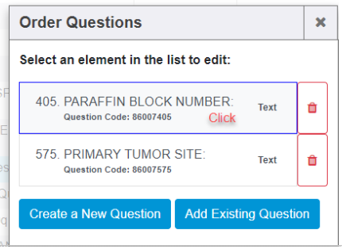
- From here, you may update the Description, the process order, the question code, or the response.
  - You may not change this from one “type” of response (like Text) to another type (like Yes/No). For this type of change, create a new question.
  - Be sure to click the Submit button at the bottom to save your changes.