Animation vs. Physics

https://www.youtube.com/watch?v=ErMSHiQRnc8

How to show a player:

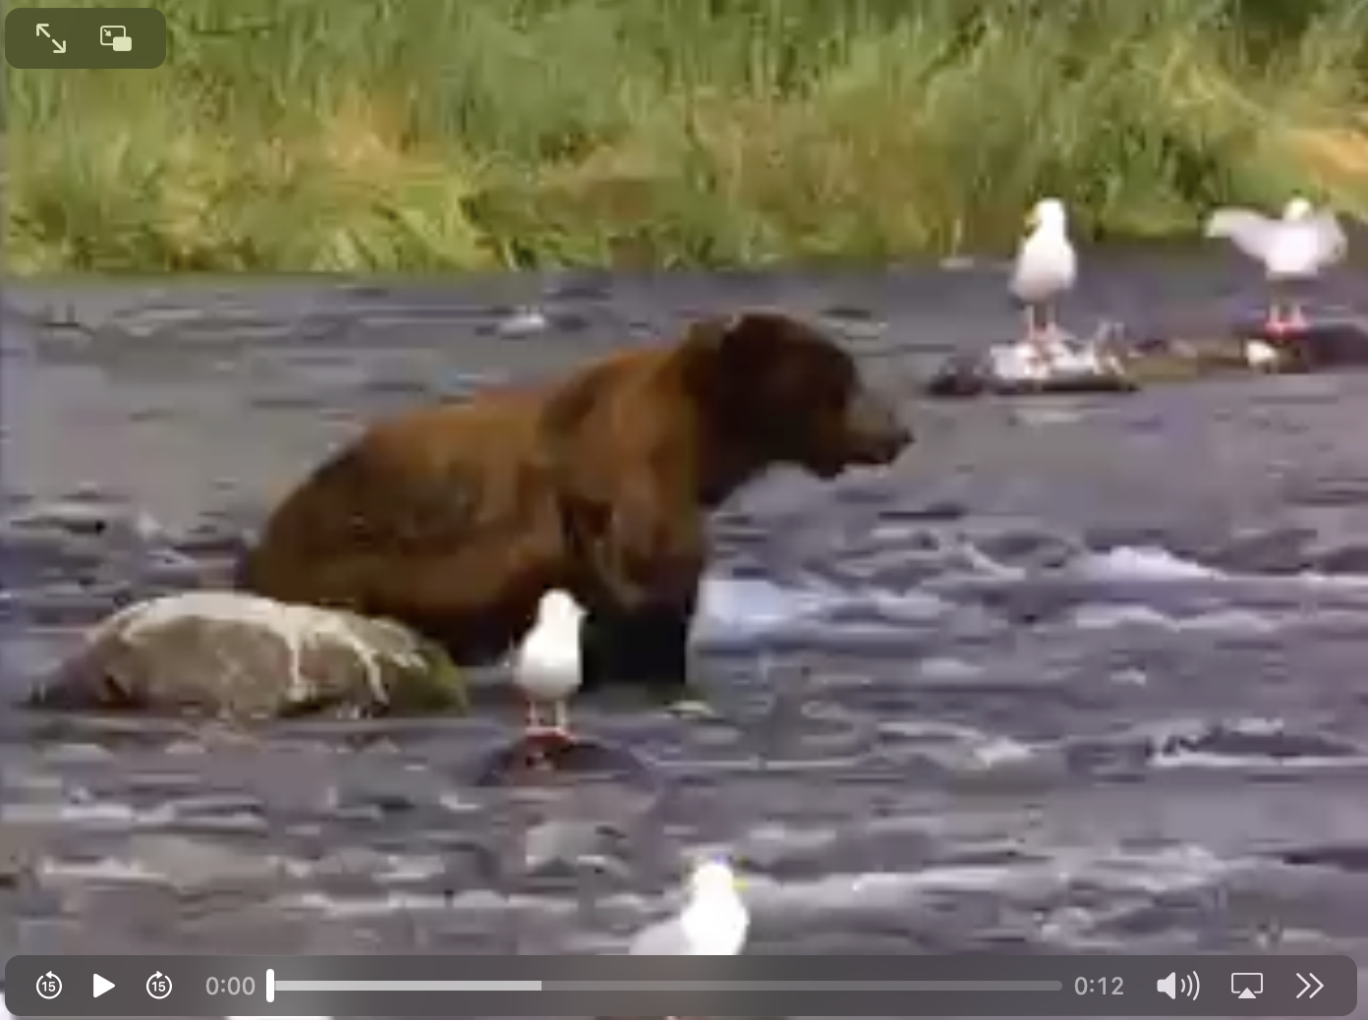

You

https://github.com/mieweb/docs_video/blob/main/EH_Task%20list.mp4

