Heading 1

Heading level 2

Some normal text with hyperlinks to a website and a link to a document on the shared drive with multiple versions of the link because people cut and paste. Link to test page. Link to doc in another folder.

Heading level 3 - with a table

Heading 1 | Heading 2 | Heading 3 | Heading 4 | Heading 5
Cell 1 | Cell 2 | Cell 3 | Cell 4  After subtable | Cell 5
  C1 | C2
  C3 | C4

Heading 3 - a diagram with links

Diagram
Diagram

Heading 3 - with a Table of contents

Heading 1
Heading level 2
Heading level 3 - with a table
Heading 3 - a diagram with links
Heading 3 - with a Table of contents
Other examples
Image
Preformatted Text

Other examples

Image

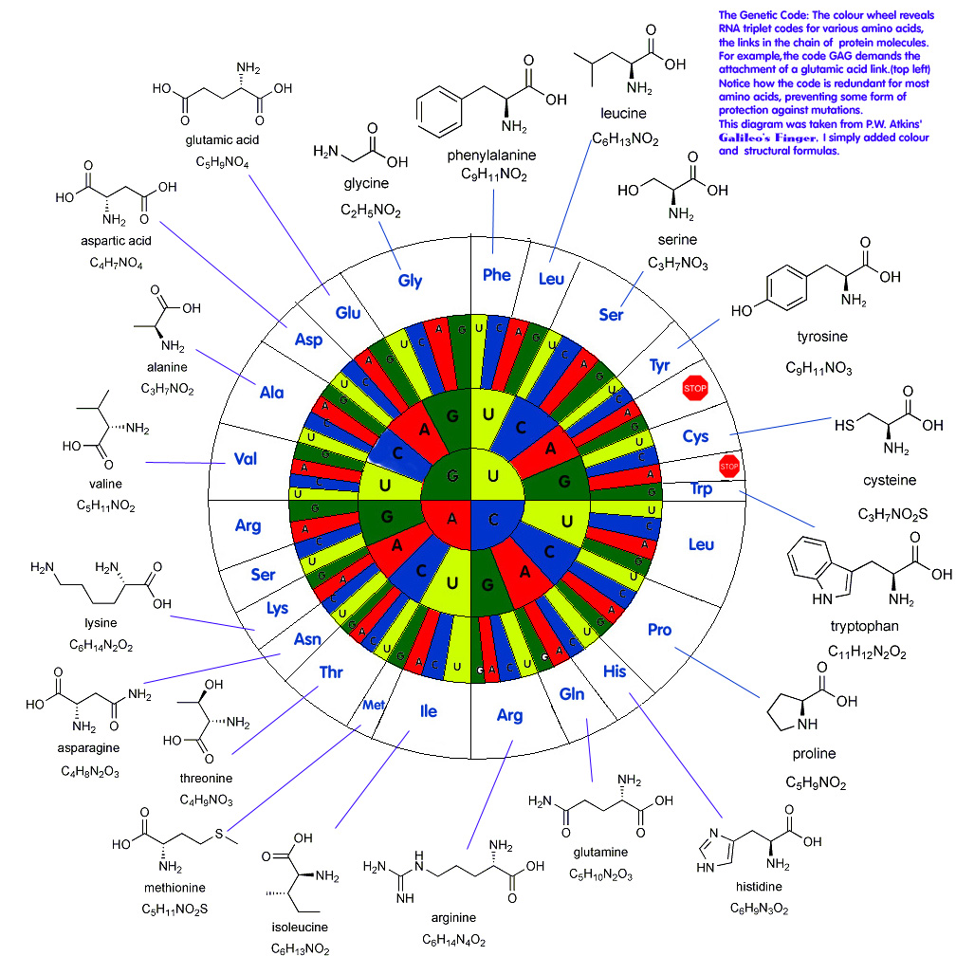

Preformatted Text

This is monospaced text. This should line up |
with this |

Code
Code blocks are part of the Markdown spec, but syntax highlighting isn't. However, many renderers -- like Github's and Markdown Here -- support syntax highlighting. Which languages are supported and how those language names should be written will vary from renderer to renderer. Markdown Here supports highlighting for dozens of languages (and not-really-languages, like diffs and HTTP headers); to see the complete list, and how to write the language names, see the highlight.js demo page.

Typescript / Javascript
{{markdown}}
```javascript
class MyClass {
public static myValue: string;
constructor(init: string) {
this.myValue = init;
}
}
import fs = require("fs");
module MyModule {
export interface MyInterface extends Other {
myProperty: any;
}
}
declare magicNumber number;
myArray.forEach(() => { }); // fat arrow syntax
```
{{/markdown}}

Video

From Youtube:

Google Drive, Docs, and Project Management with GSuite

Horizontal Lines

This is some text separated by a horizontal line

This is after the horizontal line.

Lists

- Bullet 1
- Bullet 2
  - SubBullet 1
  - SubBullet 2
- Bullet 3
- SubNumeric 1
- SubNumeric 2
- SubNumeric 3
- Alpha 1
- Alpha 2
- Alpha 3

Formatting

Some bold boldanditalic italic text

Equations

Using the actual equation object

Text equivalent
E=mc²
Inline math

Footnotes

Footnotes should display as a footnote, and should always display at the very end of the document (page)? This is some sample text with a footnote. This is some other data.

