The image should show up. Here is a link back to the README.
Label
Hyperlinks do not work in embedded drawings
because of Google. ;-)

after

Image from file:

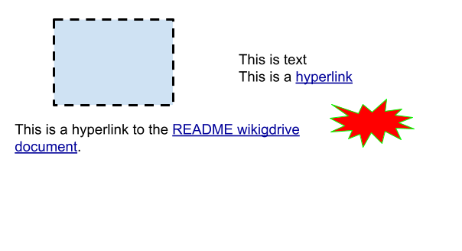

done

Inserted as unlinked:
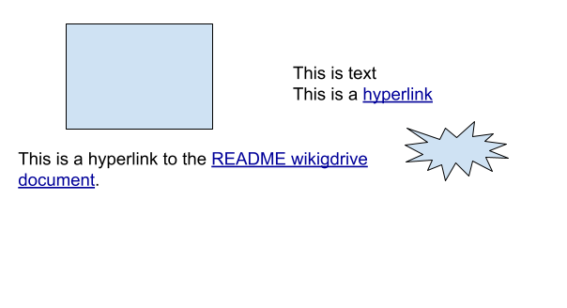

done

