The Design and Development Of Automatic Fish Feeder System Using PIC Microcontroller

M. Z. H. Noor, A. K. Hussian, M. F. Saaid, M. S. A. M. Ali, M. Zolkapli
Faculty of Electrical Engineering
Universiti Teknologi MARA Malaysia
40450 Shah Alam, Selangor, Malaysia mzhakim@salam.uitm.edu.my

Abstract— this research devoted to reduce the labor cost as well as develop better pellet dispense system. Subsequently, this research was proposed to design an automatic fish feeder system using PIC microcontroller application. The device developed combines mechanical and electrical system in controlling fish feeding activity. This device, basically consists of pellet storage, former, stand, DC motor and microcontroller. The pellets controlled by DC motor which located under the pellet storage. A control system was then attached to this device allowing the fish to be fed at the right cycle time as required or predefined by user. Timer was employed in this device to control the motor rotation attached to sphere former, which dispense the pellets into the water. The pellets dispensed into the marking area of the pond based solely on the rotation speed of the motor itself. The controller came with a keypad giving user more option in determining the suitable speed for the motor depends on their cattle. In short, the pellets in the automatic fish feeder system will be controlled by the rotation speed of DC motor.
Keyword-PIC Microcontroller; Animal feeder; fish feeder
- INTRODUCTION
An automatic fish feeder is an electronic gadget or device that has been designed to dispense the right amount of pellets at a particular time. In addition, such system also demonstrated the capability in repeating the task daily and accurately, hence promising efficiency and productivity in fish farming field in long run. In general, two basic concepts which are fixed and mobile conceived the automatic fish feeder [1]. This device fed fish following the right schedule and amount pre-defined by user, therefore avoiding the issue of overfeeding. To date, many of the fish farmers still stick with the manual feeding system. By utilizing the traditional manual feeding system, it means that more work forces would be needed by owner of fish farm in handling certain jobs, particularly in cleaning the feeder, refilling the pellet and even repair or maintenance procedure. All these process consumed considerably more time and energy compare to the automatic fish feeding system. Moreover, the benefits automatic fish feeding system emerged as the areas of the farm increased. For larger area, the manual feeding system users will certainly face difficulty in managing the entire feeding schedule.
Based on previous research, there were some efforts taken in order to replace the inefficient and unproductive manual feeding system. For instance, the Simple Automatic Fish
978-1-4673-2036-8/12/$31.00 ©2012 IEEE
Feeder which employed the timer in dispensing the pellets. However, this system was limited by the ability of dispensing pellets at a constant speed. Next, it was the Automatic feeder for marine mammals [3]. This feeder was found to be highly reliable with a very low rate of breakdowns. Unfortunately, these feeders were not specifically to handle [3]. In addition, this system caused unbalance growth of fish as the dispensed pellets focused at one part only [3].
Discovering the shortcoming of current automatic feeding systems had motivated the research to develop a system which overcome previous systems’ flaw, hence giving more advantages and benefits to the owner and workers. As a remedy of dispensing pellets solely at one part, the new system was able to dispense pellets into the desire area based on the rotation speed of the motor, combined with suitable cycle time. The system resulted in more systematic feeding schedule which certainly, will directly decrease the labor cost. This new automatic system was also designed in such a way that it can replace of human activity. This “Automatic Fish Feeder Using PIC Microcontroller Application” offered the user control feeding time up to 24 daily feeding cycles depending on the timer employed in the system and the optional reset time on the feeder. Also, the amount of pellets dispensed depended on the length of the feeding cycle adjusted on the feeder itself [2].
The rotation speed in new developed system will determine the travel distance of pellets before they landed at the desire area. Resistance was strung in the rotor circuit or adjusts the voltages of electrical machinery circuit is one of the traditional method of control speed [4] due to the fact that this method was easily set up, however some shortcomings come with such easy method. Consequently, a new kind of speed control method known as PWM (pulse width modulation) was considered in the new feeding system. Today, such speed regulating system has been widely used in the motor control speed. The power energy can be fully utilized and the circuit efficient is very high with the broad usage of PWM technological [5].
- METHODOLOGY
There are several ideas and methods required in order to target the research’s main objectives. The Figure 1 below aimed to aid researcher in explaining the methodologies of designing and implementing automatic fish feeder using PIC microcontroller application which encompassed system design, hardware and software development as well as the circuit design.
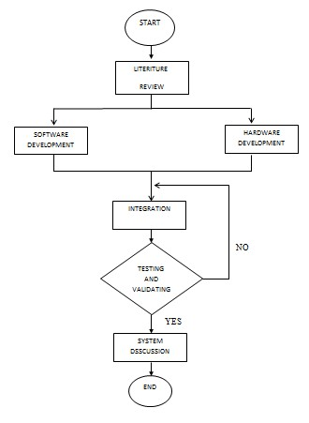
Figure 1: Methodologies of designing Automatic Fish Feeder System.
Figure 1 depicted the flowchart of the procedure conducted. Firstly, the literature review involved studies and collecting information, particularly from previous research. Researcher then reviewed the current issue or development state of automatic feeding system, and made comparison among the researches to identify the flaw of existing systems. Problems or shortcomings were identified and remedies were proposed in in hardware and software development stage. In integration stage, all circuit developed will be combined and integrated with the programming code to initiate the system. The data was initialized and processed by microcontroller on the program with the user interface. Later, the data processed by microcontroller was then sent to device as output of this system akin to user demanded or ordered. The output for this system would be the speed and the torque, generated by the DC motor and control by the microcontroller. Once the system started or failure occurred, researcher proceeds to testing and validating stage. As a result, data collected form system, especially output voltage drop and the distance of the pellet travelled will be discussed in system discussion stage.

A. System Design
The design of this Automatic fish feeder comprised of four main parts, namely main controller, pellet storage, stand and spreader. The controller of this system, a 4x4 Keypad functioned as input device which provided the user abilities to set timer and motor speed to spread the pellet into the water. Apart from that, LCD display played an important role in illustrating the data entered by the user before DC motor start to operate. PIC 16F886 controller was employed as main controller output of DC motor. In order to control the speed rotation of DC motor, L293D motor driver which work by PWM (Pulse Width Modulation) technique was utilized. As for the software design, programming of PIC16F886 was done with the aid of C language. The conceptual diagram as shown in figure 2 where the major components are included:

- PIC16F886 Microcontroller
- 4x4 Keypad
- 2x16 LCD (Liquid Cristal Display)
- L293D (Motor Driver)
- DC Motor
- LM7805 (Voltage Regulator) • Power Supply
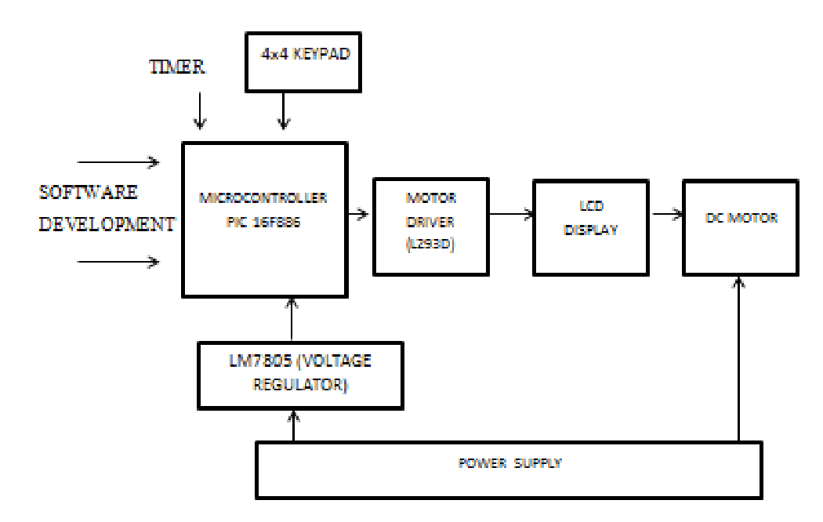 Figure 2: Conceptual diagram of the system.

B. Mechanical Design
All appropriate components used in hardware design stage were assembled to set up the feeding device. This system was simple in construction and operation, also relatively inexpensive, as well as reliable in the period of system operation. The storage that attached at the top stored the pellets and the amount decreased across the time as the motor start running. Pellets in the sphere former will be dispensed at target area based on the motor speed. The shape of the former was designed corresponding to sphere shape ensuring the spreading process more efficient compare to the other shape, especially on the amount of pellets stored. It was proven by math that given the same surface area, sphere outperformed other shape in terms of their volume. Meanwhile, during the operation of dc motor, there were several holes that allowed the pellet to be dispensed into the water. Figure 3 below shows the mechanical design of Automatic Fish feeder.

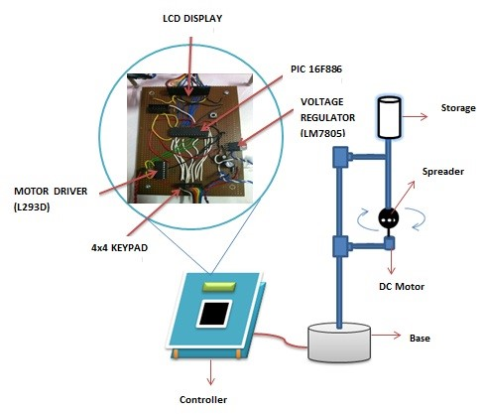

Figure 3: Mechanical Design of the system.

C. L293D motor driver for controlling motor
L293D is designed to provide bidirectional drive current of up to 600mA at voltage from 4.5V to 36V. It is to drive inductive load such as relays, solenoid, DC and bipolar stepping motor as well as other high current or high voltage loads in positive supply application. Each pair of channels is equipped with an enable input to simplify use as two bridges. This device is suitable for the use in switching applications at frequencies up to 5 kHz. For this research, L293D was applied to control the motor speed rotation. Without this component, the motor will not operate as programmed.
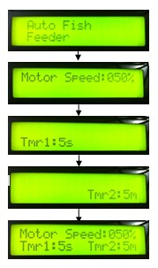
Figure 4: Flow of the system interface.
During the operation, the system would display information as in figure above and ready for the next operation. The speed option screen requested user to set the speed that suitable corresponding to the size or area of the pond itself. There are different speeds of choices depend on the PWM (Pulse Width Modulation) that had been programmed in the microcontroller at the development stage. The motor speed directly proportional to the distance travelled by pellet, hence increasing the motor speed will result in longer travel distance. In the timer case, two types of timers employed in this research. Timer 1 responds to the time entered by user and controls for the feeding time.
This timer will activate the motor at specific time requested by user. Timer 1 came with 2 options that allowed the user to set the time second (s) or minute (m). In the other hand, Timer 2 received the desired time delay after each feeding process entered by user. Timer 1 will be activated and repeated each time Timer 2 finished its calculation, and this process will continue until the system shut down. Once input parameters had been completely set up by the user, the motor will start to operate and activate the feeding mechanism, in which pellets dispensed into the pond according to the predefined rotation speed of the motor. Finally, the pellets will be shot into the marked area of the water surface. Figure 4 below shows the flows of the system interface.
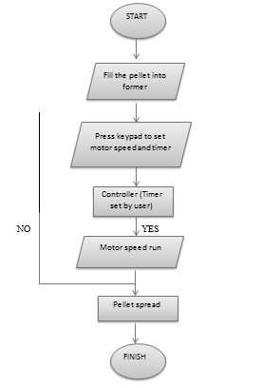

Figure 5:

Operation of the system.

III. RESULT AND DISCUSSION

A. Voltage drop at DC motor output
The study of designing Automatic Fish Feeder using PIC microcontroller is to find out the way of rotation speed of motor base on the percentage of PWM value set.
TABLE I. TABLE OF AVERAGE VOLTAGE WITH PWM VALUE SET TYPE
STYLES
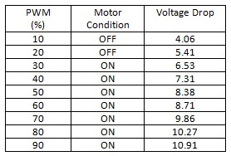

Table 1 above shows the voltage drop at the output DC motor depending on the percentage of the PWM use. Base on the result, the DC motor do not function or operate during the PWM are set to 10% and 20%. The voltage drop are too low and effect the rotation speed of the DC motor. This system is reliable since the other PWM percentage will run the DC motor smoothly. This result also shows that the DC motor will be run properly when the voltages are in between 6V until 11V. Figure 6 below shows the graph of PWM value set versus the voltage drop at DC motor output.

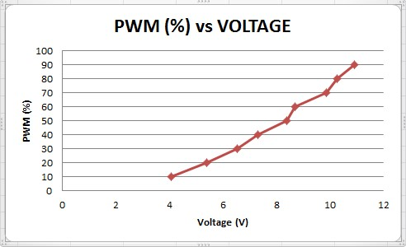
Figure 6: Graph of PWM value set versus the voltage drop at DC motor output

B. Analysis of the pellets distance
TABLE II. TABLE OF MAXIMUM AND MINIMUM PELLET DISTANCE
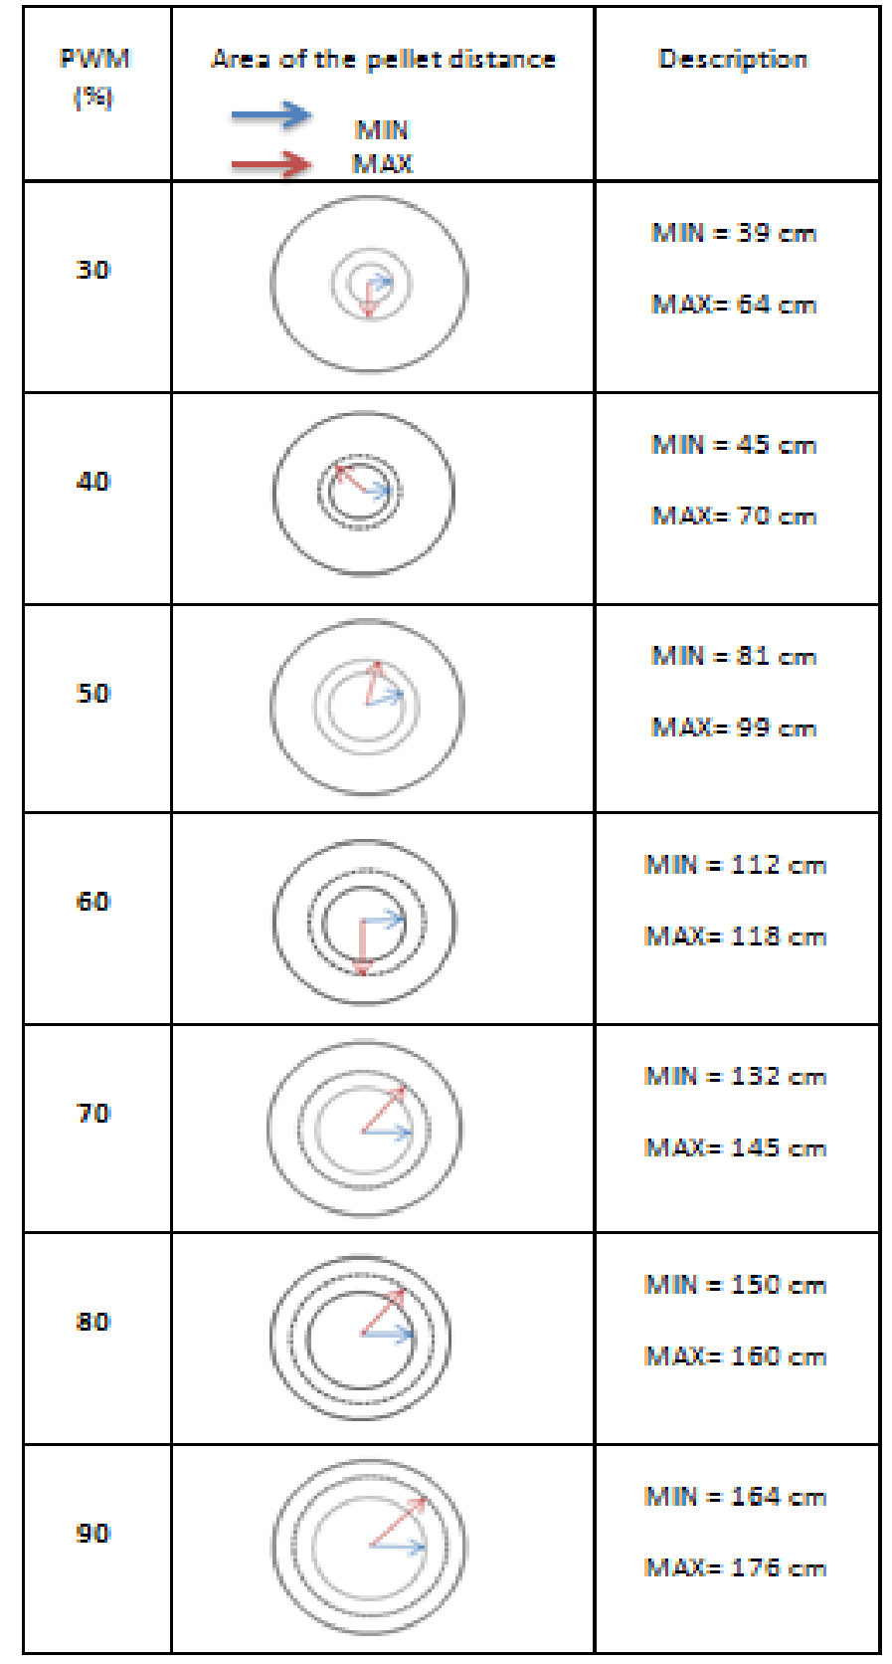
Table 2 above shows the data of maximum and minimum distance of the pellet spread and the marking area of the pellet distance. From the observation, the pellet that has been spread into the water has different distance depending on PWM value set. Therefore, the user has their own choice to feed their fish based on the size of the pond itself. Basically, the small of PWM value set is suitable for small fish feeding because the small fish did not have to compete each other in order to get the pellet compare with the big fish fed. The distance of the pellet spread play an important role to ensure that the good and efficient of the fish growth.

C. The pellet usage deal with timer
TABLE III. TABLE OF MAXIMUM AND MINIMUM PELLET DISTANCE
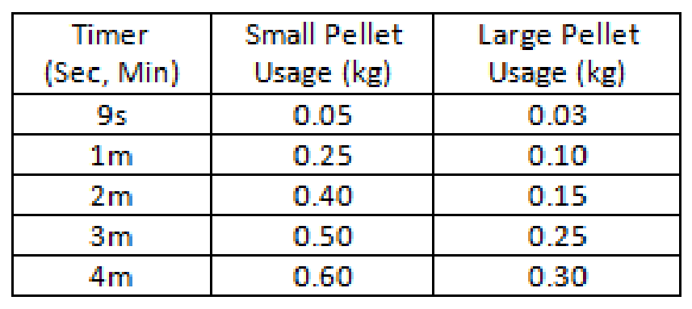

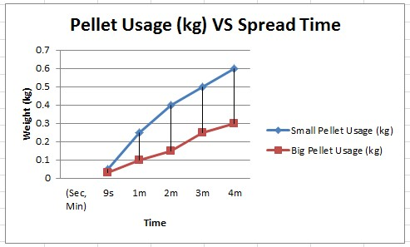

Figure 7: Graph type of pellet usage versus spreading time
Figure 7 above shows the analysis of the type of pellet usage with the spreading time. The maximum speed (90% PWM value set) has been use for this analysis. The size of the pellet will be effect to the pellet usage in this system. From the observation, the small pellet will be dispensing faster than the big pellet. The dispensing rate for small pellet is around 250g/m and this is 100g/m for the large pellets.
IV. CONCLUSION
This research is one of the alternative and easy ways to feed the fish at the right cycle time. Nowadays, the entire fish farmer has to hire more labor cost to handle any kind of work dealing with the feeding fish. So this research can reduce the owner to hire more workers and also reduce the time needed. The objectives of this research were successfully achieved through the 3 analysis that have been done. The speed rotation of the motor have been controlled by PWM technique and the different voltage drop at the DC motor output will determine the suitable speed that should be use.
Next, the analysis of the pellet distance which allows the user to choose the suitable marking area based on their cattle. The analysis of the pellet usage will make the pellet use to fed the fish more reliable and avoid the pellet usage waste. The main purpose of this research is to create and develop an innovation which is useful to overcome some of the problems that occurred nowadays. PIC microcontroller has been used for monitoring the present control system. The aim of this research is to be able to control the DC motor by using microcontroller application. Therefore, this system allows the owner to adjust the cycle time and dispensing time as required.
This research can be modified for more advance in it operation. One of the modifications is to control the pellet flow from the pellet storage into the sphere former. By doing so, the research can be more efficient in form of pellet flow control. Another modification is tried to make some modification of sphere former by having a gate to open or close when the system is running.
REFERENCES

- M.E.I Zulkefly, Development of PLC controled Ariel Fish Feeding System, Bachelor Degree Thesis in Mechanical Engineering, Universiti Tun Hussien Onn Malaysia 2010.
- Martin George Ljungqvist, Michael Engelbrecht Nielson, Bjarne Kjaer Ersboll, Stina Frosch.”image Analysis of Pellet Size For Control System in Industrial Feed Production”, Technical University of Denmark, October 201.
- Allen Goldblatt, “Automatic feeder for marine mammals”, Laboratory for marinne mammal Research University of Tel Aviv, 1992.
- Ding Jie, Wang kecheng. A new Type Speed Regulator for a PWM Speed Regulating System.Anshan Institute of science and technolgy, 2003.
- Zhijjun Liu, Lianzhi Jiang, “PWM Speed Control System of DC motor Based on AT89S51”, School of Electrical and Information Engineering Liaoning Institute of Science and Technology, 2011
- Varadi, Mechanized Feeding in Aquaculture, Inland Aquaculture Engineering, ADCP/REP/84/21, Food and Agriculture Organization (FAO), 1984.
- L. Wong, Redesign and Detail of Analysis of a Tiger Prawn Food Feeder, Bachelor Degree Thesis in Mechanical Engineering, Universiti Tun Hussein Onn Malaysia, 2005.
- Yeoh, F.S Taip, J. Endan, R.A. Talib and M.K Siti Mazlina. “Development of automatic Feeding Machine for Aquaculture Industry”. Department of Process and Food Engineering, Faculty of Engineering, Universiti Purta Malaysia, 2009.
- Song jian, Jiang Junsheng, Zhao wenliang. ”The DC-motor PWM Speed regular system Base on Single Chip microcomputer”. Study on Agricultural Mechanization,2006,1(1)
- C.M.Chang, W.Fang, R.C.Jao, C.Z.Shyu, J.C.Liao, Development of intelligent feeding controller for indoor intensive culturing of ccl. Aquacultural Engineering, 2005.

