Origin
計畫名稱：教育部國民及學前教育署112學年度補助高級中等學校與國外校際合作推動線上教學實施計畫
上課日及學科內容
- 英文9/13 【Harvesting Power from Rotten Tomatoes】
- 英文9/27 【Harvesting Power from Rotten Tomatoes】
- 歷史10/18【From Poison to Adorable Ingredient: History of Tomato】
- 歷史10/25【From Poison to Adorable Ingredient: History of Eating Tomatoes in Taiwan】
- 國文11/1 【讓我們「寫」下番茄：修辭運用】
- 國文11/8 【紙短情長：明信片與繪本製作】
- 地理11/15【永續農業與SDGs】
- 化學12/6 【番茄發電】
- 國文12/20【成果驗收：說故事與展信傳情】
- Presentation week

Warm-up
輕鬆小遊戲
Pick up one that best describes you and why
- fruit or vegetable
- sunshine or snow
- fire or water

Self-introduction
- name
- class
- why do you take this course?
- explain why you chose fruit or vegetable/ sunshine or snow/ fire or water
Grouping and teamwork
- find your teammates
- discuss the item you all agree to bring with
(Scenario: you are stranded on a deserted island, and you have to choose ONE item with you. What do you wish it to be?)

Activity 1
1. what comes to your mind when you think of tomatoes?
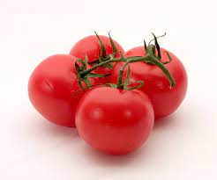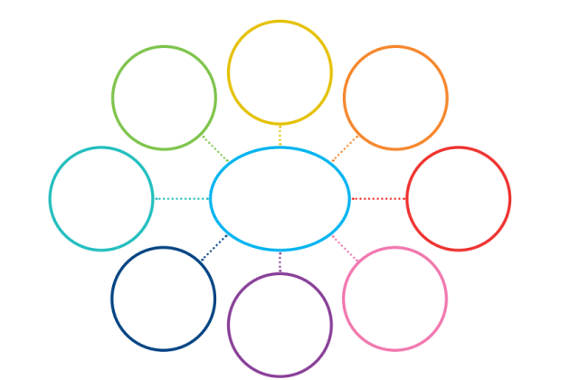
Reading activity
- Each group will be assigned one paragraph
- Work with your group members to underline main verbs and mark red where you find it confusing
- Group members present the meaning of your paragraph on stage

1 Among the common ingredients used in cuisines around the world, the humble tomato is almost universally loved. Found in everything from Italian spaghetti to garden salads, tomatoes add a splash of color to platters and stimulate diners’ taste buds. It is easy to grow tomatoes from seeds or from juvenile plants in warm climates. Ease of cultivation, along with steady consumer demand, makes them a popular crop choice for farmers.
2 Not all tomatoes that are planted make it to markets, however. In fact, millions of tons of tomatoes are thrown away annually because they have been damaged by frost or excessive rain, have been eaten by insects, or have gone rotten before they can be sold. Supermarkets and sauce factories also routinely dump huge numbers of tomatoes. Not only is this terribly wasteful, but it contributes to global warming. All these truckloads of rejected tomatoes constitute a huge quantity of organic material. As the fruit rots, it releases the greenhouse gas, methane, which becomes trapped in the atmosphere and accelerates global warming.
3 Fortunately, technological innovation and scientific knowledge have the potential for turning what seems like a problem into a solution. According to scientists, methane contributes at least 28 times more than CO₂ to global warming, and using tomatoes to generate electricity could help solve the problem of methane produced by rotten tomatoes. This is how it works. Unwanted tomatoes are put into a sealed container, called a cell, with a special kind of bacteria that uses them as a food source. The hungry bacteria instantly go to work, breaking down the tomatoes as they digest them. As this happens, a chemical reaction takes place, causing the tomatoes to release electrons. An electrical circuit has been thus developed to capture these electrons and to store them in a fuel cell that acts like a battery. This stored energy can be converted into electric power that researchers expect will one day be able to be used as an energy source. As it turns out, the natural properties of rotten tomatoes make them ideal fuel for generating electricity.
4 So far, the technology that can turn rotten tomatoes into electricity is still in the testing stage. Researchers have obtained a positive result and proved that the procedure works in the laboratory, but the electric currents they have managed to produce to date have been very weak. Even so, scientists consider it possible to find a method to increase the scale of the process and boost the level of electrical output. Take Florida—a leading producer of tomatoes—for example. Based on scientific calculations, it is presumed that the rotten tomatoes this state throws away each year could power the Walt Disney World Resort for one and a half months. What’s more, producing electricity from rotten tomatoes would also result in simultaneous waste treatment. The process could purify the vegetable matter and the foul-smelling liquid that accumulates when it rots. This is preferable to having tons of plant waste causing bad odors and occupying space in garbage dumps.
5 Another advantage of this new technology is the relatively low cost. Rotten tomatoes have no cash value. In addition, farmers and supermarkets actually find disposing of them costing a fortune. Furthermore, no other raw materials are needed after the initial investment in equipment is made.
6 The technology could be especially helpful in the places where power supplies are unstable, with people sometimes left in the dark. Most importantly, this new method of electricity production successfully reduces the emission of methane and is thus eco-friendly. Although the technology is still in the development stage, tomatoes may be the “power plants” of the future.

Activity

